Emb dim 150, nn.Dropout(0.5)

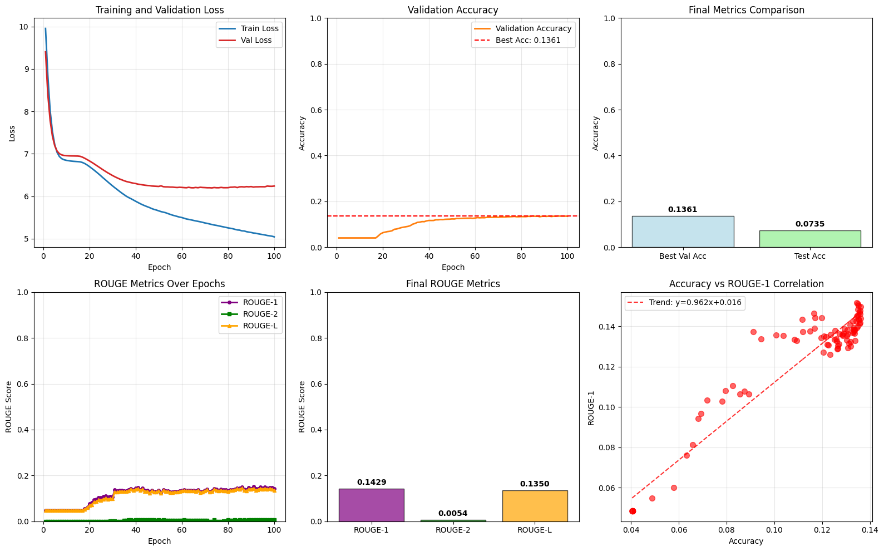

Emb_dim 300, lr=1e-4 (0,0001) , nn.Dropout(0.5)

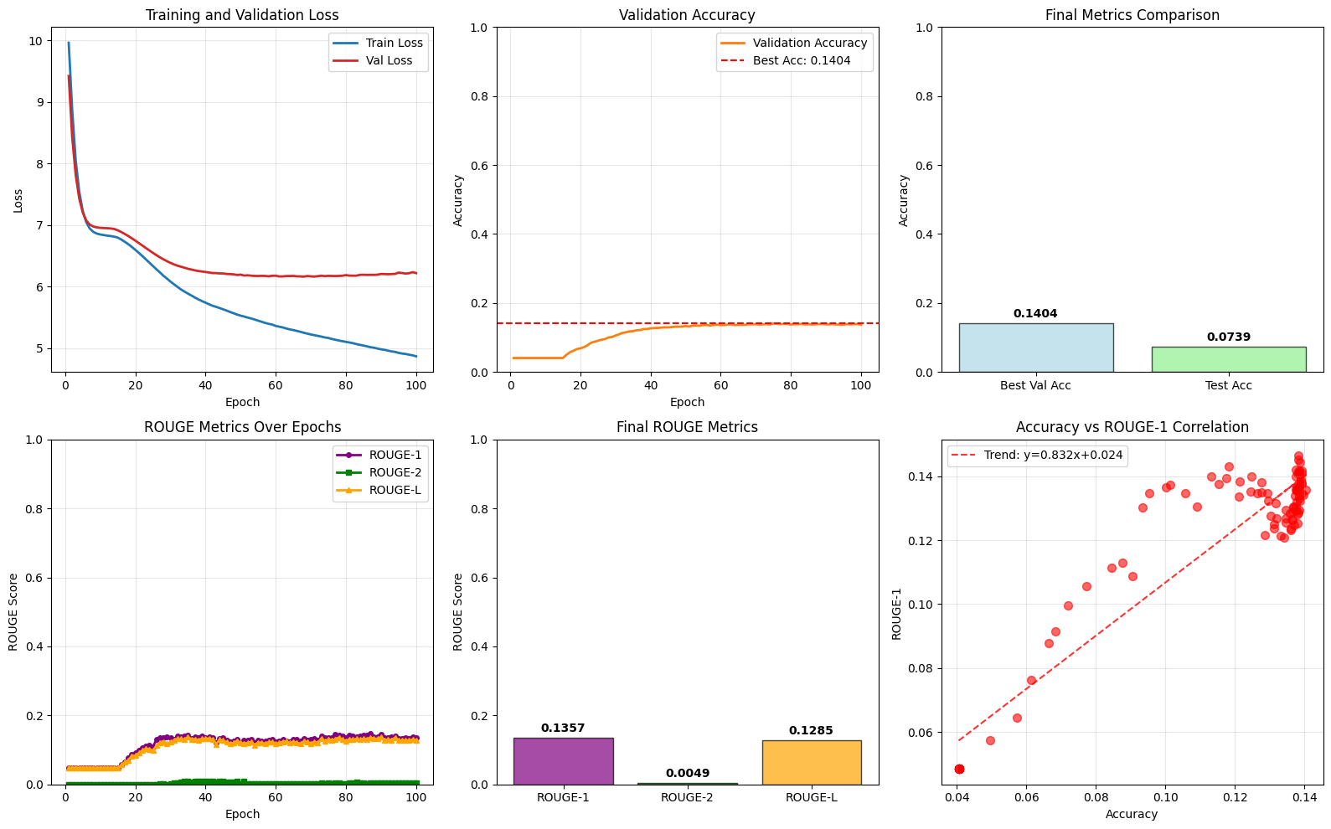

Emb_dim 300, lr=3e-3 высокая скорость обучения, weight_decay=0.01 , nn.Dropout(0.5)

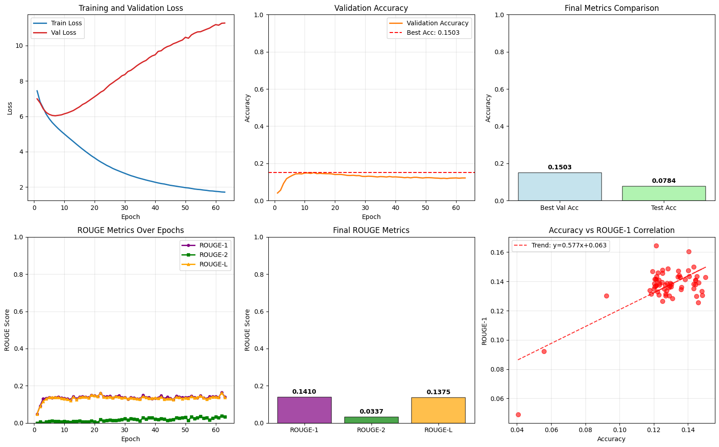

Emb_dim 300, lr= 1e-3, weight_decay=0.001 , nn.Dropout(0.5)

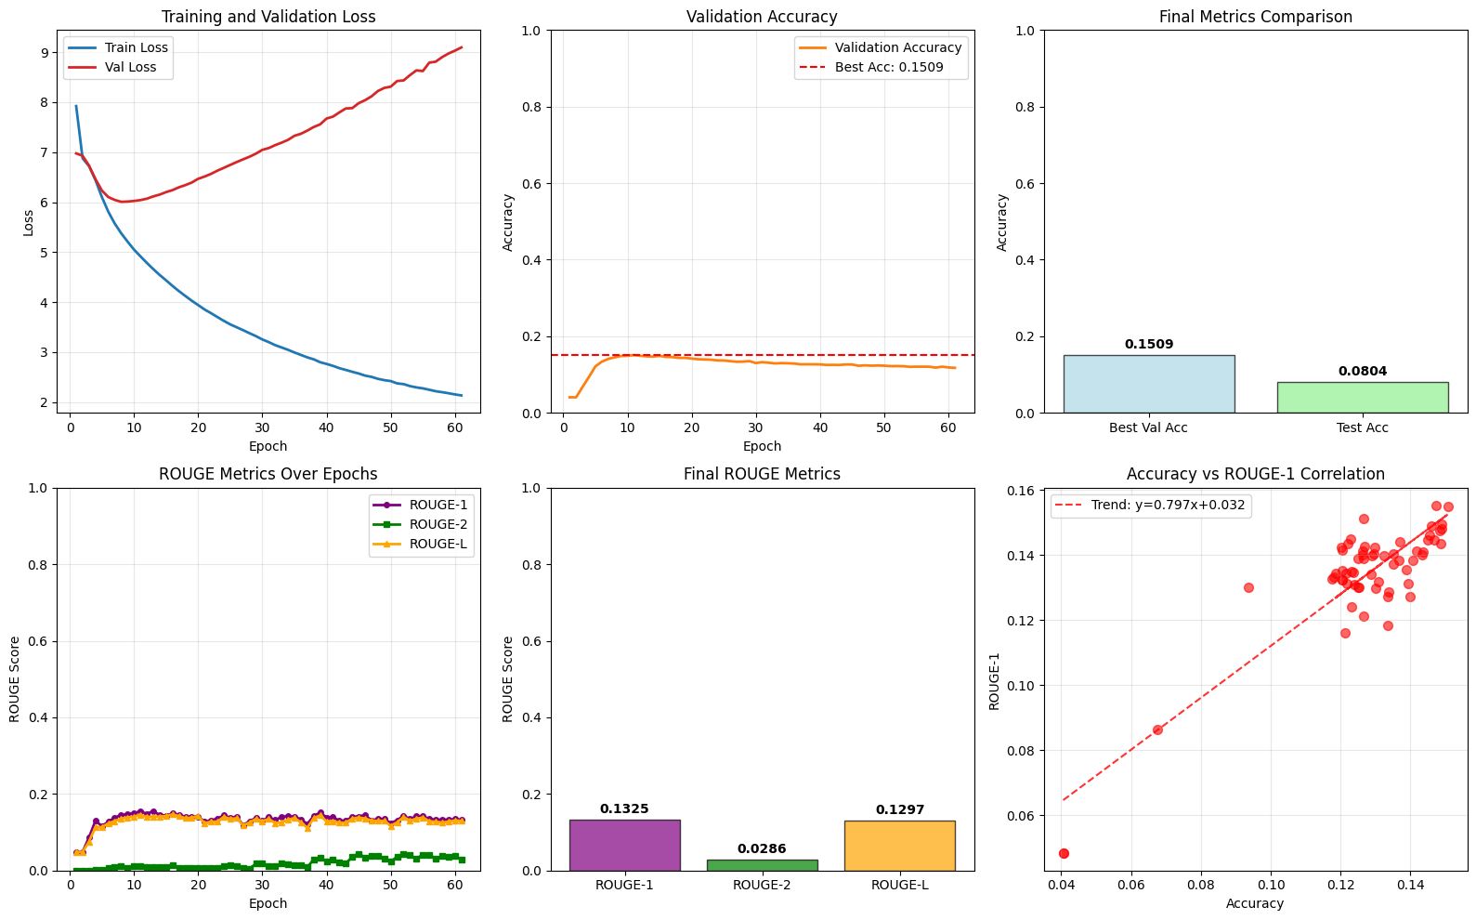

Emb_dim 300, lr= 1e-4, weight_decay=0.001 , nn.Dropout(0.5)

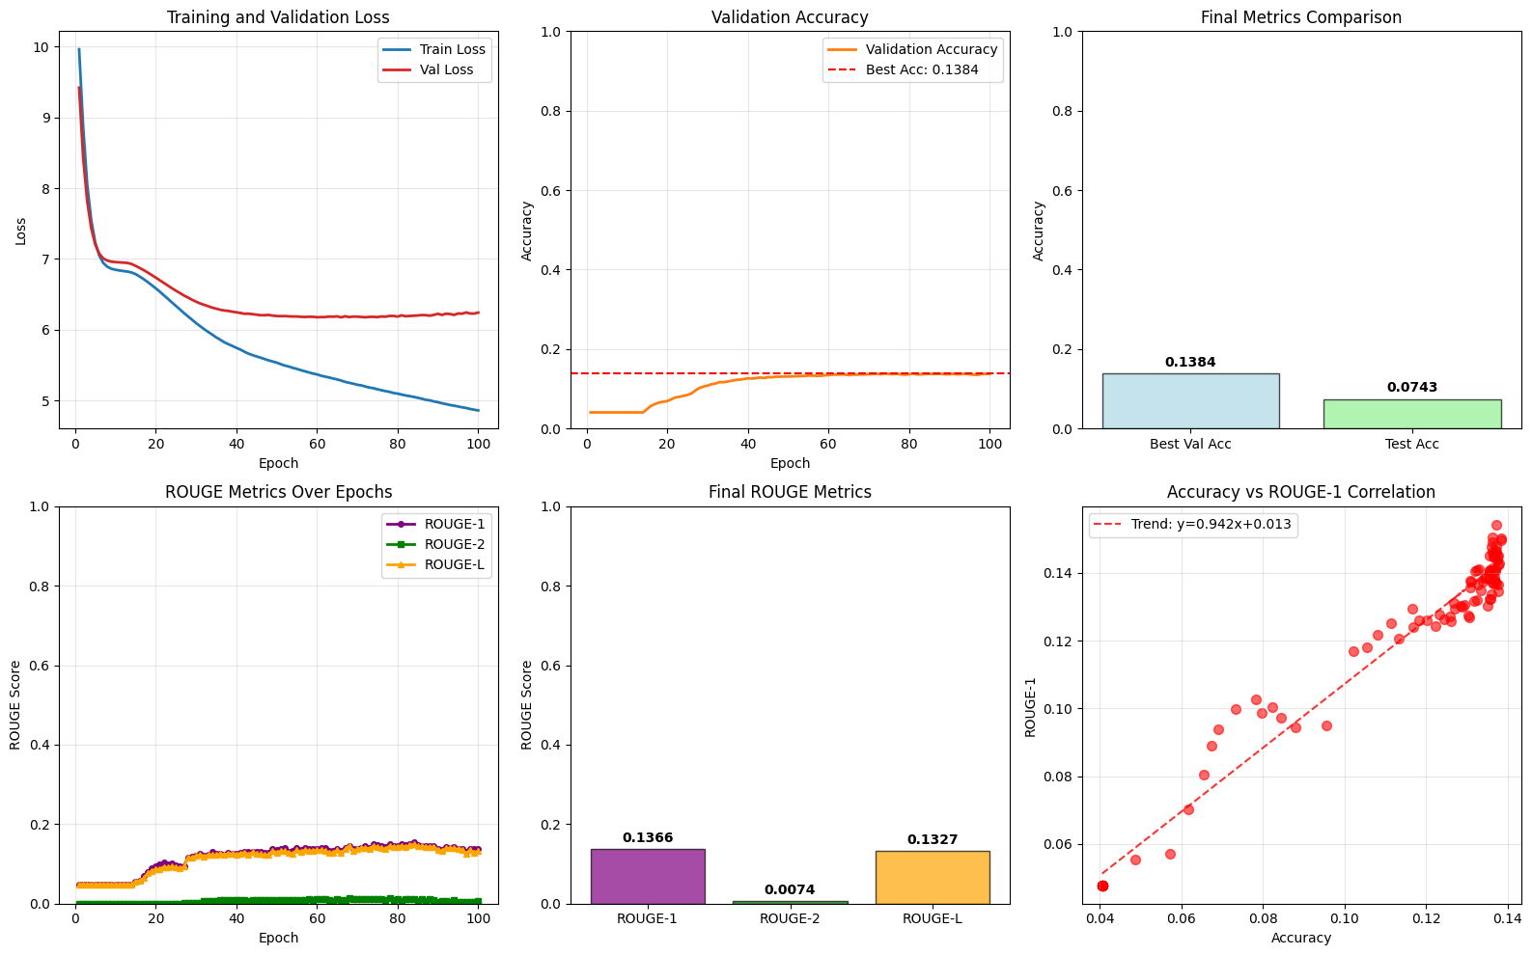

1mln sample Emb_dim 300, lr= 1e-4, weight_decay=0.001, 'hidden_dim': 256 , nn.Dropout(0.5)

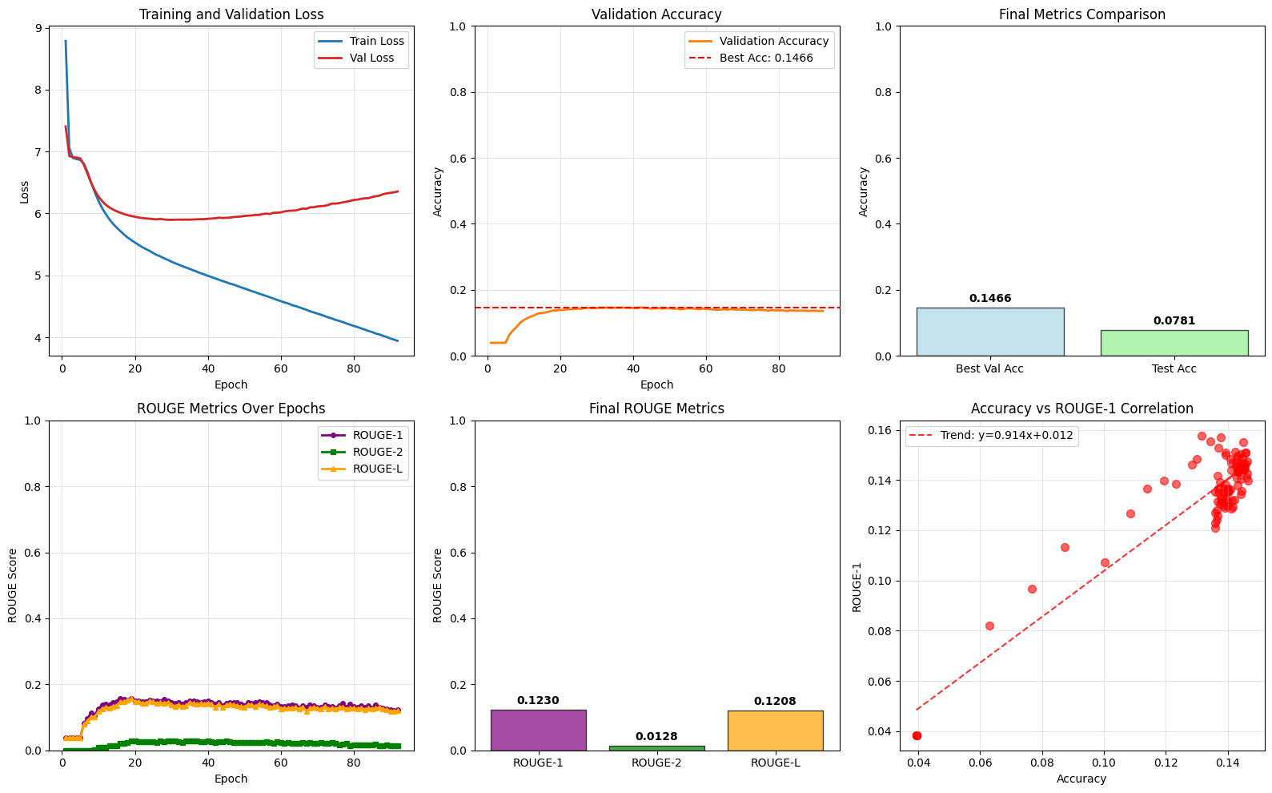

, nn.Dropout(0.5)

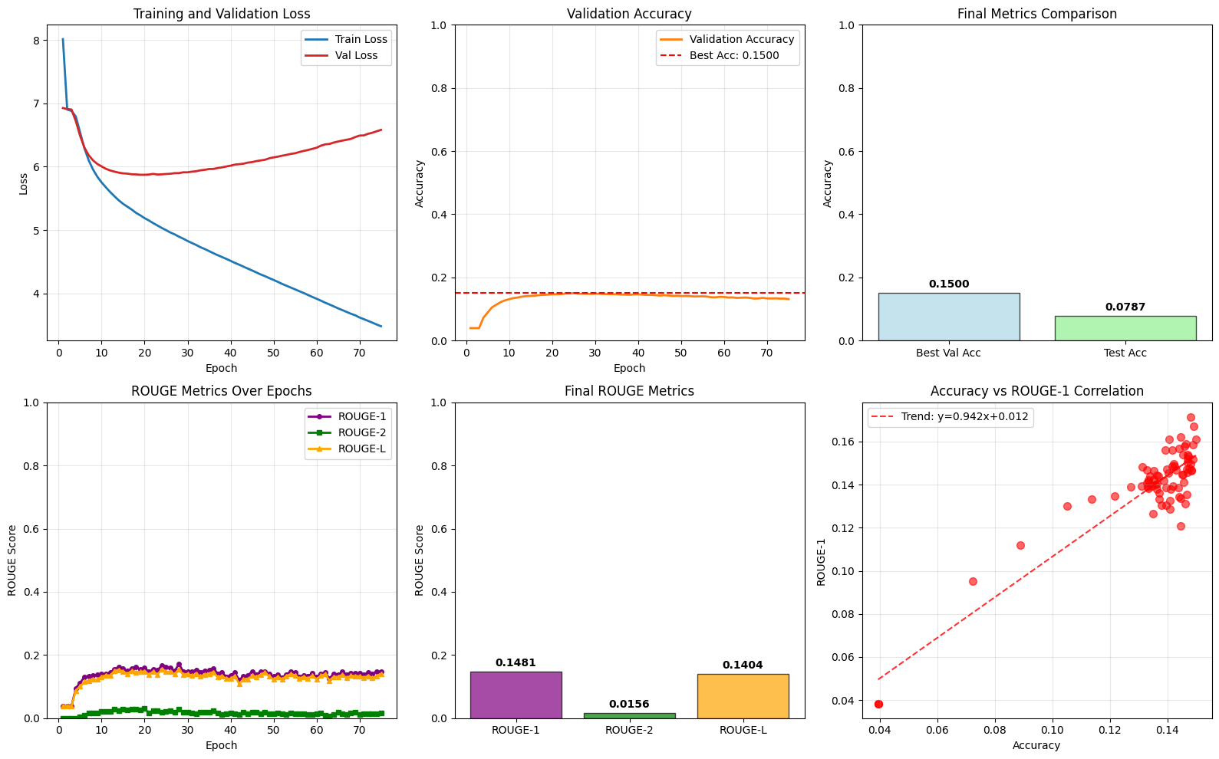

Maxlen 20

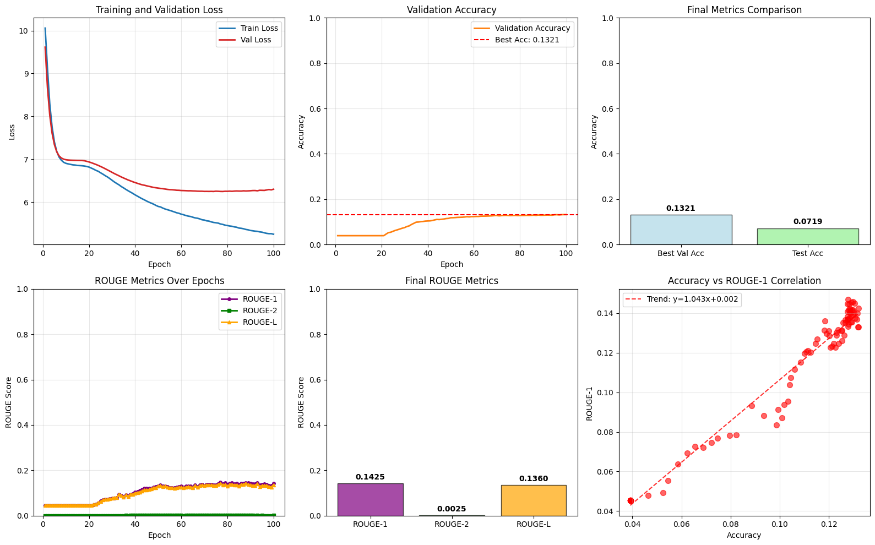

Maxlen 10

'MAX_LEN': 10,

    'num_epoch':100,

    'limit': 500000,

    'num_layers':2,

    'hidden_dim': 128, #128#256#512

    'emb_dim': 300,

    'batch_size': 256,

    'rnn_type': "LSTM",

lr=1e-4, weight_decay=0.05

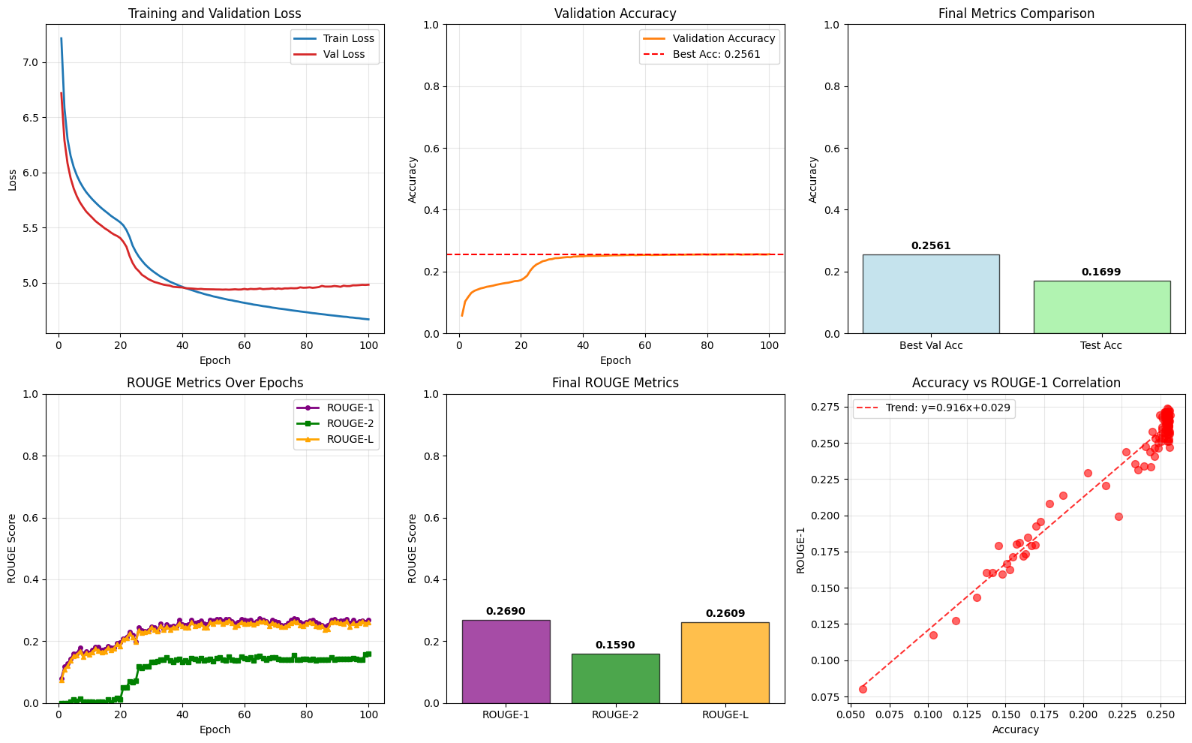

GRU

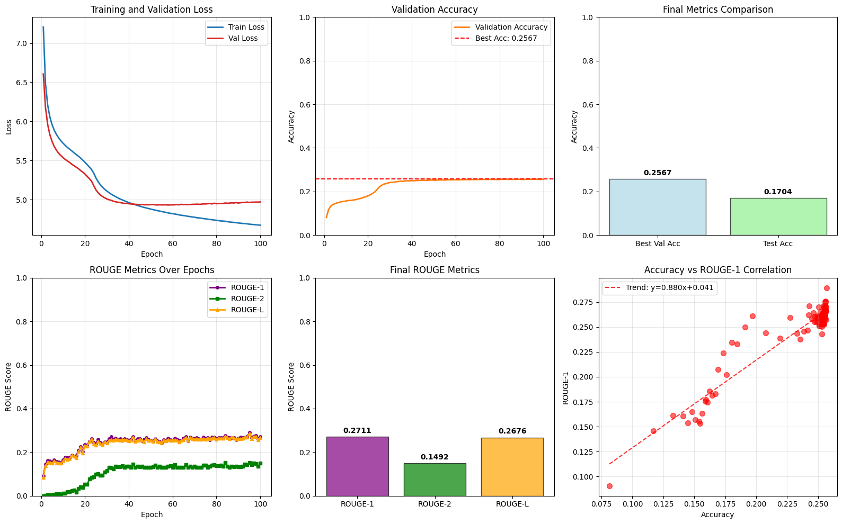

LSTM 200 эпох, выход на 162 (patience =50)

