**Task 6 by Dzmitry Shautsou**

# OLTP – Load External References – Normalization of Data

**Task Results:**

* Create sql scripts to show All created Tables and Views – Screenshot
* Create DataFlow: Sketch Diagram of loading external References (MS Visio, MS Paint, MS Word, etc.)
* Create sql: Showing result of data on next objects:
  + t_localizations
  + cu_languages
  + w_lng_links
  + cu_lng_scopes
  + cu_lng_types

(User u_dw_references)

select * from t_localizations;

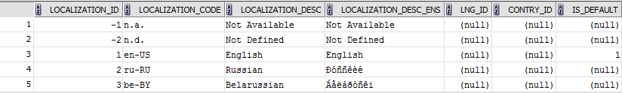

select * from cu_languages;

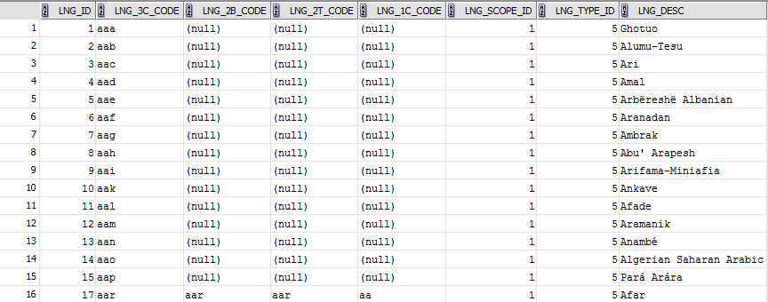

select * from cu_lng_scopes;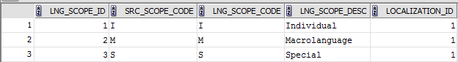

select * from cu_lng_types;

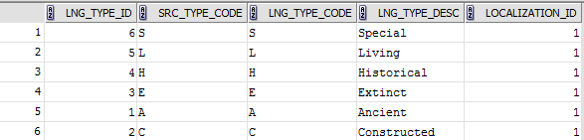

select * from t_lng_links;

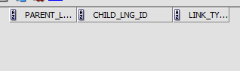

The Physical Diagram of T_Languages below:

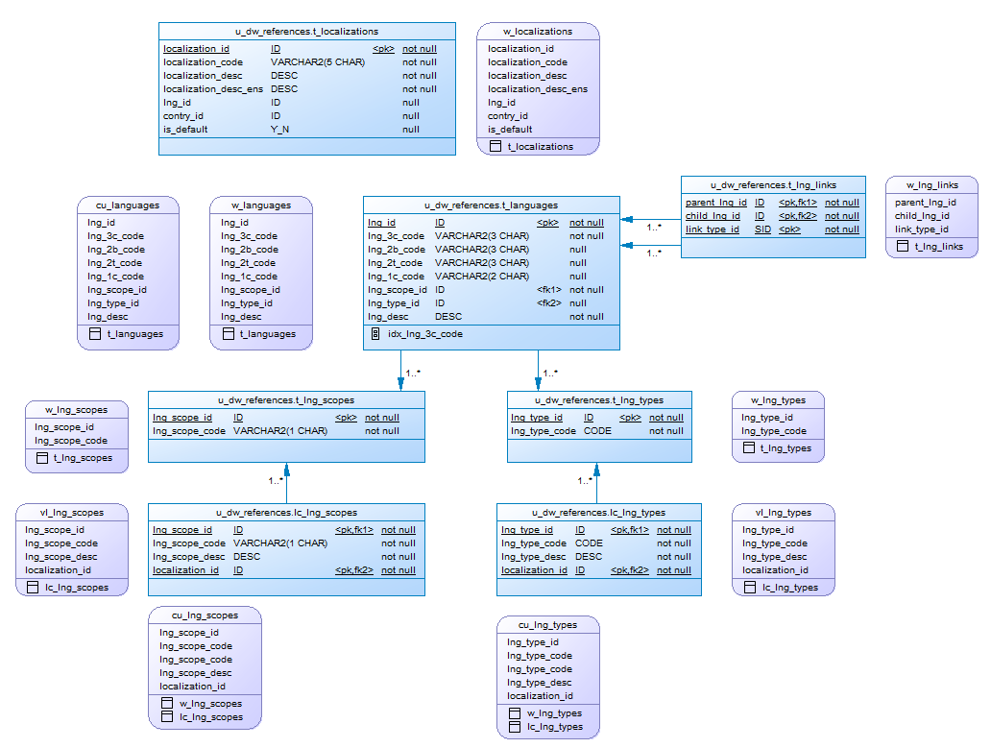

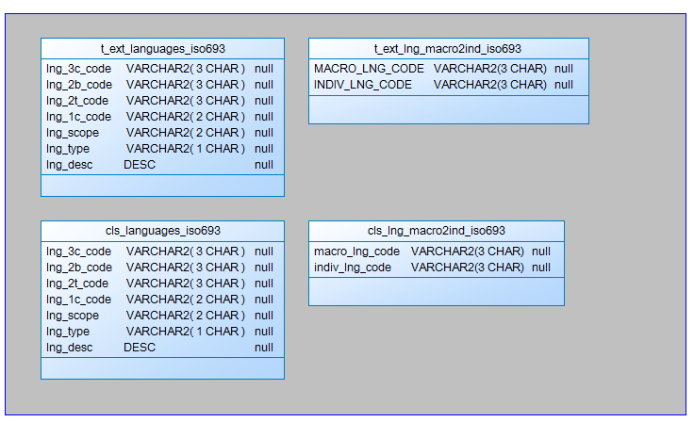

## Task 02 – Create load process for External references T_Countries

**The Main Task** is to develop SQL scripts and install needed objects for load external reference T_Countries.

**Task Results:**

* Create SQL scripts to show All created Tables and Views – Screenshot
* Create DataFlow: Sketch Diagram of loading external References (MS Visio, MS Paint, MS Word, etc.)



* Create SQL: Showing result of data on main objects:

SELECT * FROM CU_COUNTRIES;

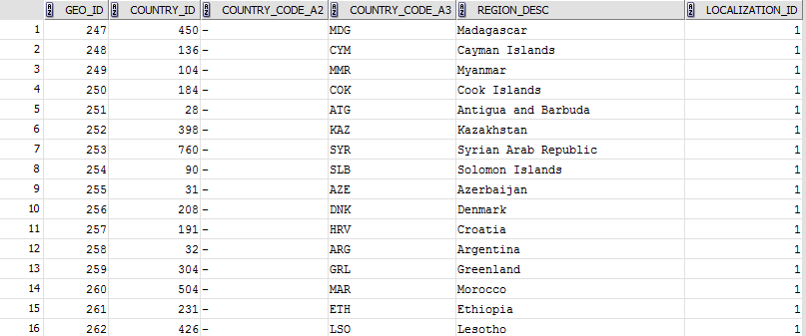

SELECT * FROM CU_GEO_REGIONS;

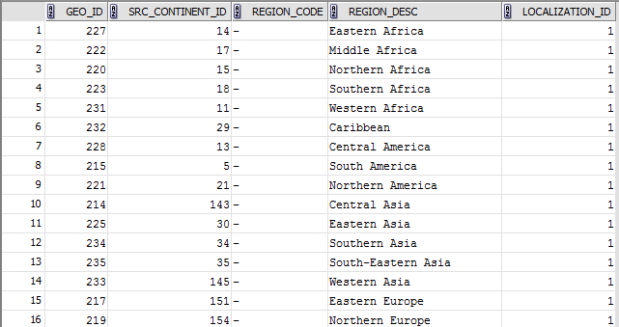

SELECT * FROM CU_GEO_PARTS;

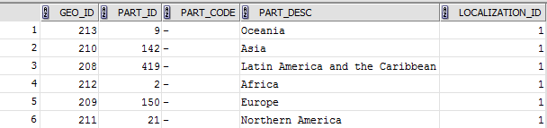

* Prepare The Physical Diagram of T_Countries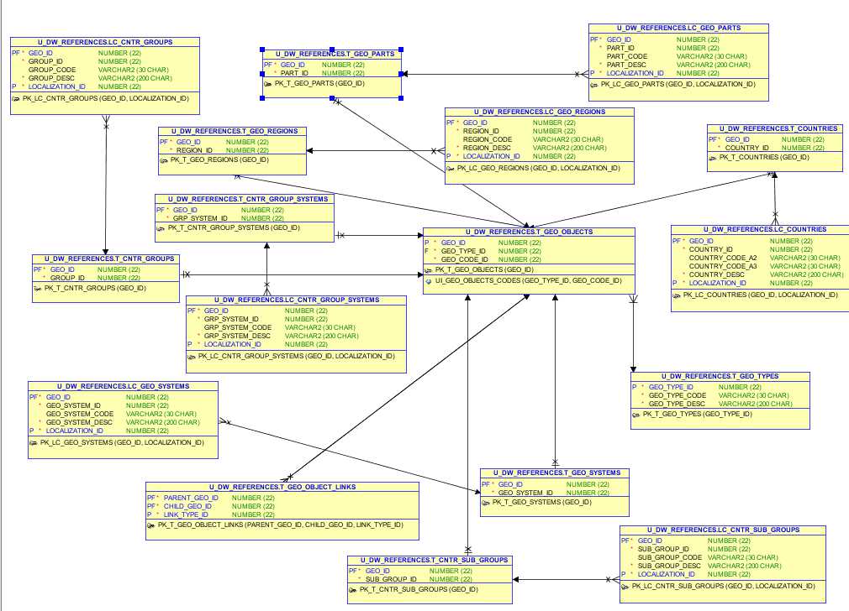

# OLAP – Business analyses task

Create any business analyses task for interesting for your business. The main idea is to use next main dimension:

* Time
* Geo-Location – T_COUNTRIES

## Task 02 – Solution concept – Business background

**The Main Task** is to create Solution concept of yours any business analyses task. You should use Developing Model, that described on MTN.NIX.07.Oracle DB.DWH_courseware06_Star Schema Basics.docx.

**Task Results:**

Create Solution Concept document, which contained next chapters:

Overview

Business Background

Benefit

Requirements

Business Requirements

Technical Requirements

Solution Sketch

Source Tables structure

Summarize Data Plan

(Watch “BusinessProposal.docx” in the same folder)

# OLAP – Develop Star-Scheme and SnowFlake Scheme.

## Task 03 – Develop Star-Scheme physical diagram

**The Main Task** is to create Star Physical diagram and Logical diagram of solution.

**Task Results:**

Create document, which contained next chapters:

* + Physical diagram



* + Logical diagram



## Task 04 – Develop SnowFlake physical diagram

**The Main Task** is to create SnowFlake Physical diagram and Logical diagram of solution.

**Task Results:**

Create document, which contained next chapters:

* + Physical diagram
  + Logical diagram
* **Logical**



* **Physical**
* 

# Create and populate Dimension of TIME DW – Layer

**The Main Task** is to create Physical diagram and Objects on DW layer:

**Task Results:**

Create document, which contained next chapters:

* + Physical diagram store on GIT
  + Links to Scripts on GIT



# OLAP – Business analyses task

## Task 06 – Solution concept – Add: Chapter Dimensions Types

**The Main Task** is to create summary table to describe all future STAR Dimensions:

Next points are mandatory:

* Start scheme must use no less one of SCD type 2 Dimension
* Start scheme must use prepared dimensions: DIM_TIME, DIM_GEO_LOCATIONS
* Start scheme must use one of period dimensions: DIM_GEN_PERIODS



**Task Results:**

Create document, which contained next chapters:

* + Chapter: Dimensions Types Description

|  |  |  |  |  |
| --- | --- | --- | --- | --- |
| Name | Type | Size | DW – Merged Dimensions | Descriptions |
| DIM_TIMES | TYPE 1 | BIG | DW.T_DAYS, DW.T_WEEKS, DW.T_MONTHS, DW.T_QUARTERS,  DW.T_YEARS | It is a specific type of dimension. Appears at the DWH and contains all the time since the introduction of the project until its completion. |
| DIM_GEO_LOCATIONS | TYPE 1 | SMALL | DW.T_COUNTRIES  DW.T_CNTR_GROUPS  DW.T_CNTR_SUB_GROUPS  DW.LC_CNTR_GROUPS  DW.T_GEO_TYPES  DW.T_GEO_SYSTEMS  DW.LC_GEO_SYSTEMS  DW.T_GEO_PARTS  DW.T_GEO_REGIONS  DW.T_GEO_OBJECTS  DW.T_CNTR_GROUP_SYSTEMS  DW. LC_CNTR_GROUP_SYSTEMS  DW.LC_CNTR_SUB_GROUPS  DW.LC_ GEO_PARTS  DW.LC_COUNTRIES  DW.LC_ GEO_REGIONS | This kind of dimension contains information about all countries, subregions, regions of the world. And also enters information on the types of economic development and unions according to the international classification. |
| DIM_CLIENT_SCD | SCD TYPE 2 | BIG | DW.T_CUSTOMERS  DW.T_TARIFFS | This dimension contains information about clients, their persons data, and tariff plan which they use(used). |
| DIM_SERVERS | TYPE 1 | BIG | DW.T_SERVERS  DW.T_LOCATIONS  DW.T_CHANNELS | This dimension contains information about our servers, their technical properties. |
| DIM_TARIFFS | TYPE 1 | SMALL | DW.T_TARIFFS | Provides information about channels of sales (description and class) |
| DIM_GEN_PERIODS | TYPE 1 | SMALL | DW.T_PERIOD_DESC | Dimension specific type, which allows grouping of facts on the basis of logic (clients tariff in our case) |

## Task 07 – Solution concept – Add: Chapter Dimensions Hierarchies

**Task Results:**

Create document, which contained next chapters:

* + Chapter: Dimensions Hierarchies

**DIM_GEN_TIME:**

**Hierarchy DAY / MONTH / QUARTER / YEAR**

|  |  |  |  |
| --- | --- | --- | --- |
| Name | LEVEL_CODE | LEVEL_DESC | LEVEL_NATURAL_KEY |
| DAY | DAY | Store all day at the calendar year | DAY_ID |
| MONTH | MONTH | Store all months at the calendar year | WEEK_ID |
| QUAR | QUARTER | Store all quarters at the calendar year | QUAR_ID |
| YEAR | YEAR | Store all years at the calendar year | YEAR_ID |

**Hierarchy WEEK / MONTH / QUARTER / YEAR**

|  |  |  |  |
| --- | --- | --- | --- |
| Name | LEVEL_CODE | LEVEL_DESC | LEVEL_NATURAL_KEY |
| WEEK | DAY | Store all weeks at the calendar year | WEEK_ID |
| MONTH | MONTH | Store all months at the calendar year | MONTH_ID |
| QUAR | QUARTER | Store all quarters at the calendar year | QUAR_ID |
| YEAR | YEAR | Store all years at the calendar year | YEAR_ID |

**DIM_SERVERS:**

**Hierarchy PRODUCTS / SUBCATEGORY / CATEGORY**

|  |  |  |  |
| --- | --- | --- | --- |
| Name | LEVEL_CODE | LEVEL_DESC | LEVEL_NATURAL_KEY |
| SERVER | PROD_NAME | Store all servers of ever y type | SERVER_ID |
| TYPE | PROD_SUBCATEGORY | Store all type of internet we provide | TYPE_ID |

**DIM_GEO LOCATIONS:**

**Hierarchy COUNTRY / SUBREGION / REGION**

|  |  |  |  |
| --- | --- | --- | --- |
| Name | LEVEL_CODE | LEVEL_DESC | LEVEL_NATURAL_KEY |
| COUNTRIES | COUNTRY_NAME | Store all countries for each region. | COUNTRY_ID |
| SUBREGIONS | COUNTRY_SUBREGION | Store all subregions for each region . | COUNTRY_SUBREGION_ID |
| REGIONS | COUNTRY_REGION | Store all regions of the world. | COUNTRY_REGION_ID |

**Hierarchy COUNTRY / REGION / CONTINENT**

|  |  |  |  |
| --- | --- | --- | --- |
| Name | LEVEL_CODE | LEVEL_DESC | LEVEL_NATURAL_KEY |
| COUNTRIES | COUNTRY_NAME | Store all countries for each region. | COUNTRY_ID |
| SUBREGIONS | COUNTRY_SUBREGION | Store all regions for each region . | COUNTRY_REGION_ID |
| REGIONS | COUNTRY_CONTINENT | Store all continents of the world. | COUNTRY_CONTINENT_ID |

## Task 08 – Solution concept – Add: Chapter Facts Aggregations

**The Main Task** is to create summary table to describe all future STAR Fact Table Aggregations:

Next points are mandatory:

* Create more than one measurement
  + Summarize aggregation
  + Additional task: Not Additive measurement

**Task Results:**

Create document, which contained next chapters:

* + Chapter: Facts Aggregations

|  |  |  |  |  |
| --- | --- | --- | --- | --- |
| Name | Code | Table Name | Additive | Descriptions |
| TRAFFIC_IN | TRAFFIC_IN | FCT_SPENDINGS_D | YES | Calculate sum incoming traffic by day. |
| TRAFFIC_OUT | TRAFFIC_OUT | FCT_SPENDINGS_D | YES | Calculate sum outgoing traffic by day. |
| SPENDING | SPENDING | FCT_SPENDINGS_D | YES | Calculate sum of money spent on incoming and outgoing traffic |