STYLE GUIDE

ITA TOOLS

**01 Colors**

**Main colors: Dark and White**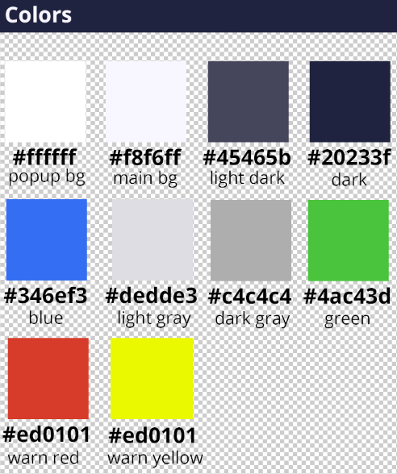

**02 Typography**

**Font - Open Sans**

Regular

*Regular Italic*

**Semi-Bold**

**Bold**

**Extra-Bold**

**03 Buttons**

**Basic button**

**Basic button state**



|  |
| --- |
| background-color: #20233f  color: #ffffff  font-weight: bold  border-radius: 50px  padding: 8px 0px  width: 210px  font-size: 16pt |

**Basic button hover state**



|  |
| --- |
| background-color: #ffffff  color: #20233f |

**04 Icons**

Icons library: Font awesome

**05 Form elements**

**Input**

When user change input state on active – placeholder jump to top. Input have 4 states: basic, active, valid and invalid.

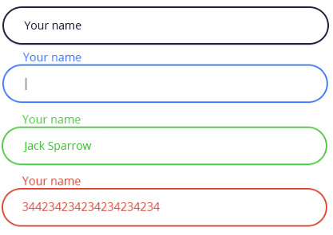

|  |  |  |  |
| --- | --- | --- | --- |
| **Input: basic** | **Input:focus** | **Input:valid** | **Input: invalid** |
| border-radius: 50px  border-color: #20233f  border-width: 2px  padding: 10px 15px  font-size: 14px  width: 450px  color: #20233f  background-color: #ffffff  Font-weight: regular | border-color: #346ef3  color: #20233f | border-color: #4ac43d  color: #4ac43d | border-color: #ed0101  color: #ed0101 |
| **plceholder** | **plceholder** | **plceholder** | **plceholder** |
| font-size: 12px  color: #20233f |  |  |  |

**Checkbox**



|  |  |
| --- | --- |
| **Checked: false** | **Checked: true** |
| border-radius: 5px  border-color: #dedde3  border-width: 1px  font-size: 12px  width: 20px  height: 20px  background-color: #ffffff | border-color: #346ef3 |
| **Check icon** |
| border-color: #346ef3  font-size: 12pt |