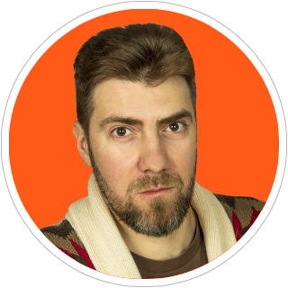

+48 (735) 216-744

dmarkov@stylive.com

twitter @damarkov

Dmitry Markov

Frontend Web Developer / Creative Technologist

**Professional web developer with 15+ years of experience in web and software development**

Creating apps with **React/Redux, Vue** and AngularJS frameworks

Passionate to design systems, user interfaces, graphic and **interactive prototypes**

Have a deep knowledge of **HTML, CSS/SASS/LESS**, **JavaScript/ES6**

Understand **SPA development** with MVC and SOLID, component-based architecture and mobile-first approach

Using **TypeScript, ESlint**, git, gulp, webpack, pug, markdown, npm

Test with **Mocha, Chai**, Sinon, Enzyme and Puppeteer

Practicing full-stack development with **NodeJs/Koa/Express** and **SQL/noSQL** databases

**Experience**

|  |  |  |
| --- | --- | --- |
| **2017 – present time**  **Senior Software Developer**  *Luxoft Poland*   * Developed and supported enterprise-level SPA with React/Redux from the scratch * Created library of shared reusable components, consulted other teams about implementation * Participated in frontend architectural solutions * Maintained linting rules and code review conventions * Conducted technical interviews for company   **2004 – 2009 Software Engineer**  *Information supply centre,  Ministry of Defence of the Russian Federation*   * Developed and maintained official website of the Ministry of Defence and its CMS * Consulted authorities and represent the Ministry on official tenders * Awarded for personal contribution, initiative and professionalism |  | **2010 – 2017**  **Web Developer / Team Lead**  *Complex pro*   * Developed web applications with Vue and AngularJS * Managed web development team * Prototyped graphics and interactive elements * Created graphical design and user interface for websites and desktop applications * Made responsive layouts with HTML/CSS * Designed style guidelines and provide UX analytics * Supervised corporate portal and trained managers * Wrote technical documentation and specifications   **2002-2004**  **Web Designer**  *Hubert Burda Publishing House*   * Mastered websites and graphic design for «Chip Russia» magazine website and its side projects * Created user interfaces and layouts for «Enter» and «Photo & Video Digital» magazines |

**Education**

|  |  |
| --- | --- |
| **Full Stack Web Developer 2016**  *The Hong Kong University of Science and Technology*  Practiced in HTML5, CSS3, JavaScript, Bootstrap, AngularJS, Ionic framework for hybrid mobile applications, Node.js, Express.js, MongoDB, test-driven development with Karma and Mocha, Gulp and Grunt automation tools | **Engineer Specialist 2002**  *Moscow State Institute of Radio Engineering, Electronics and Automation*  A-grade in English language, programming beginnings, communication systems and other. Practiced in software development and UI design |

**Additional**

|  |  |
| --- | --- |
| English — upper-intermediate (B2)  Russian — native | Member of GTC (Global Translator Community): translations from English to Russian with Translate Coursera |