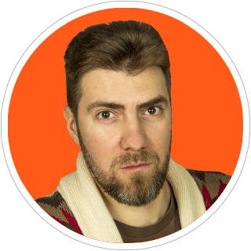

+49 (151) 561-04820

dmarkov@stylive.com

twitter @damarkov

Dmitry Markov

Frontend Developer / Software Engineer

**Professional web developer with 15+ years of experience in software development**

Creating apps with **React/Redux** and **Vue.js** frameworks

Passionate to design systems, user interfaces, graphics and **interactive prototypes**

Experienced in web design, desktop and mobile apps

Have a deep knowledge of **HTML, CSS/SASS/LESS**, **JavaScript/ES6**

Understand **SPA** development**,** **REST**/GraphQL APIs, component-based architecture and mobile-first approach

Using **TypeScript, Continuous Integration,** eslint, git, webpack, gulp, pug, markdown, npm

Testing with **Jest, Cypress.io,** React Testing Library, WebDriver, Chai, Sinon, Enzyme, Nightwatch and Mocha

**Experience**

|  |  |  |
| --- | --- | --- |
| **2020 – present time**  **Software Engineer**  *Oxygen Technologies GmbH*   * Created PWA with Vue.js, Nuxt.js and Vuetify * Set up e2e testing and continuous integration   **2017 – 2019**  **Senior Software Developer**  *Luxoft Poland*   * Developed and supported enterprise-level SPA with React/Redux from the scratch * Created library of shared reusable components * Participated in frontend architectural solutions * Maintained linting rules and code review conventions * Conducted technical interviews for company   **2004 – 2009 Software Engineer**  *Information supply centre,  Ministry of Defence of the Russian Federation*   * Developed and maintained official website * Consulted authorities * Awarded for personal contribution |  | **2019 – 2020**  **Senior Software Engineer**  *Allthings GmbH*   * Created apps with React, Typescript, CSS-in-JS and GraphQL * Wrote e2e and unit test, participated in code review * Contributed to Node.js, PHP and React Native repos   **2010 – 2017**  **Web Developer / Team Lead**  *Complex pro*   * Developed web applications with Vue and AngularJS * Managed web development team * Prototyped graphics and interactive elements * Created graphical design and user interfaces * Made responsive layouts with HTML/CSS   **2002-2004**  **Web Designer**  *Hubert Burda Russia Publishing House*   * Mastered websites and graphic design for «Chip Russia» magazine website and its side projects |

**Education**

|  |  |
| --- | --- |
| **Full Stack Web Developer 2016**  *The Hong Kong University of Science and Technology*  *(JavaScript, AngularJS, Ionic, Node.js, Express)* | **Engineer Specialist 2002**  *Moscow State Institute of Radio Engineering, Electronics and Automation* |

**Additional**

|  |
| --- |
| Languages: English — upper-intermediate (B2), Russian — native, German — basic (A1) Mentoring students at HTML Academy (JavaScript, React), Member of GTC: Global Translator Community |