11.4 SINGLE-STAGE MODULE CALCULATIONS: These equations mathematically describe the performance of a single-stage thermoelectric module as illustrated in Figure (11-l). When entering numerical data, do not forget that temperature values must be expressed in degrees Kelvin (°K). Calculations of the various parameters should be performed in the order shown.
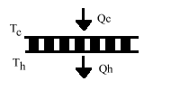
Figure (11-1)
a) The temperature difference (DT) across the module in °K or °C is:
DT = Th – Tc
b) Heat pumped (Qc) by the module in watts is:
Qc = (SM × Tc × I) – (0.5 × I2 × RM) – (KM × DT)
c) The input voltage (Vin) to the module in volts is:
Vin = (SM × DT) + (I × RM)
d) The electrical input power (Pin) to the module in watts is:
Pin = Vin × I
e) The heat rejected by the module (Qh) in watts is:
Qh = Pin + Qc
f) The coefficient of performance (COP) as a refrigerator is:
COP = Qc / Pin
Extract peltier parameters from performance Curve (Q_{c} vs DeltaT)

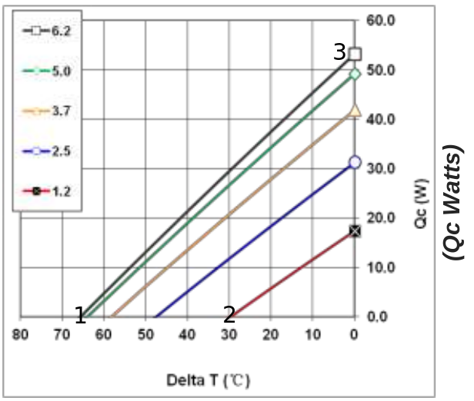

We can solve eq. (b) for K

we can choose two points 1 and 2 on the Curve where Q_{c} = 0 so we have

if whe consider point 3 in the performance Curve where dT=0 we can write

finally we can consider again point 3 where Q_{c} = 0 in order to calculate K

