APPETIT



**GET YOUR CARD**

X

RESTAURANTS BY CITY

Berlin Hamburg Munich (Munchen) Cologne (Koln)

Frankfurt am Main

Stuttgart

Dusseldorf

Dortmund

Essen

Leipzig

RESTAURANTS BY NAME

ASK Italian

Azzurro

Banana Tree

Barcelona Tapas

Belgo

Bella Italia

Byron

Cafe Rouge

Chino Latino

Chiquito

**ABOUT US**

Our company Customer testimonials Why we're different Our chosen charity Work for us

**HOW CAN WE HELP?**

Contact us FAQs

Restaurant Opportunities For Businesses Sitemap

**GET STARTED**

How To Use Buy an AppetitCard Buy an AppetitCard Gift UNiDAYS

**STAY INVOLVED**

Newsletter Sign Up Appetit blog Recommend Restaurants Restaurant Reviews AppetitCard+ Offers



## **Save Money. Eat Out.**

£1 for 60 days. Includes tastecard+ *

TRY NOW

*£1/60 days. Cancel trial anytime. Includes tastecard+. Renews at £34.99 (excluding tastecard+)

Subscribe to our newsletter to be the first to hear about exclusive offers and discounts



# **oo§®**

Download on the

AppStore



*^Y&nkie. t Penny's*

pizza, tfuf

RESTAURANTS



ROWING

Pizzn & WINE

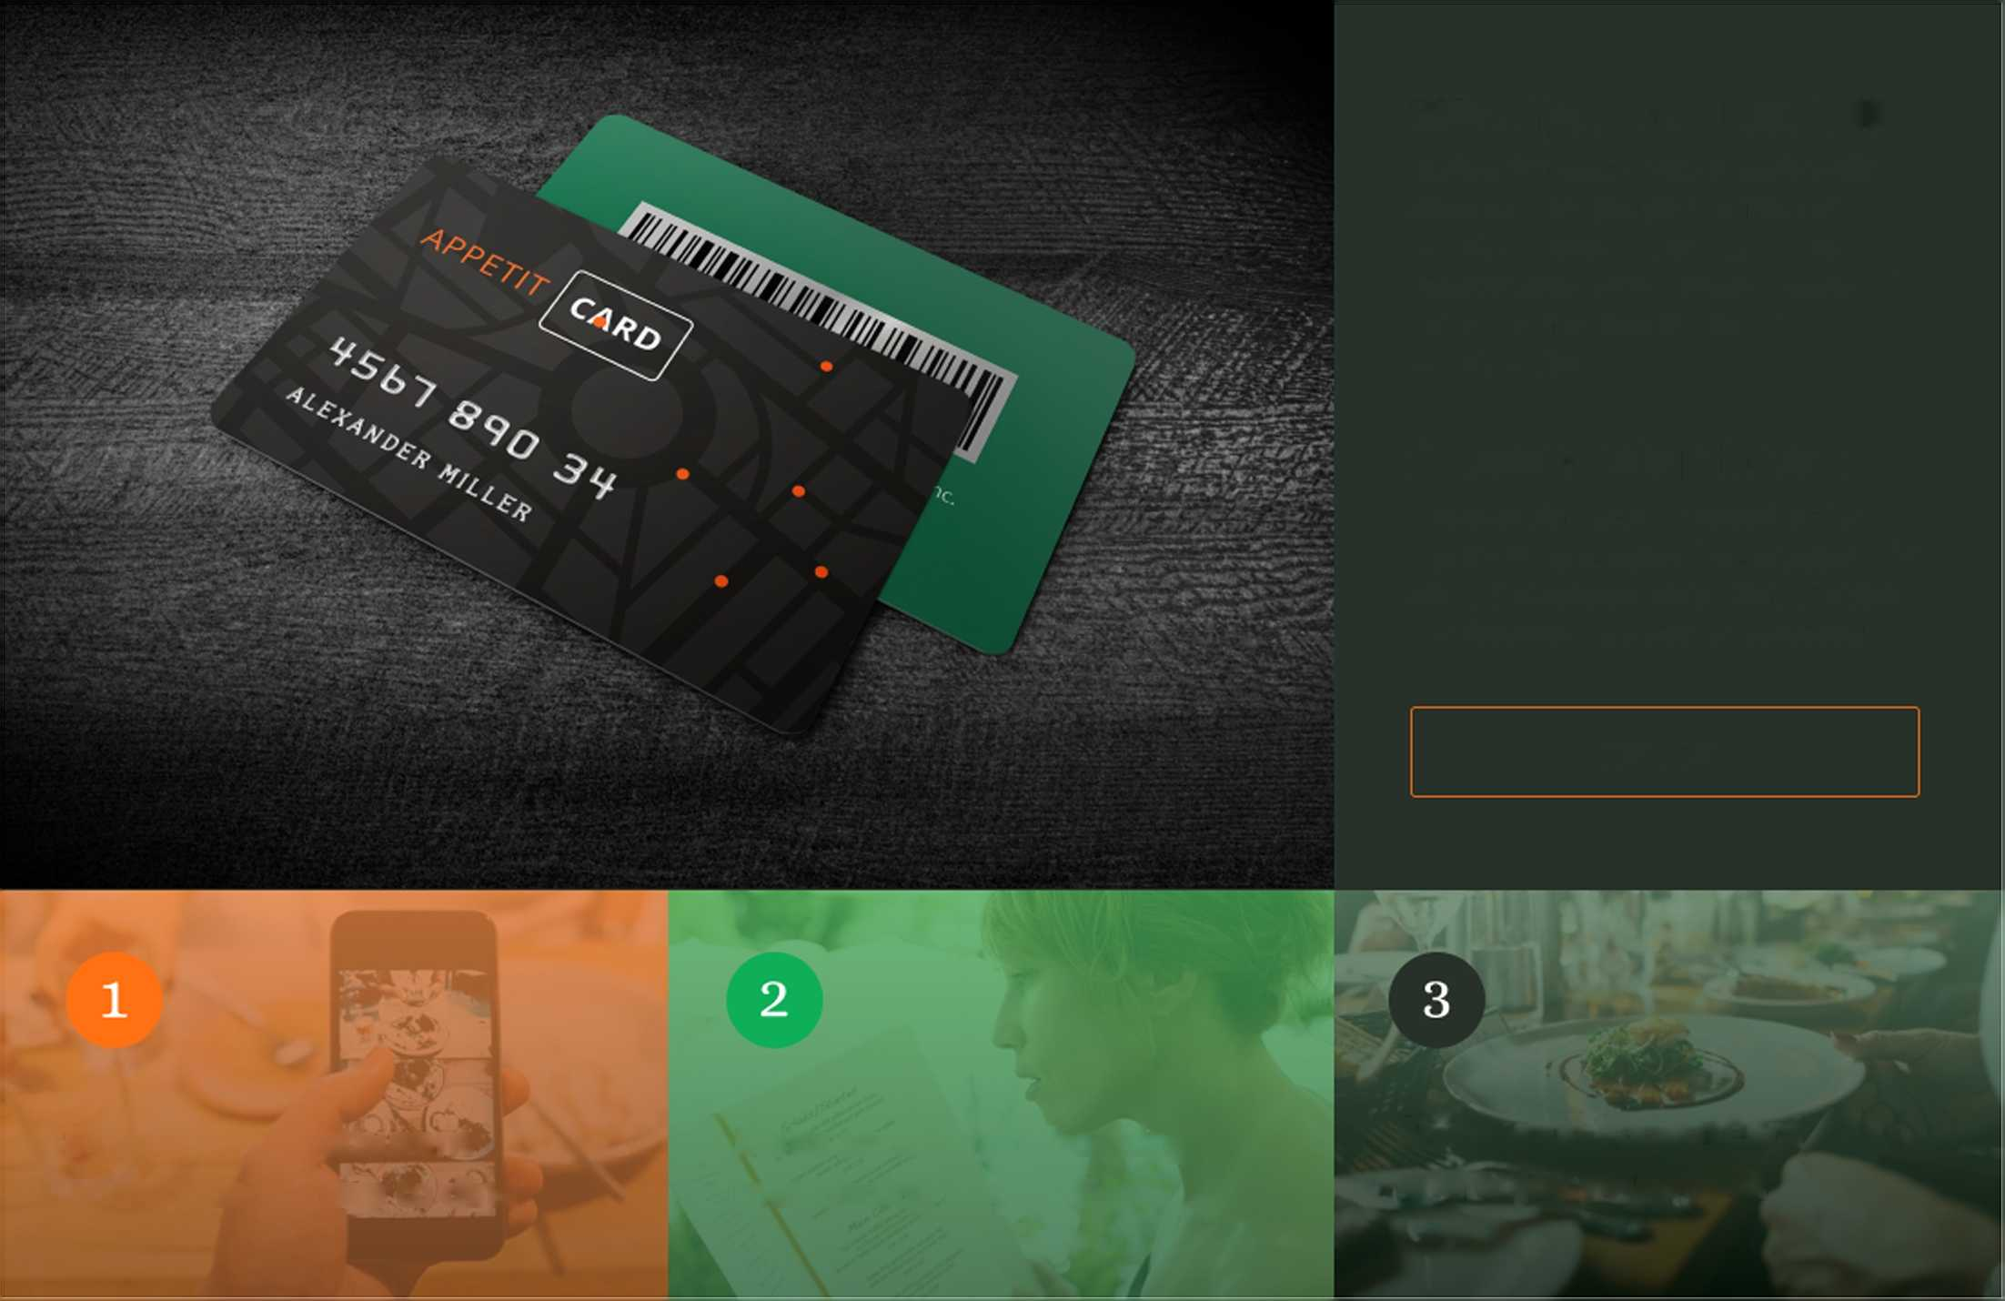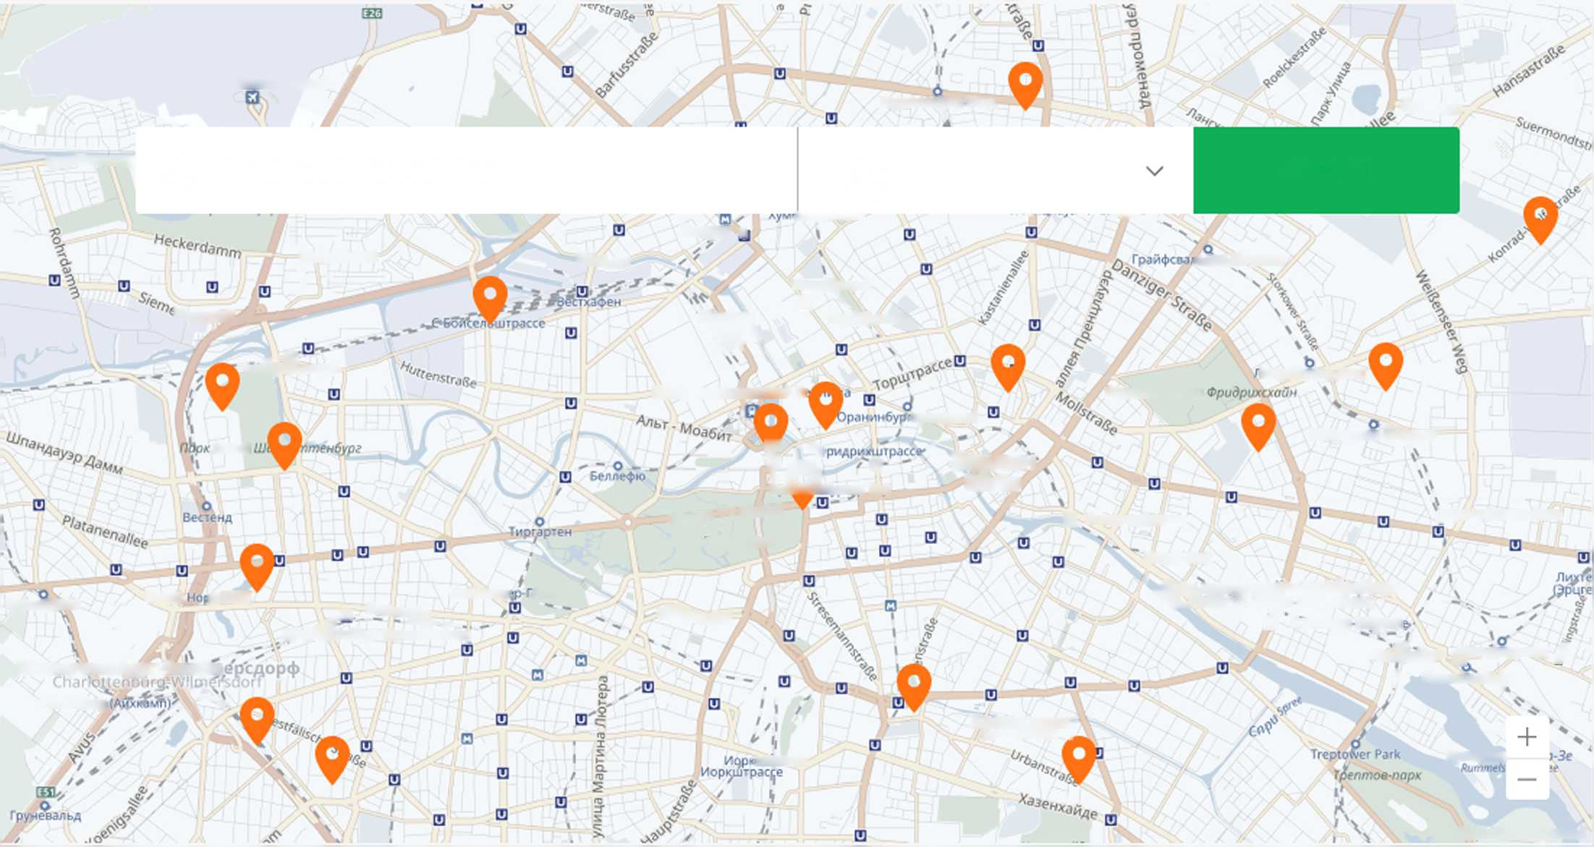

Using your AppetitCard is as easy as 1, 2, 3...

50% off your total food bill!

All diners in a party can eat and receive a 50% discount on their food, even with just one AppetitCard member in the party. However, please do check with the individual restaurant for the maximum numbers permitted per AppetitCard booking.

2 meals for the price of 1!

2 meals for the price of 1 is available for two people only and is across all courses ordered; the cheapest or equivalent dish of each course being free. Side dishes and extras are not included.

**TRY NOW**

Search for a restaurant and choose where to dine

Make an advance booking mentioning AppetitCard

Show your AppetitCard and enjoy your meal!

Search Restaurant Nearby

asponopT 6eD/iHH-Iere/ib

Caa^BUHK/iep

Q Restaurant Name

BcAojtyr r,

|  |  |
| --- | --- |
| Distance |  |
| Any  iu/lbA'AcW*1 r m r- • - •• • -v w *v | SEARCH |

6opHxo/ib^ep UJrp.

5yiua/iee

IbACRUJTpoCCC

Hopa6jmxo$

H N\

Heckerdamm

*©rdutet

^sdamm

^ 'O

FuHr<|>epHxavv\e

MuTTe

'Witte \

\\\% '

Hopi$aMxo<J>

UewrpaflbMWM bokm/i 6i

lanAc6eprjFpAnne

HapoduvO nap*k*

cpujrpaccc

UJTopxooep-lit^acce

5 ^ a ■ Bep/lHH

30MK0

LDevorp'oToo Berlin

Xepimpacce

Mecce

>A/ktuu

m *»«sira8e

^ O ""O- —

UJapndTTeH&ypr CaBMHbM-ruiaq

tlo/iormu«

apieM

UJap/iOTTeH6ypr-Bn/ibM Mcccc 3k>, A “ n

17 IAVOH9

y/wud

So/ibivou TupzapmeH

H flMMOBnu6p»o«Ke

jOpaHK^ypTcp-Anne

^^oivufer

OCWHXO^

' <J>pnnpMKCxaMH-Kpo£iu6epr

^LKiMncKsb^nKreuzberg"

ffl Bapmaya^llJTpacc

QcfSo&u* ^wibA^cpnnau / f PyMwe^bc6y^r

*flondeep kohcui*

*iMCtwefakCMOl* .

tuTpacce

*PyMM€/)bi*

*Hook* flAwmepeMbd

**TRY NOW**

The Full Key...

2=1

50%

The restaurant offers AppetitCard-holders 2 for 1 meals (across all courses ordered)

The restaurant offers AppetitCard-holders 50% OFF the total food bill

NEW



This restaurant has only joined AppetitCard in the last 30 days

Online booking available for this restaurant



x8

You must telephone book in advance and mention AppetitCard

Number denotes the maximum number of people per taste booking



The AppetitCard offer is not available on Friday evenings



The AppetitCard offer is not available on Saturday evenings



The AppetitCard offer is not available during December

The AppetitCard offer is available in December, however set menus and other restrictions may apply.

**TRY NOW**

APPETIT CARD oo@®

**ABOUT US HOW CAN WE HELP? GET STARTED STAY INVOLVED**

Subscribe to our newsletter to be the first to hear about exclusive offers and discounts



Our company Contact us How To Use Newsletter Sign Up

Customer testimonials FAQs Buy an AppetitCard Appetit blog

Why we’re different Restaurant Buy an AppetitCard Gift Recommend

Our chosen charity Opportunities UNiDAYS Restaurants

Work for us For Businesses Restaurant Reviews

Sitemap AppetitCard+ Offers

©2017-2018 AppetitCard. All Rights Reserved.