FEDERAL STATE AUTONOMOUS EDUCATIONAL INSTITUTION

OF HIGHER EDUCATION

ITMO UNIVERSITY

Report

on the practical task No. 4

“Algorithms for unconstrained nonlinear optimization. Stochastic and

metaheuristic algorithms”

Performed by

*Dmitry Pogrebnoy*

*j4132c*

Accepted by

Dr Petr Chunaev

St. Petersburg

2021

# Goal

The use of stochastic and metaheuristic algorithms (Simulated Annealing, Differential Evolution, Particle Swarm Optimization) in the tasks of unconstrained nonlinear optimization and the experimental comparison of them with Nelder-Mead and ﻿Levenberg-Marquardt algorithms.

# Formulation of the problem

**Part I**

Generate the noisy data $(x_{k},y_{k})$, where $k=0,…,1000$, according to the rule:

$$y_{k}=\left\{\begin{aligned}-100+δ_{k},f\left(x_{k}\right)←100, \\ f\left(x_{k}\right)+δ_{k},-100≤f\left(x_{k}\right)≤100, \\ 100+δ_{k},f\left(x_{k}\right)>100,\end{aligned}\right.x_{k}=\frac{3k}{1000},$$

$$f(x)=\frac{1}{x^{2}-3x+2},$$

where $δ_{k}∈N(0,1)$ are values of a random variable with standard normal distribution. Approximate the data by the rational function

$$F(x,a,b,c,d)=\frac{ax+b}{x^{2}+cx+d}$$

by means of least squares through the numerical minimization of the following function:

$$D(a,b,c,d)=\sum_{k=0}^{100}{{(F(x_{k},a,b,c,d)-y_{k})}^{2}}.$$

To solve the minimization problem, use Nelder-Mead algorithm, ﻿Levenberg-Marquardt algorithm and **at least two** of the methods among Simulated Annealing, Differential Evolution and Particle Swarm Optimization. If necessary, set the initial approximations and other parameters of the methods. Use $ε=0.001$ as the precision; at most 1000 iterations are allowed. Visualize the data and the approximants obtained **in a single plot**. Analyze and compare the results obtained (in terms of number of iterations, precision, number of function evaluations, etc.).

**Part II**

Choose at least 15 cities in the world having land transport connections between

them. Calculate the distance matrix for them and then apply the Simulated Annealing

method to solve the corresponding Travelling Salesman Problem. Visualize the

results at the first and the last iteration. If necessary, use the city dataset from

https://people.sc.fsu.edu/~jburkardt/datasets/cities/cities.html

# Brief theoretical part

**Simulated annealing (SA)** is a probabilistic technique for approximating the global optimum of a given function. Specifically, it is a metaheuristic to approximate global optimization in a large search space for an optimization problem. It is often used when the search space is discrete. For problems where finding an approximate global optimum is more important than finding a precise local optimum in a fixed amount of time, **simulated annealing** may be preferable to exact algorithms such as gradient descent, Branch and Bound.

The name of the algorithm comes from **annealing** in metallurgy, a technique involving heating and controlled cooling of a material. The state of some physical systems, and the function E(s) to be minimized, is analogous to the internal energy of the system in that state. The goal is to bring the system, from an arbitrary initial state, to a state with the minimum possible energy. The principle of simulated annealing can be expressed in the following algorithm. At each step, the simulated annealing heuristic considers some neighboring state of the current state, and probabilistically decides between moving the system to that state or staying in-state. These probabilities ultimately lead the system to move to states of lower energy. Typically this step is repeated until the system reaches a state that is good enough for the application, or until a given computation budget has been exhausted.

**Differential evolution (DE)** is a method that optimizes a problem by iteratively trying to improve a candidate solution with regard to a given measure of quality. It is meta-heuristic algorithm, and it makes no assumptions about the problem being optimized and can search very large spaces of candidate solutions. However, it it not guaranteed that an optimal solution will be ever found.

**DE** optimizes a problem by maintaining a population of candidate solutions and creating new candidate solutions by combining existing ones according to its simple formulae, and then keeping whichever candidate solution has the best score or fitness on the optimization problem at hand. In this way the optimization problem is treated as a black box that merely provides a measure of quality given a candidate solution and the gradient is therefore not needed.

**Particle swarm optimization (PSO)** solves a problem by having a population of candidate solutions (dubbed particles) and moving these particles around in the search-space according to simple mathematical formulae over the particle's position and velocity. Each particle's movement is influenced by its local best known position, but is also guided toward the best known positions in the search-space, which are updated as better positions are found by other particles. This is expected to move the swarm toward the best solutions.

# Results

**Part I**

Two meta-heuristic algorithms were chosen to solve the problem – differential evolution (*scipy* Python library) and particle swarm optimization (*pyswarms* Python library). *Scipy* implementations of Nelder-Mead and Levenberg-Marquardt algorithms were used for comparison.

The function to be optimized has 2 breaks within the given scope of definition. This should be a huge disadvantage for both Nelder-Mead algorithm, which works under the assumption that a function to be optimized is convex, and Levenberg-Marquardt algorithm, which suggests that the solution lies in the area where the gradient is close to zero. Therefore, the approximate function was clipped as the generation function to have no values more than 100 and less than -100. The gradient of the approximate function for Levenberg-Marquardt algorithm was computed analytically with respect to the values over 100 and less than -100 (gradient was considered 0 in those points as the function there has constant value).

The optimization algorithms were initialized 5 times with different initial parameters from $U(-4,4)$. They were also initialized with true values of parameters (known from generating formula) to see if the algorithms are able to find parameter values which are more optimal than true values themselves. The best values of the parameters were chosen from the first 5 experiments with random initialization.

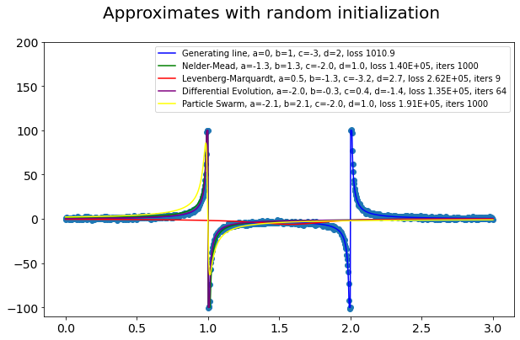 It can be seen that function with true parameter value has value of loss function about 103, while the approximations which captured one break have value of 1.40 · 105, and approximations which came to the nearly constant approximation – 2.6 · 105. Among the best experiments, Nelder-Mead algorithm, differential evolution and particle swarm optimization found 1 break, but Levenberg-Marquardt algorithm failed to capture any.

The reason why Levenber-Marquardt shows such a result probably relates to our data - the space where we are looking for optimum is not even continuous, has several optimums, and the neighborhood of the optimum point is relatively narrow. So, if we start in the wrong position - not in the neighborhood of the optimal point in which the loss function is decreasing in the direction of the right optimal point, the gradient as well as Hessian must be pushing the Levenberg-Marquardt optimizer to the optimum point with broader neighborhood i.e. to the point where it fails to capture any gap.

The analysis of 5 experiments with random parameter initialization shows that differential evolution algorithm was able to capture one break 1 times out of 5, and Nelder-Mead algorithm was able to do so 2 time.

|  |  |  |
| --- | --- | --- |
| Method | Average loss | Breaks captured |
| Particle Swarm | 2.2E+05 | 0 |
| Differential Evolution | 2.5E+05 | 1 |
| Nelder-Mead | 1.9E+05 | 2 |
| Levenberg-Markquerdt | 2.7E+05 | 0 |

Initialization with true values leaded to the solution with optimal loss value for all algorithms but particle swarm optimization, which shifted to the local optimum and was again able to capture only one break. Differential evolution and Nelder-Mead algorithm were able to find solutions with loss value less than that with true parameter values.

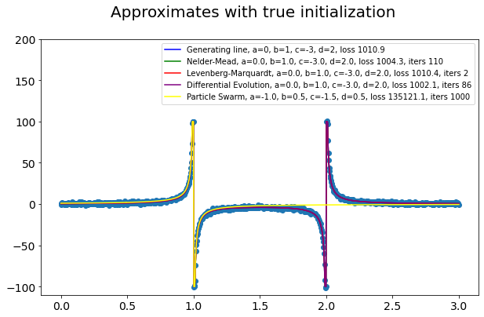

# Part II

I took 20 American cities with their coordinates and applied the annealing method to solve the TSP problem. After the first iteration, I got the following result. It can be seen that the path is very long and not optimal.

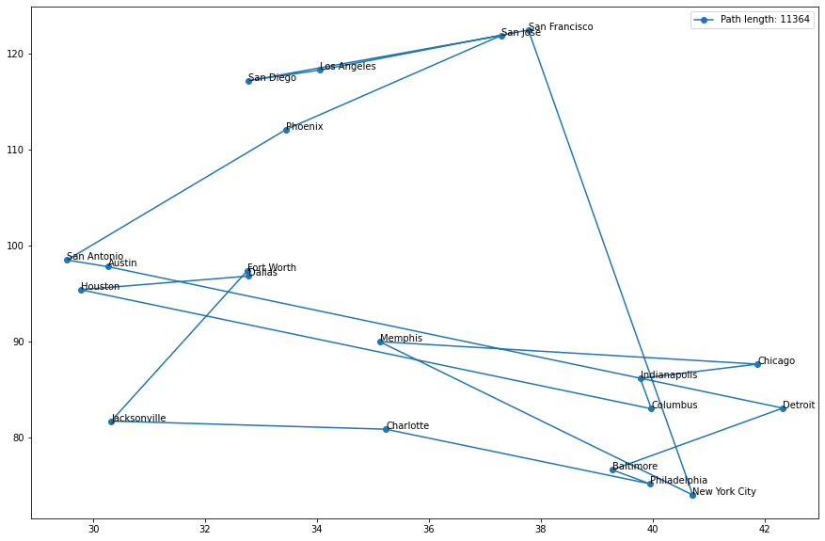

After 50,000 iterations, I got this result. As you can see, the path has become almost twice as short and has been reduced from 11 thousand to 6 thousand.

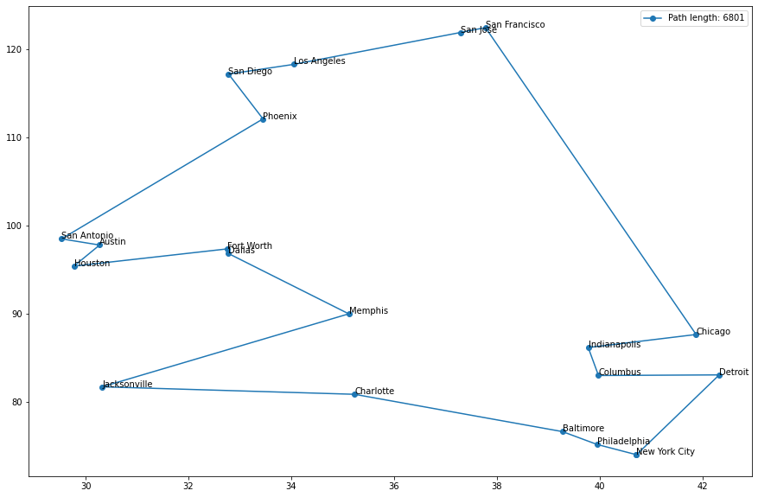

# Conclusions

The performance of two meta-heuristic methods – differential evolution and particle swarm optimization was analyzed and compared with that of direct Nelder-Mead algorithm and gradient-based Levenberg-Marquardt algorithm. Both meta-heuristic methods happened to be closer to the solution more often, than Nelder-Mead and Levenberg-Marquardt algorithms. Nevertheless, it was found that particle swarm optimization cannot find the best solution if area near the optimal values is too narrow.

Gradient-based methods such as Levenberg-Marqardt show poor results because it not well suited for the problems with non-continuous search space with several optimum points.

The annealing method was also applied to solve the TSP problem for 20 American cities. The expected results obtained.

# Appendix

Source code can be found at https://github.com/DmitryPogrebnoy/algo_itmo/tree/main/task4.