FEDERAL STATE AUTONOMOUS EDUCATIONAL INSTITUTION

OF HIGHER EDUCATION

ITMO UNIVERSITY

Report

on the practical task No. 8

“Practical analysis of advanced algorithms”

Performed by

*Dmitry Pogrebnoy*

*J4132c*

Accepted by

Dr Petr Chunaev

St. Petersburg

2021

# Goal

Practical analysis of advanced algorithms.

# Formulation of the problem

I. Choose two algorithms (interesting to you and not considered in the course) from the above-mentioned book sections.

II. Analyse the chosen algorithms in terms of time and space complexity, design technique used, etc. Implement the algorithms and produce several experiments. Analyse the results.

# Brief theoretical part

Two classical algorithms were chosen for the analysis. The first one is matrix-chain multiplication, and the second one is Floyd-Warshall algorithm for finding all shortest paths between vertices in a directed weighted graph. Both of the algorithms use dynamic programming as a main technique.

## Matrix-chain multiplication

*1) Finding optimal substructure*

Let us identify subproblem as computing the optimal parenthesization of product $A_{i}⋅A_{i+1}⋅...⋅A_{j}$, where $i⩽j$. Suppose that optimal parenthesization splits the product at the Ak, Ak+1. Then the parenthesization of the “prefix” subchain $A_{i}⋅A_{i+1}⋅...⋅A_{k}$ is the optimal parenthesization. If it were not optimal, then the optimal parenthesization of the larger subproblem $A_{i}⋅A_{i+1}⋅...⋅A_{j}$ would had less that optimal cost, which is impossible.

Thus, the way to construct the optimal solution from optimal solutions to subproblems.

*2) The recursive solution*

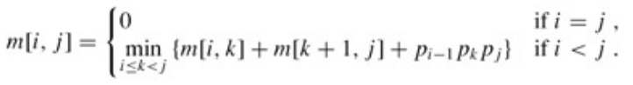Next, we define the cost of an optimal solution recursively in terms of the optimal solutions to subproblems. The subproblem is formulated as computing the cost of multiplication $A_{i}⋅A_{i+1}⋅...⋅A_{j}$. Let *m[i, j]* be the minimum number of required operations for the subproblem. *m[i, j]* equals to 0 if *i = j* since no multiplication is required. Let us assume that the optimal parenthesization splits the product $A_{i}⋅A_{i+1}⋅...⋅A_{j}$ between Ak and Ak+1, where *i ≤ k < j*. Then, *m[i, j]* is equal to the minimum cost for computing the subproducts $A_{i...k}$ and $A_{k+1...j}$, plus the cost of multiplying these two matrices together. Then the optimal cost is

To help us keep track of how to construct an optimal solution, let us define *s[i, j]* to be a value of *k* at which we can split the product A i A i+1 A j to obtain an optimal parenthesization. That is, *s[i, j]* equals a value *k* such that

$m[i,j]=m[i,k]+m[k+1,j]+p_{i-1}⋅p_{k}⋅p_{j}$.

*3) Computing the optimal costs*

If we just implemented the recursive algorithm at this point, we would get an algorithm that takes exponential time to run. So we instead find the restrictions that can be used to improve it.

We have relatively few subproblems: one subproblem for each choice of *i* and *j* satisfying *1 ≤ i ≤ j ≤ n, $C_{n}^{2}+n=O(n^{2})$* , that is, the maximum number of subproblems is O(n2).

To construct optimal solution we use bottom-up approach. The algorithm should fill in the table m in a manner that corresponds to solving the parenthesization problem on matrix chains of increasing length.

The algorithm constructed can be found by the link in the appendix.

The time complexity of the algorithm is O(n3) – we have O(n2) subproblems each of which is solved in O(n) time. The space complexity is O(n2) since we have to store additional matrix [n, n].

## Floyd-Warshall algorithm

*1) Optimal substructure*

The algorithm considers the "intermediate" vertices of a shortest path, where an intermediate vertex of a simple path $p=v_{1},v_{2},...,v_{l}$ is any vertex of *p* other than *v1* or *vl*, that is, any vertex in the set $v_{2},v_{3},...,v_{l-1}$.

The Floyd-Warshall algorithm is based on the following observation. Under our assumption that the vertices of *G* are $V=1,2,...,n$, let us consider a subset $1,2,...,k$ of vertices for some *k*. For any pair of vertices $i,j∈V$, consider all paths from *i* to *j* whose intermediate vertices are all drawn from $1,2,...,k$, and let *p* be a minimum-weight path from among them. Consider that path *p* is simple. The Floyd-Warshall algorithm exploits a relationship between path *p* and shortest paths from *i* to *j* with all intermediate vertices in the set $1,2,...,k-1$. The relationship depends on whether or not *k* is an intermediate vertex of path *p*.

* If *k* is not an intermediate vertex of path *p*, then all intermediate vertices of path *p* are in the set $1,2,...,k-1$. Thus, a shortest path from vertex *i* to vertex *j* with all intermediate vertices in the set $1,2,...,k-1$ is also a shortest path from *i* to *j* with all intermediate vertices in the set $1,2,...,k$.
* If *k* is an intermediate vertex of path *p*, then we break *p* down into two parts by vertex k. *p1* is a shortest path from *i* to *k* with all intermediate vertices in the set $1,2,...,k$. Because vertex *k* is not an intermediate vertex of path *p1*, we see that *p1* is a shortest path from *i* to *k* with all intermediate vertices in the set $1,2,...,k-1$. Similarly, *p2* is a shortest path from vertex *k* to vertex *j* with all intermediate vertices in the set $1,2,...,k-1$.

*2) Recursive solution*

Let $d_{ij}^{(k)}$ be the weight of a shortest path from vertex *i* to vertex *j* for which all intermediate vertices are in the set $1,2,...,k$. When *k = 0*, a path from vertex *i* to vertex *j* with no intermediate vertex numbered higher than 0 has no intermediate vertices at all. Such a path has at most one edge, and hence $d_{ij}^{(k)}=w_{ij}$. A recursive formula is as folows:

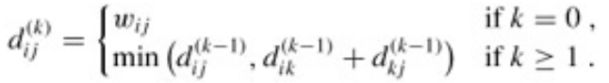The final solution is constructed with bottom-up technique again and is available by the link in the appendix.

The time complexity is O(n3) since the algorithm contains 3 loops with length n each.

# Results

Algorithms were implemented using Python 3.9 programming language.

The experiments conducted were to measure time complexity based on the size of the input. The random input was generated for each algorithm. For Floyd-Warshall algorithm it was the random weighted undirected graph with positive and negative weights with |V| varying from 10 to 50 and |E| having value from {2|V|, 3|V|, 4|V|}. For matrix-chain multiplication algorithm it was an array with random shapes of matrices. The size of an array (number of matrices) was varying from 5 to 100.

The time complexity of both Floyd-Warshall algorithm and matrix-chain multiplication algorithm happened to coincide with the theoretical approximation O(n3).

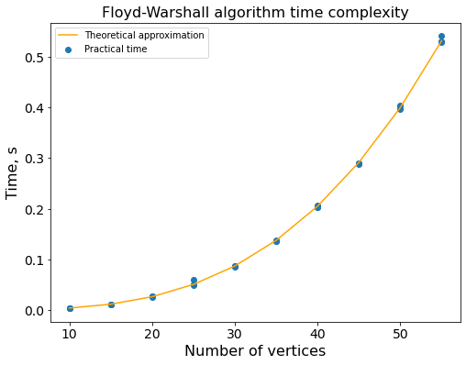

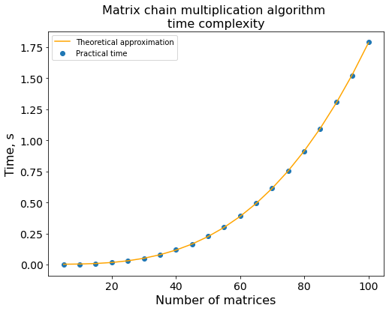

# Conclusions

The dynamic programming approach for solving all shortest paths problem and matrix chain multiplication problem was discussed. Both algorithms solving the problems were implemented and the experiment of measuring time complexity was conducted. The measured times coincided with the theoretical values of O(n3).

# Appendix

Source code can be found at https://github.com/DmitryPogrebnoy/algo_itmo/tree/main/task8.