Saint Petersburg National Research University of Information Technologies, Mechanics and Optics (ITMO University)

Report

**about laboratory works**

**Assignment 12.**

**Assignment 13.**

**Assignment 14.**

**Assignment 15.**

**Student** Pogrebnoy D.A. j4132c

Saint-Petersburg, 2021

# Assignment 12.

**Task**

Find and fix errors in Assignment12.c, add the for loop. When should you use a loop?

**Implementation**

Source code and data gathered are available on <https://github.com/DmitryPogrebnoy/Parallel-algorithms-of-data-analysis-and-synthesis/blob/master/OmpiTasks/Task12/Assignment12.cpp>

The description of the code is described in the comments.

Output example:

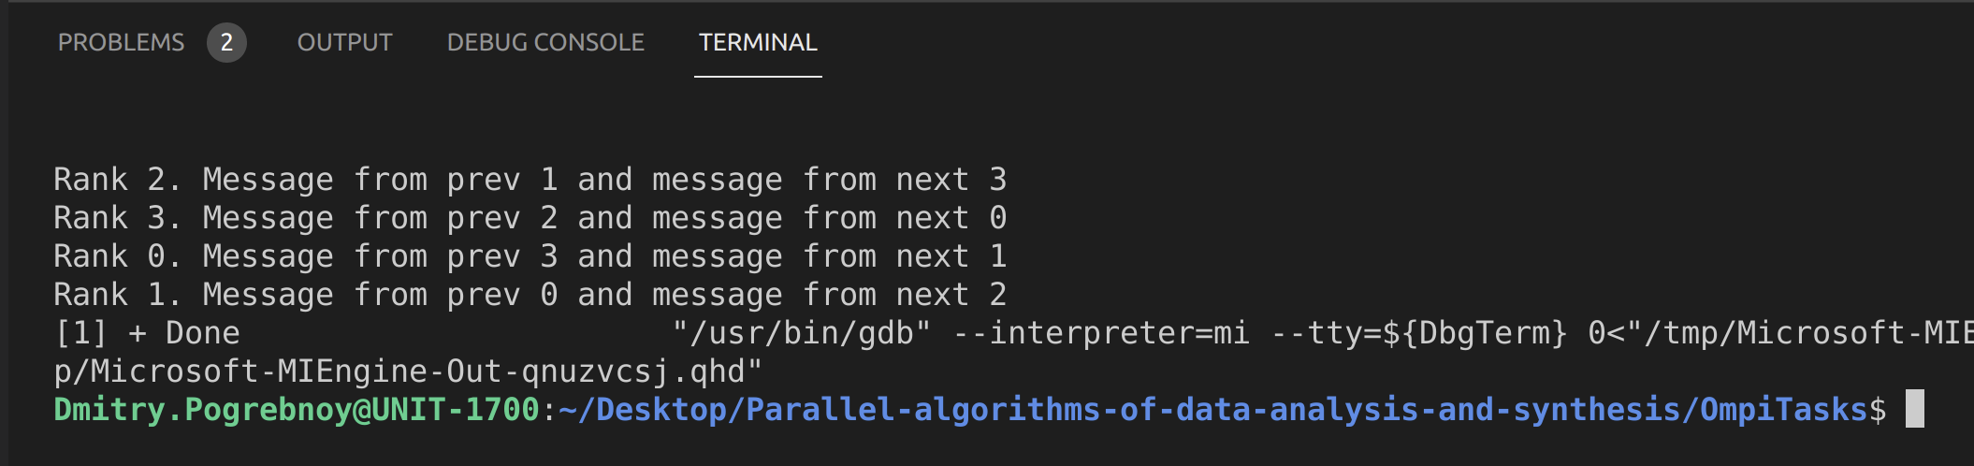

# Assigments 13.

**Task**

Find out which process will perform the multiplication of two 500x500 square matrices faster.

Complete the code Assignment13.c. You can use the necessary code from the previous assignments.

**Implementation**

Source code and data gathered are available on <https://github.com/DmitryPogrebnoy/Parallel-algorithms-of-data-analysis-and-synthesis/blob/master/OmpiTasks/Task13/Assignment13.cpp>

The description of the code is described in the comments.

Output example:

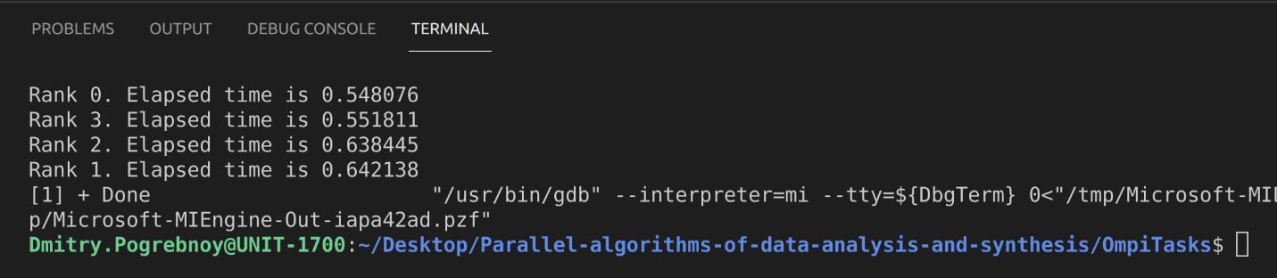

# Assignment 14.

**Task**

Understand the new functions in Assignment14.c.

Create your own global function for finding the maximum element, compare the correctness of execution with the MPI_MAX operation in the MPI_Reduce() function.

**Implementation**

Source code and data gathered are available on <https://github.com/DmitryPogrebnoy/Parallel-algorithms-of-data-analysis-and-synthesis/tree/master/OmpiTasks/Task14>

The description of the code is described in the comments.

Output of initialAssignment14.cpp example:

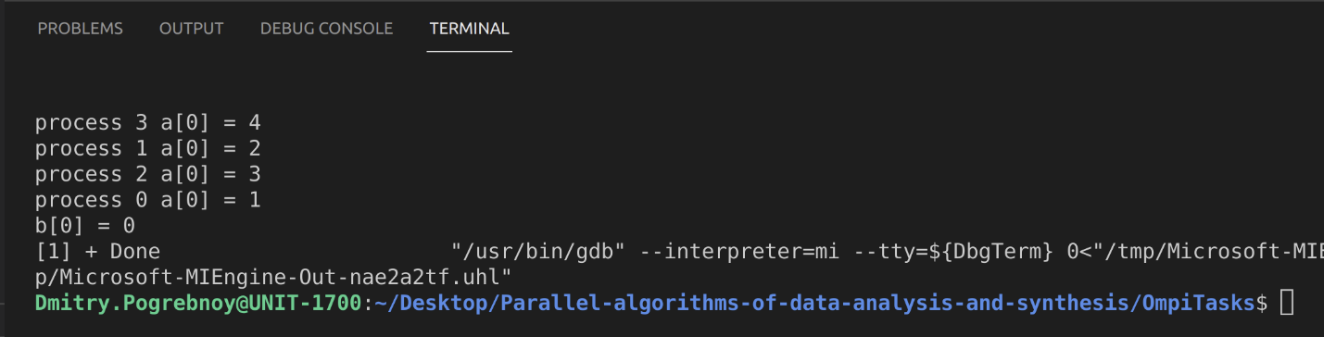

Output of implemented task example:

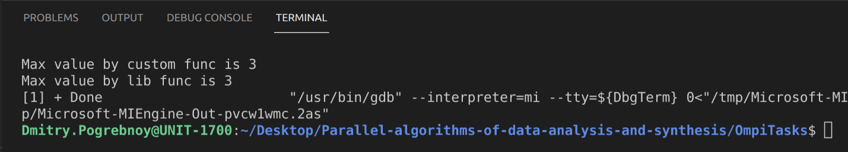

# Assignment 15.

**Task**

Understand the new functions in Assignment15.c.

Append part of code.

**Implementation**

Source code and data gathered are available on <https://github.com/DmitryPogrebnoy/Parallel-algorithms-of-data-analysis-and-synthesis/blob/master/OmpiTasks/Task15/Assignment15.cpp>

The description of the code is described in the comments.

Output example:

