Saint Petersburg National Research University of Information Technologies, Mechanics and Optics (ITMO University)

Report

**about laboratory works**

**Assignment 19.**

**Student** Pogrebnoy D.A. j4132c

Saint-Petersburg, 2021

# Assignment 19.

**Task**

To complete the task, you need to create and compile two programs: server and client. In one window of the SSH client, a server is launched for one process, which gives out the port name.

An example of a command to start the server: mpiexec -n 1 ./serv.o

Then the client is launched in another window, specifying the port name separated by a space in single quotes (example command: mpiexec -n 1 ./client.o ‘port name’).

Understand the new functions in Assignment19_serv.c and Assignment19_client.c and explain programs execution.

Check the work by running the server and the client. Add the program and send an arbitrary message to each other.

**Implementation**

Source code and data gathered are available on <https://github.com/DmitryPogrebnoy/Parallel-algorithms-of-data-analysis-and-synthesis/tree/master/OmpiTasks/Task19>

The description of the code is described in the comments.

OpenMPI is broken, so I used MPICH to compile and run the source code.

Run server:

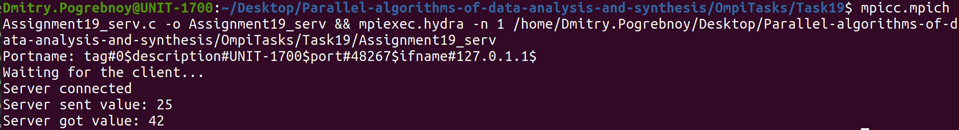

Run client:

