Saint Petersburg National Research University of Information Technologies, Mechanics and Optics (ITMO University)

Report

**about laboratory works**

**Assignment 9.**

**Assignment 10.**

**Assignment 11.**

**Student** Pogrebnoy D.A. j4132c

Saint-Petersburg, 2021

# Assignment 9.

**Task**

Write an MPI program in which the global vector addition operation is modeled by a doubling (cascade) scheme using point-to-point data transfers. Compare the execution time of such a simulation using the MPI_Reduce procedure on as many processes as possible. Each process stores an array of 1,000,000 elements equal to ‘1’.

**Implementation**

Source code and data gathered are available on <https://github.com/DmitryPogrebnoy/Parallel-algorithms-of-data-analysis-and-synthesis/blob/master/OmpiTasks/Task9/Task9.cpp>

The description of the code is described in the comments.

Output example:

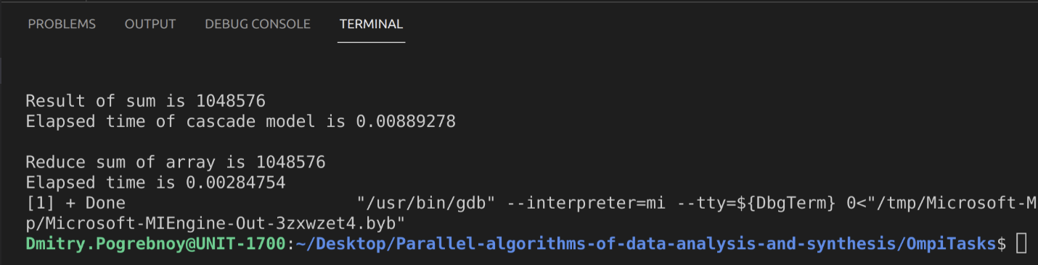

# Assigments 10.

**Task**

Complete the program Assignment10.c. Compile and run it. Study the code carefully and explain how it works.

**Implementation**

Source code and data gathered are available on https://github.com/DmitryPogrebnoy/Parallel-algorithms-of-data-analysis-and-synthesis/blob/master/OmpiTasks/Task10/Assignment10.cpp

The description of the code is described in the comments.

Output example:

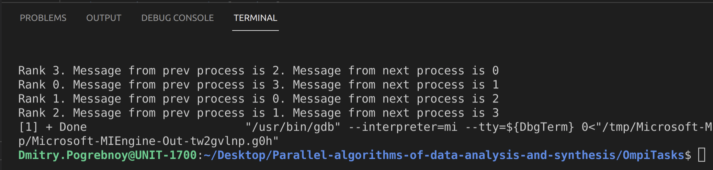

# Assignment 11.

**Task**

Based on Assignment 10, write a program for ring topology exchange using the MPI_Sendrecv() function.

**Implementation**

Source code and data gathered are available on https://github.com/DmitryPogrebnoy/Parallel-algorithms-of-data-analysis-and-synthesis/blob/master/OmpiTasks/Task11/Task11.cpp.

The description of the code is described in the comments.

Output example:

