|  |
| --- |
| NCBI |
| NetStorage Server Interactions with Meta DB |
|  |
|  |
| **Sergey Satskiy** |
| **2/4/2016** |

|  |
| --- |
| Document version: 1.0 |

Changes history

|  |  |  |  |
| --- | --- | --- | --- |
| Version | Date | Author | What changes |
| 1.0 | Feb 4, 2016 | Sergey Satskiy | Initial revision |

Table of Contents

Introduction 3

NetStorage Messages 3

GETOBJECTINFO 4

GETATTRLIST 5

GETCLIENTOBJECTS 5

GETATTR 6

SETATTR 7

DELATTR 8

SETEXPTIME 9

CREATE 10

WRITE 11

READ 12

DELETE 13

RELOCATE 14

EXISTS 15

GETSIZE 16

LOCKFTPATH 17

GETCLIENTSINFO 17

GETMETADATAINFO 17

RECONFIGURE 17

HEALTH 17

ACKALERT 17

# Introduction

This document provides diagrams of a workflow for each of the NetStorage messages which may involve accessing the object records in the MS SQL Server ‘Objects’ table. The diagrams do not include error handling to make them clearer.

Please note the diagrams are merely a simplified pseudo code but not the actual implementation.

For a detailed description of the NetStorage protocol please refer to the “NetStorage Server Overview” document.

# NetStorage Messages

This chapter contains sections with diagrams for each individual NetStorage server message.

#### GETOBJECTINFO

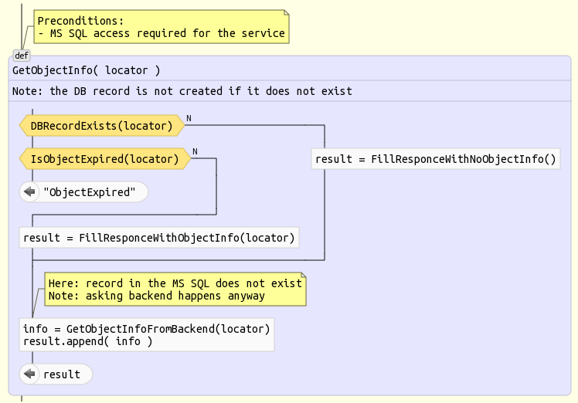

#### GETATTRLIST

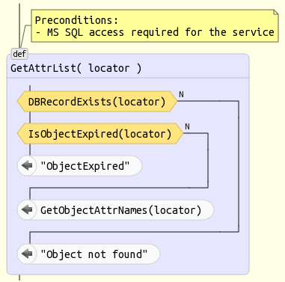

#### GETATTR

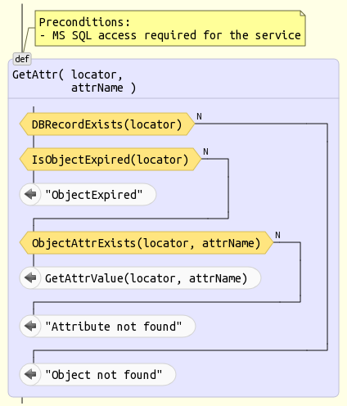

#### SETATTR

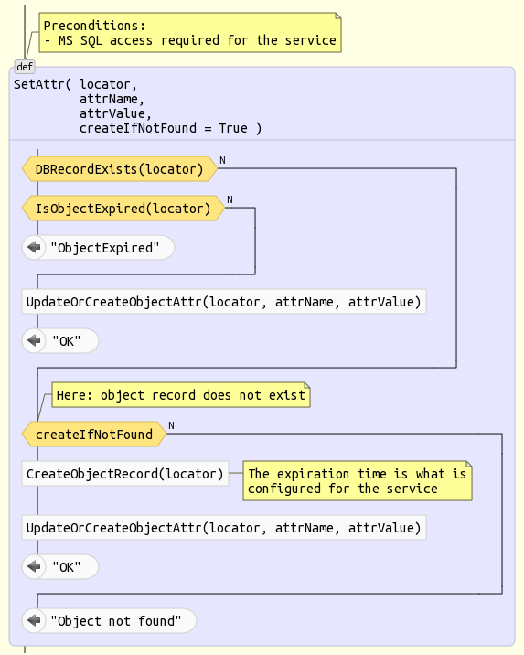

#### DELATTR

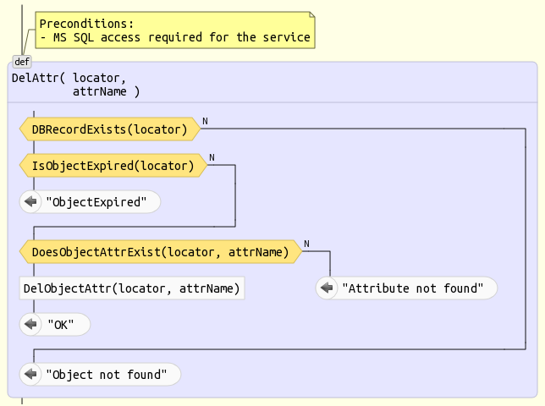

#### SETEXPTIME

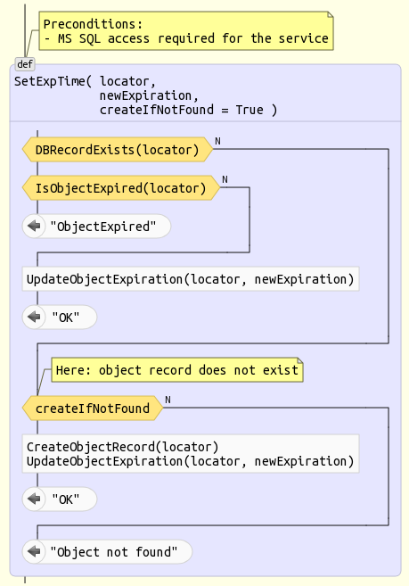

#### CREATE

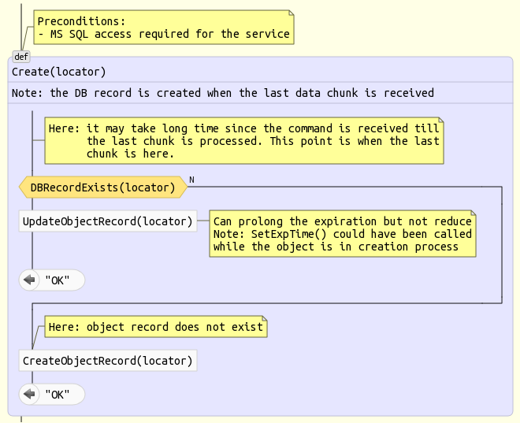

#### WRITE

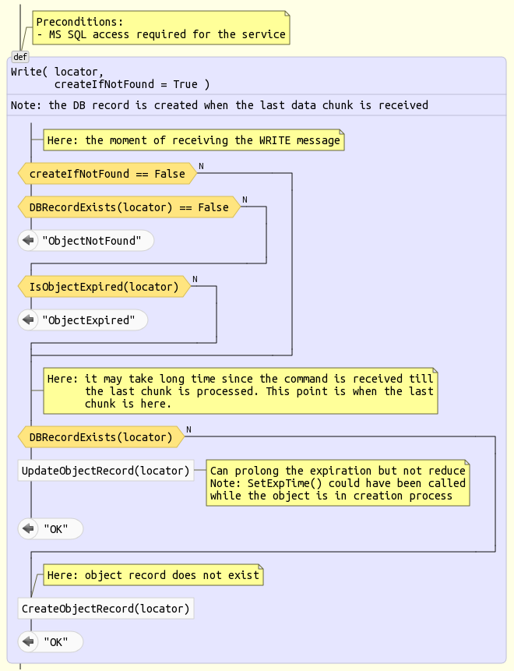

#### READ

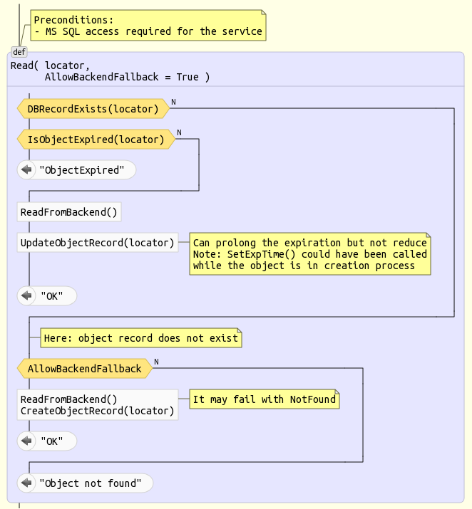

#### DELETE

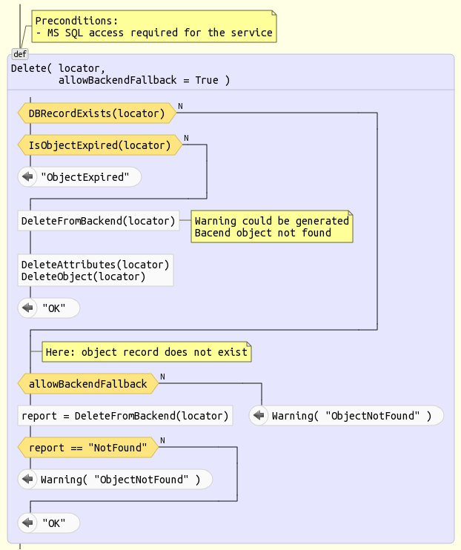

#### RELOCATE

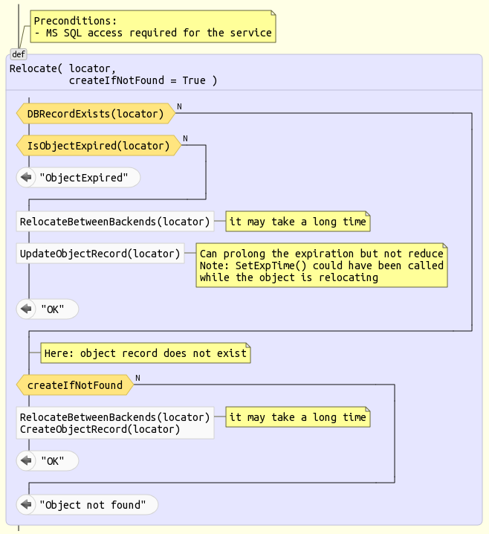

#### EXISTS

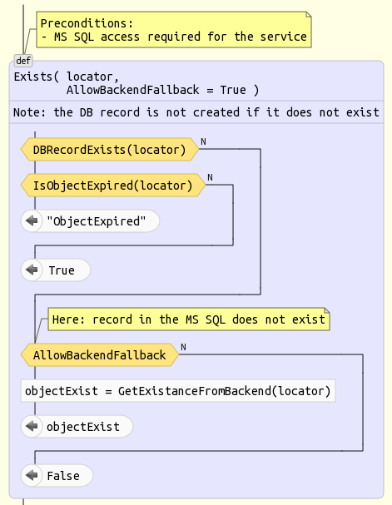

#### GETSIZE

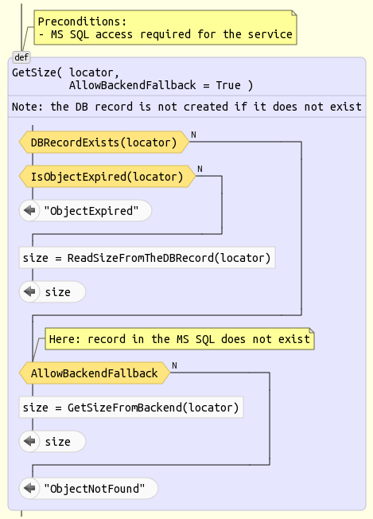

#### LOCKFTPATH

The message does not involve interactions with the MS SQQL ‘Objects’ table.

#### GETCLIENTSINFO

The message does not involve interactions with the MS SQQL ‘Objects’ table.

#### GETMETADATAINFO

The message does not involve interactions with the MS SQQL ‘Objects’ table.

#### RECONFIGURE

The message does not involve interactions with the MS SQQL ‘Objects’ table.

#### HEALTH

The message does not involve interactions with the MS SQQL ‘Objects’ table.

#### ACKALERT

The message does not involve interactions with the MS SQQL ‘Objects’ table.

#### GETCLIENTOBJECTS

The message does not involve interactions with the MS SQQL ‘Objects’ table.