**Concept and requirements development project**

**QAGroup website** [**https://qagroup.com.ua**](https://qagroup.com.ua)

Version 1.2

Prepared by Dmitry Silayev

28/10/2022

**Table of Contents**

1. Functional Decomposition Mind map ................................................................................ 3

2. Product Vision .................................................................................................................... 3

2.1 Statement……………….......................................................................................... 3

2.2 Features .................................................................................................................. 4

2.3 Dependencies\Assumptions .................................................................................... 5

3. Business/Stakeholder *Requirements*....................................................................................... 5

3.1 Business Requirement “Publications” ..................................................................... 5

3.1.1. Stakeholder Requirement “List” .................................................................. 5

3.1.2. Stakeholder Requirement “Read” ..... ........................................................ 5

3.1.3. Stakeholder Requirement “Search” ............................................................. 5

3.2 Business Requirement “Actual publications” ........................................................... 6

3.2.1. Stakeholder Requirement “Review” ............................................................ 6

3.2.2. Stakeholder Requirement “Link” ................................................................. 6

3.3 Business Requirement "Actual events" ................................................................... 6

3.3.1. Stakeholder Requirement “Review” ............................................................. 6

3.3.2. Stakeholder Requirement “Link” .................................................................. 6

3.4 Business Requirement “Practical Course "SOFTWARE TESTING"………...…….. 6

3.4.1. Stakeholder Requirement “User experience” ............................................. 6

3.4.2. Stakeholder Requirement “Link” .................................................................. 7

3.5 Business Requirement “Services”............................................................................ 7

3.5.1. Stakeholder Requirement “Сontent classes” .............................................. 7

4. Web Visual Prototype................................... ……………………….................................... 8

5. User Story/Acceptance Criteria .... ……………………….................................................... 9

5.1 User Story “[Актуальні публікації](https://qagroup.com.ua/publications/)” .... ……..…………………….................................. 9  
 Acceptance Criteria .... …………………..……………………...................................... 9

5.1.1. Preconditions ………….………..……………………...................................... 8

5.1.2. Behavior ………………..………..……………………...................................... 9

5.1.3. Publications statuses …………..……………………...................................... 9

5.1.4. Edge cases …..…………..……..……………………...................................... 9

5.1.5. Negative cases ………..………..……………………...................................... 9

5.1.6. Out of scope …..………………...……………………...................................... 9

5.2 User Story "Actual events" ……………..…………………….................................... 10

Acceptance Criteria .... ………..……………………………….................................... 10

5.2.1. Preconditions ………..…………….………………….................................... 10

5.2.2. Behavior ………..……………………..……………….................................... 10

5.2.3. Events statuses ……..…………….………………….................................... 10

5.2.4. Edge cases ………..……………….………………….................................... 10

5.2.5. Negative cases ……..………………..……………….................................... 10

5.2.6. Out of scope ………….……………………………….................................... 10

6. Functional algorithm BPMN (Business Process Model and Notation) diagram ……....... 11

**Revision History**

|  |  |  |  |
| --- | --- | --- | --- |
| **Name** | **Date** | **Reason For Changes** | **Version** |
| **Dmitry Silayev** | **28/10/2022** | **Сorrection according to mentor's recommendations** | **1.1** |
| **Dmitry Silayev** | **28/10/2022** | **English translation** | **1.2** |

**1. Functional Decomposition** [**Mind map**](https://drive.google.com/file/d/1xpoPPwmgXJmgLkqSmVyZPCOiSPGnRPA-/view?usp=share_linkSR-z)

[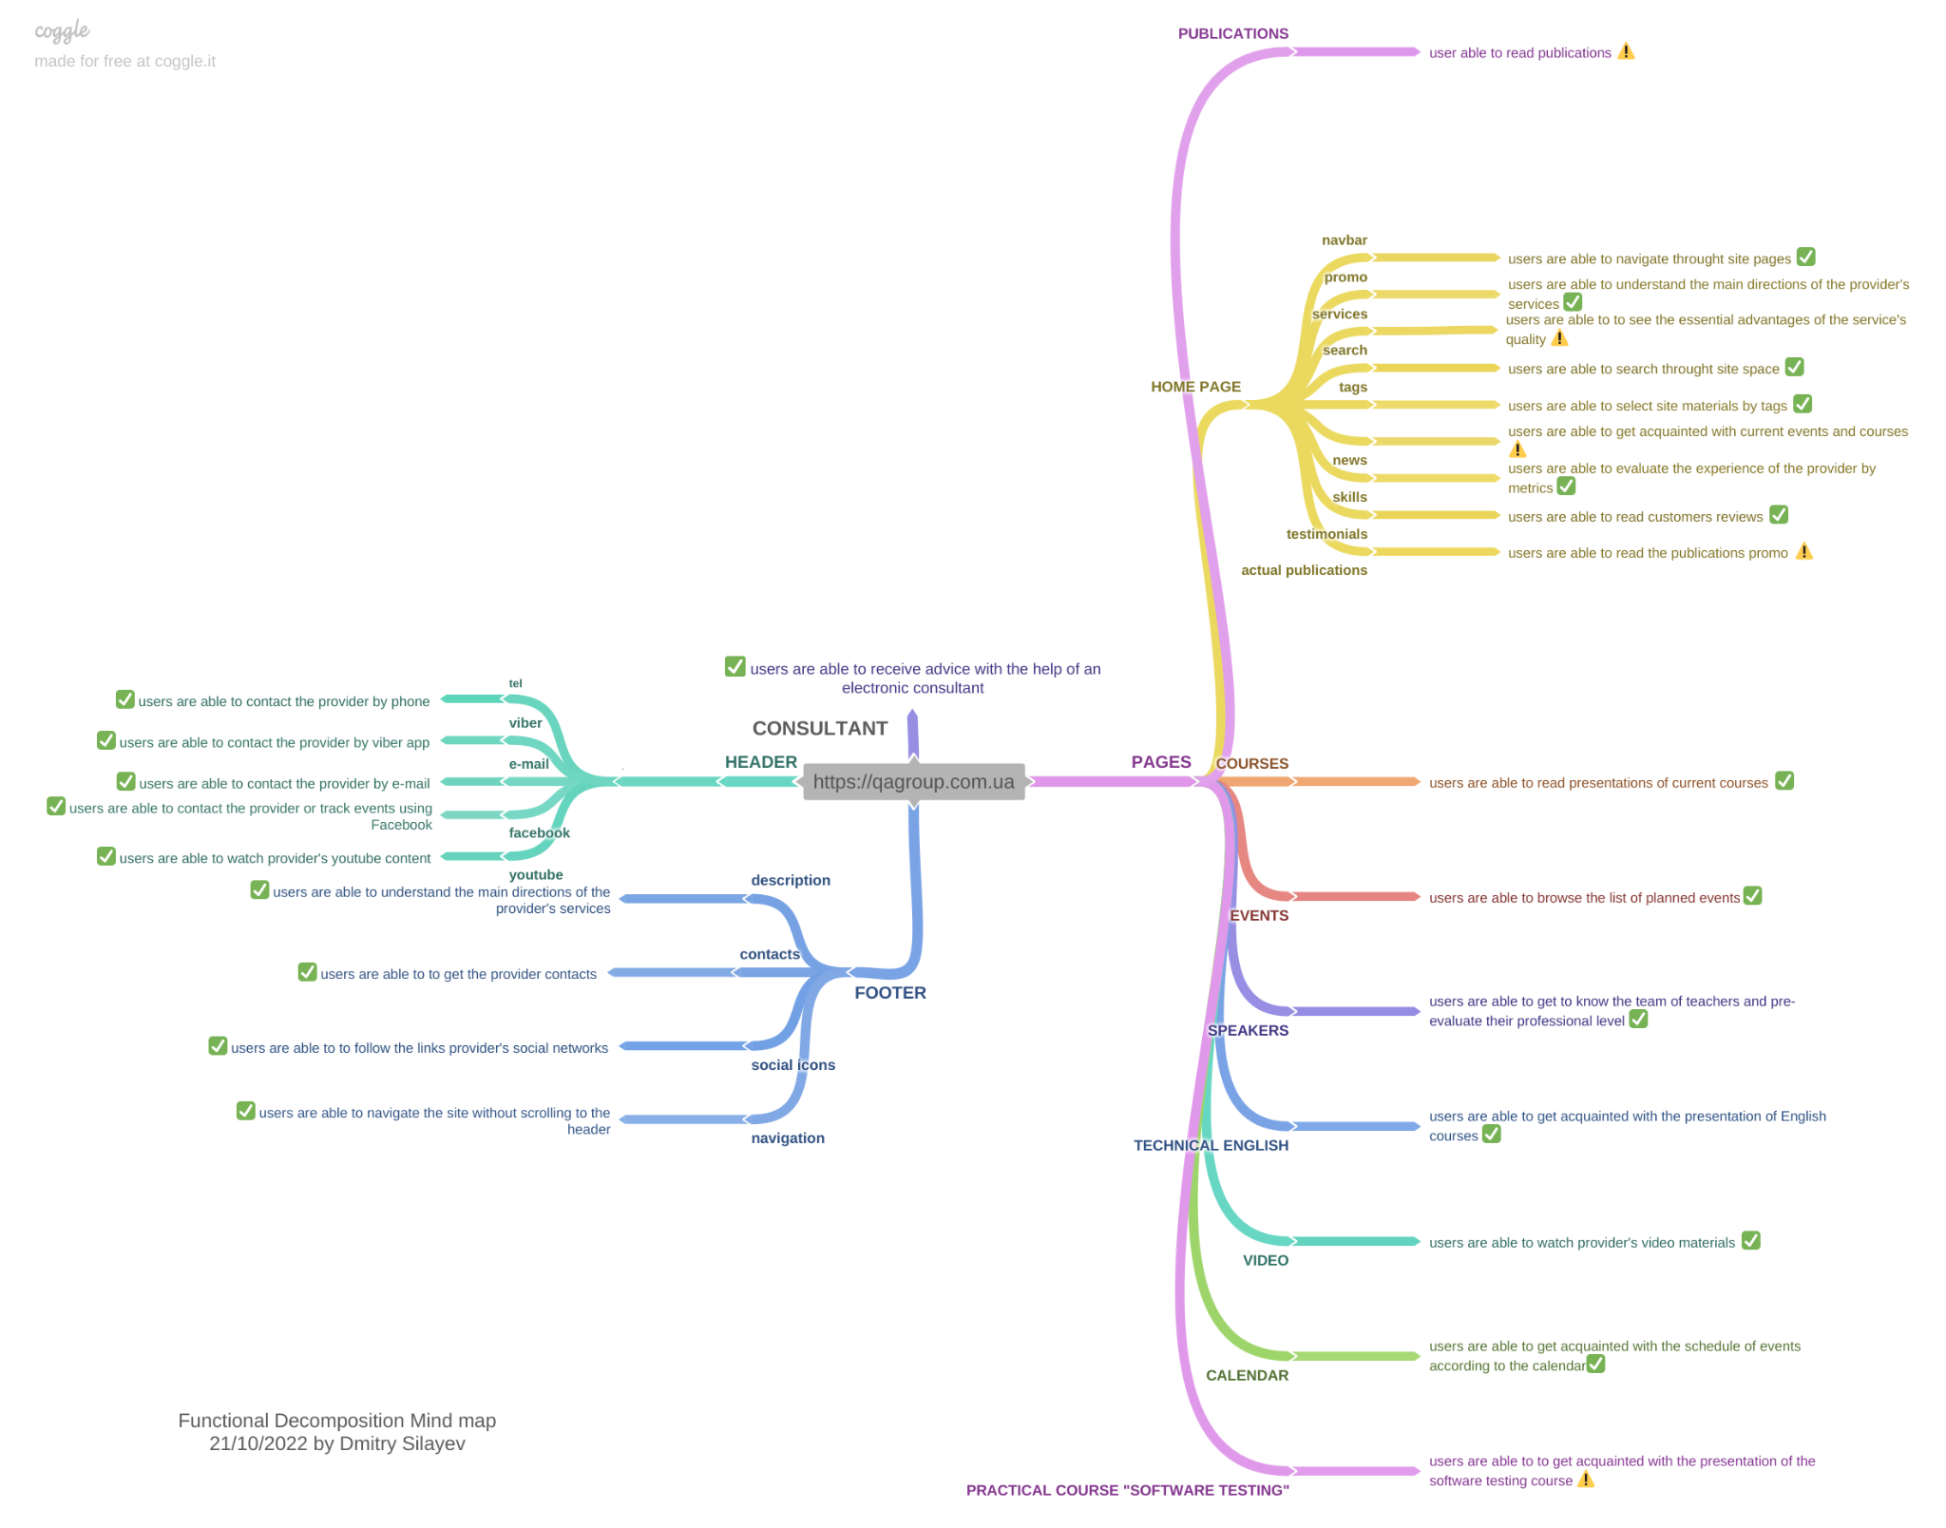](https://drive.google.com/file/d/1xpoPPwmgXJmgLkqSmVyZPCOiSPGnRPA-/view?usp=share_linkKz1xacIiZOsGpRVjuIiXz/view?usp=sharing)

**2. Product Vision**

**2.1. Statement**

The goal of the Concept and requirements development project is to improve the user experience within the system<https://qagroup.com.ua> to expand the user base and increase the total number of students.

To achieve the goal:

- carry out a set of SEO measures to promote the site to the first positions of the first page in the Google global search system;

- emphasize the freeness of some events, to attract an additional audience, with subsequent advertising during the event of the site and services;

- emphasize and highlight the main business topic on the site, namely the acquisition by students of the QA course of deep and extensive practical experience, which is the main competitive advantage of QAGroup courses and increases the chances of students' employment;

- highlighting the technical English course to uniqueness by positioning it not as a simple language study, but as a study of the QA profession in English, which increases the chances of further employment of students;

- highlight the topics of conducting test interviews for employment in English, which increases the chances of a positive interview.

**2.2. Features**

**“Publications” page**

Develop a "Publication" page on the site as an SEO tool to expand the site's findability using global search systems, which will increase the user base by appearing in the top search lists, as well as keep visitors on the site with the help of exclusive QAGroup author's materials;

**"Actual publications"** **module**

Fix the "Current Publications" module on the site's home page, to allow users to go to the "Publication" page, keep them interested in the site, and increase the overall user base.

**“News” module**

Install banners in the “News” module of the main page with an emphasis on free current events to increase the number of participants in these events, which will lead to a general increase in the number of students of QAGroup courses.

**“Practical Course "SOFTWARE TESTING" page**

Move the site page "PRACTICAL COURSE "SOFTWARE TESTING" to the beginning (left side) of the navigation panel, which is under the header on each site page so that the user can easily find the page with the main business purpose of the site, which will lead to an overall increase in the number of students of QA courses.

**“Services module”**

In the "services" module, install banners that will announce and highlight the following topics:

Now it is almost impossible to get a job in the QA-engineer specialty without practical experience, without knowledge of English, and experience passing an interview in English.

Therefore, QAGroup provides the opportunity for students to acquire a QA course:

- deep and extensive practical experience, which increases the chances of employment by 50%;

- knowledge of the QA profession in English, which increases the chances of further employment by 70-90%;

- an experience of test interviews for employment in English, which increases the chances of a positive interview by 50-70%.

**2.3. Dependencies\Assumptions**

To effectively carry out the implementation of SEO measures to promote the site to the first positions of the first page in the Google global search system, it is necessary to involve SEO specialists from another company. Therefore, the results of this task will also depend on the quality of work of this company.

The effectiveness of the "Publication" page in terms of the overall increase in site users depends on the constant and qualified filling of the page with materials.

In the period of military aggression of Russia, it is impossible to accurately predict the time of the modernization of the site.

**3. Business/Stakeholder Requirements**

**3.1. Business Requirement “Publications”**

The system should support the display of materials in different formats. Predefined formats: JPEG, PNG, TIFF. (The list can be supplemented).

**Stakeholder Requirements “Publications”**

3.1.1. **List**   
As a user, I want to be able to view a list of posts.

3.1.2. **Read**  
As a user, I want to be able to view the full text of the selected publication.

3.1.3. **Search**  
As a user, I want to be able to sort materials by topic.

**3.2. Business Requirement "Actual publications"**

The system should provide for the possibility of automatic display of the specified content on those pages of the site, which according to the statistics of analytics tools (specify the tool(s)) is the most visited (take into account the pages ranked 1-5 in terms of attendance during the last calendar month).

**Stakeholder Requirements "Actual publications"**

3.2.1. **Review**  
As a user, I want to be able to view a list of titles of current publications on the main page of the site

3.2.2. **Link**  
As a user, I want to be able to go to the "Publications" page by clicking on a link from the list of current publications.

**3.3. Business Requirement "Actual events"**

The system should provide different displays of content by class.

Content classes:

1. Free events (announcement)

2. Paid events (announcement)

**Stakeholder Requirements "Actual events"**

3.3.1. **Free events highlighting**  
As a user, I want to be able to see a visual emphasis on free events when viewing the "Current Events" list.

3.3.2. **Link**  
As a user, I want to be able to go to the "Events" page by clicking on the link from the "Current events" list

**3.4. Business Requirement “Practical Course "SOFTWARE TESTING"**

The system should provide the ability to navigate through the sections of the site. (Develop a design and functional solution for the way of navigation).

**Stakeholder Requirements “Practical Course "SOFTWARE TESTING"**

3.4.1. **User experience**  
As a user, I want to be able to intuitively understand where the information with the main services of the site is located.

3.4.2. **Link**  
As a user, I want to be able to go to the "PRACTICAL COURSE "SOFTWARE TESTING" page from any page of the site.

**3.5. Business Requirement “Services”**

The system should provide different displays of content by class.

Content classes:

1. Advantages

2. Practice

3. QA in English

4. Interview in English

**Stakeholder Requirements**

3.5.1. **Сontent classes**  
As a user, I want to be able to select content by Advantages, Practice, QA in English, and Interviews in English classes.

**4. Web** [**Visual Prototype**](https://drive.google.com/file/d/1ba7Q0qKzovjhHnSABnq99mH50n-SAIMM/view?usp=sharing)

[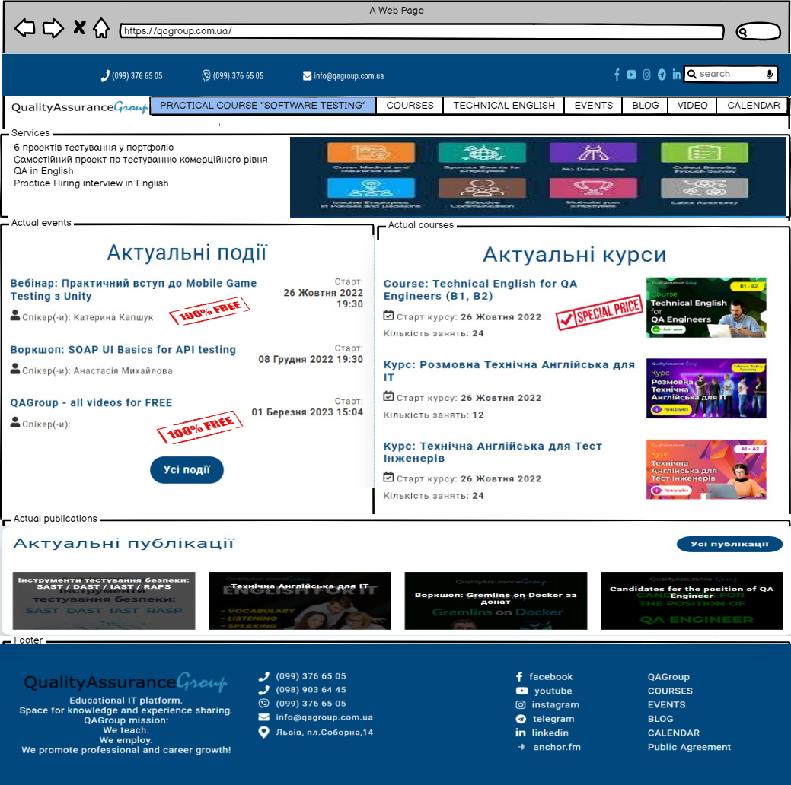](https://drive.google.com/file/d/1ba7Q0qKzovjhHnSABnq99mH50n-SAIMM/view?usp=sharing)

**5. User Story/Acceptance Criteria**

**5.1. User Story “**[**Актуальні публікації**](https://qagroup.com.ua/publications/)**”**

As a user, I want to be able to view posts within the system.

**Acceptance Criteria**

5.1.1. Preconditions  
The user is on the main page of the site in the "Current publications" module

5.1.2. Behavior  
a) if the user hovers over the post title, the system should dynamically display a summary of the post  
b) if the user clicks on the post title, the system should open the post  
c) if the user clicks on the name of the "Current Publications" module, the system should go to the "Publications" page

5.1.3. Publications statuses  
a) new  
b) viewed  
c) status less

5.1.4. Edge cases  
a) If the user clicks on the title of the publication, but the publication has been deleted, the system should go to the top of the “Publications” page

5.1.5. Negative cases  
a) If the user clicks on the title of a publication, but the "Publications" page is not available, the system should display a popup above the title of the publication with the inscription "We apologize for the technical inconvenience"

5.1.6. Out of scope  
a) Functionality that will allow users to rate publications  
b) Functionality that will allow users to mark publications as selected

**5.2. User Story "Actual events"**

As a user, I want to be able to view current events within the system.

**Acceptance Criteria**

5.2.1. Preconditions  
The user is on the main page of the site in the "Current events" module

5.2.2. Behavior  
a) if the user hovers the cursor over the name of the event, the system should dynamically display the type of event by the need for payment with the corresponding inscriptions "free" or "ticket cost ... hryvnias"  
b) if the user clicks on the name of the event, the system should open the page with the description of the event  
c) if the user clicks on the name of the "Current Events" module, the system should go to the "Events" page

5.2.3. Events statuses  
a) new  
b) viewed  
c) status less

5.2.4. Edge cases  
a) If the user clicks on the event name, but the event is deleted, the system should go to the top of the “Events” page

5.2.5. Negative cases  
a) If the user clicks on the event name, but the "Events" page is not available, the system should display a popup above the event name saying "Sorry for the technical inconvenience"

5.2.6. Out of scope  
a) Functionality that will allow users to leave feedback on events  
b) Functionality that will allow users to mark events as selected

**6. Functional algorithm** [**BPMN diagram**](https://drive.google.com/file/d/1SkCqfFjSrbPdlf56IUyxbjaTzAS2IoJ_/view?usp=share_linkg)

**User Story “Product delivery”**

[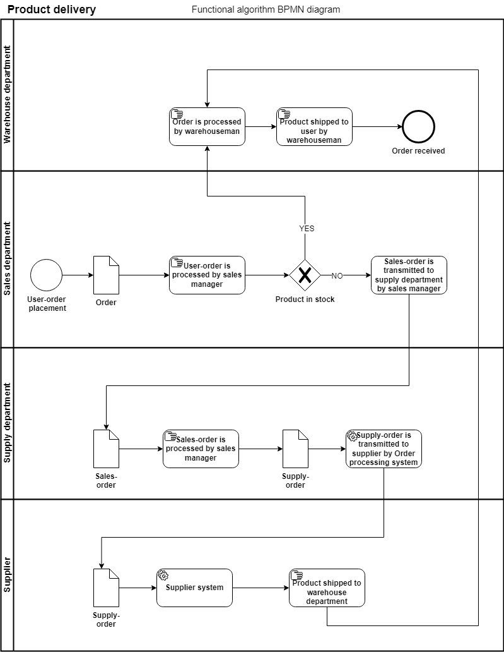](https://drive.google.com/file/d/1SkCqfFjSrbPdlf56IUyxbjaTzAS2IoJ_/view?usp=share_link)