

**Test Plan**

Website: <https://oliva.in.ua/shop/>

Documentation version 1.0

**Table of Contents**

1. Introduction ........................................................................................................................ 3

1.1. General information ................................................................................................. 3

1.2. Purpose ................................................................................................................... 3

1.3 Source data .............................................................................................................. 3

2. Scope of the project ........................................................................................................... 3

2.1 Product structure……….......................................................................................... 3

2.2 Features to be tested (IN-SCOPE) .......................................................................... 4

2.3 Features not to be tested (OUT OF SCOPE) .......................................................... 4

3. Test strategy...................................................................................................................... 4

3.1 Suspension criteria ................................................................................................. 4

3.2 Test methods .......................................................................................................... 4

3.3 Test types ............................................................................................................... 5

3.3.1. Functional testing ........................................................................................ 5

3.3.2. Non functional testing ................................................................................. 5

3.4 Test levels............................................................................................................... 5

4. The criteria of quality................................... ……………………….................................... 5

5. Testing Process Risks ...................……………………….................................................... 5

6. Testing Tools ...................………………………………….................................................... 5

7. Environmental Needs ...................……………………….................................................... 6

8. Test Team Expectations .................……………………….................................................... 6

9. Criteria for Starting and Ending Testing ...................……………………….......................... 6

9.1 Entry criteria .... ……..……………………………….…………….................................. 6  
9.2. Exit criteria .....................………………..……………………...................................... 6

10. Responsibilities of Test Team Members ................……………………….......................... 7

10.1 QA Lead ............……..…………………………….…………….................................. 7  
10.2. QA ...............................………………..……………………...................................... 7

11. Test Deliverables ....................………………..……………………...................................... 7

12. Schedule ................................………………..……………………...................................... 8

13. Risks and Contingencies .......………………..……………………...................................... 8

14. Responsibilities ......................………………..…………………….................................... 10

15. Approvals ...............................………………..…………………….................................... 11

**Revision History**

| **Name** | **Date** | **Reason For Changes** | **Version** |
| --- | --- | --- | --- |
| **Maryana Matchyshyn/Liza Sheptytska** | **15/01/2023** |  | **1.0** |
| **Dmitry Silayev** | **25/01/2023** | **Сorrection according QA-lead recommendations** | **1.1** |

1. **Introduction**

**1.1. General information**

This document describes the methods and procedures used by Group **3** in the functional testing process of the website **“**[https://oliva.in.ua/shop](https://oliva.in.ua/shop/)**”.** The document allows one to get an idea of the planned work on project testing.

**1.2. Purpose**

This test plan document for the **“Oliva.in.ua”** supports the following objectives:

* Identify existing project information and features to be tested.
* Recommendations and description of the testing strategies to be employed.
* Identify required resources and provide a test effort estimate.
* List the test project deliverables, the resources and schedule required to complete testing, and the risks associated with the plan.

**1.3 Source data**

Oliva.in.ua – the website that allows the user to buy high quality goods (military uniform, hunting and fishing clothes), place an order, order the delivery of product.

1. **Scope of the project**

**2.1. Product structure**

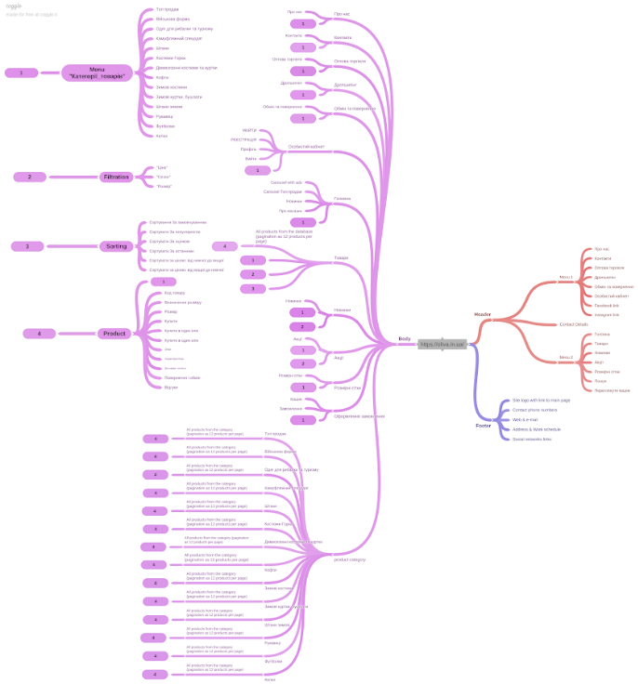

[Oliva.in.ua structure mind map](https://drive.google.com/file/d/1KEmqKOX9fblQBVfn62mVi7-MVX9U0JeH/view?usp=share_link)

**2.2. Features to be tested (IN-SCOPE)**

* Personal cabinet: Sign Up and Log In, User profile, Log Out
* Products: Search Form, Menu “Product’s categories”, Filter “Price”, Filter “Season”, ‘Filter “Size”, Sorting By default, By popularity, By rate, By last added, By price: from the highest to the lowest, By price: from the lowest to the highest; Adding goods to the cart. Feedback form.
* Ordering: As not registered User, As Logged In User, By “Купити в один клік» button
* Main page “Головна”
* Header
* Footer
* Pages ‘Про нас’, ‘Контакти’, ‘Оптова торгівля’, ‘Обмін та повернення’, ‘Новинки’, ‘Акції’, ‘Розмірні сітки’.

**2.3. Features not to be tested (OUT OF SCOPE)**

* External payment systems
* Dropshipping feature (temporary not available)
* Second language pages testing

1. **Test strategy**

The project uses an agile approach with weekly iterations. At the end of each week, the tasks identified for that iteration will be done and reviewed by team members.

Without knowing the internal structure or program source code, the **Oliva.in.ua** will be tested using a “black box” methodology.

**3.1 Suspension criteria**

The Testing Team may suspend partial or full-testing activities on a given build if any of the following occurs:

* There is a fault with a feature that prevents its testing.
* A severe problem has occurred that does not allow testing to continue.

**3.2 Test methods**

Testing is the process of attempting to find discrepancies between the program and its functional specification/ requirements. The goal is to make sure that all functions of the **Oliva.in.ua** work correctly.

***Black box testing*** – is considered the primary method of functional testing.

**3.3 Test types**

**3.3.1. Functional testing**

* manual testing
* automation testing

**3.3.2. Non functional testing**

* GUI Testing
* UX Testing
* API Testing
* load Testing
* security Testing

**3.4 Test levels**

* System testing
* Acceptance Testing

1. **The criteria of quality**

The product should operate following the requirements and the functional specification (if present). The product should not contain critical and blocking defects in the final version of the project.

1. **Testing Process Risks**

The next issues may influence testing works:

* changes and modifications of the software product that were not planned and discussed with the test team beforehand;
* changes in the software requirements that were not discussed with the test team beforehand;
* delays in correcting/fixing errors;
* delays in delivering new builds to the test team.

1. **Testing Tools**

* Test case creation - **Google Tables**
* Test case tracking - **Google Tables**
* Test case execution - **Manual**
* Test case management - **Google Tables**
* Defect management - **Google Documents**
* Test Summary Report - **Google Documents**
* Project structure - **Coogle** **Mind Map**

1. **Environmental Needs**

| **OS:** | **Browsers:** |
| --- | --- |
| Windows 10 | Google Chrome  Version 109.0.5414.75 |
| macOS 10.10.5 | Google Chrome  Version 87.0.4280.141 |
| macOS 12.6 | Google Chrome  Version 108.0.5359.124 |

1. **Test Team Expectations**

The test team must be provided with valid, updated documents during the whole testing process.

All the required equipment, instruments, devices, and software must be acquired and prepared before testing. All show-stopping errors must be corrected as soon as possible. Release notes should be added to each software release to the test team.

1. **Criteria for Starting and Ending Testing**

**9.1. Entry criteria**

* All the necessary documentation, design, and requirements information should be

available that will allow testers to operate the system and judge the correct behavior

* All the standard software tools including the testing tools must have been successfully installed and functioning properly
* Proper test data is available
* QA resources have completely understood the requirements
* QA resources have sound knowledge of functionality
* Reviewed сhecklists, test cases and RTM

**9.2. Exit criteria**

* All defined test cases & check-lists are passed and marked “Pass” status
* A certain level of requirements coverage has been achieved
* No high priority or severe bugs are left outstanding
* All high-risk areas have been fully tested, with only minor residual risks left outstanding
* The schedule has been achieved

1. **Responsibilities of Test Team Members**

**10.1. QA Lead**

* Acts as a primary contact for development and QA team.
* Responsible for Project schedule and the overall success of the project.
* Participation in the project plan creation/update process.
* Planning and organization of the test process for the release.
* Coordinate with QA analysts/engineers on any issues/problems encountered during testing.
* Report progress on work assignments to the PM.

**10.2. QA**

* Understand requirements
* Writing and executing Test cases
* Preparing Requirement Traceability Matrix (RTM)
* Reviewing Test cases, RTM
* Defect reporting and tracking
* Retesting and regression testing
* Bug Review meeting
* Preparation of Test Data
* Coordinate with QA Lead for any issues or problems encountered during test preparation/execution/defect handling.

1. **Test Deliverables**

* Software Requirements Specification
* Test Plan
* Test case specifications/Check List
* Requirement Traceability Matrix (RTM)
* Bug report
* Test summary report
* Presentation

1. **Schedule**

| **Task name** | **Start** | **Finish** | **Estimation, hours** | **Comments** |
| --- | --- | --- | --- | --- |
| **Exploring the testing product and Mind Map creating** | 10.01.23 | 15.01.23 | 40 |  |
| **Writing requirements** | 16.01.23 | 21.01.23 | 40 |  |
| **Requirement Analysis** | 21.01.23 | 23.01.23 | 24 |  |
| **Test Plan Writing** | 23.01.23 | 26.01.23 | 24 |  |
| **Requirement Traceability Matrix Creation** | 21.01.23 | 23.01.23 | 24 |  |
| **Test cases creation** | 23.01.23 | 27.01.23 | 40 |  |
| **Test Execution** | 27.01.23 | 28.01.23 | 16 |  |
| **Bug reports writing** | 27.01.23 | 05.02.23 | 16 |  |
| **API, Performance, Automation testing, Security testing** | 31.01.23 | 04.02.23 | 40 |  |
| **Test summary report writing** | 05.02.31 | 07.02.31 | 16 |  |
| **Test result presentation** | 05.01.31 | 08.02.31 | 40 |  |

1. **Risks and Contingencies**

Legend:

**VH** – Very High;

**H** – High;

**M** – Medium;

**L** - Low

| **Risk** | **Probability** | **Impact** | **Actions** |
| --- | --- | --- | --- |
| Problems in the test equipment. Breakdown of computer hardware or failures on the server side of the project. This can lead to a significant slowdown in project activities. | L | M | Availability of spare equipment, which will be provided if necessary. |
| The testing team consists of inexperienced workers; this can lead to the omission of different bugs. | VH | VH | Experienced people: RM or another tester will help the testing team resolve any problems in urgent cases. |
| Different types of leave (sickness or vacation) of any Member of the testing team can lead to an additional workload on other project participants. | H | M | RM can provide a project for an additional temporary person to work with during the absence of a team member. |
| Force majeure circumstances that may lead to the de-energization of the workplace, which will lead to the suspension of work on the project | L | M | The presence of another room in the absence of electricity at the permanent workplace |
| Changes (decreases) to the budget or resources for the project | L | H | To think over and register all the necessary resources and their estimated amount. For example, you can specify all resources with a small margin |
| Company devices do not match the requested devices for testing from the customer | L | M | In advance to announce to the customer what devices the company has, and, in case of a critical need for those or other devices to include their purchase in the budget |
| Unstable Internet access | H | VH | It is quite difficult to control an unstable Internet connection, but before starting the project, you need to make sure that there are no big failures in Internet providers |
| Localization of all project participants | M | M | When including participants in the project, it is necessary to correctly take into account the localization of each one. The team should consist of people who work in approximately the same time frame for fast and high-quality communication |
| Test environment prepared too late | L | M | Constant communication with developers |
| The project is dominated by blocking and critical bugs | L | L | If the main number of bugs in the project is blocking and critical, you need to contact the PM or the development team head, as well as regularly monitor whether the bugs found are taken to work |
| Customer changes requirements too often, or at the last minute | L | H | Discuss with the customer all the necessary functions, design details, the capabilities of this site in detail. Mark strict time limits when the customer can still make changes, constantly communicate with the customer, and show the work done |

1. **Responsibilities**

Divided on all **Group 3** team members

(e.g. SRS, Test Plan, Test Case Specifications, Traceability Matrix, Bug Report, Test summary report, Presentation)

| Liza Sheptytska | Software Requirements Specification  Test Plan  Test case specifications  Requirement Traceability Matrix  Bug report  Test summary report |
| --- | --- |
| Maryana Matchyshyn | Software Requirements Specification  Test Plan  Test case specifications  Requirement Traceability Matrix  Bug report  Test summary report |
| Dmytro Silayev | Software Requirements Specification  Test Plan  Test case specifications  Requirement Traceability Matrix  Bug report  Test summary report |
| Volodymyr Andrukh | Software Requirements Specification  Test case specifications  Requirement Traceability Matrix  Bug report |
| Olena Ivanovska | Software Requirements Specification  Test Plan  Test case specifications  Requirement Traceability Matrix  Bug report |
| Anna Chulak | Software Requirements Specification  Test case specifications  Requirement Traceability Matrix  Bug report |

1. **Approvals**

|  | Name | Position | Signature | Date |
| --- | --- | --- | --- | --- |
| 1. | _______________ | _______________ | _______________ | ____.____.________ |
| 2. | _______________ | _______________ | _______________ | ____.____.________ |
| 3. | _______________ | _______________ | _______________ | ____.____.________ |