** Test Summary Report**

for  
**Online Shopping "OLIVA"**

<https://oliva.in.ua/shop/>

# 

# **Version 1.0**

# **Prepared by**

# **Maryana Matchyshyn**

# **Liza Sheptytska**

# **Dmytro Silayev**

# **Volodymyr Andrukh**

# **Anna Chulak**

# **Olena Ivanovska**

# **QAGroup 45 Practical course**

# **11/01/2023**

**VERSION HISTORY**

| ***Version №*** | ***Implemented***  ***By*** | ***Revision***  ***Date*** | ***Approved***  ***By*** | ***Approval***  ***Date*** | ***Reason*** |
| --- | --- | --- | --- | --- | --- |
| 1.0 | Maryana MatchyshynLiza SheptytskaDmytro SilayevVolodymyr AndrukhAnna ChulakOlena Ivanovska | 07.02.2023 | Lupach O. |  | Initial Summary report |

**TABLE OF CONTENTS**

1. Introduction ......................................................................................................................... 4

1.1. Purpose .................................................................................................................... 4

2. Test summary...................................................................................................................... 4

2.1 Test scope ................................................................................................................. 4

2.2 Out of scope ….......................................................................................................... 4

2.3 Types of testing performed ….................................................................................... 5

2.3.1 Functional testing........................................................................................... 5

2.3.2 Non-functional testing..................................................................................... 5

2.3.3 Test levels....................................................................................................... 5

2.4 Metrics…….. .............................................................................................................. 6

3. Test environment...……………............................................................................................ 7

4. Entry and exit criteria………………..................................................................................... 8

5. Summary of Results........................................................................................................... 8 6. Summary of Activities ...................................................................................................... 11

7. Recommended Improvements ………............................................................................... 12

8. Test deliverables.............................................................................................................. 12

APPENDIX A: Test Summary Report Approval ……………………………………..…………. 13

# **INTRODUCTION**

## **PURPOSE**

The purpose of testing online shopping “Oliva” is to check the correct functioning of the system and identify bugs and defects with further recommendations for the site improvement.

# **2. TEST SUMMARY**

The "OLIVA" online store is designed to provide stable sales revenue, satisfy the market of goods through the Internet, provide a market for new brands and increase customer satisfaction, selling affordable hunting and fishing suits, active recreation and military clothing at a good price and quality.

## **2.1 TEST SCOPE**

•Personal cabinet: Sign Up and Log In, User profile, Log Out

•Products: Search Form, Menu “Product’s categories”, Filter “Price”, Filter “Season”, Filter “Size”, Sorting By default, By popularity, By rate, By last added, By price: from the highest to the lowest, By price: from the lowest to the highest; Adding goods to the cart. Feedback form.

•Ordering: As not registered User, As Logged In User, By “Купити в один клік» button

•Main page “Головна”

•Header

•Footer

•Pages ‘Про нас’, ‘Контакти’, ‘Оптова торгівля’, ‘Обмін та повернення’, ‘Новинки’, ‘Акції’, ‘Розмірні сітки’.

**2.2 Out Of Scope**

* External payment systems
* Dropshipping feature (temporary not available)
* Second language pages testing

**Test Date**: 10.01.2023 - 08.02.2023

## **2.3 Types of testing performed**

During the testing, the following types of testing were used:

**2.3.1 Functional testing**

* Manual testing
* Automation testing

**2.3.2 Non-functional testing**

* GUI Testing
* UX Testing
* API Testing
* Load Testing
* Security Testing

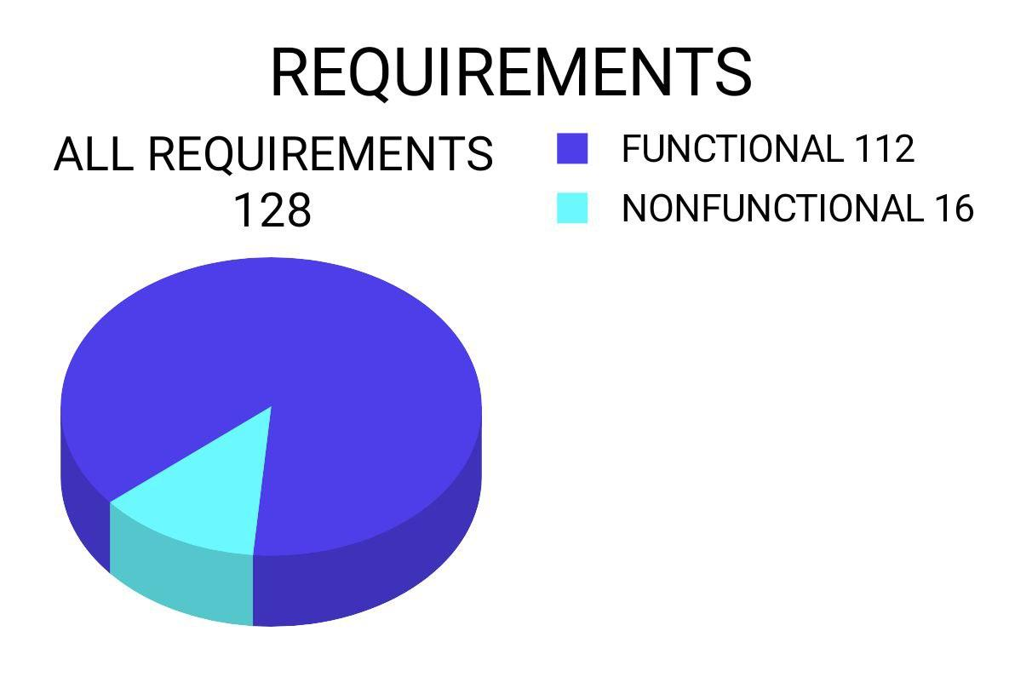

**2.3.3 Test levels**

* System testing
* Acceptance Testing

## 

## **2.4 METRICS**

1. ***Test Cases Passed and Failed:***

| ***TCs planned*** | ***TCs executed*** | ***TCs Passed*** | ***TCs Failed*** |
| --- | --- | --- | --- |
| 222 | 222 | 213 | 9 |

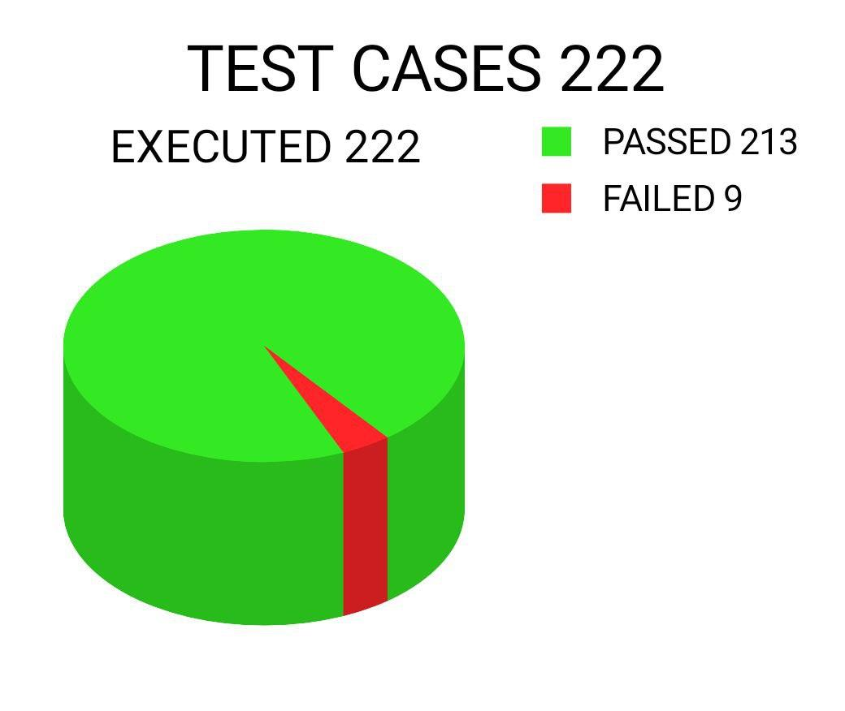

1. ***Test Cases Priority:***

|  | ***Highest*** | ***High*** | ***Medium*** | ***Low*** | ***Lowest*** | ***Total*** |
| --- | --- | --- | --- | --- | --- | --- |
| ***Closed*** |  |  |  |  |  |  |
| ***Opened*** | 0 | 90 | 129 | 3 | 0 | 222 |

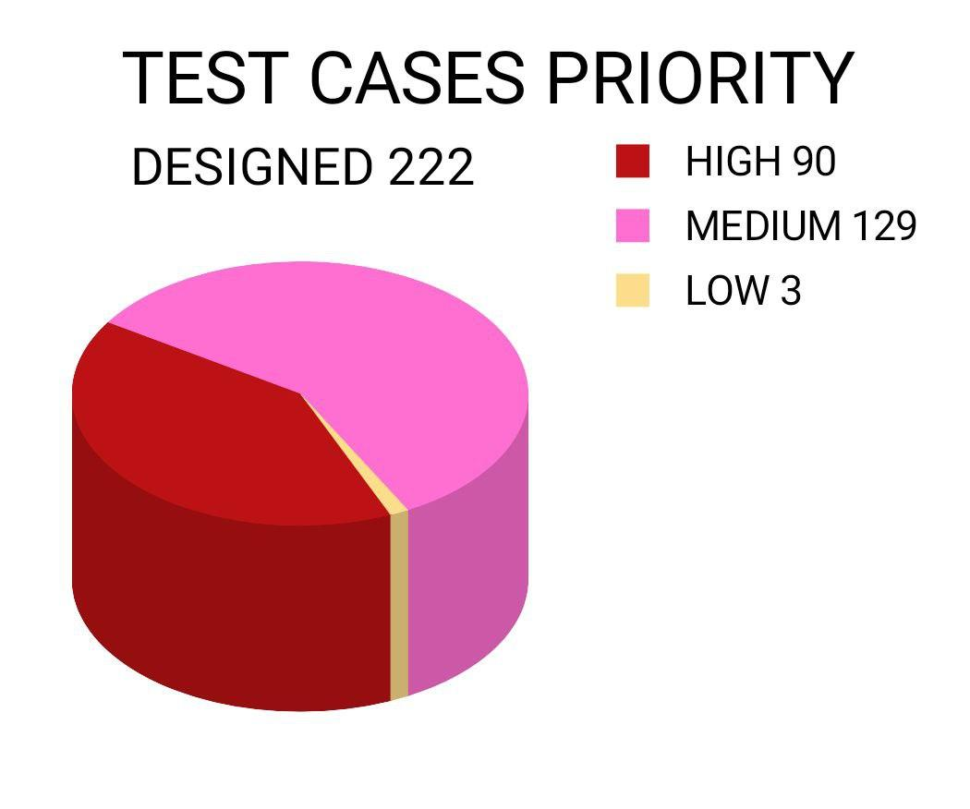

1. ***Checklist Test Cases Passed and Failed***

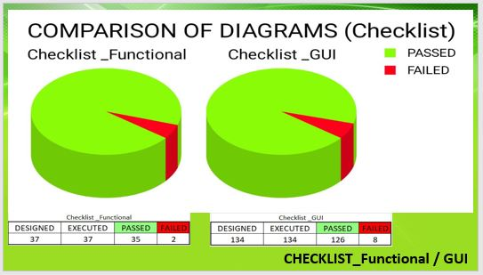

Checklist _Functional

| ***TCs planned*** | ***TCs executed*** | ***TCs Passed*** | ***TCs Failed*** |
| --- | --- | --- | --- |
| 37 | 37 | 35 | 2 |

Checklist _GUI

| ***TCs planned*** | ***TCs executed*** | ***TCs Passed*** | ***TCs Failed*** |
| --- | --- | --- | --- |
| 134 | 134 | 126 | 8 |

**3. TEST ENVIRONMENT**

| Application URL | https://oliva.in.ua/ |
| --- | --- |

# 

| **OS** | **Browser** |
| --- | --- |
| macOS 12.6 | Google Chrome 108.0.5359.124 |
| macOS 10.10.5 | Google Chrome 87.0.4280.141 |
| Windows 10 | Google Chrome Version 109.0.5414.75 |

# **4. ENTRY AND EXIT CRITERIA**

| ***Criteria Type*** | ***Criteria Description*** |
| --- | --- |
| Entry | * Requirements are testable, documented, and have been approved and signed-off. |
| Exit | * The education in QAGroup is finished. * The Test Cases are passed and match the requirements. * All severity 1 (critical) and severity 2 (major) defects have been fixed, fully tested, and meet system requirements. * A certain level of requirements coverage has been achieved. * All high-risk areas have been fully tested, with only minor residual risks left outstanding. * Cost – when the budget has been spent. * The schedule has been achieved |

# **5. Summary of Results**

Based on the collected requirements 222 test cases were designed. 100% of test cases were executed.



| Designed | Executed | Passed | Blocked | Failed |
| --- | --- | --- | --- | --- |
| 222 | 222 | 213 | 0 | 9 |

# 

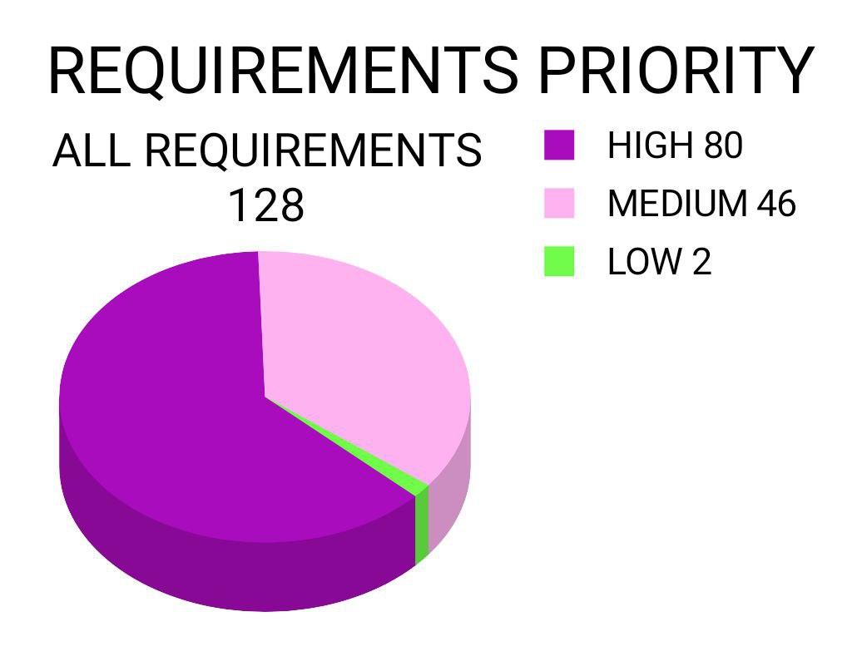

| **Requirements priority**  **Critical** | **Requirements priority**  **High** | **Requirements priority Medium** | **Requirements priority**  **Low** |
| --- | --- | --- | --- |
| 0 | 80 | 46 | 2 |

During the testing 23 bugs were found. Bug reports were written.

| **Bugs severity Major** | **Bugs severity Minor** | **Bugs severity Low** |
| --- | --- | --- |
| 7 | 12 | 4 |

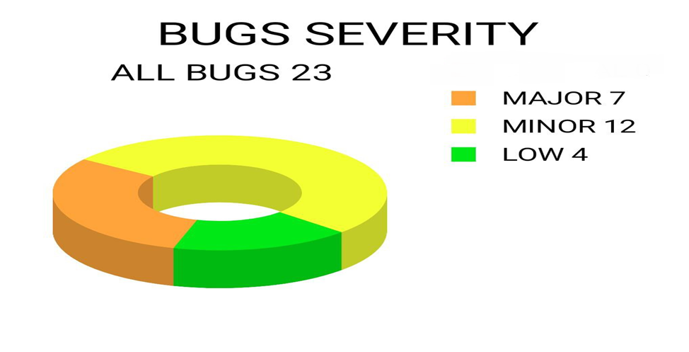

| **Bugs Priority High** | **Bugs Priority Medium** | **Bugs Priority Low** |
| --- | --- | --- |
| 4 | 13 | 6 |

# 

# **6. Summary of Activities**

| **Task name** | **Start** | **Finish** | **Estimation, hours** |
| --- | --- | --- | --- |
| **Exploring the testing product and Mind Map creating** | 10.01.2023 | 15.01.2023 | 8 |
| **Writing requirements** | 16.01.2023 | 21.01.2023 | 16 |
| **Requirement Analysis** | 21.01.2023 | 23.01.2023 | 8 |
| **Test Plan Writing** | 23.01.2023 | 26.01.2023 | 16 |
| **Requirement Traceability Matrix Creation** | 21.01.2023 | 23.01.2023 | 130 |
| **Test cases creation** | 23.01.2023 | 27.01.2023 | 54 |
| **Test Execution** | 27.01.2023 | 28.01.2023 | 8 |
| **Bug reports writing** | 27.01.2023 | 05.02.2023 | 16 |
| **API, Performance, Automation testing, Security testing** | 31.01.2023 | 04.02.2023 | 70 |
| **Test summary report writing** | 05.02.2023 | 07.02.2023 | 32 |
| **Test result presentation** | 05.01.2023 | 08.02.2023 | 20 |
| **Estimated total time:** | | | 378 |

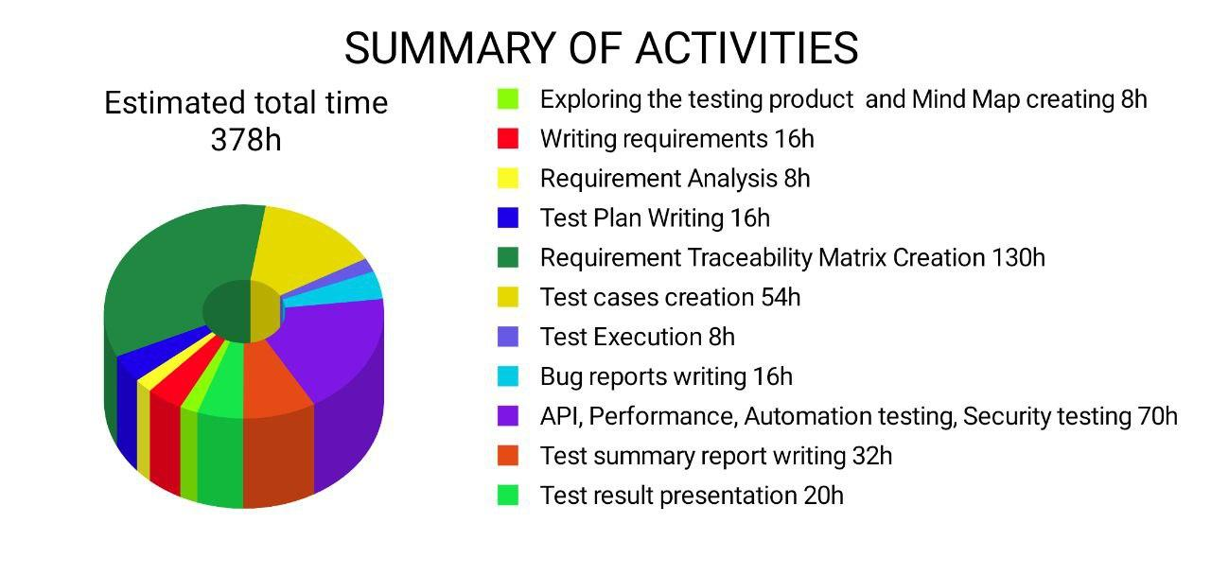

**7. Recommended Improvements**

As a result of testing, we recommend the following:

* Fix bugs according to bug-reports
* Improve site security according to security report
* Improve Performance to decrease response time
* Improve sorting function to exclude not available goods
* We understand that the russian language is necessary for SEO promotion of the site in the eastern part of Ukraine. We recommend removing the flag and replacing the word "русский" with RU

**8. Test deliverables**

* Requirements specification
* Mind Map
* Test plan
* Traceability matrix
* Test cases
* Check-lists
* Bug reports
* Use-cases
* API testing collection documentation
* Performance Testing Report
* Security Testing Report
* Test summary report

**APPENDIX A: Test Summary Report Approval**

The undersigned acknowledge they have reviewed the ***“Oliva”*** **Test Summary Report** and agree with the approach it presents. Changes to this **Test Summary Report** will be coordinated with and approved by the undersigned or their designated representatives.

Signature: ____________________________

Name: _______________________________

Title: _______________________________

Role: _______________________________

Signature: ____________________________

Name: _______________________________

Title: _______________________________

Role: _______________________________

Date: _____________

___

Ddd Date: _____________