**C# - ADO.NET and SQL Server**

<http://www.youtube.com/watch?v=OJfYSZzZOP8&list=PL364D9F01461F5F87&index=1>

Quick video describing a simple way to save data to SQL using the sqlDataAdapter object by Fabio Scopel.

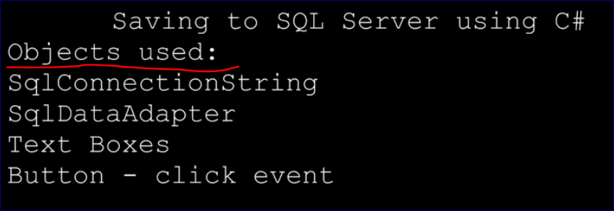

**Create a table**

USE bucky;

CREATE TABLE [tblContacts]

(

[ID] INT IDENTITY NOT NULL

,[FIRSTNAME] NVARCHAR(100)

,[LASTNAME] NVARCHAR(100)

)

SELECT * FROM [bucky].[dbo].[tblContacts]

2) Create a C# windows form project

Add two text boxes and one button

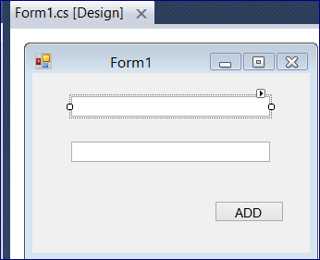

Click on the first box and rename it to “txtFirstName” and the second box to “txtLastName”

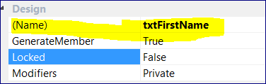



Now click the button “Click Record” to change the code in it.

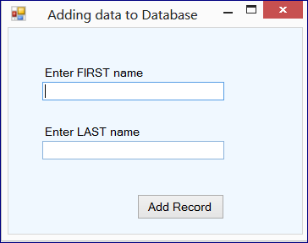

Add a module: using System.Data.SqlClient;

using System;

using System.Collections.Generic;

using System.ComponentModel;

using System.Data;

using System.Drawing;

using System.Linq;

using System.Text;

using System.Windows.Forms;

using System.Data.SqlClient;

namespace addingDataToSqlServer

{

public partial class Form1 : Form

{

public Form1()

{

InitializeComponent();

}

private void button1_Click(object sender, EventArgs e)

{

/* if we didn't import "System.Data.SqlClient"

we would use the full reference to create a SqlConnection object

e.g.: System.Data.SqlClient.SqlConnection myConn1;

*/

SqlConnection cs = new SqlConnection("Data Source=A-DMVAKH-W500\\DIMSQL; Initial Catalog=bucky; Integrated Security=TRUE");

/*-----------------------

test the connection

-----------------------

cs.Open();

MessageBox.Show(cs.State.ToString());

cs.Close();

*/

// "SqlData Adapter" sends data from the form to the pipe

SqlDataAdapter da = new SqlDataAdapter();

da.InsertCommand = new SqlCommand("INSERT INTO tblContacts VALUES(@FIRSTNAME, @LASTNAME)", cs);

da.InsertCommand.Parameters.Add("@FIRSTNAME", SqlDbType.VarChar).Value = txtFirstName.Text;

da.InsertCommand.Parameters.Add("@LASTNAME", SqlDbType.VarChar).Value = txtLastName.Text;

// Open/close connesction and execute the query

cs.Open();

da.InsertCommand.ExecuteNonQuery();

cs.Close();

}

}

}