**C# -- Learning Notes**

**Bucky**

<http://thenewboston.org/list.php?cat=15>

<http://www.youtube.com/course?list=EC0EE421AE8BCEBA4A>

# C# Beginners Tutorial - 1 - Introduction and Installing C# 2010

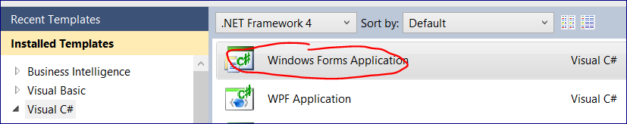

# C# Beginners Tutorial - 2 - Changing Forms Properties

Double click on the control and then adjust the form

Or click once and resize the form as you draw it.

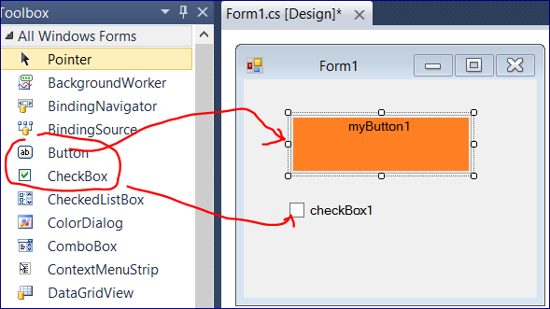

We can adjust properties such as the background

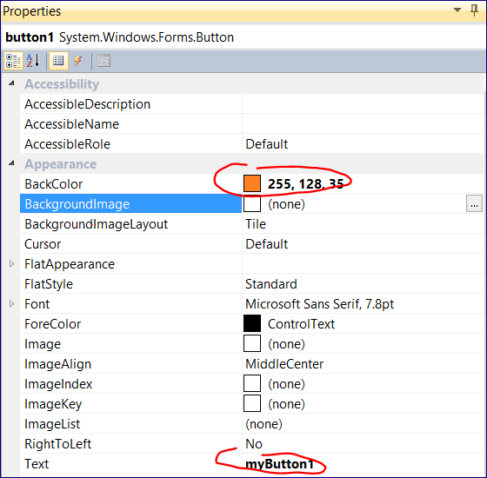

To run the program press F5 or 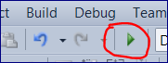

To stop debugging press **“Stop”** or **“X”** on the form or **Shift + F5**

# C# Beginners Tutorial - 3 - Showing MessageBoxes

Create a button and double click on it

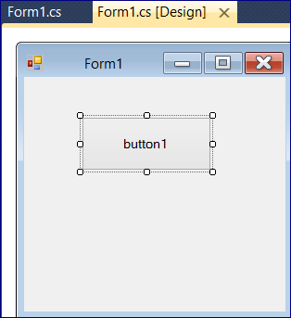

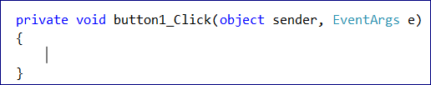

Print in the space between { } for the button1_click

MessageBox.Show("Hello", "MyTitle");

Run the program

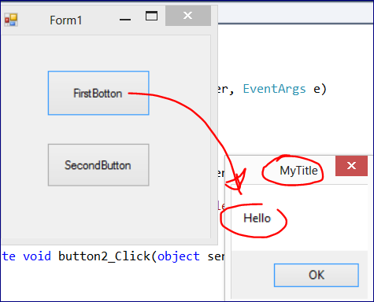

Right Click on Properties for the “FirstButton”

And click the “Event Handler” icon

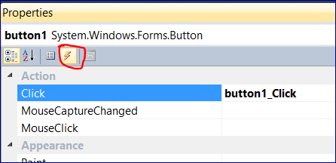

Find Mouse Hover and double click on the field

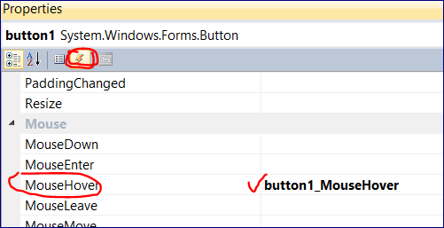

private void button1_Click(object sender, EventArgs e)

{

MessageBox.Show("Hello! You pressed the first button", "MyTitle");

}

private void button2_Click(object sender, EventArgs e)

{

//MessageBox.Show("HelloAgain", "MyTitle2");

}

private void button2_MouseHover(object sender, EventArgs e)

{

MessageBox.Show("You are hovering your mouse over the Second Button");

}

# C# Beginners Tutorial - 4 - Variables

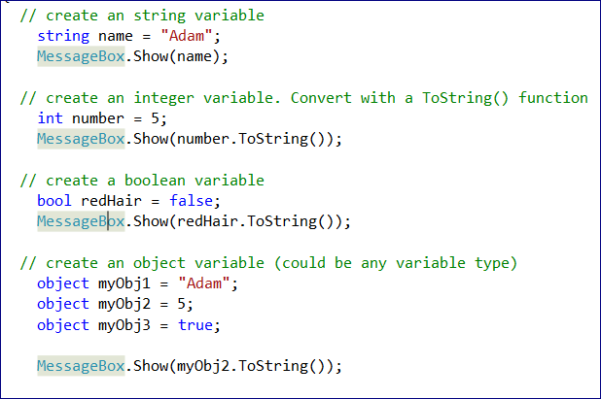

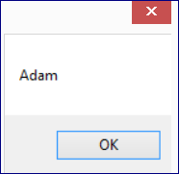

# C# Beginners Tutorial - 5 - Changing Properties With Code

To check the name of the control (e.g. a button)

Click on the button

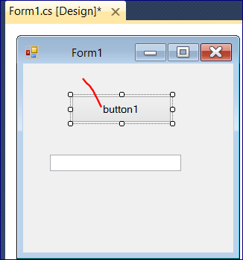

Then in the “Property” window you will see

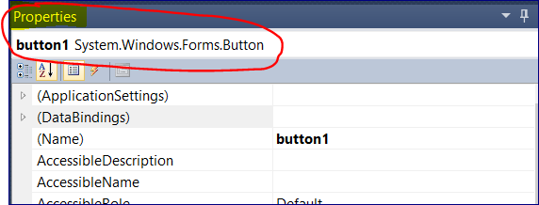

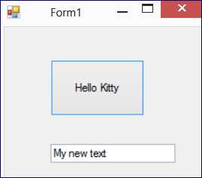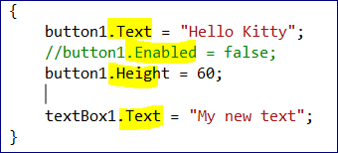

# C# Beginners Tutorial - 6 - If Statements

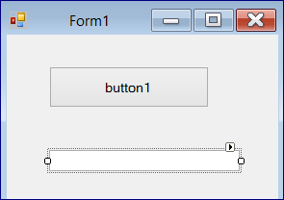

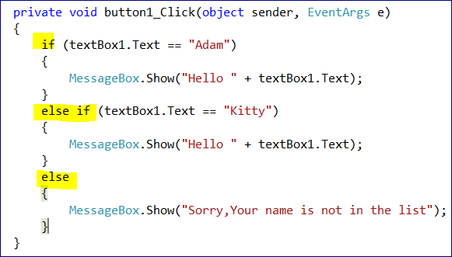

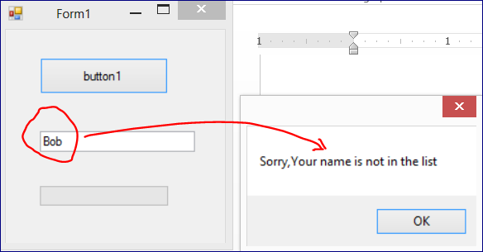

# C# Beginners Tutorial - 7 - More on If Statements

**We want to check if a user checked a checkbox.**

