**Notes_Python3 Essential Training**

Due to its power, simplicity, and complete object model, Python has become the scripting language of choice for many large organizations, including Google, Yahoo, and IBM. In Python 3 Essential Training, Bill Weinman demonstrates how to use Python 3 to create well-designed scripts and maintain existing projects. This course covers the basics of the language syntax and usage, as well as advanced features such as objects, generators, and exceptions. Example projects include a normalized database interface and a complete working CRUD application. Exercise files accompany the course.

<https://www.youtube.com/playlist?list=PLvRMjkCT20cFfS4Uzg2wHBPgU6yjJEIev>

08. Creating sequences with generator functions

Generator function creates an iterator.

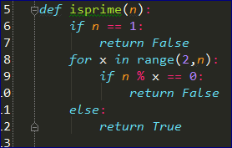

This is a generator:

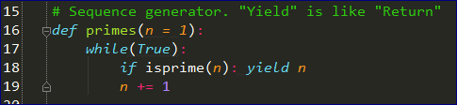

**Yield** returns the number ONLY IF isprime returns TRUE

This is a Generator function. It generates an iterator that’s suitable for use in a FOR loop.

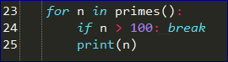

# 09. Reusing code and data with a class

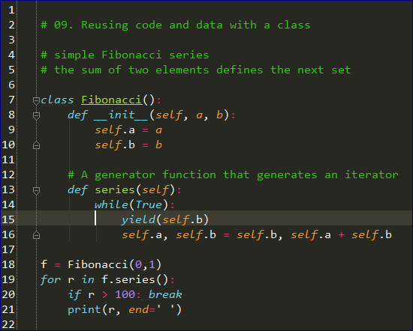

# 10. Greater reusability with inheritance and polymorphism

# 11. Handling errors with exceptions

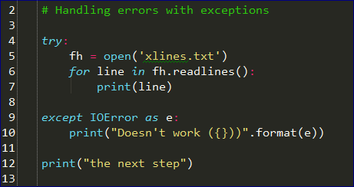

# 14. Creating a main script

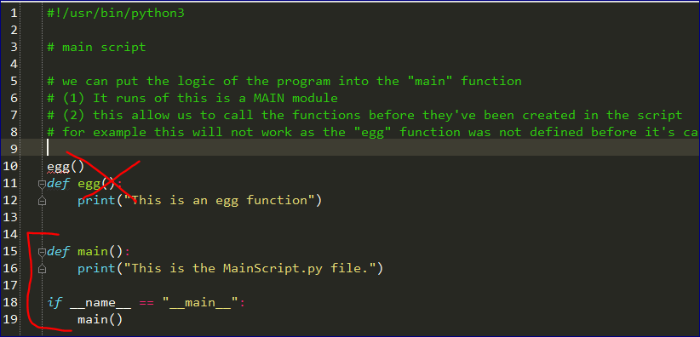

# 18. Selecting code and values with conditionals

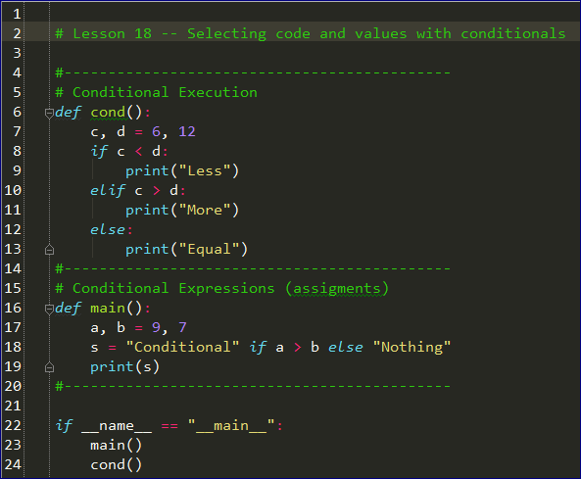

# 19. Creating and using functions

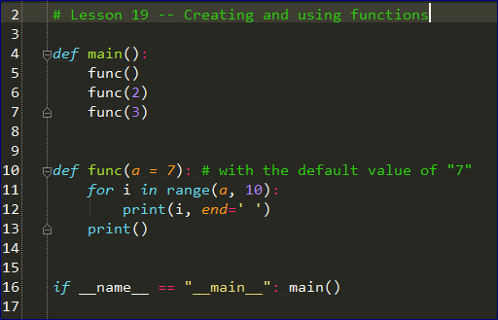

# 20. Creating and using objects

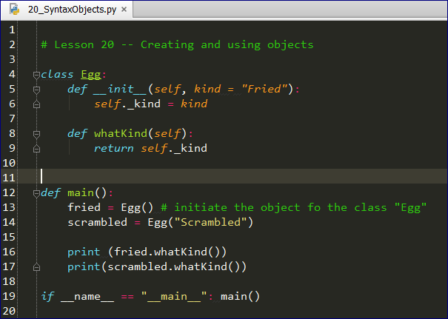

# 21. Understanding variables and objects in Python

Everything in Python is an object including variables.

Every object has:

* ID
* Type
* Value

All variables are the first class objects.

# 22. Distinguishing mutable and immutable objects

# Variables in Python are referances to different objects

print("---------------------------------------")

z = 77

print(id(z))

z = 79

print(id(z))

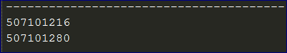

**Most fundamental types in Python are immutable:**

* Numbers
* Strings
* Tuples

# 23. Using numbers

# 24. Using strings

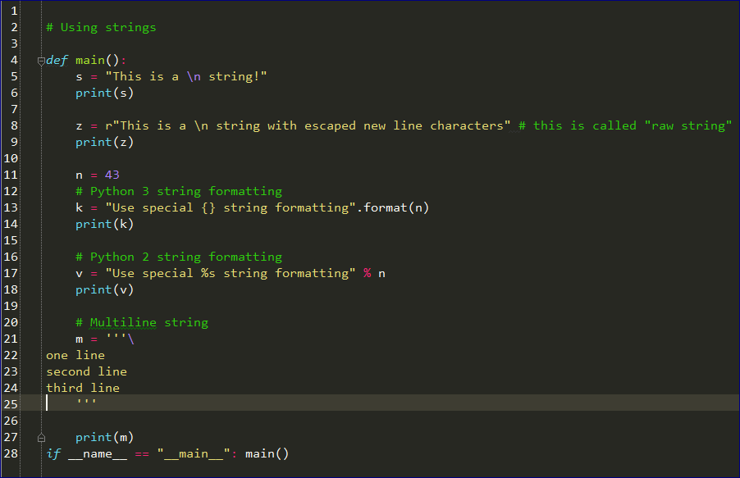

# 25. Aggregating values with lists and tuples

