**MySQL.docx**

***Data files from Bucky:***

<http://tnbforum.com/viewforum.php?f=152&sid=1a465c1428b95e56b8476b4d910f3a3e>

+++++++++++++++++++++++++++++++++++++++++++++++++++++++++++++++++++++++++++++++++

[**http://www.youtube.com/watch?v=KgiCxe-ZW8o**](http://www.youtube.com/watch?v=KgiCxe-ZW8o)

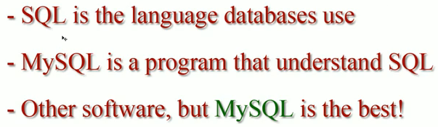

1. We need to **install an SQL SERVER** (if you work in a corporation they have it installed and you do not need SERVER but for education we need SERVER)

2. or **find a hosting company with the SQL Server already installed** on it.

**Create free webhosting site:**

<http://www.000webhost.com/>

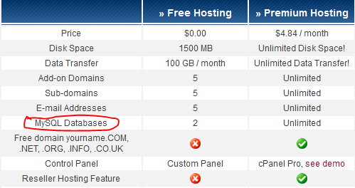

**Create a database:**

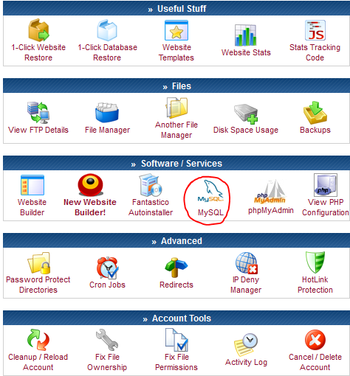

**Type the name of your database, user, and password**

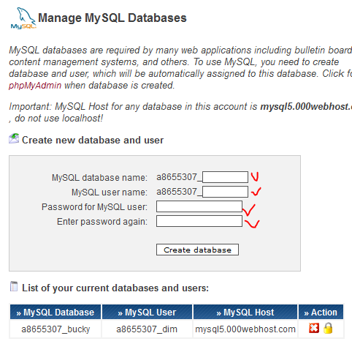

**Database**: a8655307_bucky

**UserName**: a8655307_dim

**Password**: tutorial37

**One you have done that go to PHP Admin**

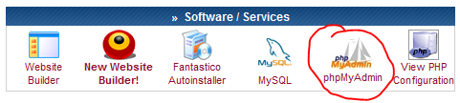

**and select your database**

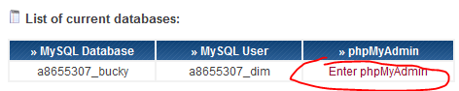

**You can import dataset that you would like to explore**

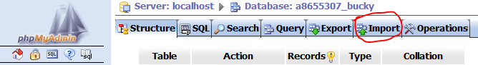

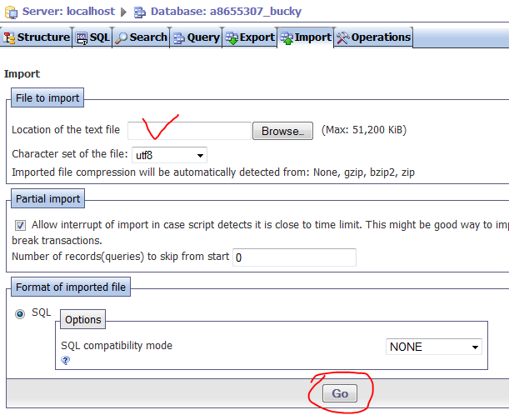

Finally you will get something like that:

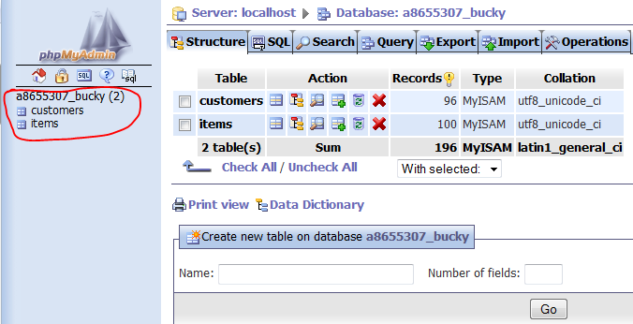

++++++++++++++++++++++++++++++++++++++++++++++++++++++++++++++++++++++++++++++++++++++++++

<http://www.apachefriends.org/en/xampp.html>



Many people know from their own experience that it's not easy to install an Apache web server and it gets harder if you want to add MySQL, PHP and Perl.

XAMPP is an easy to install Apache distribution containing MySQL, PHP and Perl. XAMPP is really very easy to install and to use - just download, extract and start.

XAMPP is a free and open source cross-platform web server package, consisting mainly of the Apache HTTP Server, MySQL database, and interpreters for scripts written in the PHP and Perl programming languages.   
  
It is used as a development tool, to allow website designers and programmers to test their work on their own computers without any access to the Internet.

*********************************************