Workflow Template Deployment Instructions

[Company name] | [Company address]

Replace SP 2010 Out of box workflows with these powerplatform templates

Karl Reigel

2020

Introduction: SharePoint 2010 Workflows are being retired in SharePoint Online effective November 1, 2020. (See Support Article: [SharePoint 2010 workflow retirement](https://support.microsoft.com/en-us/office/sharepoint-2010-workflow-retirement-1ca3fff8-9985-410a-85aa-8120f626965f))

It is recommended to replace these workflows with Power Platform workflows. Workflows often have a specific business need and therefore Microsoft cannot cover every possible business scenario. However, here are some sample templates that have similar functionality to the SharePoint 2010 Out of the Box, OOB, workflows.

Contents

Deploy the Required Lists: CreateWorkflowHistoryList and CreateWorkflowTaskList 2

Confirm the Workflow History List is created 10

Creating the Workflow Task List 11

II. Setup The Main Approval Flow 19

III. Importing the Collect Feedback Approval Flow 32

Import the Collect Signatures Flow 37

Import and Setup the Approval Task Update Flow 43

Import and Setup Power App Used by these Flows 49

Power App Fixing the Submit Feedback Button 62

Fixing the Collect Signature Submit Button 64

Workflow Task List Column Formatting 66

Adding the Power App Link to the Flow 70

Ending Notes: 73

# Deploy the Required Lists: CreateWorkflowHistoryList and CreateWorkflowTaskList



1. Leave these files as .zip files. Do NOT unzip the files.
2. Open Microsoft Flow <https://us.flow.microsoft.com/en-us/>
3. Go to **My Flows**  
   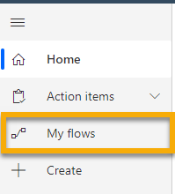
4. **Import Flow** by clicking on the import button  
   
5. Click the **Upload** button  
   
6. Browse to the location of the zip files.
7. Highlight **CreateWorkflowHistoryList.zip**   
   **\*\*\*IMPORTANT\*\*\*** Do NOT navigate away from this page while uploading. Wait until it is finished uploading before clicking away or trying to continue to the next step.



1. You will now see **CreateWorkflowHistory** in the **Name** column and you should see **Create as New** in the **Import Setup**  column.  
   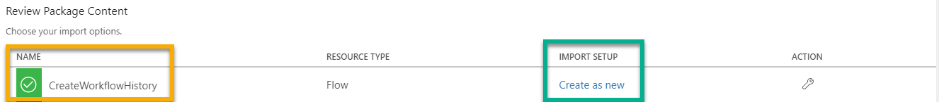

**Note: If you do not see **Create as New** in the **Import Setup** Columnit could have a status of “Update”. If it does click on **Update** and then in the **Setup** drop-down select **Create as New**.

1. On the Import Setup panel select **Create as New** and specify a **Resource Name** I have left the name as the default **CreateWorkflowHistory**  and click the **Save** button.  
     
   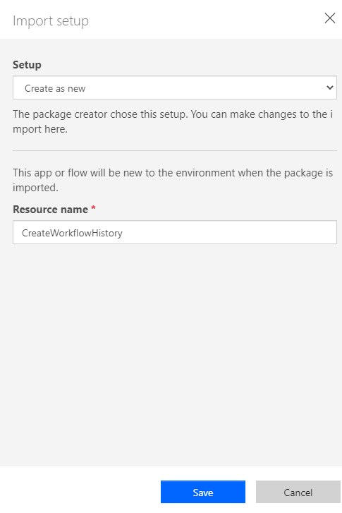
2. Next, we will look at the **Related Resources** section and in the **Import Setup** column click on **Select during import**. This will open the **Import setup,** panel for your related resources.
3. If under **Create New** is blank, then you will click on **Create New** and it will open another tab in your browser.  
   **Figure 1.1** :Shows **Create New** is blank  
   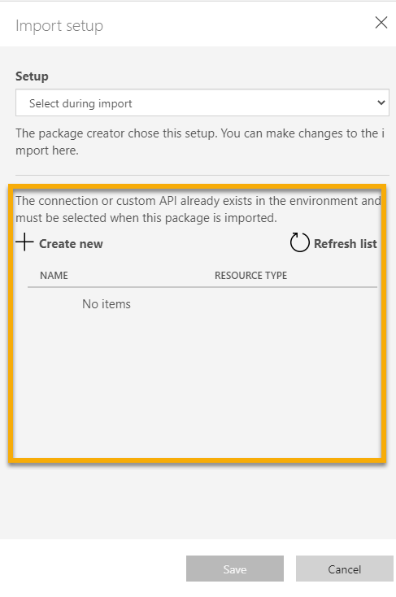
4. This opens the **Create a Connection** tab.   
   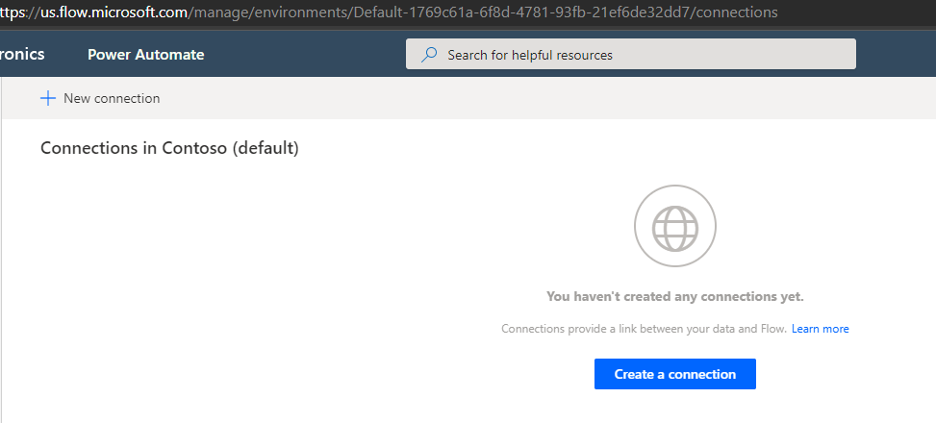
5. Click on the **New Connection** button  
   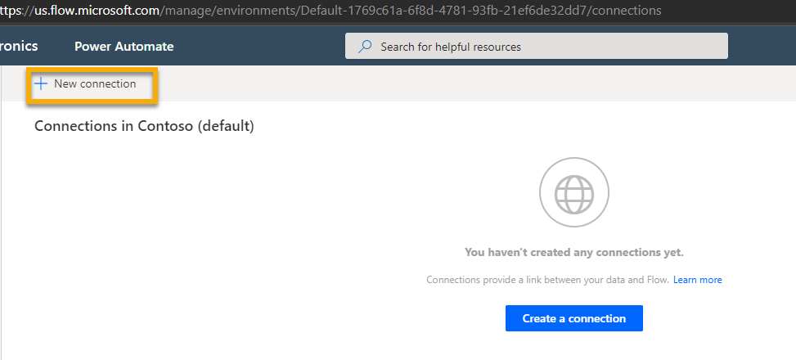
6. Select **SharePoint**  
   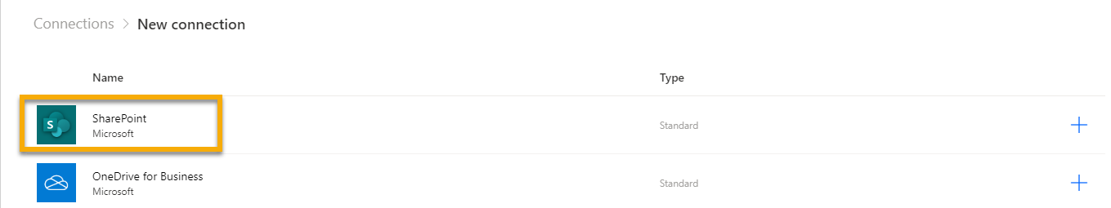
7. Select radio button **Connect directly (cloud-services)** and then click the **Create** button  
   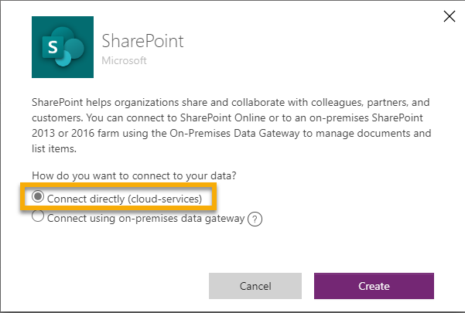
8. Supply the correct log-in information then navigate back to the other tab.
9. You should see the connection with the login you provided on the other tab. If you do not then select the **Refresh** button.
10. Select the credentials and then click the **Save** button  
    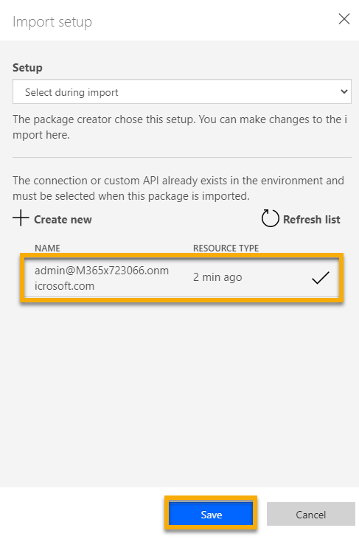
11. Once you have successfully saved, then at the bottom of the page click the **Import** button, and again do NOT navigate away from this page, just let it finish. If you accidentally did then you will have to go back and click on import again.  
    
12. Once import has completed you will see the following confirmation message at the top of the screen. Then you will click **Open flow**.  
    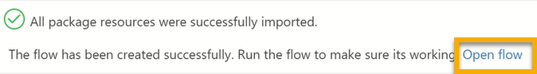
13. This will open a new page. On this new page you will edit the flow. The only thing you need to change is **Send an HTTP request to SharePoint**.  
    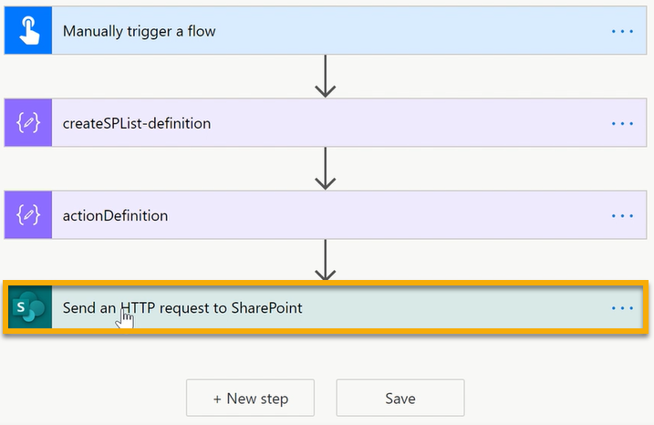
14. By clicking on **Send an HTTP request to SharePoint** it will expand the window. You are going to want to change the **Site Address** to the Site Collection you want to deploy the Workflow History List to.  
    
15. Click the **X** next to the dropdown. If the site you want to deploy to does not appear in the list, then you will scroll down to the bottom and click on **Enter Custom Value** and then Copy and Paste or manually type the URL of the site you are deploying the Workflow History List to.
16. Then click the **Save** button.
17. Because this is a manual trigger flow you will need to trigger the flow. To trigger the flow click on the **Test** button.  
    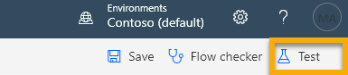
18. Select **I’ll perform the trigger action** and then click the **Test** button  
    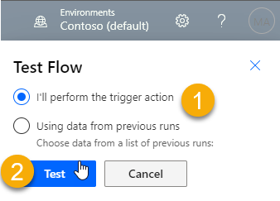
19. Click the **Run Flow** button on the bottom-right part of the page  
    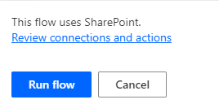
20. When the flow completes you should see the following message  
    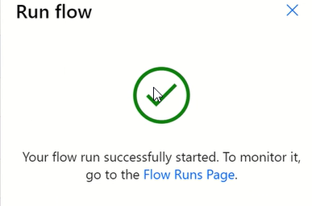
21. Click on the **Done** button
22. You will be taken t the Workflow Status page and you will see your flow ran successfully and all the green check marks that appear at each step.  
    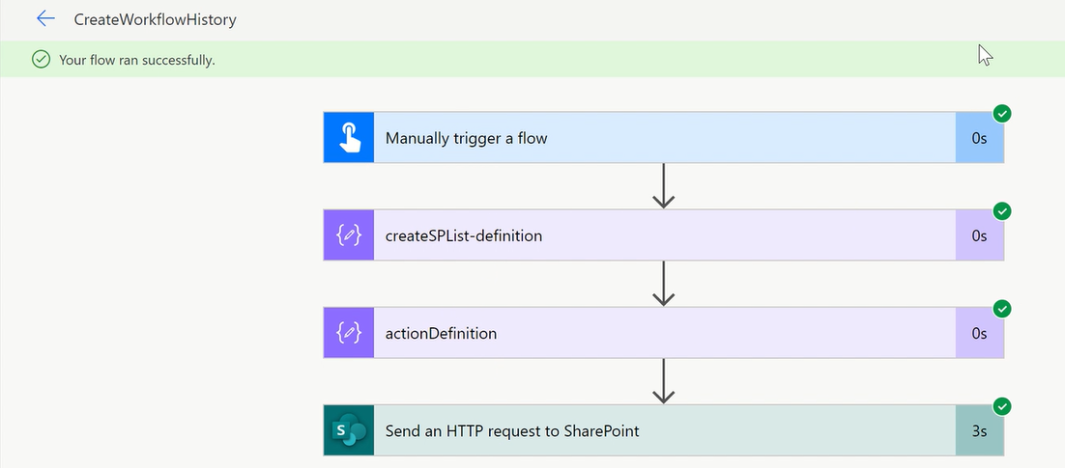

## Confirm the Workflow History List is created

1. Navigate to the SharePoint Site Collection you specified in **Step 22**
2. Click on the **Gear Icon** and then **Site Contents**.  
   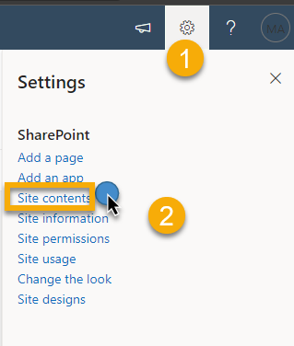
3. You should see the **Workflow History List** is now created.  
   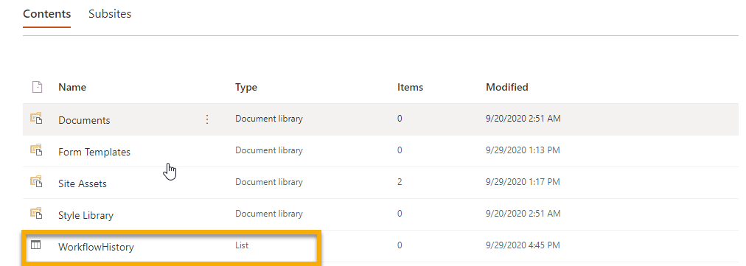

## Creating the Workflow Task List

1. Go to **My Flows**  
   
2. **Import Flow** by clicking on the import button  
   
3. Click the **Upload** button  
   
4. Browse to the location of the zip files.
5. Highlight **CreateWorkflowTaskList.zip**   
   **\*\*\*IMPORTANT\*\*\*** Do NOT navigate away from this page while uploading. Wait until it is finished uploading before clicking away or trying to continue to the next step.



1. You will now see **CreateWorkflowTask** in the **Name** column and you should see **Create as New** in the **Import Setup** column.
2. Next, we will look at the **Related Resources** section and in the **Import Setup** column click on **Select during import**. This will open the **Import setup,** panel for your related resources.
3. If under **Create New** is blank, then you will click on **Create New** and it will open another tab in your browser.   
   **Note: Since you just added the connection to SharePoint the connection should be in the list to select.  
     
   

1. Select the credentials and then click the **Save** button  
   
2. Once you have successfully saved, then at the bottom of the page click the **Import** button, and again do NOT navigate away from this page, just let it finish. If you accidentally did then you will have to go back and click on import again.  
   
3. Once import has completed you will see the following confirmation message at the top of the screen. Then you will click **Open flow**.  
   
4. This will open a new page. On this new page you will edit the flow. The only thing you need to change is **Send an HTTP request to SharePoint**.  
   
5. By clicking on **Send an HTTP request to SharePoint** it will expand the window. You are going to want to change the **Site Address** to the Site Collection you want to deploy the Workflow History List to.  
   
6. Click the **X** next to the dropdown. If the site you want to deploy to does not appear in the list, then you will scroll down to the bottom and click on **Enter Custom Value** and then Copy and Paste or manually type the URL of the site you are deploying the Workflow History List to.
7. Then click the **Save** button.
8. Because this is a manual trigger flow you will need to trigger the flow. To trigger the flow click on the **Test** button.  
   
9. Select **I’ll perform the trigger action** and then click the **Test** button  
   
10. Click the **Run Flow** button on the bottom-right part of the page  
    
11. When the flow completes you should see the following message  
    
12. Click on the **Done** button
13. You will be taken t the Workflow Status page and you will see your flow ran successfully and all the green check marks that appear at each step.  
    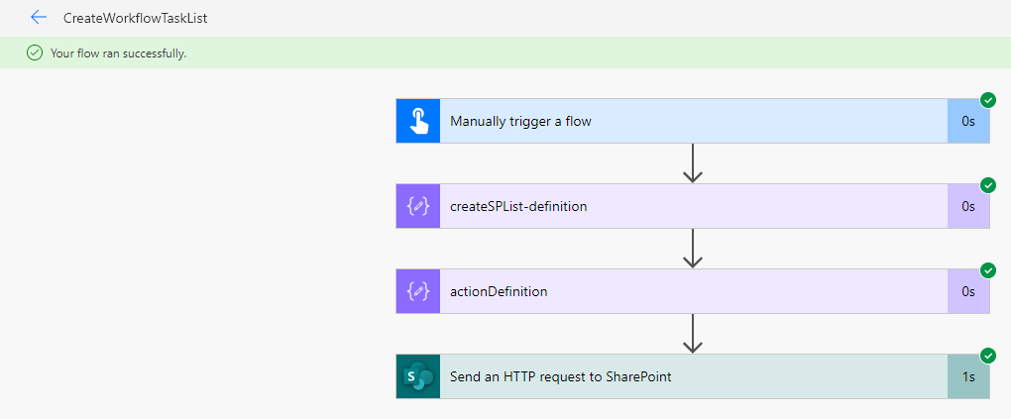
14. Confirm the Workflow Task List was created.
15. Navigate to the SharePoint Site Collection you specified in **Step 16**
16. Click on the **Gear Icon** and then **Site Contents**.  
    
17. You should see the **Workflow Task List** is now created.  
    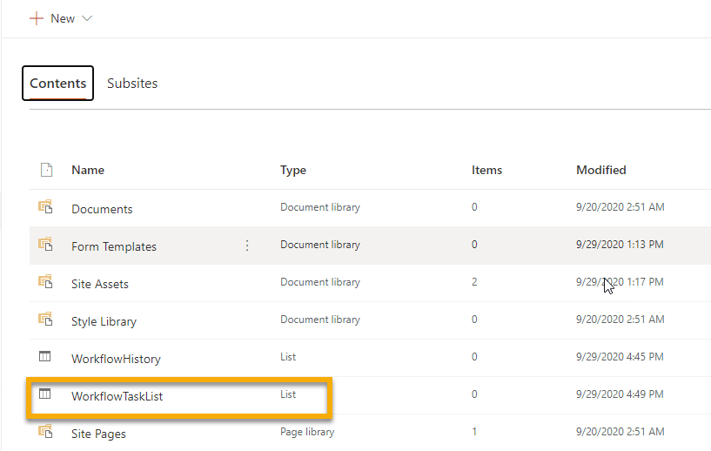
18. Congratulations. You can now deploy these lists to any other site by modifying the URL you wish to deploy them to on the **Edit the Workflow** page in the **Send an HTTP Request to SharePoint.**

# II. Setup The Main Approval Flow

**Before you Begin: Prior to setting this up you have to have the Workflow History List and Workflow Task List set up in the site collection.

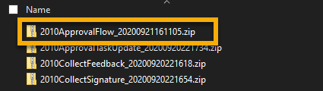

1. Go to **Microsoft Flow**
2. Click on **My Flows**
3. Click on **Import** button
4. Select the **2010ApprovalFlow** Zip File
5. Highlight and click open  
   **Do NOT navigate away from this screen. Allow the upload to complete.
6. You should see the **Package Content** and **Related Resources**.   
   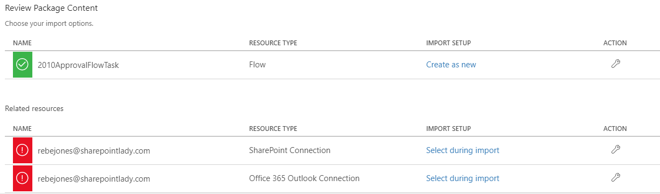
7. In the **SharePoint Connection Resource Type** in the **Import Setup** column click the **Select during import** link to establish the correct connection.  
   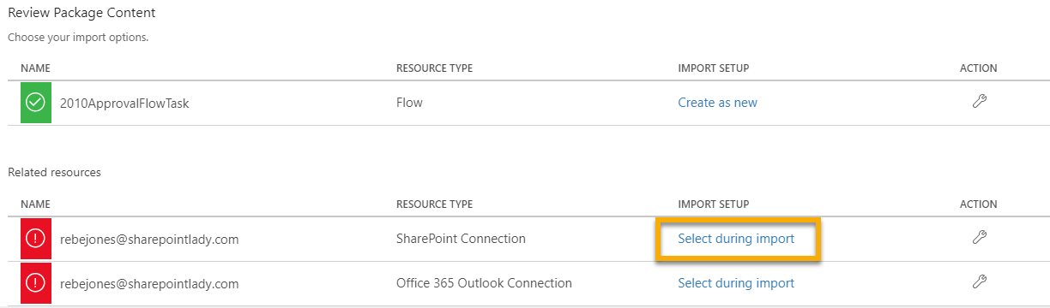
8. Select the Account and click the **Save** button.
9. Click on Select during import for the Office 365 Outlook Connection.  
   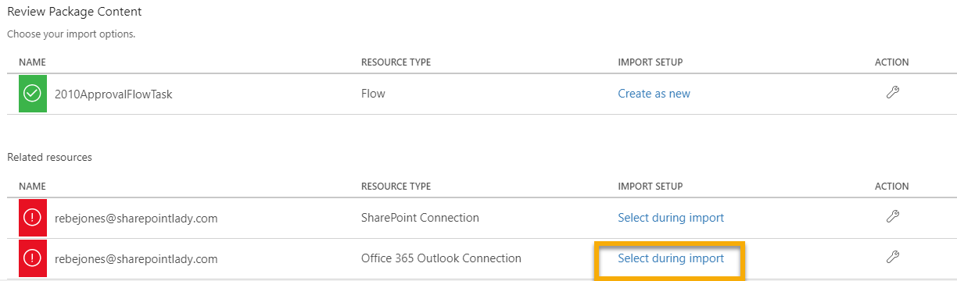
10. Select the correct connection and click the **Save** button.
11. You should now see the **Import Setup** column has the updated account information.  
    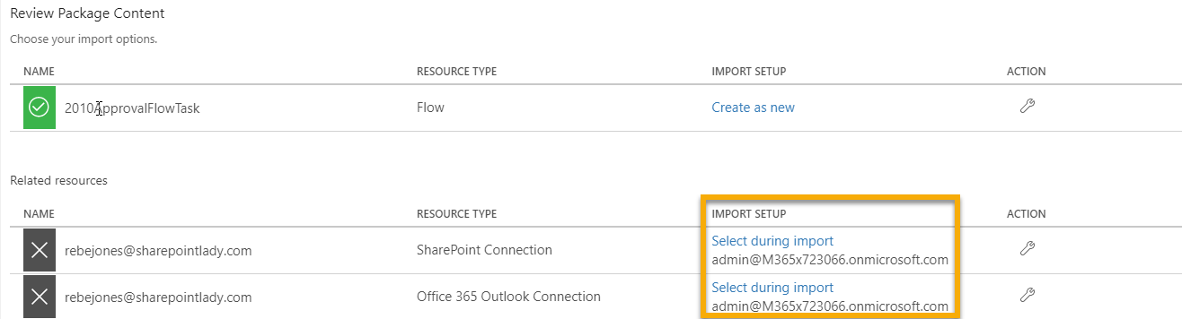
12. Click the **Import** button and do NOT navigate away from the screen until import is complete.  
    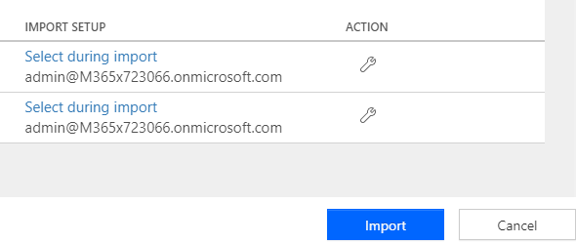
13. Do NOT panic. The status will say **Import failed for one more package resources**. There are some steps we will now take to remediate.  
    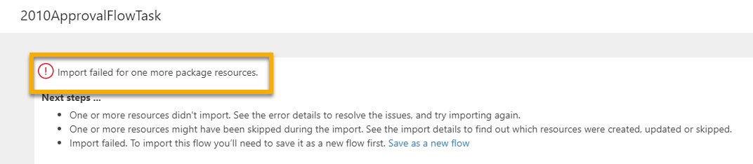
14. Click on **Save as a new flow** link.  
    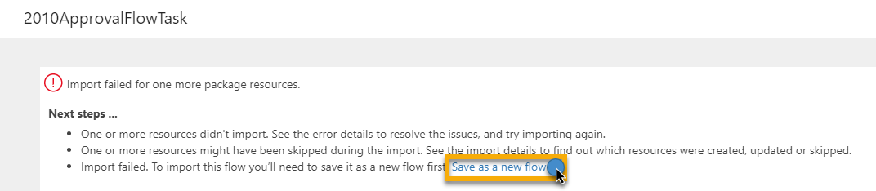
15. This will open a new tab. It will open the flow. We will need to modify the Connections that have the yellow triangle  
    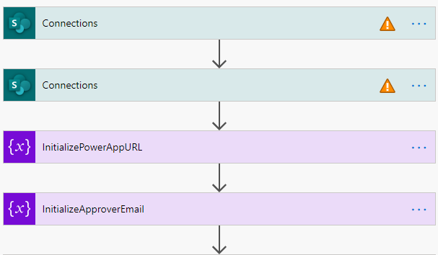
16. Click on the green **Connections** to expand it, and then select an existing connection or create a new one  
    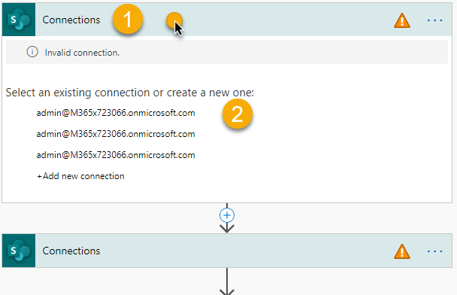
17. We are going to be updating the **Site Address** and then we can select the **Library Name**. Click the **X** in the **Site Address Column** and you can select the site collection if it appears in the list, or if it does not then you would scroll to the bottom of the list and select Enter custom value.  
    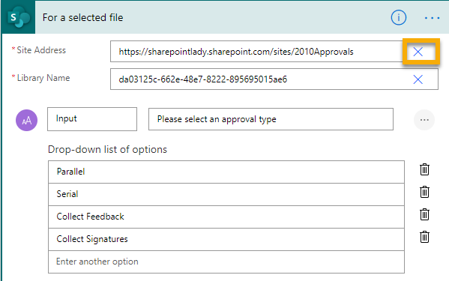
18. I will select my site collection as I can see it appear in the list.  
    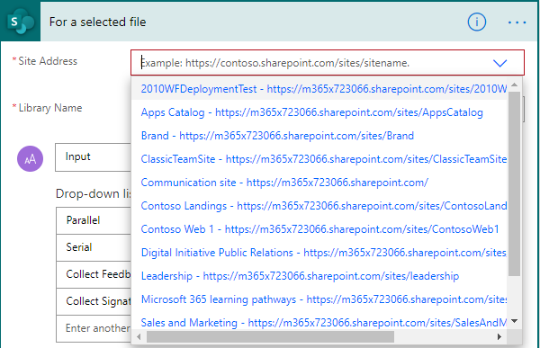
19. I can now see my Site is correctly populated, and I can now click the **X** to select the **Library Name** that I want this Workflow deployed to.  
    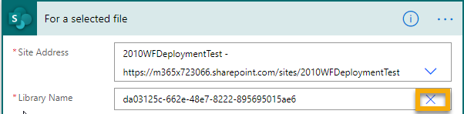
20. I will select the library I want to deploy this to:  
    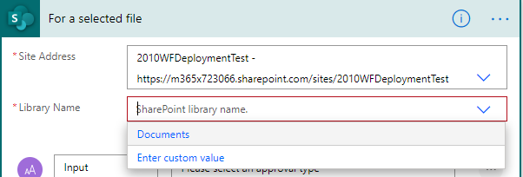
21. Click the Header to collapse that action and we will now move to the next action that still has the yellow triangle.  
    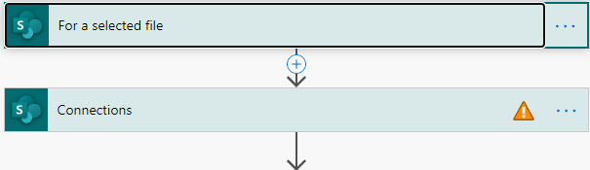
22. Click in the header of the second action with the yellow triangle to expand it.
23. Establish your connection
24. This next steps will be identical to what we had done before where we will need to update the **Site Address**, **Library Name** only. Do NOT modify the Id field. This will be fine.  
    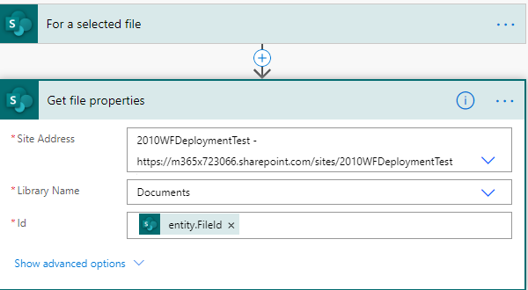
25. Collapse the header again.
26. Notice the yellow triangles are gone. For now just notice the PowerApp URL as we will come back to that at a later step.  
    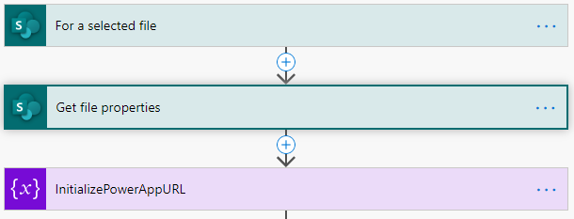
27. Scroll to the bottom of the page and we are going to update the **ApprovalTypeCase** by expanding the header.  
    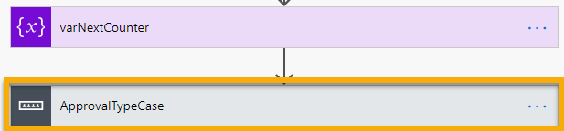
28. When you expand it we’ll start with the Parallel Approval and will be updating the connection, and then updating the **site collection** and then selecting the **Workflow History List**.

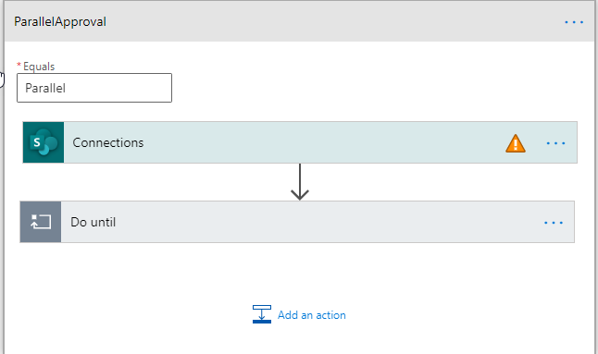

1. 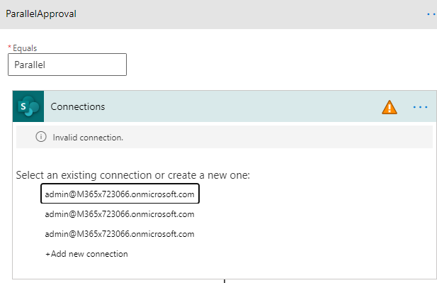
2. 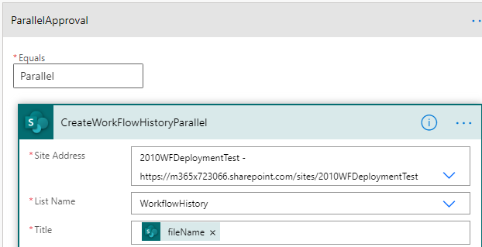
3. Now underneath **Parallel Approval** we will need to modify **Do Until** Connections  
   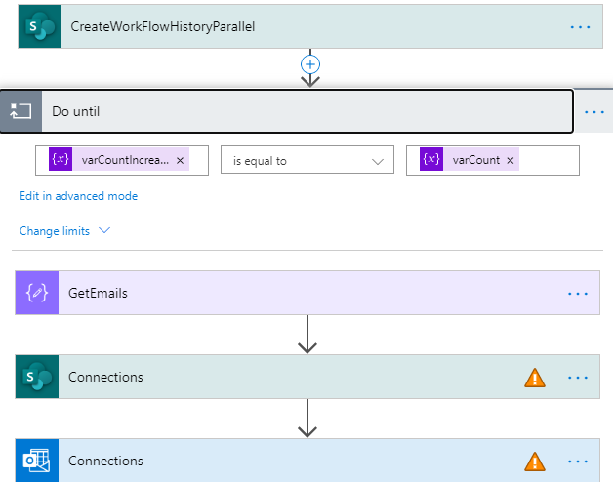
4. Notice this is asking for the **Workflow Task Parallel**, so this time we’ll be updating to the **Workflow Task List**.  
   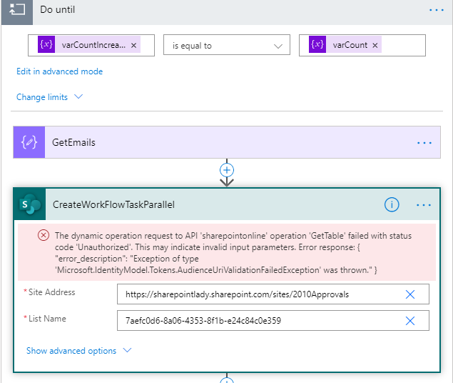
5. 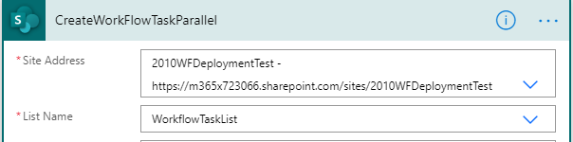
6. Update the connection for the SendParallelTaskEmail by selecting an existing or creating a new connection.  
   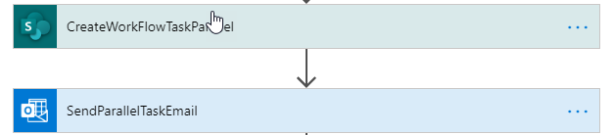
7. Once they have been updated we can now repeat these actions for **Serial Approval**.   
   
8. We will now do the same for **Collect Feedback**  and **Collect Signature**
9. All are updated, but notice in the upper-right there is still a **Flow Checker** error  
   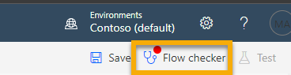
10. The issue is with the Parallel Approval workflow.  
    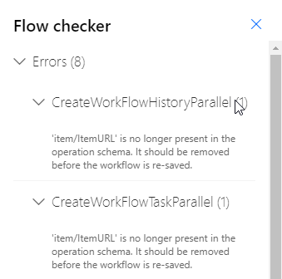
11. The issue is in **item/ItemURL**. We are going to copy the expression to the line above it **ItemURL**.  
    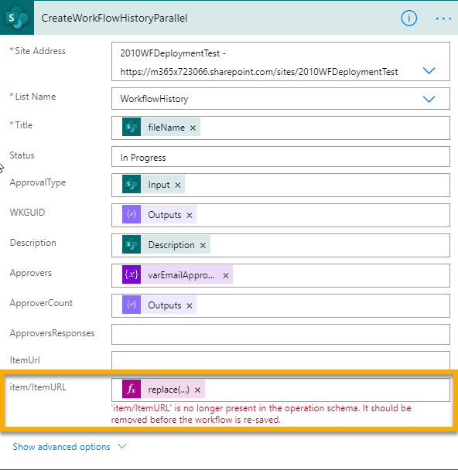
12. Click on the word **replace**. Do NOT click on the x.  
    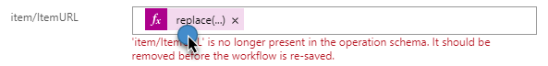
13. Click in the Expression Line and then use the shortcut keys Ctrl+A to select all on that line and then Ctrl+C to copy the data.
14. Click the **ItemURL** line then click **Expression** and then click the function line and use the shortcut keys **Ctrl+V** to paste the function  
    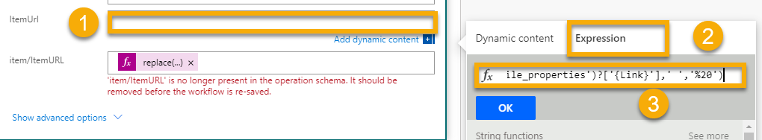
15. Then Click the **OK** button
16. Now you can click the **x** on the **item/ItemURL** line to remove the function from there.  
    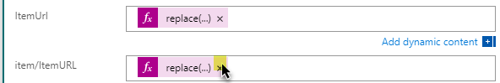
17. This is what it will look like  
    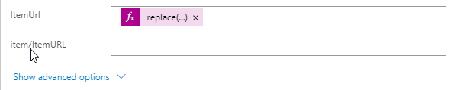
18. Repeat the function replacement for the **CreateWorkFlowHistory** and in the **DoUntil** section for the **CreateWorkflowTask** section for **ParrallelApproval**, **SerialApproval**, **CollectFeedback**, and **CollectSignature**
19. When you have completed this, the **Flow checker** should no longer display errors.  
    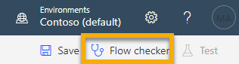
20. Click the **Save** button.  
    
21. **Note: We will come back to this workflow to update **InitializePowerAppURL** section, but before we can update this section of this flow we must deploy the PowerApp.  
    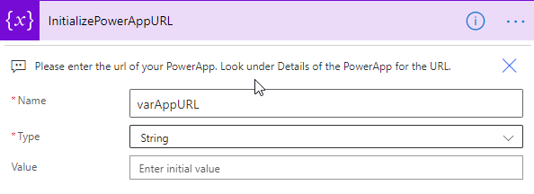

# III. Importing the Collect Feedback Approval Flow

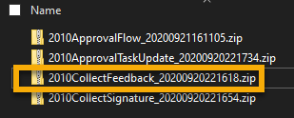

1. In Microsoft Flow click on MyFlows in the left pane of the page
2. In the top center click on the Import button
3. Navigate to the **2010CollectFeedback** Zip File, select, and then click the **Open** button.  
   **Note: Do NOT Navigate away from the screen
4. After upload completes, just like before we will make sure the **Import Setup** column shows **Create as New** for 2010CollectFeedback Flow and then for the **Resource Type** of **SharePoint** **Connection** click no **Select During Import** and select the connection you established before.
5. Click the **Import** button
6. You will see an error when it is done importing just like on the previous Flow. Click on the **Save as new flow** link.  
   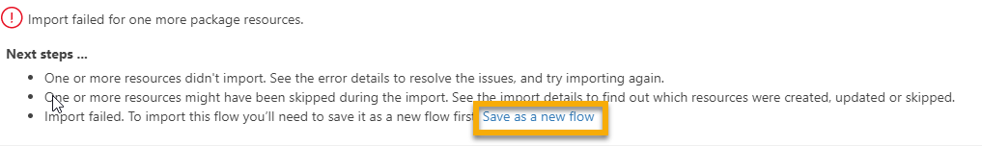
7. Select **varSiteCollectionURL** and we are going to paste in the URL to the site that contains the Workflow History List. To clarify we are supplying the link to the site, not to the actual list.  
   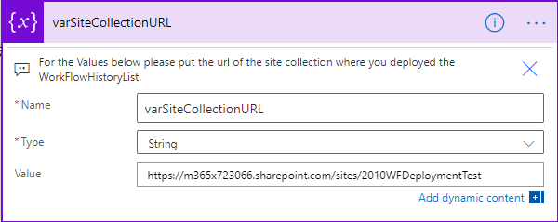
8. Next select **varListName** and the value should be **WorkflowHistory** unless you changed it. **Note: This is case sensitive.  
   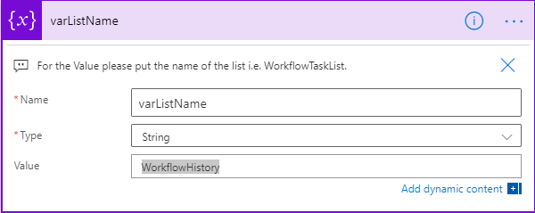
9. Fix the SharePoint connections. The first one we will select the URL of the site and then select the WorkflowTaskList  
   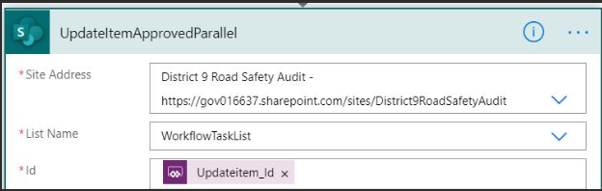
10. Fix the SharePoint connection for the GetWorkFlowHistoryItem. Once we have the connection there should be nothing else to fix for this one.  
    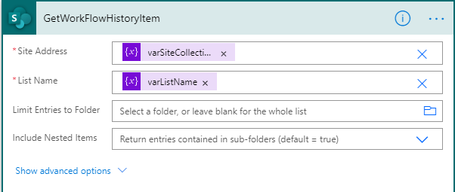
11. Under **UpdateWorkflowHistoryList** we need to fix a connection.  
      
    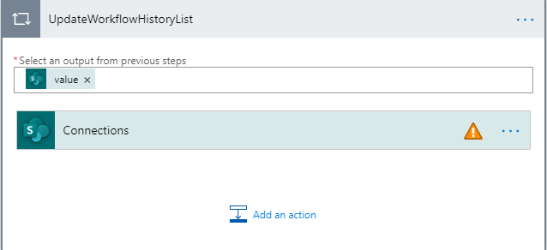
12. After selecting the connection set the Site Address to the site with the WorkFlow History, and then pick the WorkFlowHistoryList.  
    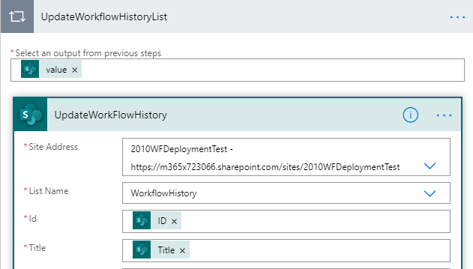
13. Select **CheckApproverCount** and fix the connection here as well as this will **UpdateWorkFlowHistoryComplete**  
    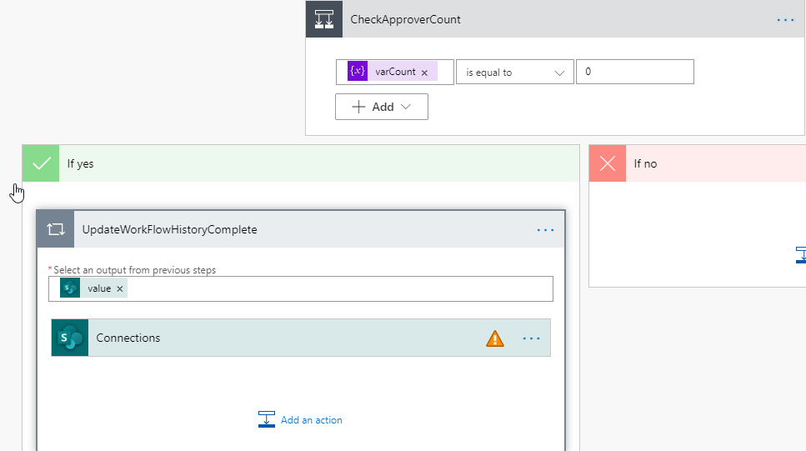
14. Fix the **Site Address** and **List Name** and the list name is the WorkFlowHistory  
    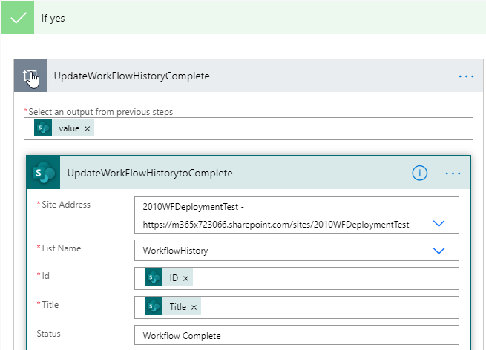
15. There is a Warning in the Flow Checker. This warning is just letting us know that this Flow is connected to a PowerApp and if we change the triggers then we could break the PowerApp.  
    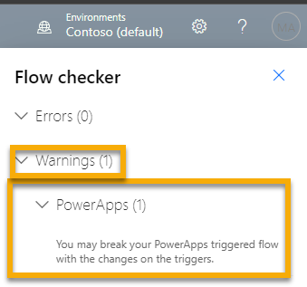
16. Click the **Save** button.
17. This completes the import of the Collect Feedback Flow.

# Import the Collect Signatures Flow

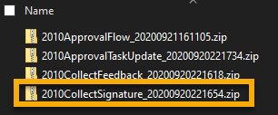

1. In Microsoft Flow click on MyFlows in the left pane of the page
2. In the top center click on the Import button
3. Navigate to the **2010CollectSignature** Zip File, select, and then click the **Open** button.  
   **Note: Do NOT Navigate away from the screen
4. After upload completes, just like before we will make sure the **Import Setup** column shows **Create as New** for 2010CollecctSignature Flow and then for the **Resource Type** of **SharePoint** **Connection** click no **Select During Import** and select the connection you established before.
5. Click the **Import** button
6. You will see an error when it is done importing just like on the previous Flow. Click on the **Save as new flow** link.  
   
7. Just like before we are going to need to fix a few of the connections in the imported Flow  
   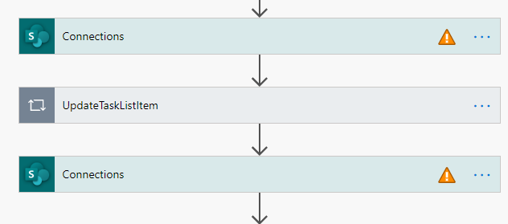
8. For the first SharePoint Connection we are going to update the connection and then supply the Site Address, and the WorkflowTaskList.  
   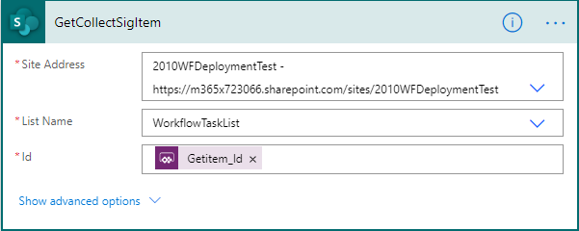
9. Next we will need to fix the UpdateTaskListItem which has 2 connections. The first on   
   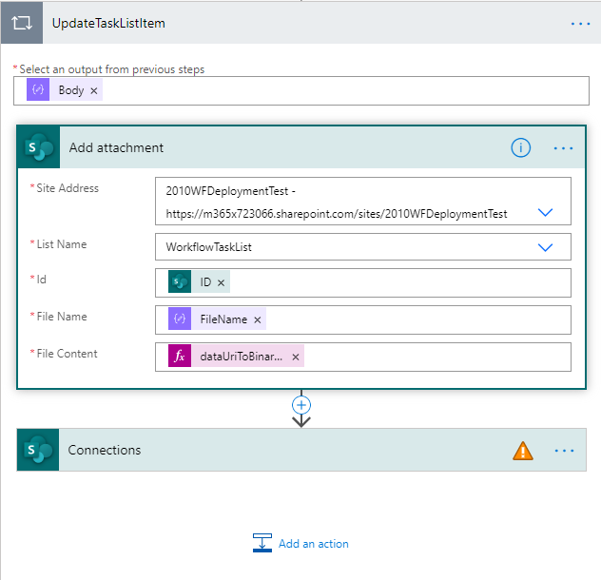
10. For the next Connection in UpdateTaskListItem we again have to supply the Site Address and List Name. This completes the UpdateTaskItem.  
    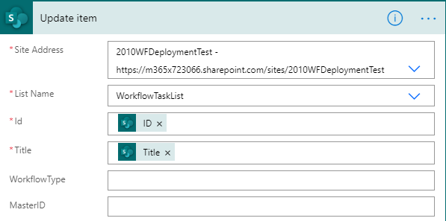
11. We must now update the next connection in the Flow which is GetWorkFlowHistoryItem. We will again supply the correct Site Address, and since this is for the Workflow History we are going to select the Workflow History List.  
    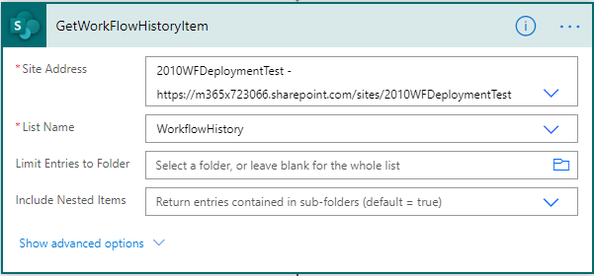
12. Next, we need to Update WorkFlowHistoryItem.  
    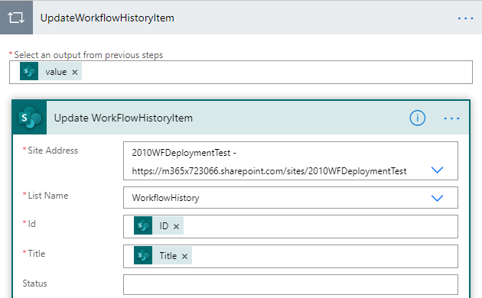
13. Finally, update CheckApproverCount>UpdateWorkFlowHistoryComplete  
    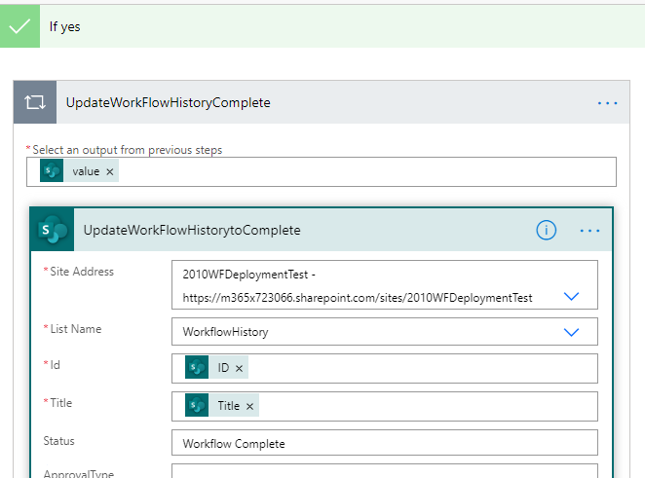
14. You will see a warning in Flow Checker. This is just a warning letting you know that this is triggered by a PowerApp and if you change this Flow it can break the PowerApp.  
    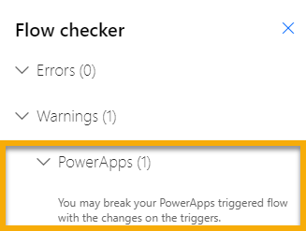
15. Final Step is to click the Save button.
16. This completes the Collect Signature Workflow Import.

# Import and Setup the Approval Task Update Flow

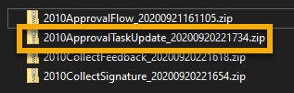

1. In Microsoft Flow click on MyFlows in the left pane of the page
2. In the top center click on the Import button
3. Navigate to the **2010ApprovalTaskUpdate** Zip File, select, and then click the **Open** button.  
   **Note: Do NOT Navigate away from the screen
4. After upload completes, just like before we will make sure the **Import Setup** column shows **Create as New** for 2010ApprvalTaskUpdate Flow and then for the **Resource Type** of **SharePoint** **Connection** click no **Select During Import** and select the connection you established before.
5. Click the **Import** button
6. You will see an error when it is done importing just like on the previous Flow. Click on the **Save as new flow** link.  
   
7. In the Flow update varSiteCollectionURL with the URL of the site collection that contains your WorkflowHistoryList  
   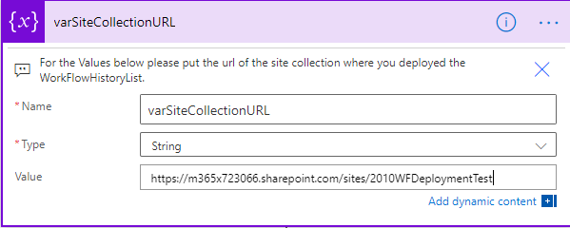
8. Update varListName with the name of the Workflow History list. This is case sensitive  
   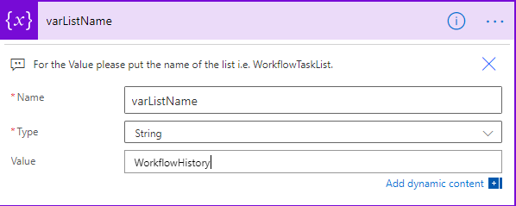
9. Update Switch. This will have connections under Case and Under Default.  
   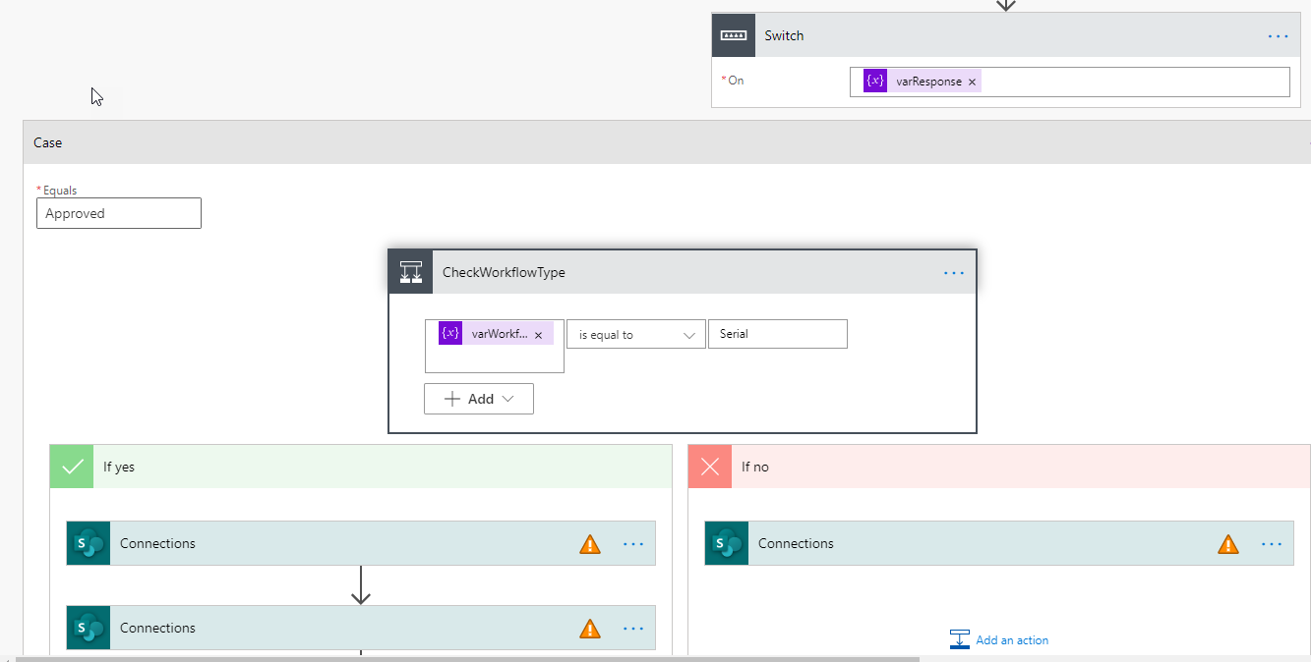
10. Update ItemApprovedSerial with the task list information  
    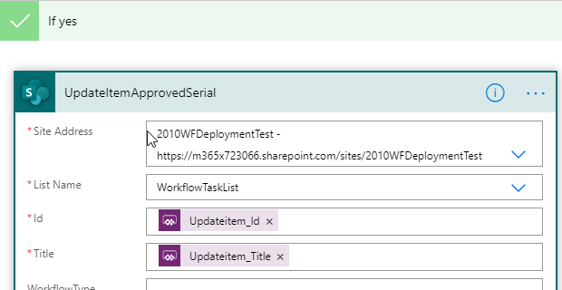
11. Update getNextSerialApprover with the task list information  
    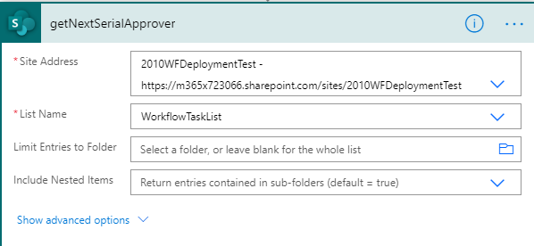
12. Update Condition>If No>Apply to Each>ChangeNextSerialApproverStatus  
    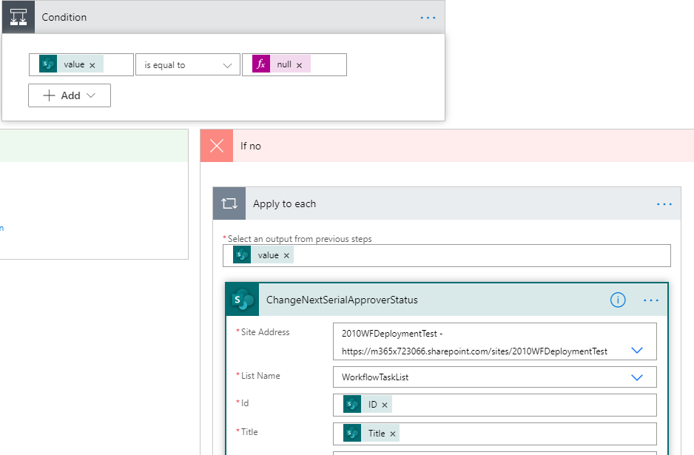
13. Update If No>UpdateItemApprovedParallel   
    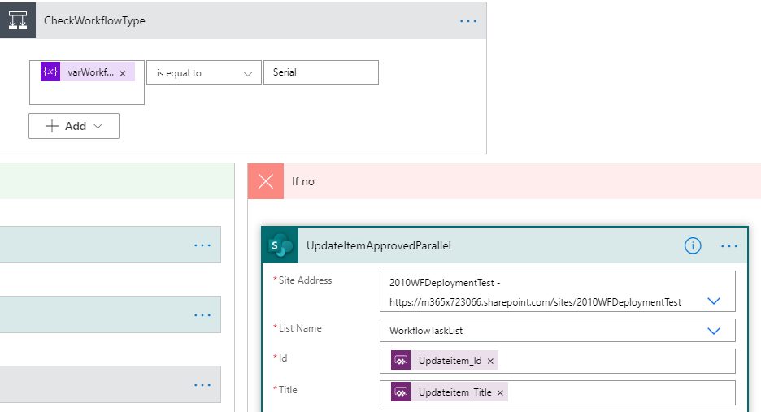
14. That part of the case is done and now we move to the **Default** side.
15. On the Default side you will need to update both the Yes and No side:
    1. UpdateItemSerialReject
    2. UpdateItemParallelReject  
       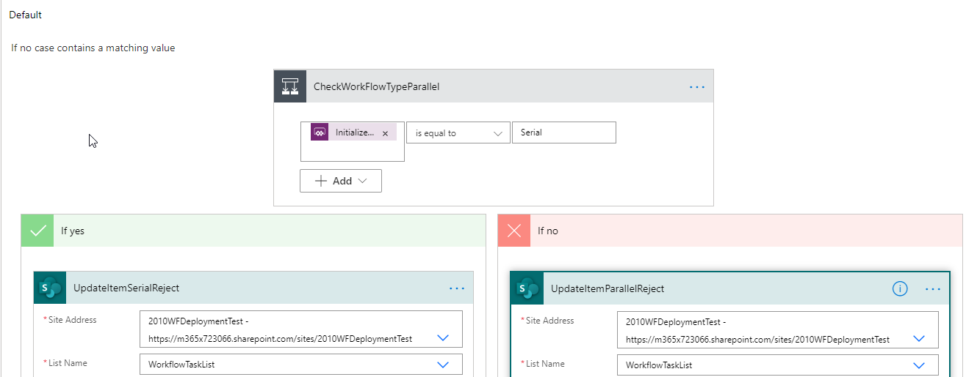
16. Then scroll down to UpdateWoorkflowHistoryList

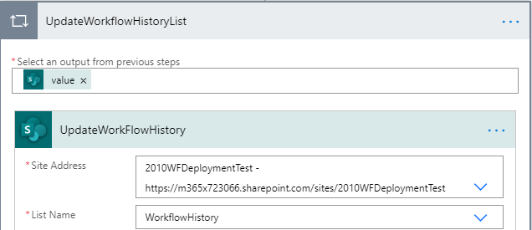

1. Then CheckApproverCount>If Yes>UpdateWorkFlowHistory  
   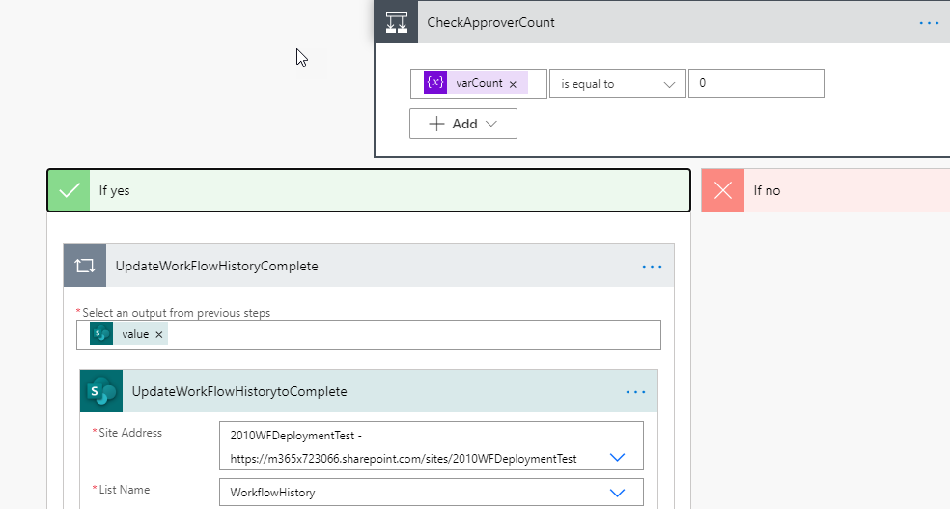
2. Flow Checker will have the PowerApps Warning  
   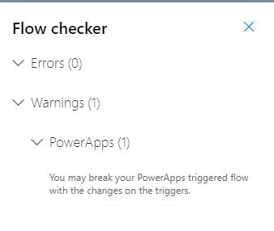
3. Click the Save button.
4. The Flow Checker will go away.
5. You are finished with the Approval Task Update Flow.

You should now see the following in MyFlows:  
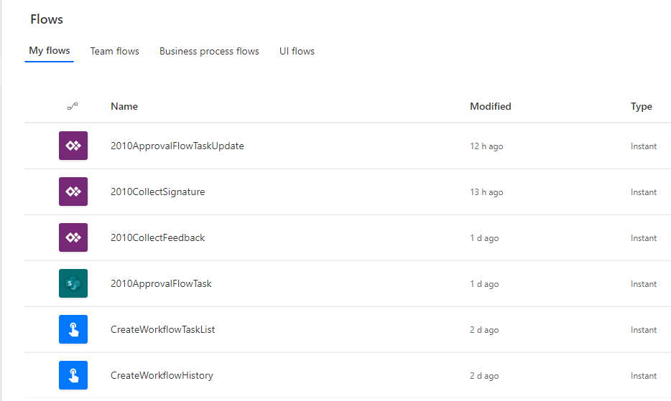

# Import and Setup Power App Used by these Flows

1. Navigate to Power Apps  
   **Note: You may need to sign-in
2. Verify the environment you are in is the correct one by looking in the upper right-hand corner of the page, especially if you have multiple environments. You need to be in the same environment that you created your workflows in.  
   
3. On the left side of the page click on **Apps**. In the top-center of the page click on **New** and then select **Canvas**. As this will be a Canvas app.  
   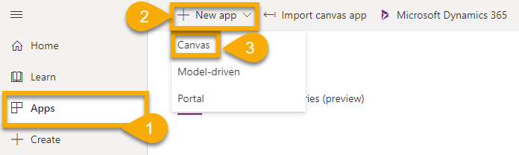
4. Once the Canvas App screen opens click **Open** and then click **Browse**.  
   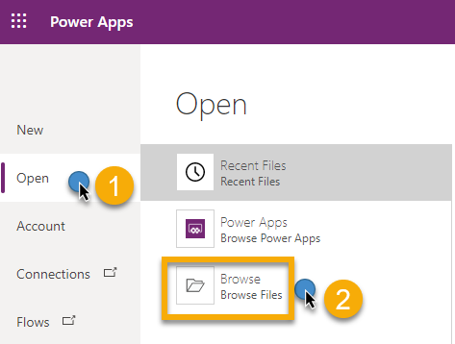
5. We will browse to the location, select **AssignApproval.msapp** and click the **Open** button.  
   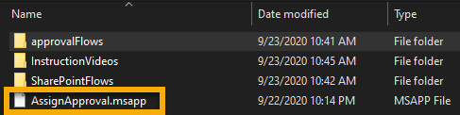
6. You will be asked to verify your permissions for SharePoint. After verifying click the **Allow** button.  
   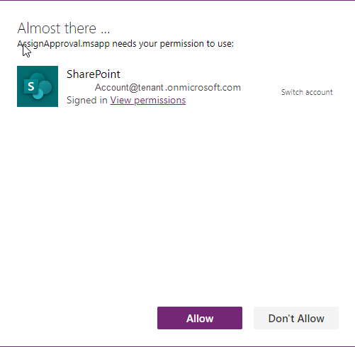
7. Then click on **File** and then **Save**.
8. Select **The cloud** in the Save as area.  
   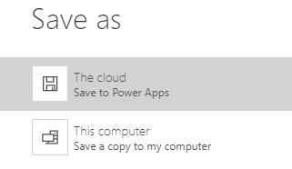
9. Provide a Name for the Power App and then click the **Save** button.  
   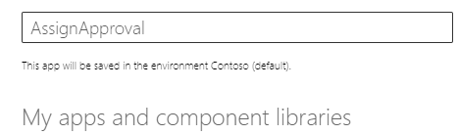
10. When you save it, it also publishes it. After it has saved, click the **Back** arrow.  
    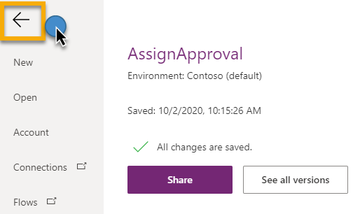
11. Note: Now that it has initially been saved, it will autosave.
12. Open Notepad.exe because it will be necessary to copy and paste some formulas.  
    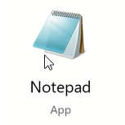
13. In Power Apps if you click on **Data** you will see Flows that are not connected. We are going to need to connect these first.  
    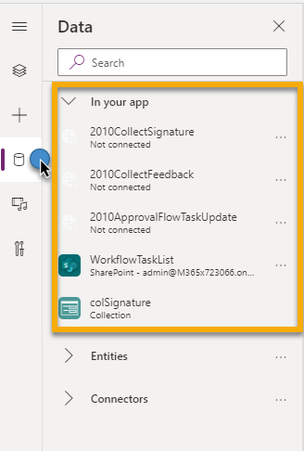
14. **Click** the **ellipses** next to **2010ApprovalFlowTaskUpdate** and then click **Remove**.  
    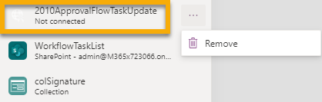
15. **C lick** the **ellipses** next to **2010CollectSignature** and then click **Remove**.  
    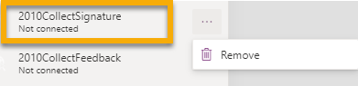
16. **Click** the **ellipses** next to **2010CollectFeedback** and then click **Remove**.  
    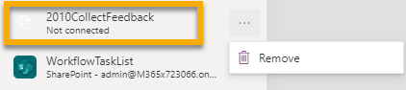
17. **Click** the **ellipses** next to **WorkflowTaskList** and then click **Remove**.  
    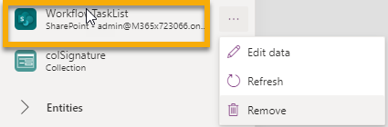
18. In the Data panel search for “SharePoint”, select the SharePoint icon, and then select your connection.  
    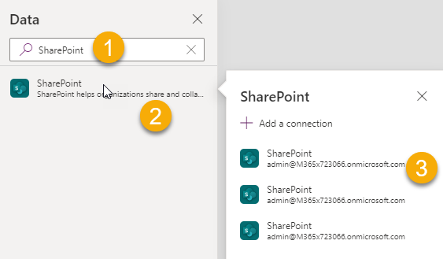
19. This will open the Connect to a SharePoint site panel on the right-hand side of the page. And you can select your site collection or you can past the URL in the top box and click the Connect button.  
    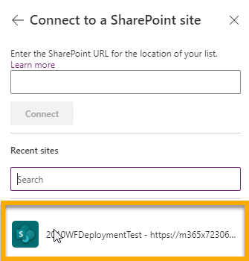
20. **Select** the **WorkflowTaskList** and then click the Connect button at the bottom of the panel.  
    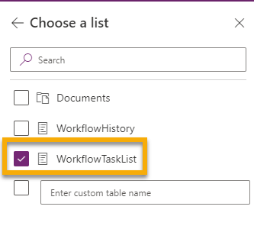
21. Note that the Red X’s are vanishing as we correct the App  
    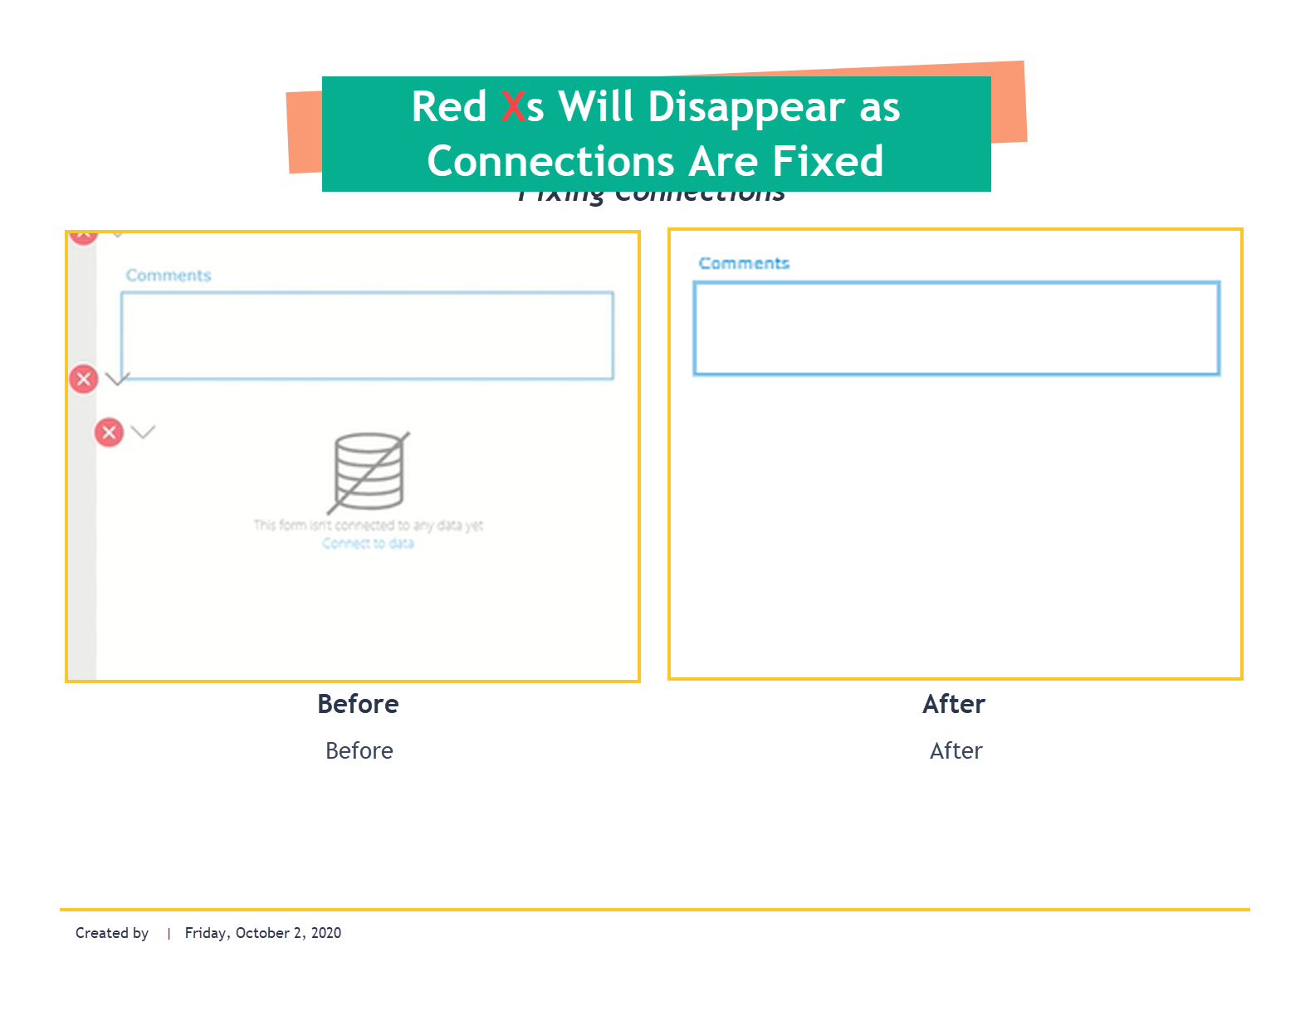
22. Click on the **Tree View** icon on the left and then we are going to start with **scParallelSerial**  
    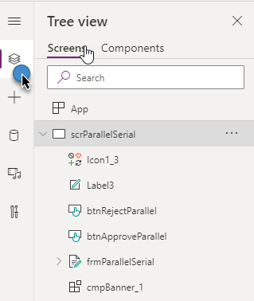
23. Click on the **Approve** button in the center and then notice that we are **OnSelect** and notice there is a **Formula**.  
    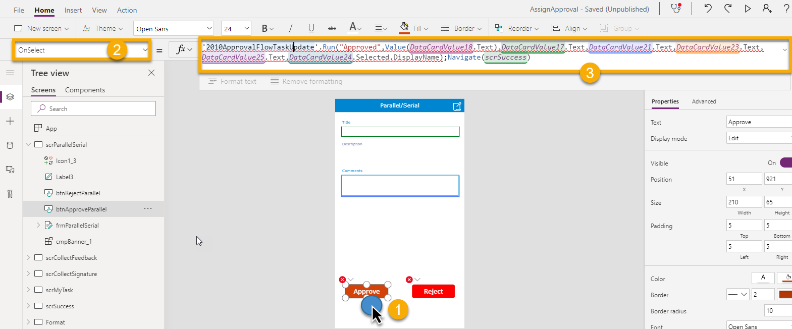
24. **Click** in the formula window, then **Ctrl+A** to select the whole formula, **Ctrl+C**  to copy the formula, then go to Notepad and paste the formula **Ctrl+V** into **Notepad**.
25. In the Power Apps formula bar, clear everything.  
    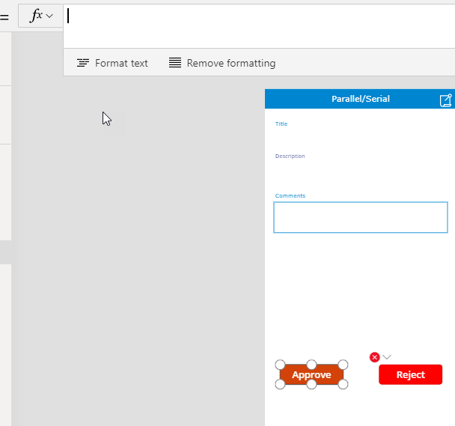
26. Keep the **Approve button** selected, go to the top tool menu and click **Action**, and then click on **Power Automate** in the ribbon.  
    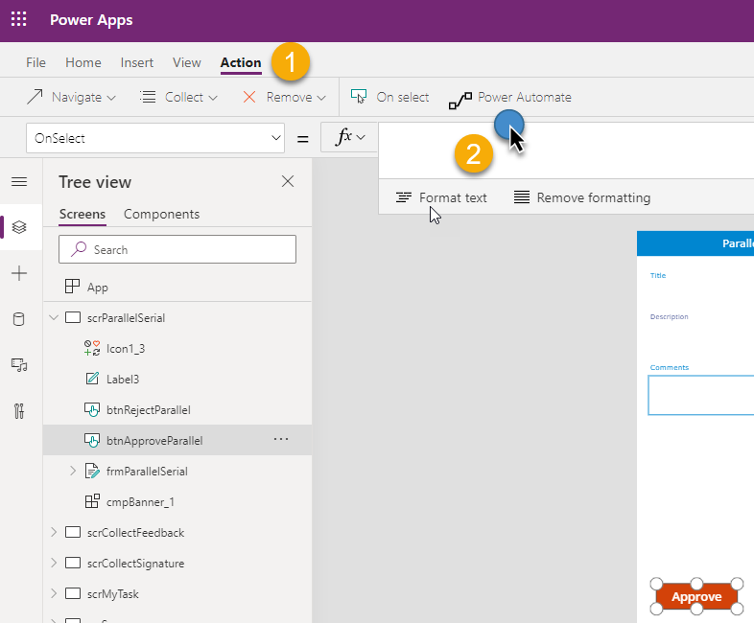
27. Select the **2010ApprovalTaskUpdate Flow**.   
    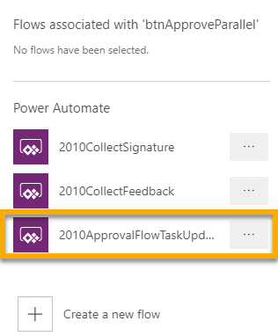
28. Once it is finished adding, it can be seen in the formula bar  
    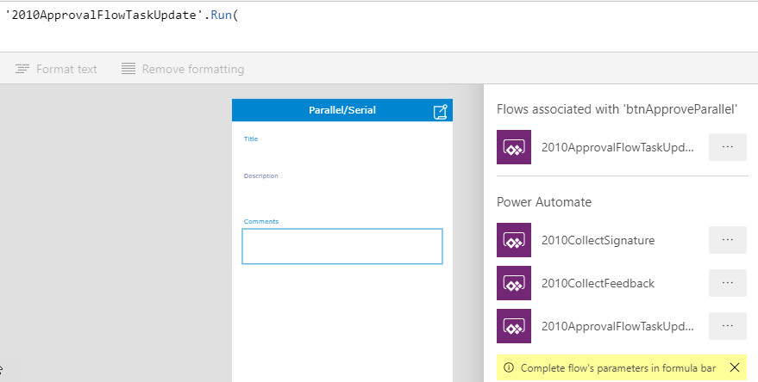
29. If you changed the name of the Workflow then you should keep everything up to the .Run( If you kept the name of the Workflow then you can copy the formula pasted into Notepad earlier and now we will copy it back into the formula bar.  
    
30. We will now have to check our Data Cards. Start with Data Card 18. Before we begin it is easier to do some setup. This form is our **frmParallelSerial**, so if you expand the form this will be easier to follow as we move through the formula. In the **Tree View pane** expand **frmParallelSerial**.  
    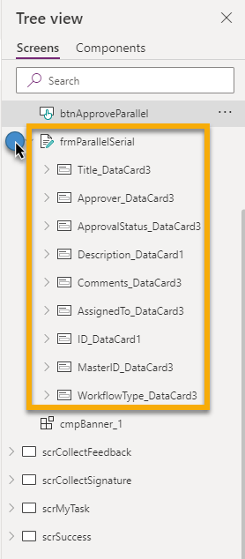
31. 1. Approve button is selected  
    2. Since DataCard18Value click on Value  
    3. Run Condition is Updateitem)ID  
    4. ID_DataCard1 is in the Tree View and we will need to expand this to check Data Card 18  
    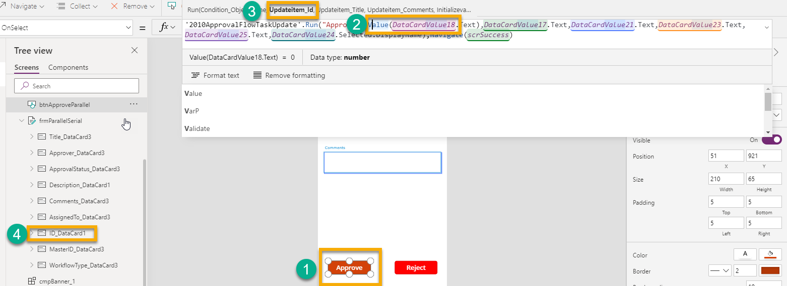
32. When we expand **ID_DataCard1** in **Tree View** we can see **DataCardValue18** which shows this is correct and nothing needs to be changed.  
    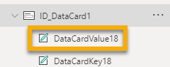
33. Repeat for the other Data Card Values in the formula. This is just for verification. If everything was done correctly to this point all the Data Cards should be fine and should not need to be changed.
34. As a safety precaution we repeat the process to verify the **Reject** button. And since they use the same form everything should be good.

## Power App Fixing the Submit Feedback Button

1. In the **Tree View** select **srcCollectFeedback** and you will see the **Collect Feedback** form in the center of the page. Notice the **Submit Feedback** button needs some attention because of the red X.  
   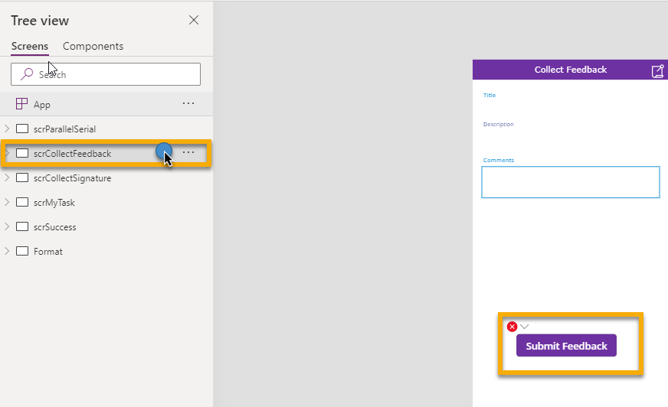
2. Select the Submit Feedback button and copy the formula in the formula bar to Notepad.  
   
3. Once you have copied it to Notepad, then we can **delete the formula** in the Formula Bar.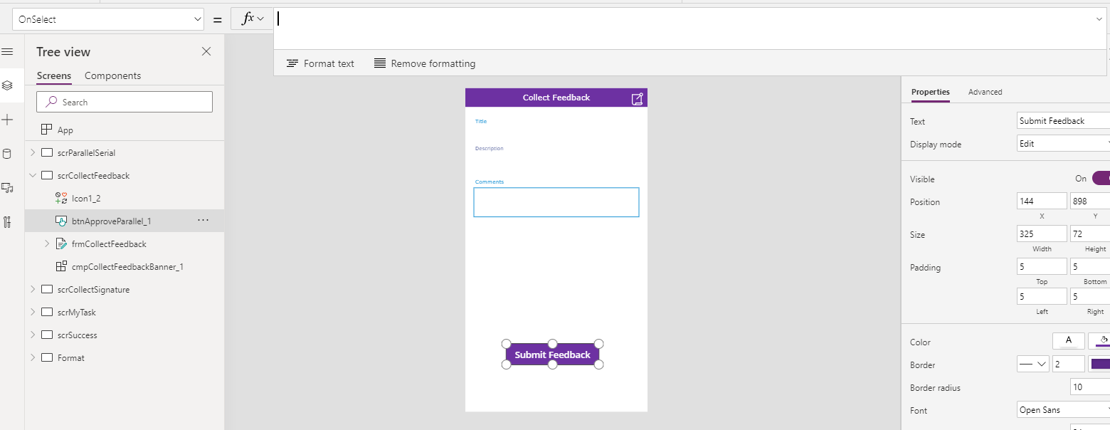
4. With the Submit Feeback button selected, click **Action**, then click **Power Automate**, and then **Select 2010CollectFeedback**.  
   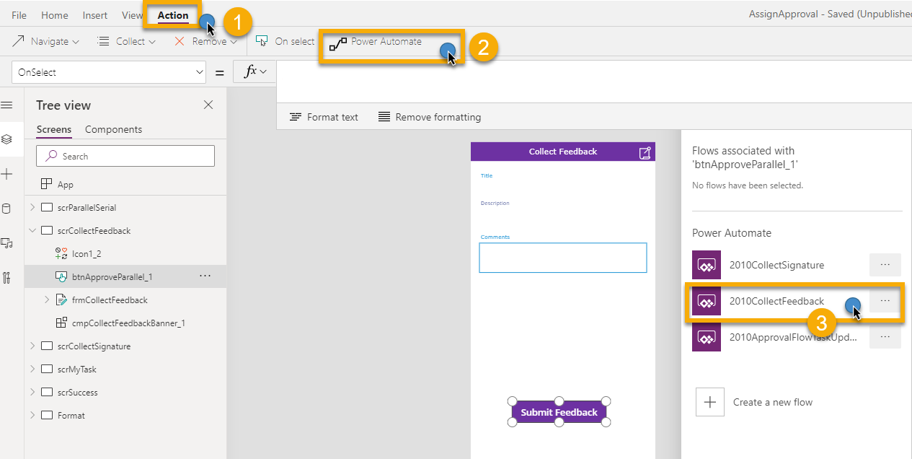
5. Once it is added it will look like this.  
   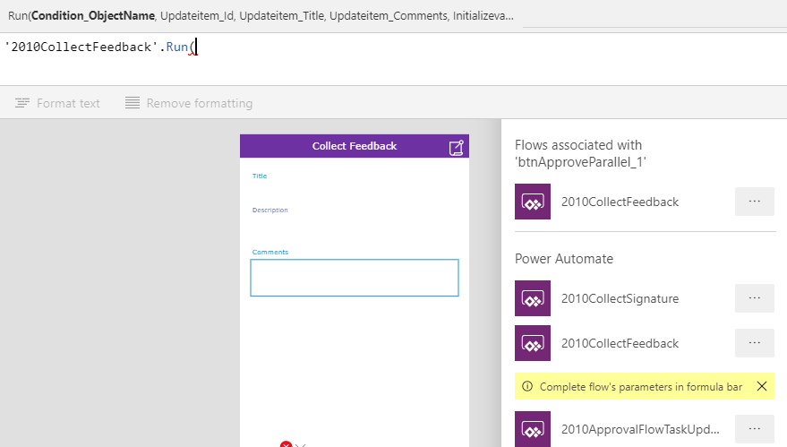
6. Go to Notepad, copy the formula you had pasted into Notepad for Collect Feedback, and then paste it back into the Formula Bar.  
   

## Fixing the Collect Signature Submit Button

1. In Tree View select srcCollectSignature.
2. In the center of the screen click on the Submit button.
3. Copy the Formula to Notepad  
   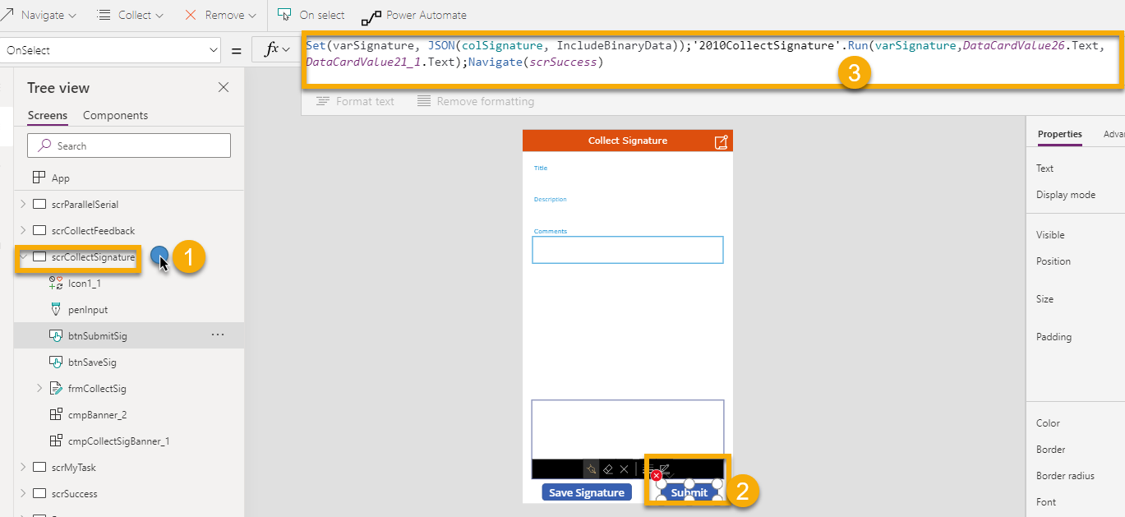
4. With the Submit button selected click **Action**, then click **Power Automate**, then click **2010CollectSignature**.  
   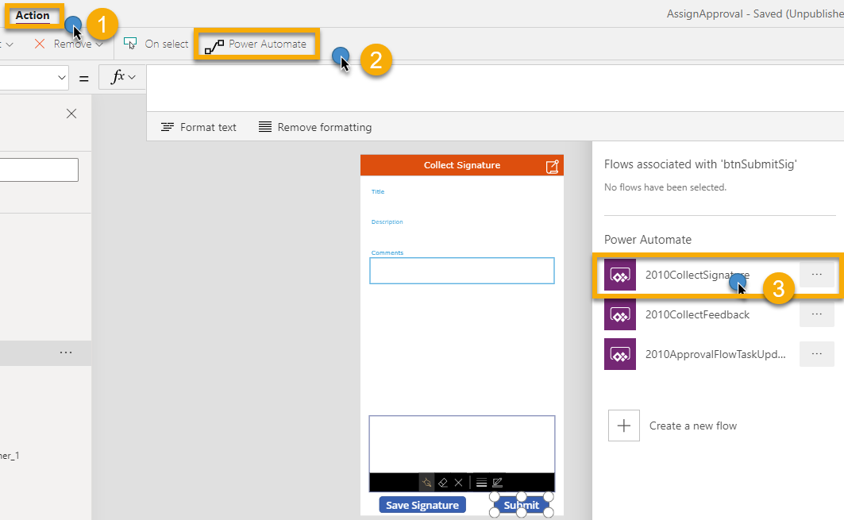
5. After it is added, then you can copy the formula for Collect Signature back to the Formula Bar.  
   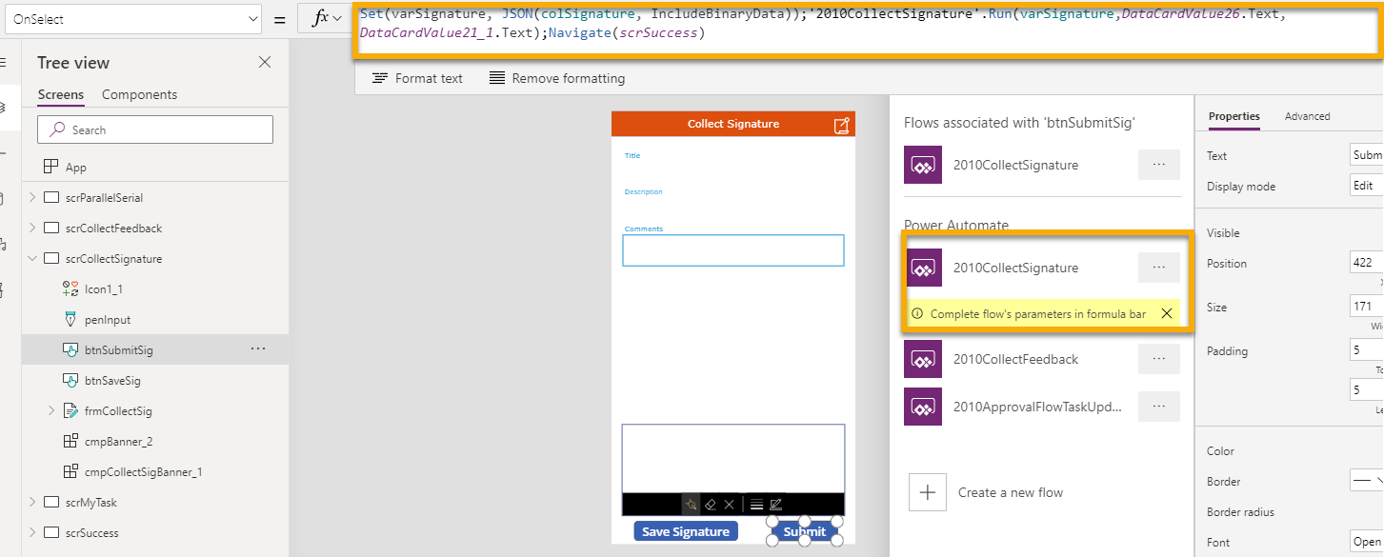
6. File **Save**.
7. Click the **Publish** button.
8. This concludes importing and setting up the Power App.

# Workflow Task List Column Formatting

The column formatting is going to allow the users to click from their workflow task item and open up the Power App so they can approve or reject their task.

1. Open Power Apps and Click on Apps
2. Verify you are in the correct environment.
3. Click the ellipses next to your app.
4. Click on Details in the menu.  
   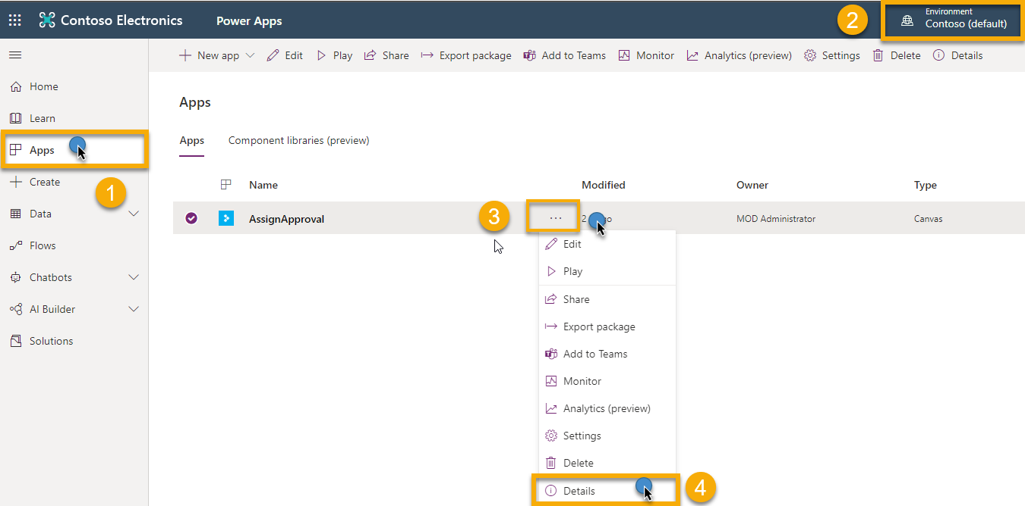
5. Copy the Web Link on the Details page.  
   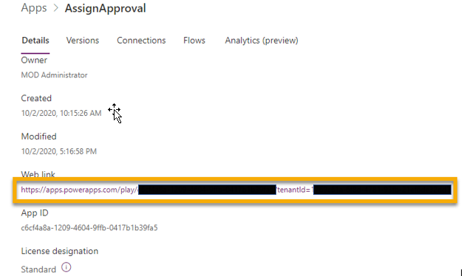
6. Browse to the solutions folder on your device that contains the template files and look for the file **columnFormatting.txt**.  
   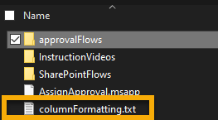
7. Open the file in Notepad. Look for the word PowerAPPURL.   
   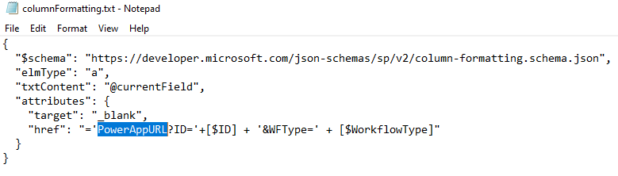
8. We are going to replace this with the URL of the Power App that we recorded in Step 5.  
   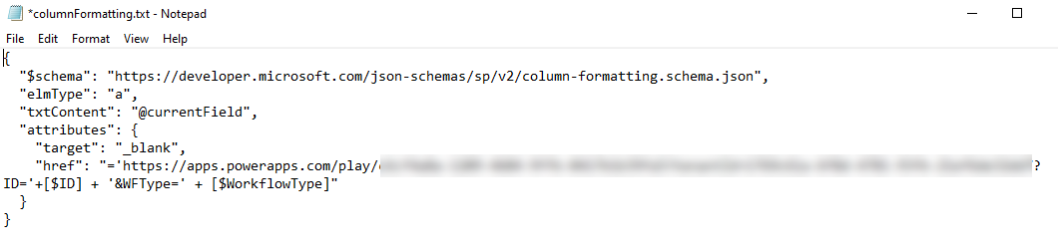
9. Now Copy the entire contents of this file.
10. Navigate to the Workflow Task List in SharePoint and select the dropdown on the WorkflowType Column.  
    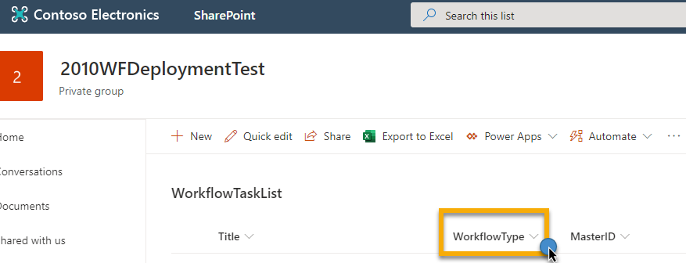
11. Click the dropdown for WorkflowType. Then Column settings. Then click Format this column.  
    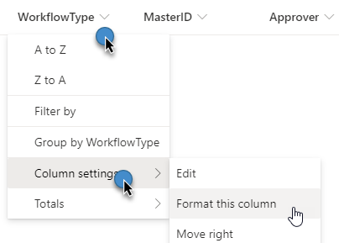
12. Click on Advanced Mode.  
    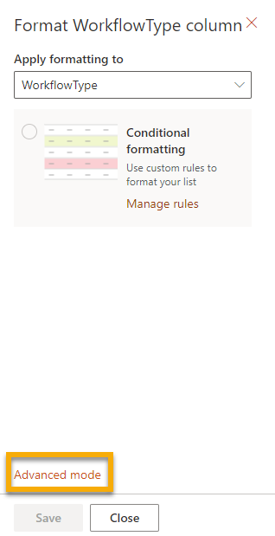
13. In advanced Mode we can **paste** in the JSON formatting copied from the **columnFormatting.txt** file, and then click the **Save** button.  
    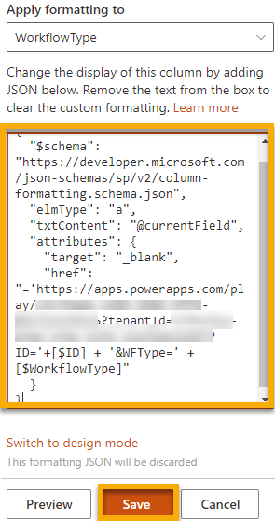
14. Now when a new item comes up, this column will be clickable for the users allowing them to click on their task and open the Power App.

# Adding the Power App Link to the Flow

1. Open Power Apps and Click on Apps
2. Verify you are in the correct environment.
3. Click the ellipses next to your app.
4. Click on Details in the menu.  
   
5. Copy the Web Link on the Details page.  
   
6. Open Power Automate. Then Click on My flows. Then look at 2010ApprovalFlowTask, and click Edit.  
   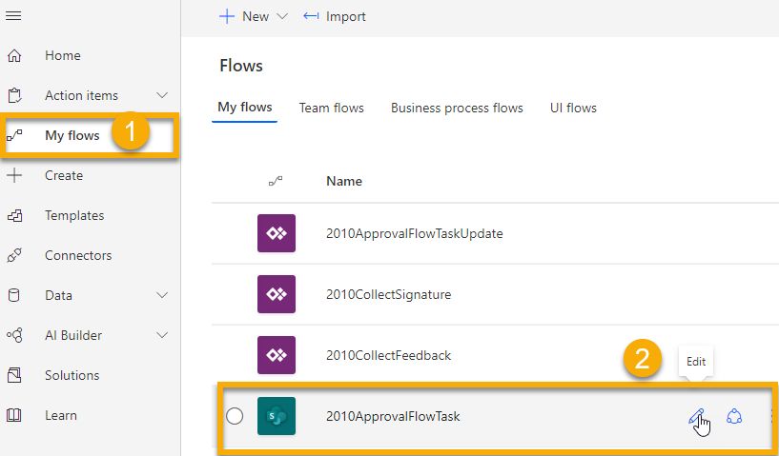
7. When the Flow opens click on InitializePowerAppURL, and paste the URL to your Power App in the Value window.  
   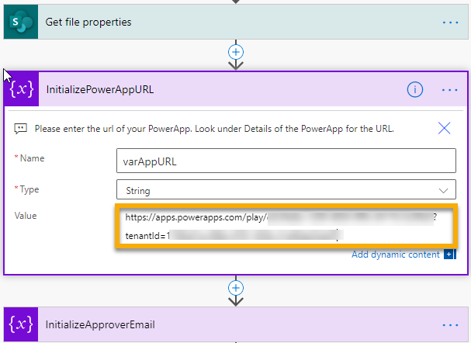
8. Then click the **Save** button.

# Ending Notes:

You have successfully deployed these sample Power Platform solutions that replicate the SharePoint 2010 Out of the Box Workflows. It is important to note again that these are not a direct replacement for the SharePoint 2010 Out of the Box Workflows. These are intended as a starting point to help you get started with Power Platform as SharePoint 2010 Workflows are being deprecated in M365 starting November 1, 2020.

Hopefully, now that you have become more familiar with Power Platform you can see how much more powerful it is, offering a wealth of features that could not be accomplished with the 2010 Workflows. We hope these will help your company with this transition and that they will be a conversation and idea starter to further develop these Flows to meet your organization’s needs.

Please work with your Microsoft Account Team so we can partner together to achieve your business goals.