Plotting Moderately Large Data
This article is about something a bit different from the previous ones. In this one, we will be seeing how to plot moderately large data.
Whenever we plot data in a scatter plot, the idea is to identify structure in the plot, i.e. the relationship between the variables plotted on the X and Y variables. But as data set size grows, scatter plots get overwhelmed to the extent that it becomes impossible to see any structure in it. Finally, I will show two distinct ways to modify the usual scatter plot for big data.
Lets Begin!
#R #Rstats #transform #transparency #hexagon #hexbin #datascience #statistics #graphs #plotting #data
For this exercise, we will work with the diamonds dataset. This dataset comes with the ggplot2 package and has 10 variables on 53,940 diamonds. Of these 10 variables, we will be using 2: price which is the price of the diamond in US dollars, and carat, which is the diamond’s weight.
First we need to install some required packages, load them and load up our data.
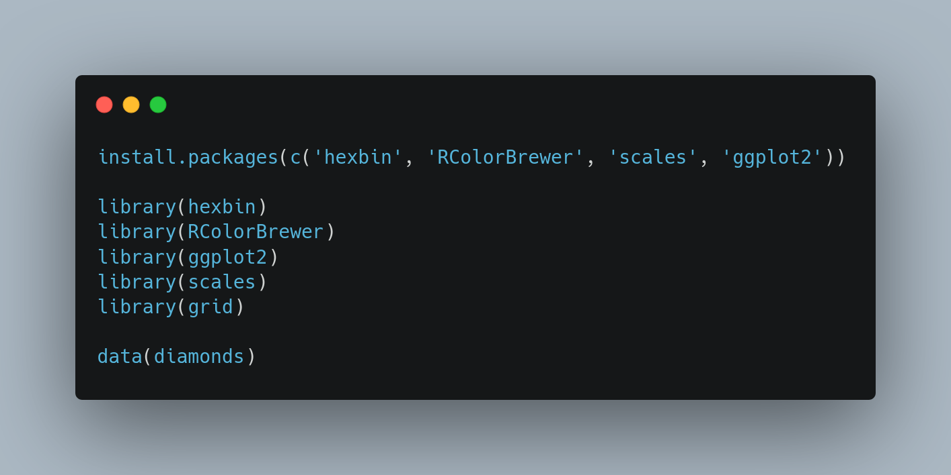
Lets start with a basic plot.
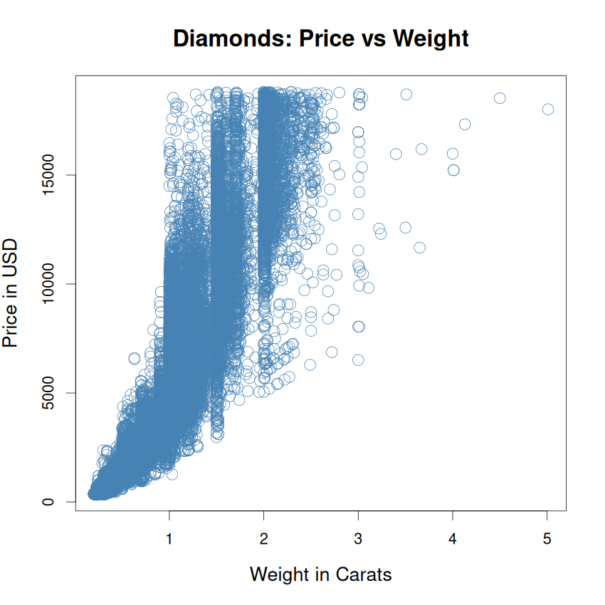
Whoa – that graph’s just … ink. There is some increasing relationship between the two variables, but that’s just about it. We can see very little beyond that.
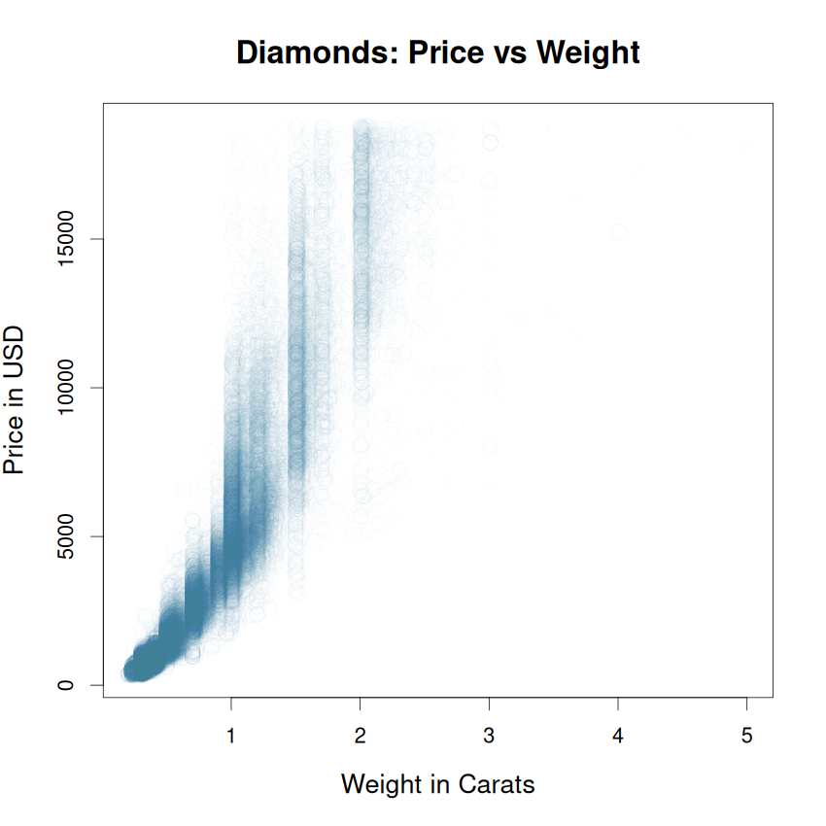
The first, and more primitive way to deal with this is to add a little bit of transparency to our points. This is the resulting plot.
There are two problems with this plot:
- Where the points are dense, like in the lower left, we are still seeing smudging.
- Where the points are sparse, transparency has made them almost invisible.
The second way, and more sophisticated way to deal with this kind of over plotting is to use hexagonal binning. Think of it as a 2-dimensional histogram, where each cell (equivalent bar to usual 1-D histogram) is colored according to the number of points that fall in that cell. We could use rectangular cell, but hexagons have some optimal space-filling properties (think honeybees).
An actual plot will be instructive.
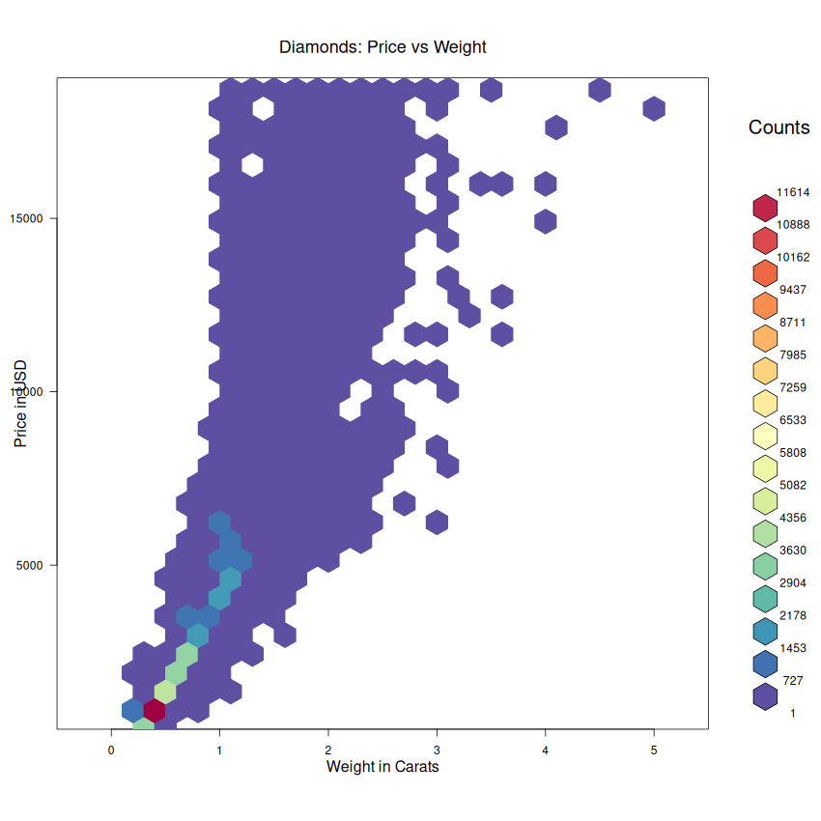
Now we’re talking!
I have intentionally used a dark color scheme to generate this plot. Putting the information in the plot and the legend alongside together, it is easy to see that most of the area in our plot is almost blank. The darkest blue is the lowest bin (from the legend) and the same color is all over our plot.
Does this suggest something? From our previous learning, when we have skewed data like this, a log or square root transform is often helpful in getting a more even spread of the data and in uncovering relationships.
See, we are already learning from our data – all thanks to hexbin!
Lets now generate the same plot, with the X (weight) and Y-axis (price) being log transformed. [I have changed the color scheme now. The initial plot was meant to highlight the blank spaces. This and subsequent plots lay emphasis on the higher density regions].
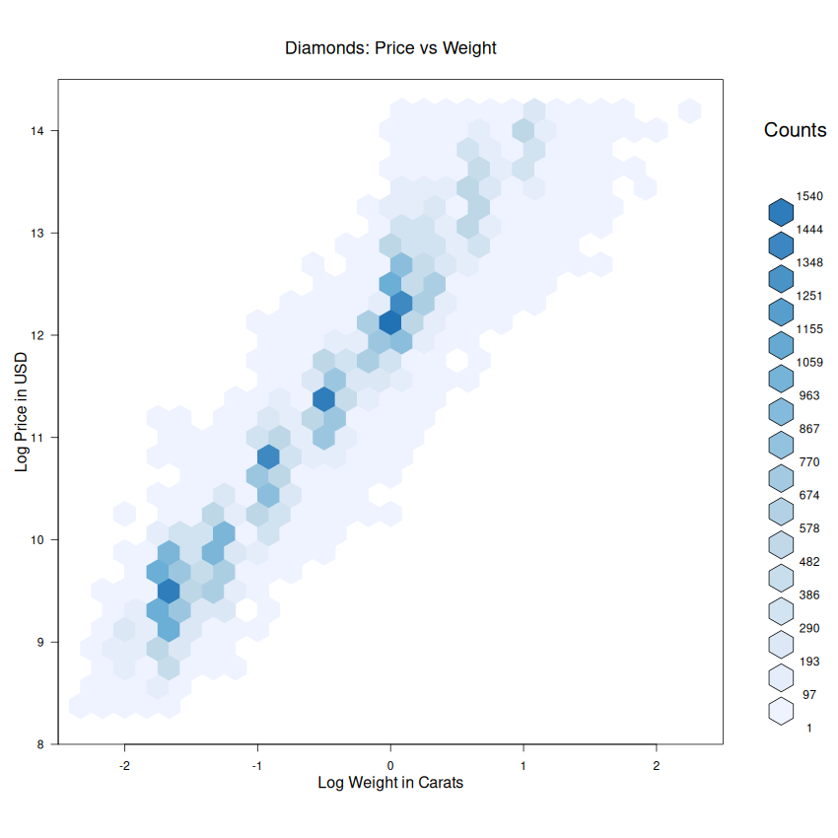

We can see that there is nearly a straight line relationship between the two logged quantities. If we look at it more closely, another structure is visible as well: there are certain carats that have more density - see the vertical slots with higher densities, with vertical spaces between them. Its probably because diamonds are cut to round figures.
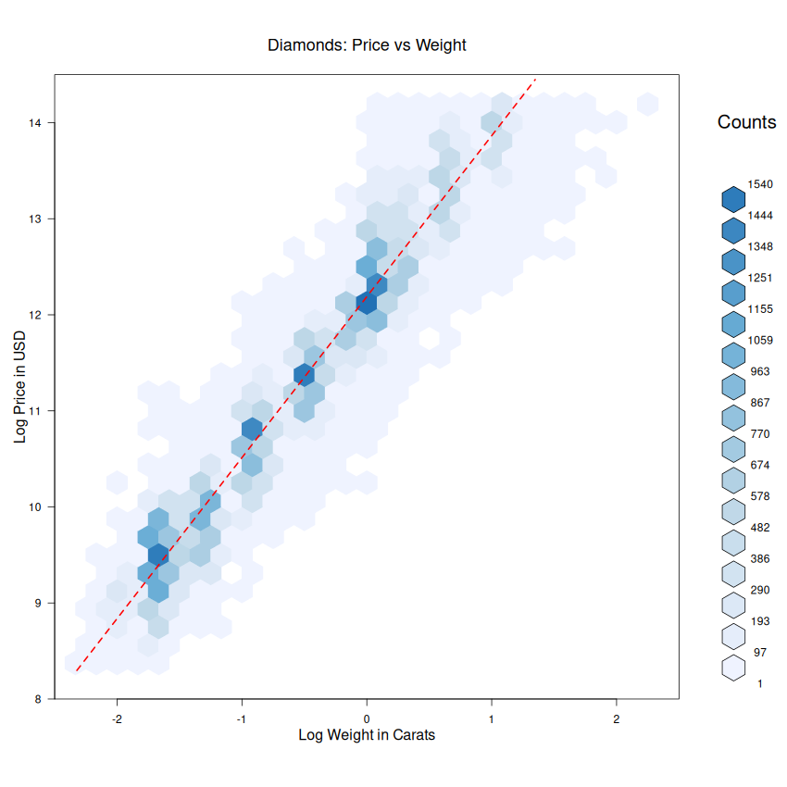
Finally, let me add an OLS to trace out the relationship.
Isn’t it just beautiful?
That’s all folks!

