An Introduction to the Bootstrap
The phrase "pull oneself up by one's bootstraps" was used to describe an absurd, impossible task, often referencing the story of Baron Munchausen who lifted himself out of a swamp by pulling on his own bootstraps. See the image above for Google Gemini’s impression of the same.
Over time, the meaning shifted, and it now refers to achieving something difficult through one's own resources and efforts, as in bootstrapping a business.
In Statistics, the term “bootstrap” was introduced by the great statistician Bradley Efron. It refers to a specific technique that allows us to estimate interval estimates of population parameters – that too, almost for free. The only thing required is some computational power.
Before we go on to understand the bootstrap, Lets first understand some key terms.
1️⃣The first key term is “statistic”. A statistic is any function that can be computed from the sample values alone. Examples of statistic are the sample mean, and the sample standard deviation.
2️⃣The second key term is “interval estimate”. From the NIST Engineering Statistics Handbook:
Confidence limits for the mean are an interval estimate for the mean. Interval estimates are often desirable because the estimate of the mean varies from sample to sample. Instead of a single estimate for the mean, a confidence interval generates a lower and upper limit for the mean. The interval estimate gives an indication of how much uncertainty there is in our estimate of the true mean. The narrower the interval, the more precise is our estimate.
3️⃣The third thing we need to understand is the concept of “sampling distribution”. From Google Gemini,
A sampling distribution is probability distribution of a statistic (like the mean or standard deviation) that is calculated from multiple random samples of a population. It describes the variability of a statistic across different samples and is crucial for making inferences about the population.
Now lets see how these things fit together.
👉 We start from collecting some data – this becomes our sample.
👉 We compute the quantity of interest – this becomes our statistic.
👉 Next, we want to describe how our statistic varies across samples (the sampling distribution)
👉 In essence, we have drawn only 1 sample, but we want to describe the variability of our statistic across multiple samples
👉 This is a chicken and egg problem – having drawn only one sample, how can we describe variability across multiple samples?
This is where the bootstrap of Efron steps in. It is a very simple algorithm.
💡 Draw a sub-sample of the same size from the original sample
💡 This sub-sample is drawn with replacement, so some values may repeat in the sub-sample
💡 Compute the statistic of interest from this sub-sample
💡Repeat the above 3 steps R (a big number, say 100 – 500) times
💡The distribution of the ‘R’ statistic values thus computed approximate the sampling distribution
In essence, we drew just a single sample, but from this single sample, we have obtained the distribution of the statistic across multiple samples. Amazing isn’t it?
Lets now take a practical example. We shall use the Cars93 dataset from the MASS package. This is data about 93 Cars that were being sold in the US Market in the year 1993.
R has built in capability for bootstrapping via the boot package that ships with the basic R install.
The following code sets you up.
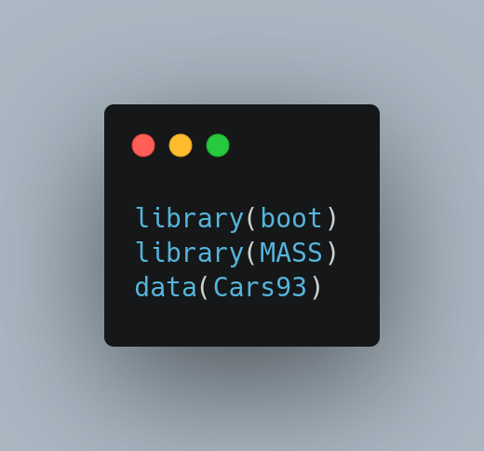

Let concentrate on the mileage variable: Miles per gallon (city): MPG.city. Lets start from a histogram.
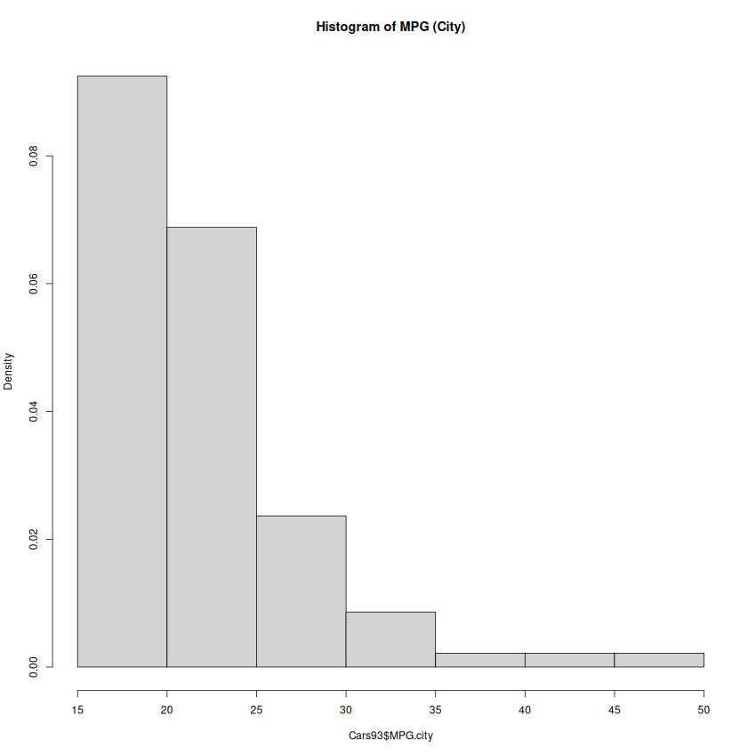

We can see that the distribution is quite skewed. With such a skewed distribution, our traditional confidence intervals are questionable. Nevertheless, lets start from a traditional t-based confidence interval.

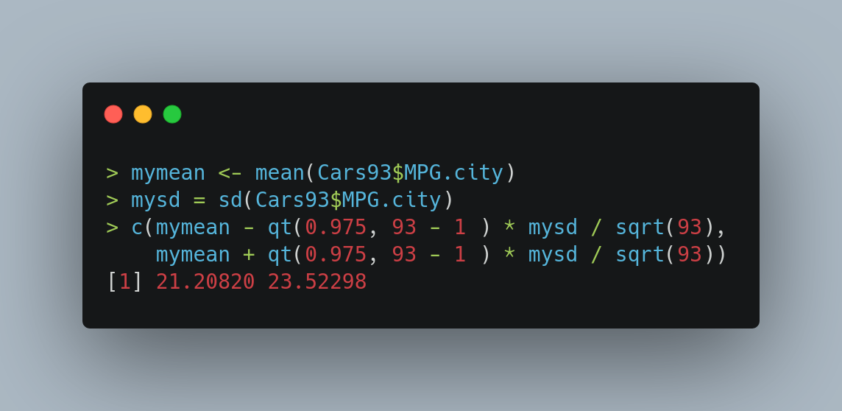
Lets now look at a bootstrap analysis of the same.
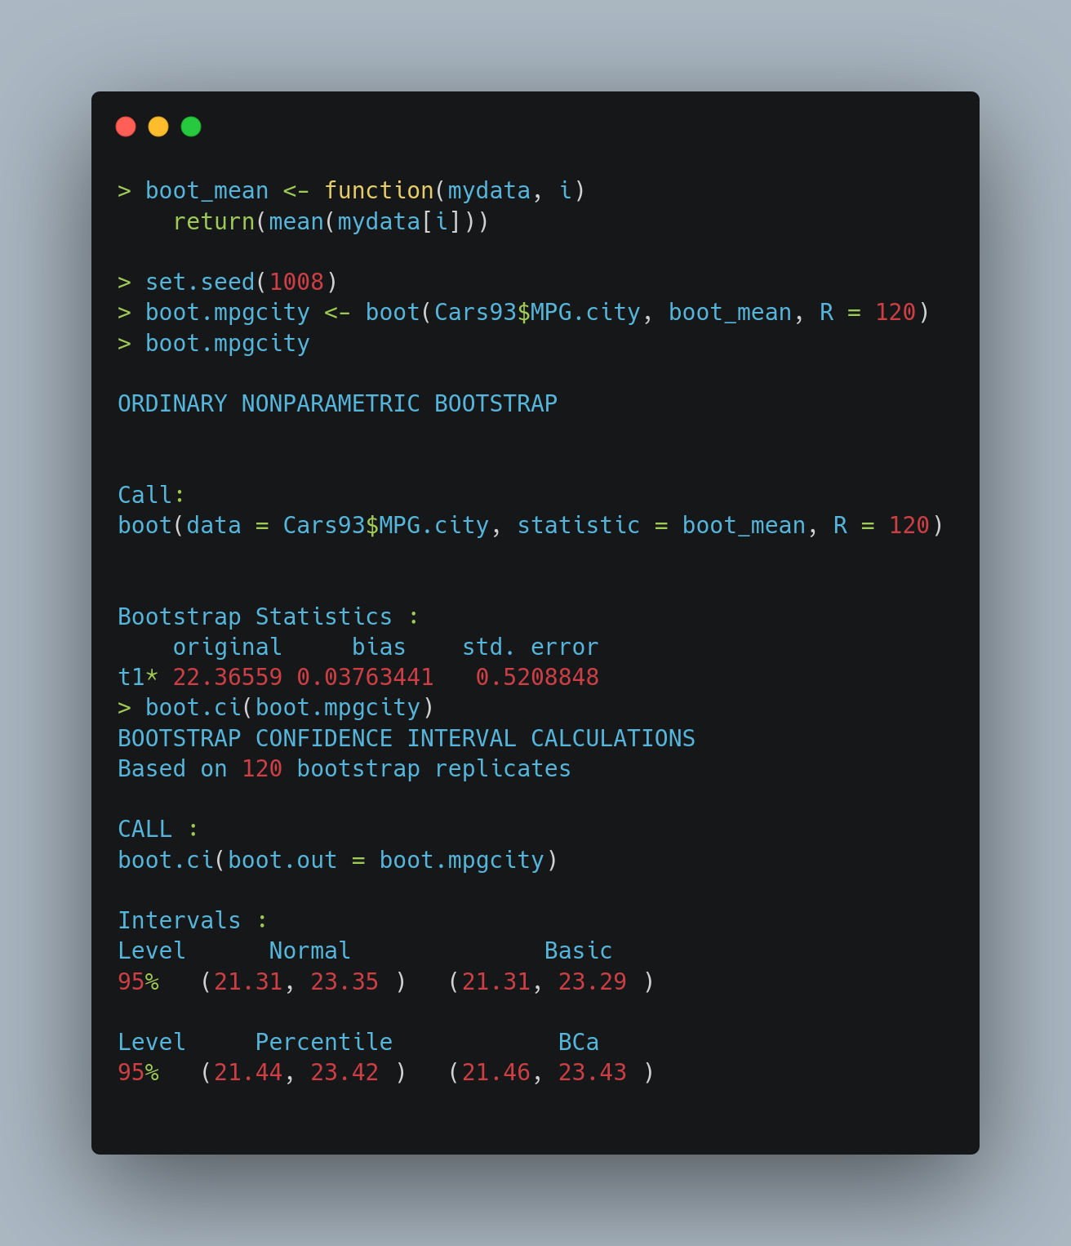
The first thing we need to use the boot function is to define a function that will calculate our statistic for the given data and indices. This is easier than it seems: for our function boot_mean, we just subset the data and call the usual mean function.
Next, I have set the seed – this is only for reproducibility.
Finally, I have called the boot function with the data and the boot_mean function, and the number of replicates (sub-samples), R = 120. You can set it higher, but values more than 200 are rarely required.
Printing out our boot.mpgcity object is already rewarding. It has given us the bias and the standard error of our estimate! And we got this without any work on our part!!
Finally, I have called the boot.ci function on our boot.mpgcity object to get interval estimates. This function by default calculates 4 types of interval estimates. I always prefer the Percentile based estimates, since these are simple to understand and robust. In fact, the percentile based estimates are nothing but the 2.5% and 97.5% quantiles of the estimated sampling distribution.
Great! In this case we can see the bootstrapped intervals and the ones derived from theory agree quite well.
For another example, let me look at the ratio of the highway mileage and city mileage. For each car in the dataset, we compute this ratio, and finally use a geometric mean [since this is the preferred way to combine ratios.] This statistic is a non-linear function of the sample values, and hence there is no available theoretical interval estimate.
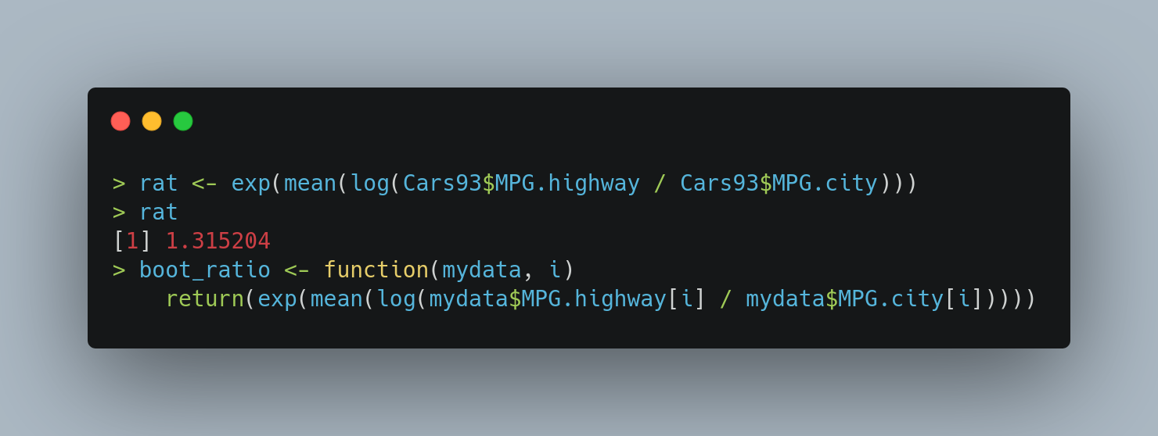
Lets look at the bootstrapped confidence intervals.
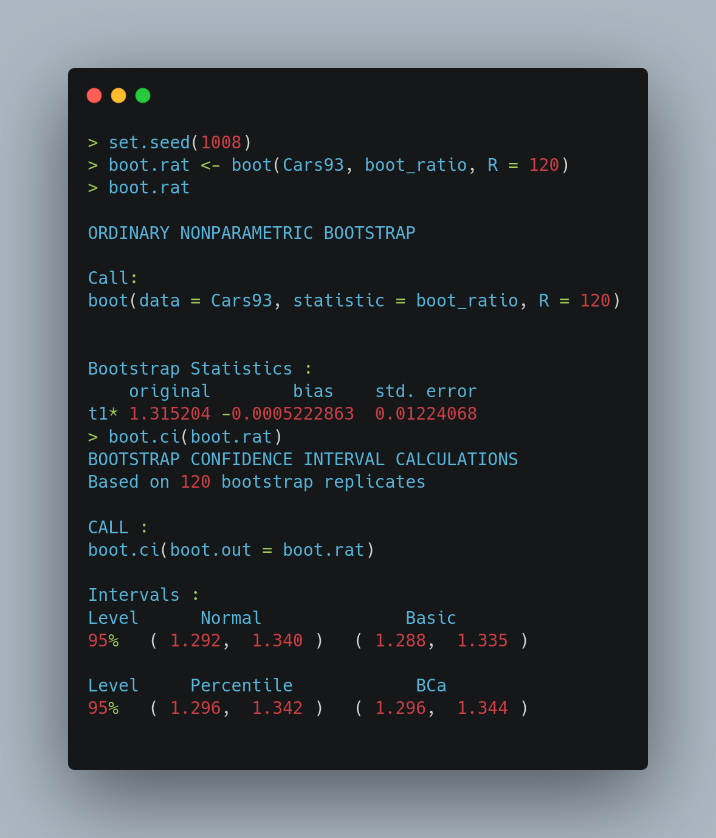
Lets look at one final example. This time, I’ll pick the Weight of the car as the variable of interest. Lets compute the statistic and the usual theoretical confidence interval.
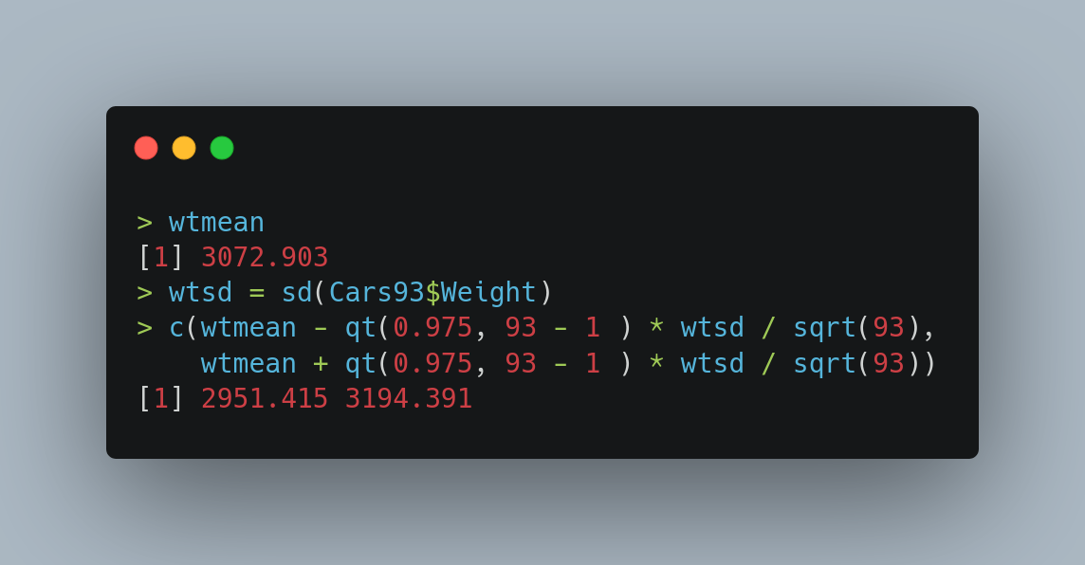

Finally, I compute the bootstrap intervals.
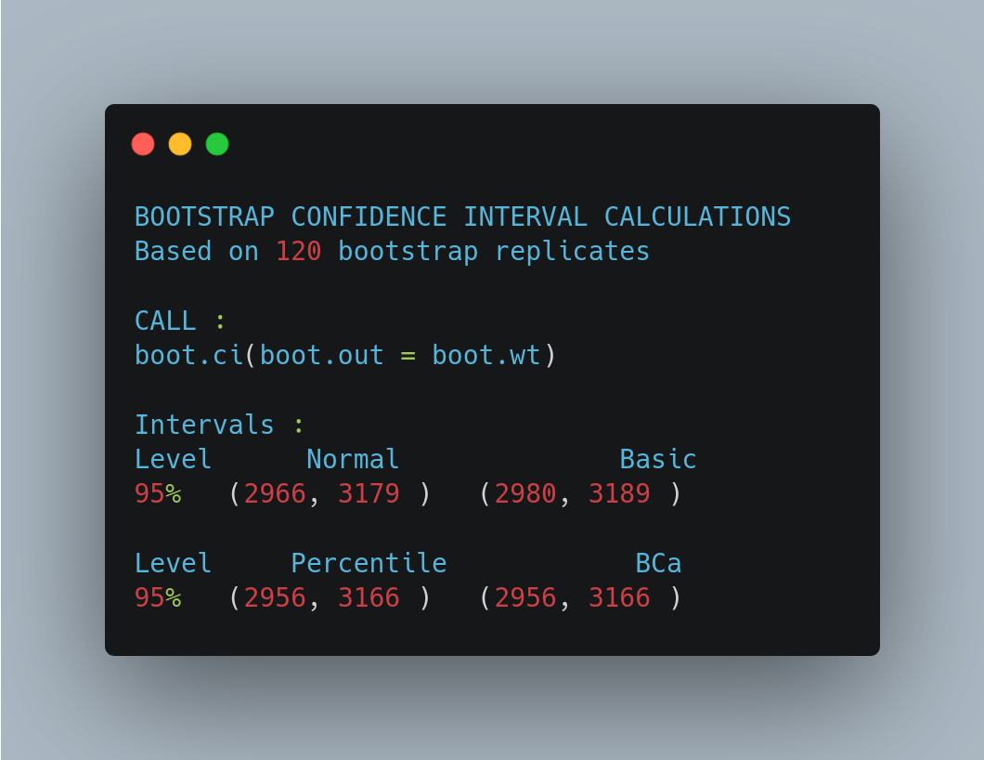

Wow, thats a large difference between the traditional CI and bootstrap CI. While the lower end of both sets of confidence intervals agree, they do not agree on the upper end. This is because our traditional interval is constrained to be symmetric about the sample mean, but the bootstrap interval is adaptive to the shape of the sampling distribution.
Lets look at our estimated sampling distribution. The ‘R’ replicates of our statistic are accessible as boot.wt$t. That is, the name of the object, followed by a $ sign and the letter t.
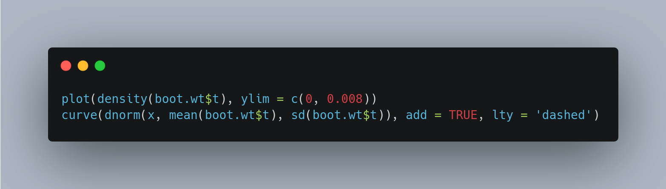

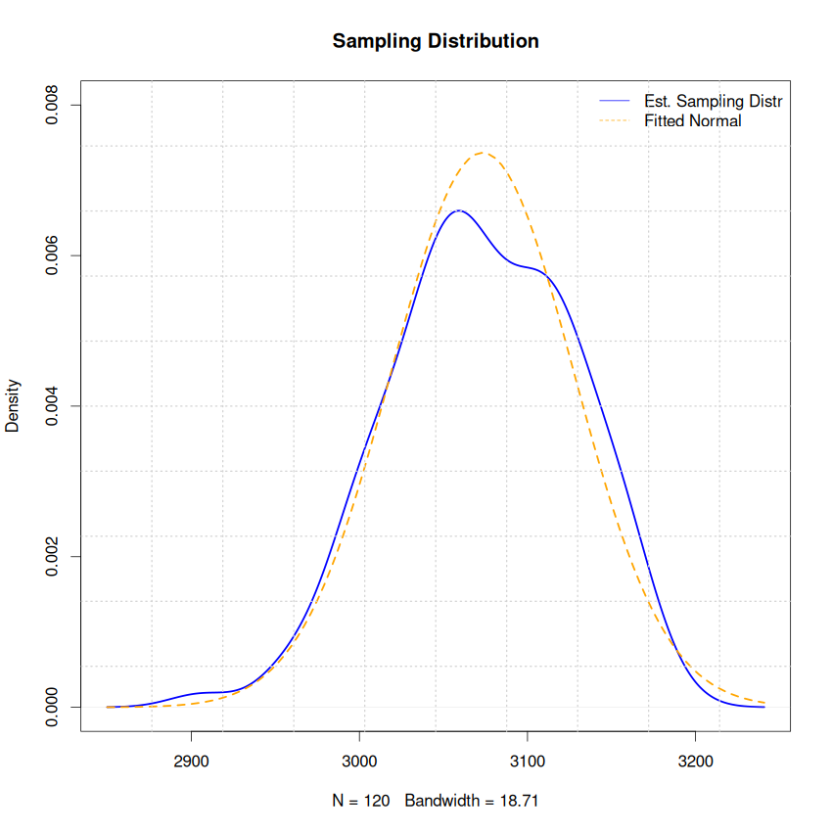
The sampling distribution is distinctly non-symmetric, with more weight on the left that the right. This deviation from the normal distribution is the reason our bootstrapped intervals can be considered more reliable than the traditional ones.
That’s all folks!

