Evaluating the Normal Density for Stock Market Returns
Twice previously, I analyzed stock returns of the Gamestop stock (NYSE: GME). The first time I fit the Generalized Lambda Distribution (GλD) and on the second occasion I used the skew-t distribution. The idea was to introduce these relatively exotic distributions for general use in financial data.
https://www.linkedin.com/pulse/flexible-modeling-using-generalized-lambda-mohit-dayal-6lcac
https://www.linkedin.com/pulse/alternate-flexible-distributions-mohit-dayal-hmdqc
Now that we have covered the bootstrap, I will show how we can explore our fitted models further. Specifically, I introduce the parametric bootstrap and show how we can code it in R. We will use this form of the bootstrap to demonstrate how we can conclusively rule out the normal density as a model for this data (and financial data in general).
Lets begin!
For reasons of brevity, I will confine myself to the GλD fit, which was a bit better than the skew-t. Each of the models had been fit using Maximum-Likelihood. Most of the analysis here carries over identically to the skew-t since both models have 4 parameters.
Lets start from loading our data and fitting the GλD.
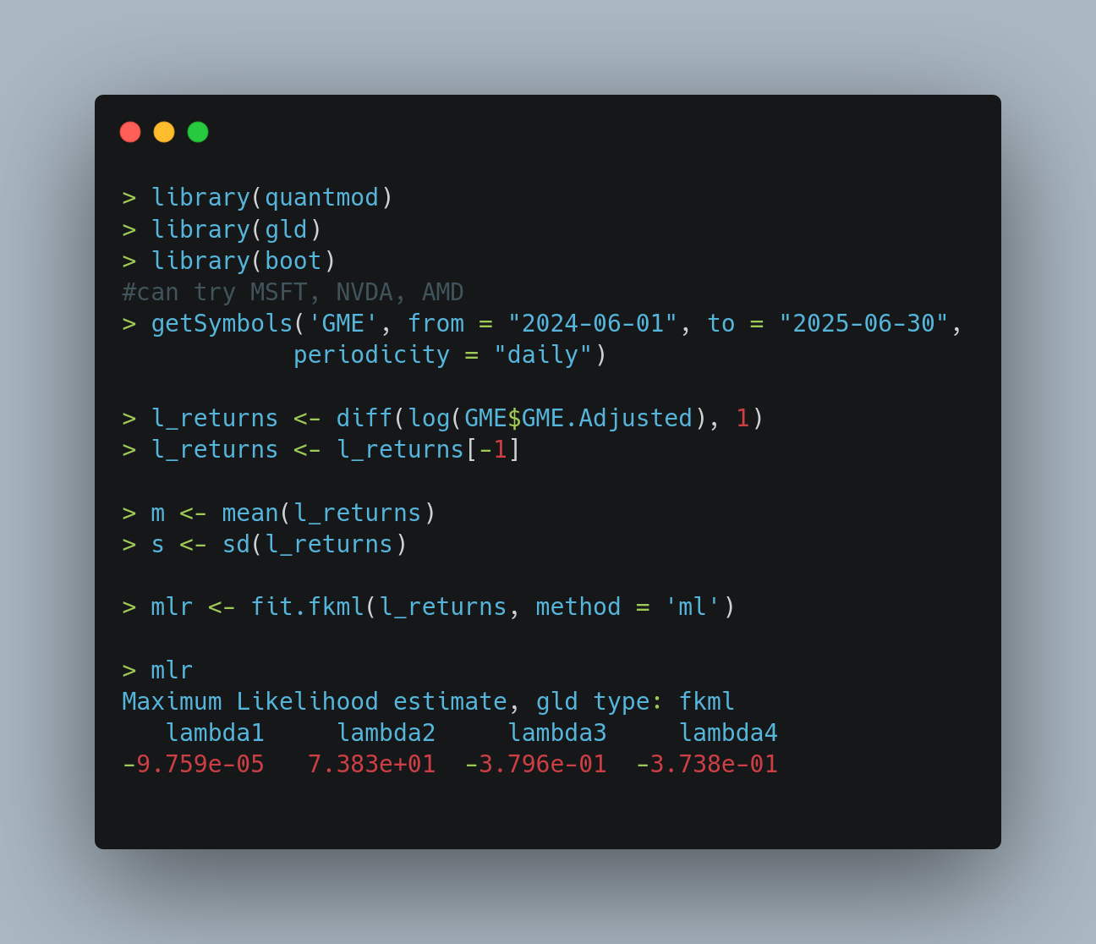
We have already seen the fit is very good, for more details, see the articles linked above.
The next thing we want to do is to estimate the uncertainty in parameters just estimated. There is a well known theoretical result that ML estimates are consistent, asymptotically normal (CAN). Unfortunately, we can place only limited reliance on such theory when dealing with these exotic distributions.
The other option open to us is the bootstrap, which is more generally applicable. However, there is a problem with applying the (usual) non-parametric bootstrap to this data.
To recall, in the usual bootstrap,
👉 one starts from the data,
👉 sub-samples it,
👉 and estimates a statistic(s) on each sub-sample.
The usual bootstrap samples data with replacement. In particular, each bootstrap sample will have repeated data points in it. Thus bootstrap samples have less entropy (dis-orderliness) than the original sample. This leads to at least two problems:
💡Estimating the GλD from a (usual) bootstrap sample is optimistic (under-states the randomness), since only a few distinct values are seen
💡The estimation routine itself might fail because of repeated values in the bootstrap sample
Enter: The Parametric Bootstrap.
The parametric bootstrap changes the usual procedure slightly. Instead of starting from the data, we start from a model.
👉 Fit a model to the data, and ensure its a good fit (very important)
👉 Generate samples (of the same size) from this model
👉 Estimate a statistic(s) from each such generated sample
By now it should be clear why we call this method “parametric bootstrap” – since the fundamental quantity now is not the sample data but a model fit to this data.
Let us carry out a parametric bootstrap on our data.
1️⃣ We will use our mlr object as the model for the data
2️⃣ From this model, we will generate samples
3️⃣ From each such sample, we will (re-)estimate our GλD parameters
It sounds a bit circular – doesn’t it? But rest assured, it solves both the problems above.
💡Estimating the GλD from a parametric bootstrap sample is realistic, since data is observed over the full range instead of only a few distinct values
💡The estimation routine has less chance of failing since repetition in values is never observed
Let us look at the R code now.
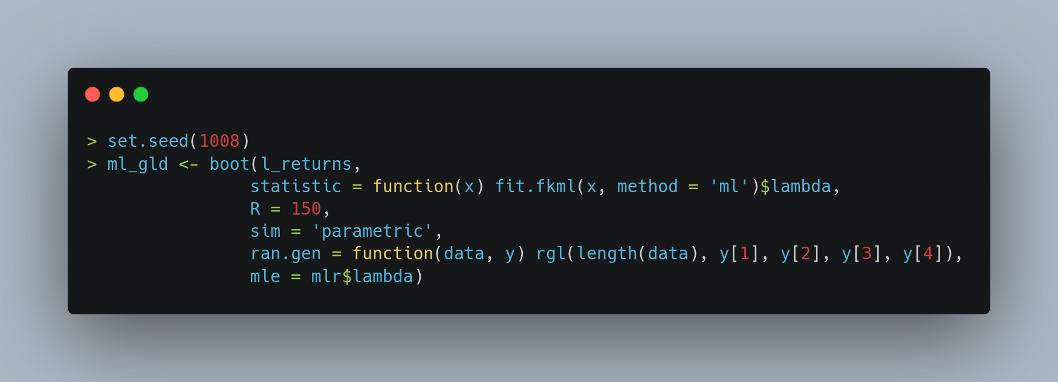
🗨️ I start from setting the seed – an absolute must for getting replicable results.
🗨️ Next I call the boot function. The first argument to it is always the data, which here is called l_returns.
🗨️ Next we need to pass a function that will return the statistic of interest – here it is the lambda component of the return value of the fit.fkml function.
🗨️ The next argument is the number of replicates – anything from 70-200 works.
🗨️ The sim specifies that this is a parametric bootstrap
🗨️ Now comes the most important argument: ran.gen. Here we need to specify a function that will generate samples from our model. It needs to be a function of two arguments: the data and the parameters of the parametric model (specified as mle in the next argument)
🗨️ Finally, there is an argument called mle – this helps the second argument of the function in the previous argument
If everything goes off well, you will see output like the one below. We can see the bias and the se.
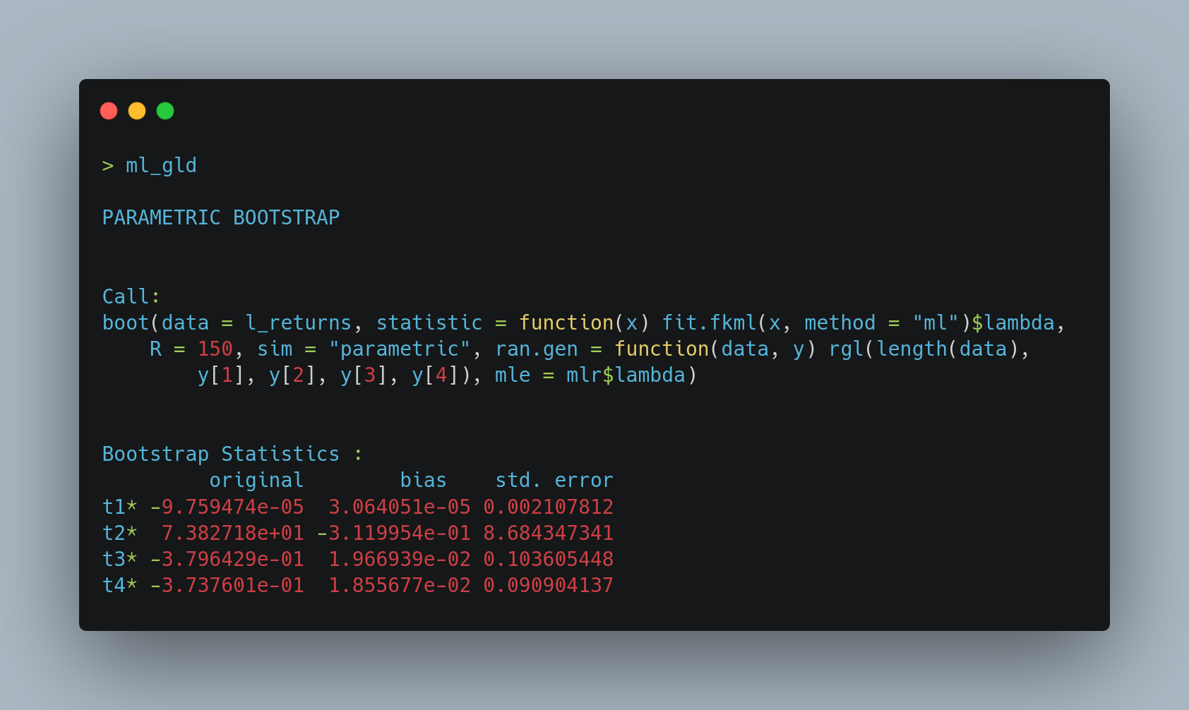
Let us start from looking at the (bootstrap) distributions of our 4 estimated statistics. Bootstrap theory tells us that these distributions approximate the respective sampling distributions.
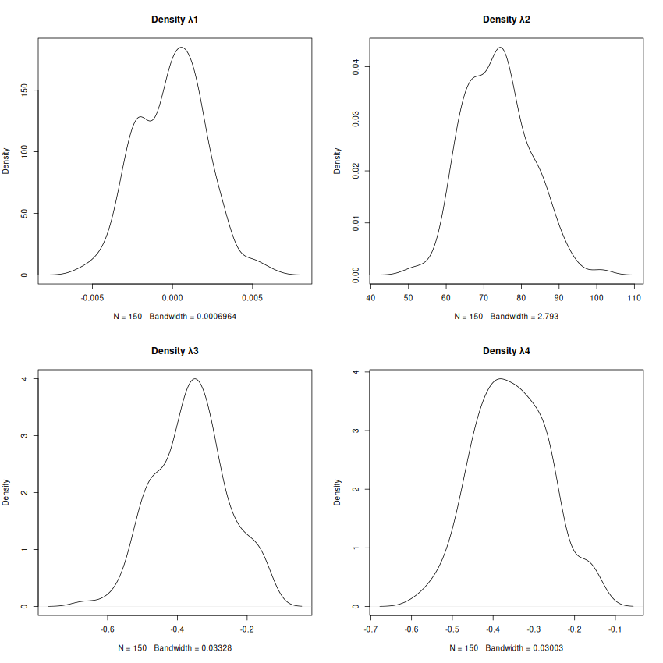

It is quite clear that none of the 4 statistics follow a normal distribution. So much for the theory of CAN of ML Estimates. This is par for the course for these exotic distributions. Their MLEs rarely follow the normal distribution. This is exactly why the Bootstrap becomes so essential when working with them.
As the next task, lets estimate the confidence intervals of our statistics. Since we have 4 (> 1) of them, lets apply the Bonferroni correction of using α/4 instead of α for the significance level.
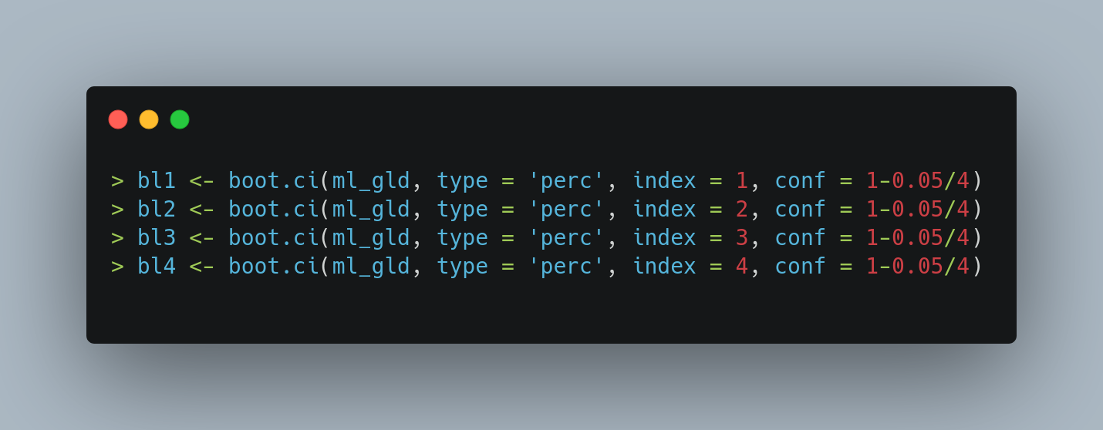
We will now put our interval estimates together. What do we mean by that?
From the code snippet above, we can see that the object bl1 contains the interval estimate of λ1, bl2 contains the interval estimate of λ2, and so on. So we can concat the lower bound from each of bl1, bl2, bl3 and bl4. We then do it for the upper bounds as well. Lets see what looks like.
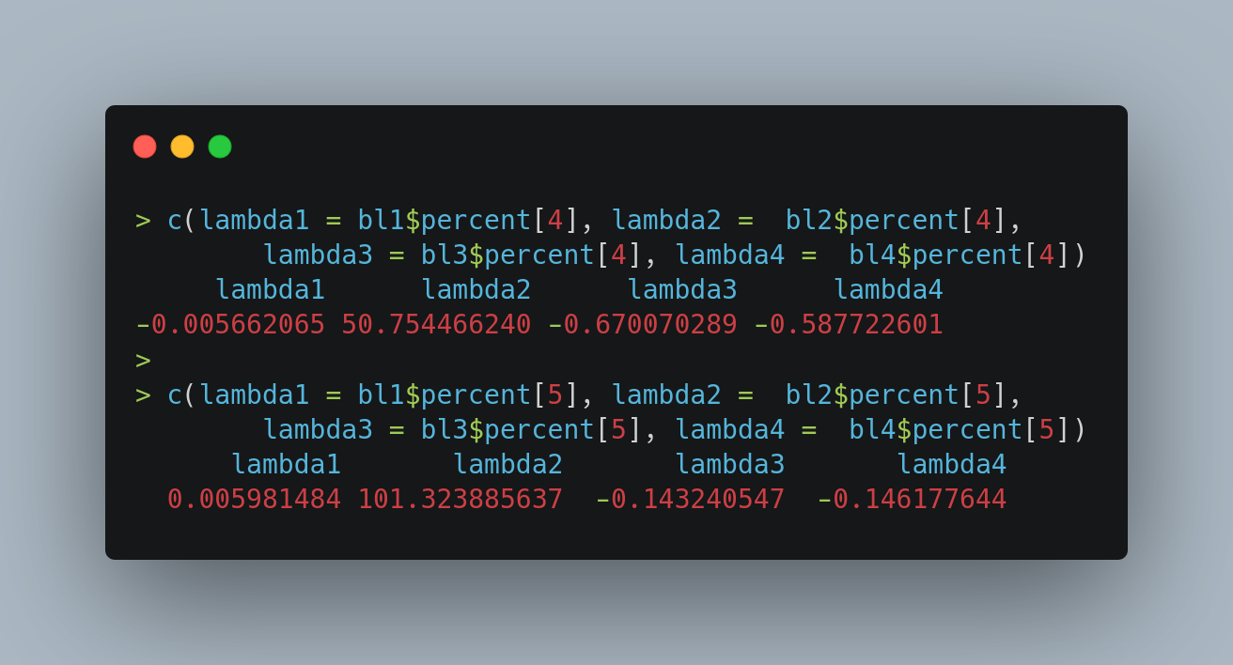
We can think of the first vector (concatenated lower bounds) as defining the parameters for “a lower bound GλD” and the second vector (concatenated upper bounds) as defining “an upper bound GλD.”
Thus from interval estimates on the parameters, we have been able to transition to an interval estimate on the distribution!
Lets now visualize this.
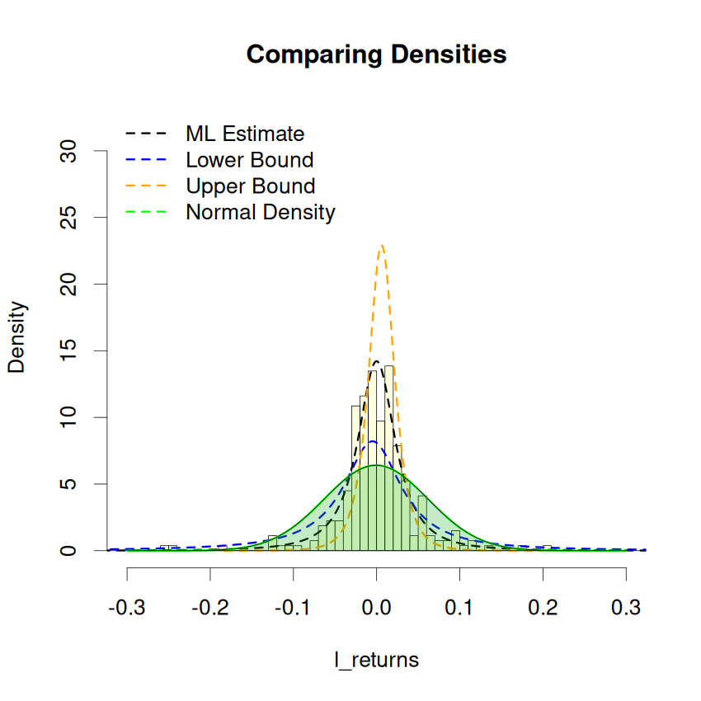

We can see that the ML Estimate (black line) follows the data (histogram bars) very closely. The blue line is a lower bound on the distribution. The orange line is an upper bound on the distribution. Any plausible distribution for the data will lie between the blue & orange lines. Each of these 3 distributions are very peaked and narrow around the mode.
On the other hand, the green curve is the fitted normal density. Its nature is completely different from the 3 Gλ densities. It is far too broad in the middle around the mode. It is also much flatter.
Overall, the Normal model does not look anything like any plausible distribution for the data we have. This, I would say, is almost conclusive evidence that the Normal model is not suitable for this data at all.
That’s all folks!

