Distance Metrics in Clustering
Clustering is a task in data science where we want to assign observations to different groups based on their (multivariate) observations. In Machine Learning terminology, clustering is a part of “unsupervised learning”, because here one tries to learn groups in data without providing an explicit criterion by which the data will be partitioned.
It cannot be emphasized enough, that in clustering, the multivariate observations are of central importance. The scaling of the variables, and how variables are made to correlate with each other decide the quality of the clusters found.
In this article, we will explore the function daisy (DISsimilAritY coefficients) in the R package cluster. Specifically, we will focus attention on how this function enables us to communicate crucial details about the variables in our data to the clustering algorithm.
Lets begin!
daisy is a function in the cluster package in R that allows us to compute a dissimilarities matrix for any dataset. This set of dissimilarities can then be passed to any clustering algorithm to find clusters.
To start with, lets look at the daisy documentation to see what kinds of variables are supported.
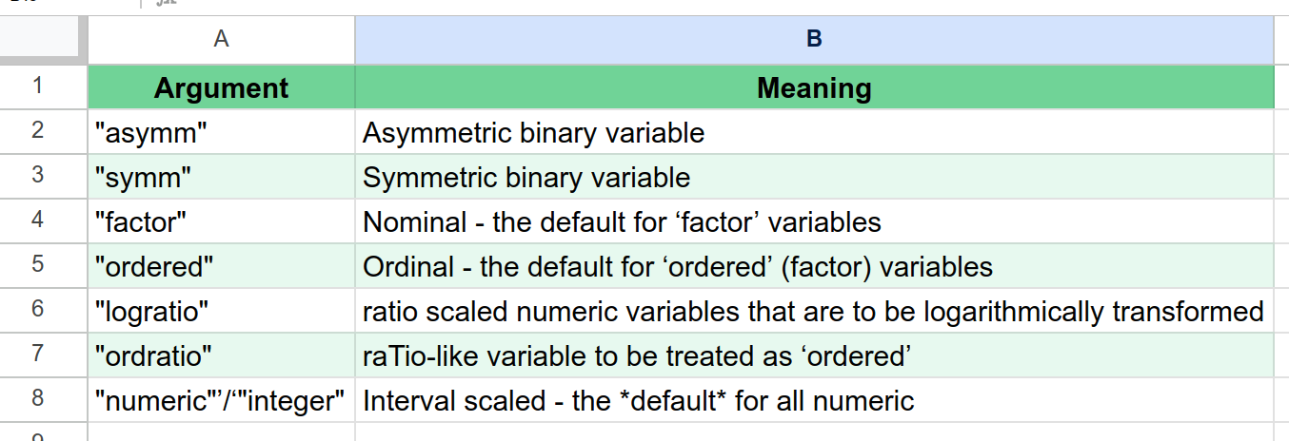
The most interesting of these are probably “asymm”, “ordered” and “ordratio”.
👉 “asymm” is used when you have a binary variable, but the importance of 0 is very different from 1. For example, customers who have defaulted on their loan are very different from those that have not. We use “asymm” to communicate to the algorithm this asymmetry in information.
👉 “ordered” is used when you have a nominal variable but there is ordering within its levels. For example, “primary education” < “secondary education”. There is an ordering even though the levels are not numeric.
👉 “ordratio” is used when you have a numeric variable but you just want its ordering to be used, not its actual values.
To illustrate, lets use the Bank Marketing dataset from the UCI Machine Learning Repository. “The data is related with direct marketing campaigns (phone calls) of a Portuguese banking institution.”.

We will only use the following variables.
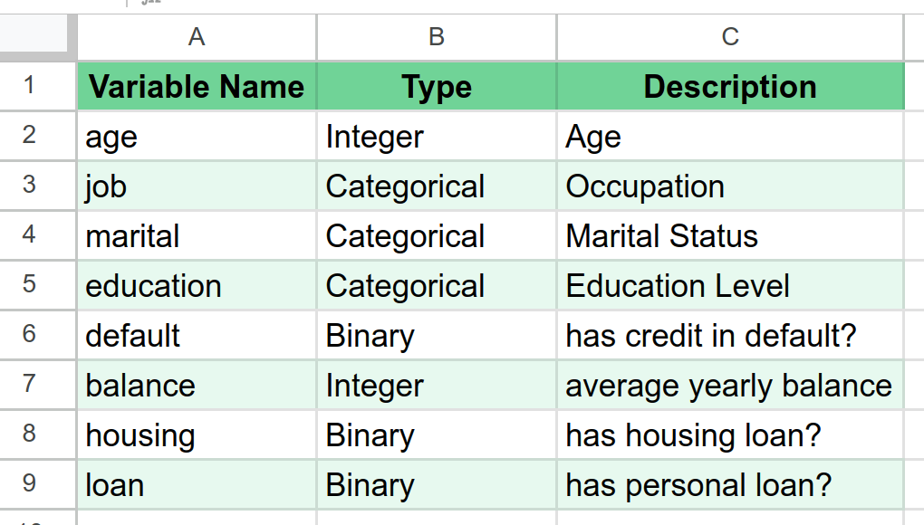
Let us fire up R now, read the data and encode our variables.
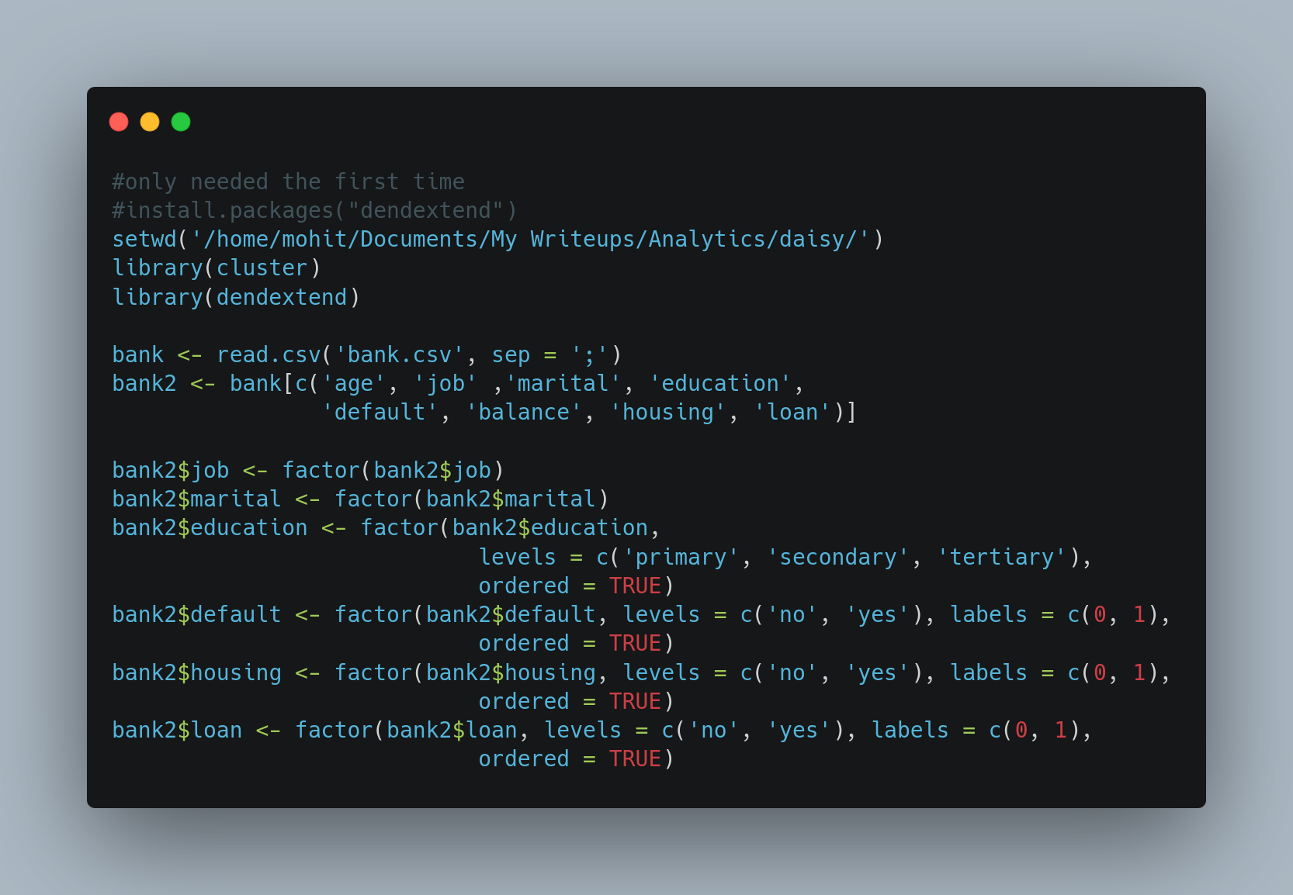
Note that,
👉 We created job and marital as unordered nominal variables, they could be turned into ordered if we wanted to prioritize certain job categories or marital statuses based on business requirement.
👉education has a natural ordering, and this was preserved in the factor variable created.
👉default, housing and loan are all asymmetric binary variables, since a 1 on any of these is more important than a 0. Notice that the labels on each of these is set to 0/1. This is a requirement of the daisy function.
Finally, lets compute the dissimilarities.
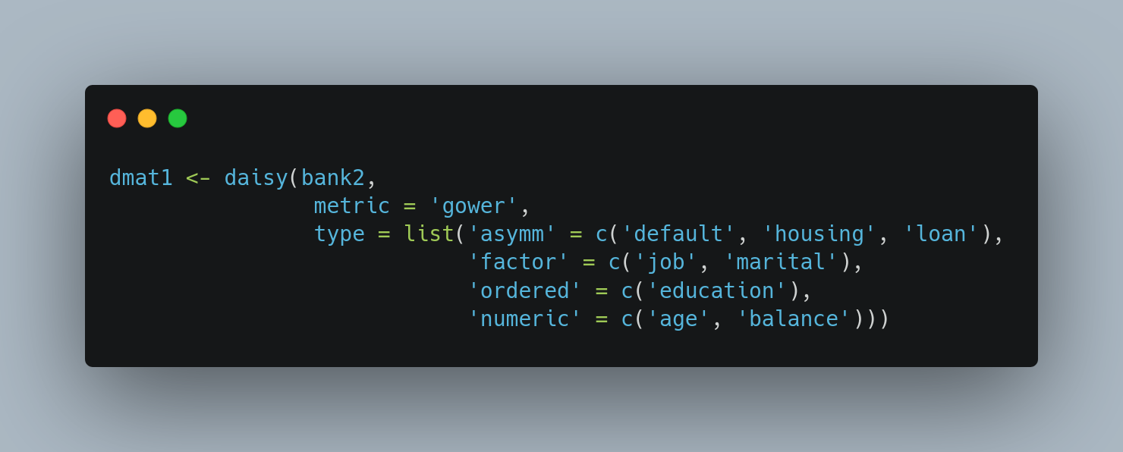
Notice how we have communicated what each kind of variable is as arguments to the function.
Next, for sake of comparison, lets create a second copy of the data. In this second copy, we convert every variable to a numeric code, disregarding the asymmetric binary or the factor information. This is often the usual practice of many data analysts.
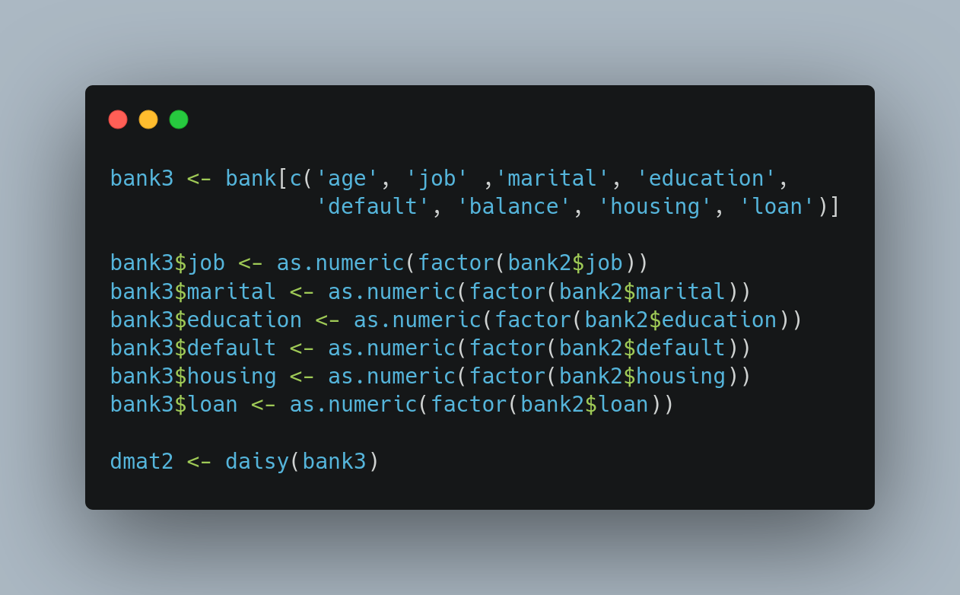

Lets now pass our dissimilarities matrix to a hierarchical clustering algorithm and compare the resulting dendrograms.
The code:
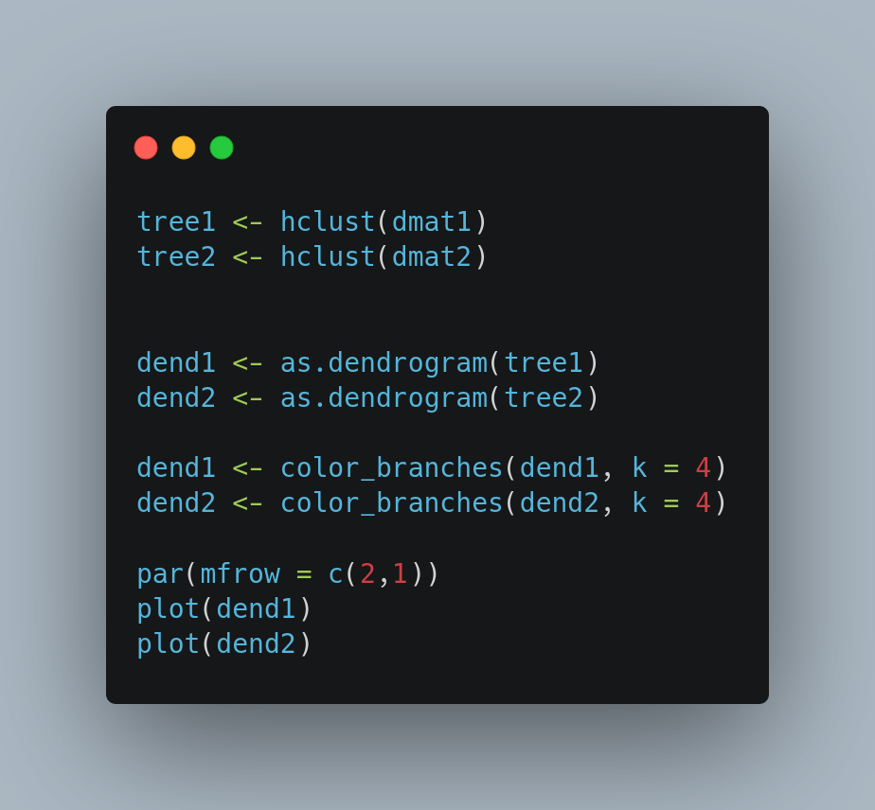

The result speak for themselves. When we pass more information to the daisy function (top panel), we get a more even clustering with at least 4 large groups of decreasing sizes. On the other hand, the dendrogram from the naive processing of data reveals a degenerate dendrogram, with almost all points in a single cluster.
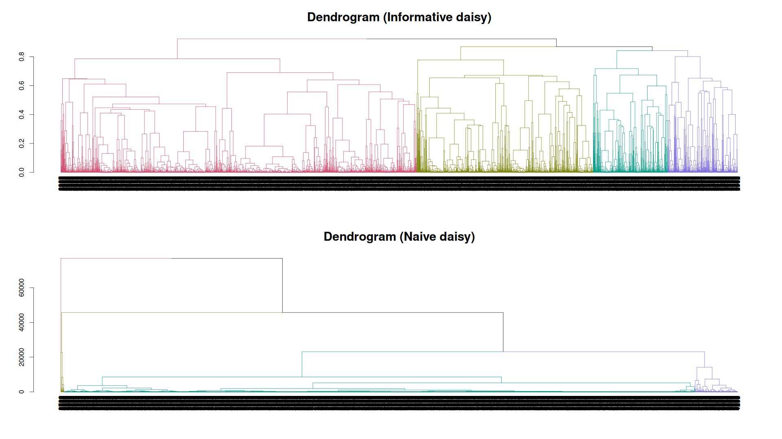

The same information can be presented as a bar plot. As before, we request 4 clusters from each dendrogram and plot the sizes of the clusters returned.
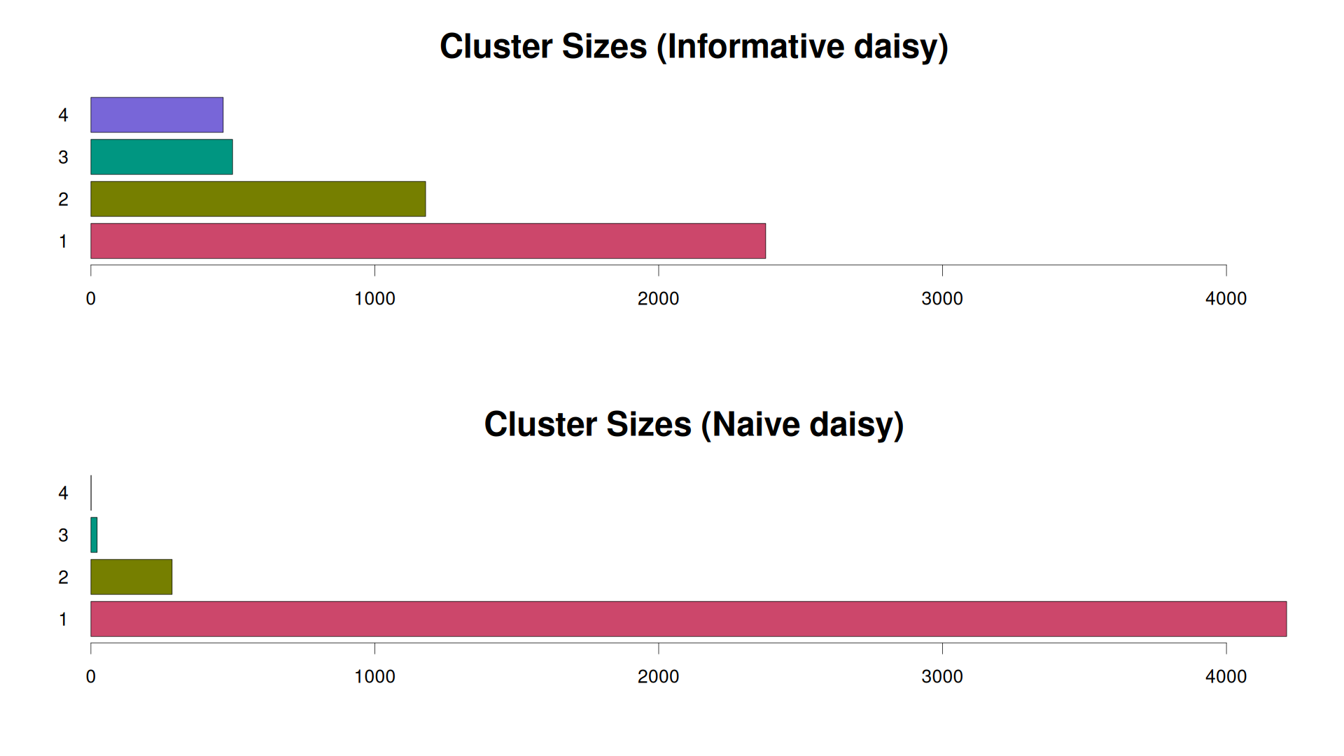
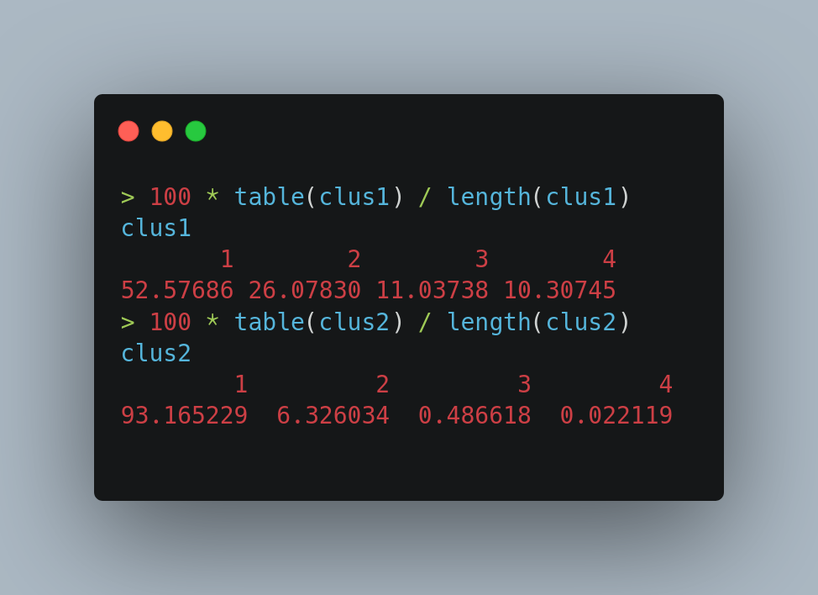

It is clear that not passing critical information to daisy, and just treating everything as numeric results in a clustering that is more of an outlier detection exercise. More than 93% of points are put in a single cluster, while the two smallest clusters are less than 0.5% each.
The results from “Informative Daisy” are more balanced.
That’s all folks!

