Estimating Derivatives of the Regression Function
When working with data, quite frequently, one is interested in estimating a regression function. In previous articles,
https://www.linkedin.com/pulse/smoothing-scatter-plots-mohit-dayal-rmiwc
https://www.linkedin.com/pulse/choosing-scatter-plot-smoothers-mohit-dayal-zrc4c
we have seen how to estimate a regression function non-parametrically. The benefit of doing this is that we usually, get a better fit, and the shape of the fitted curve allows us to form ideas about the form of the relationship.
However, often enough, the interest lies not so much in the regression function itself, but in its slope parameter. Essentially, we are interested in studying how the Y-variable changes as the X-variable changes. Recall from calculus, that the rate of change of Y with respect to X is called the derivative.
In this article, I will show how one can use non-parametric methods in R to directly estimate the derivative function. This derivative is estimated locally, so that it varies across the range of X. This gives us richer information about the (local) variation in Y as X varies.
Let’s begin!
For the purposes of this exercise, we will use the CASchools dataset that comes with the AER package in R. This is a very big R package with lots of dependencies. So if you run into difficulty, you can just grab this dataset as a csv file from my github link at the end of this article 👇.
The dataset contains data on test performance, school characteristics and student demographic backgrounds for school districts in California. It has 420 rows.
The methods described here are best appreciated when you have a few thousand rows in your data. But for the sake of this article, 420 rows will do just fine.
Lets load up our packages and data.
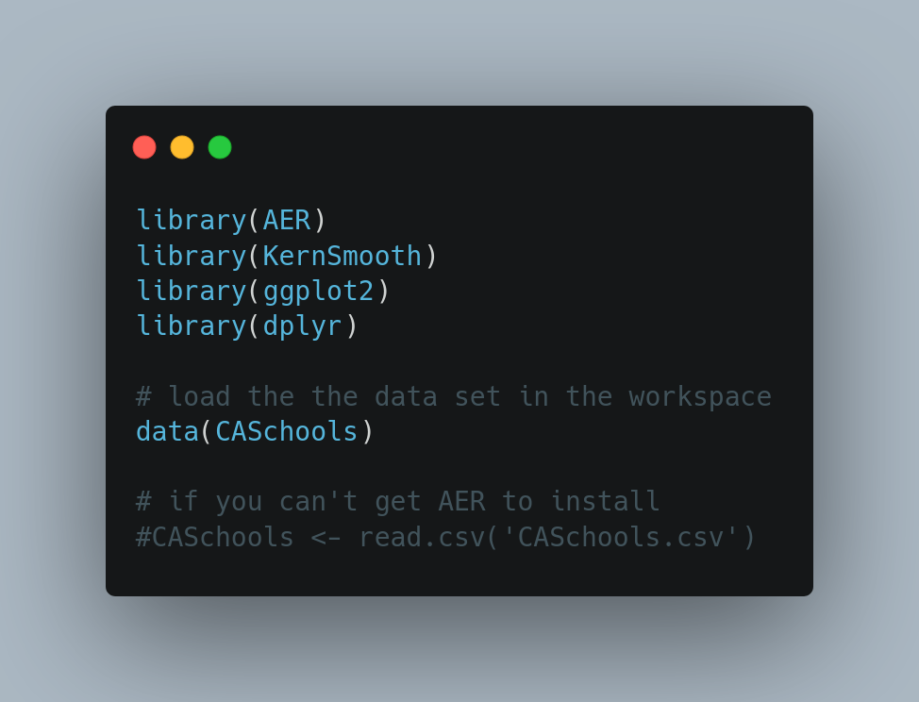

In this data, we are interested in the relationship between the Test Scores (Y-variable) and Student to Teacher Ratio (STR) (X-variable). Lets see how these relate.
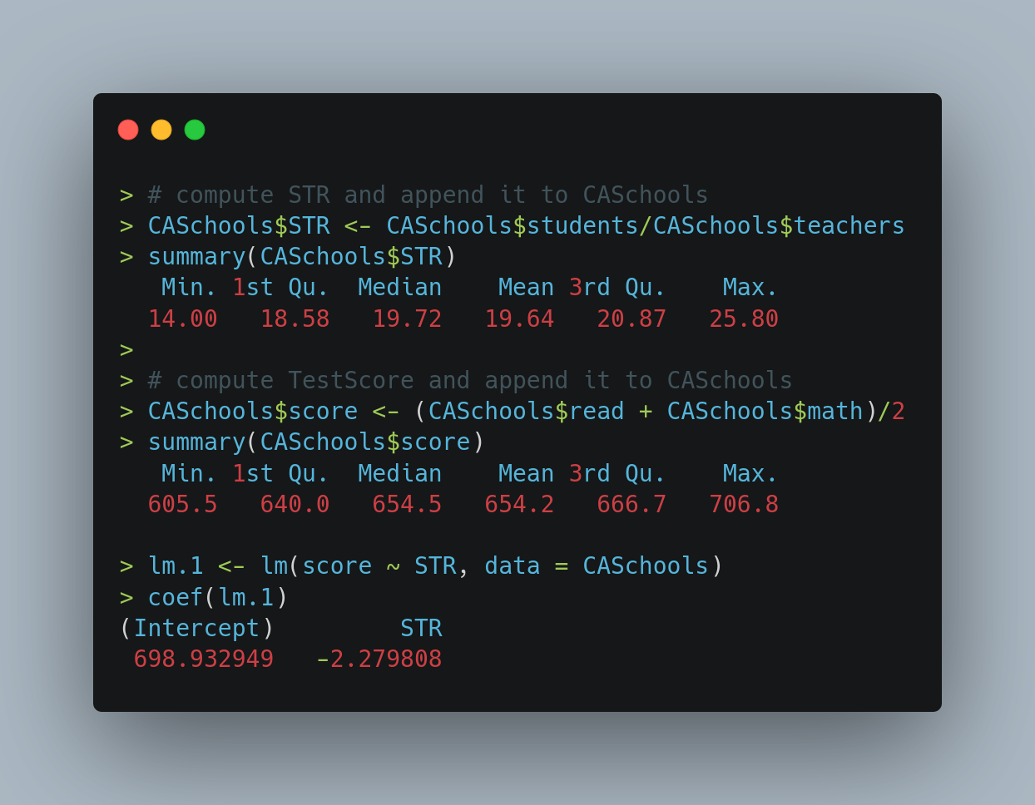
We can see some basic summary statistics in the image above. I would highlight two things:
- Our X-variable : STR: varies from 14 to 25.8. This will be important later on.
- The linear model of score vs STR reveals a negative relationship with slope of -2.28.
Before going further, lets also look at a graph.
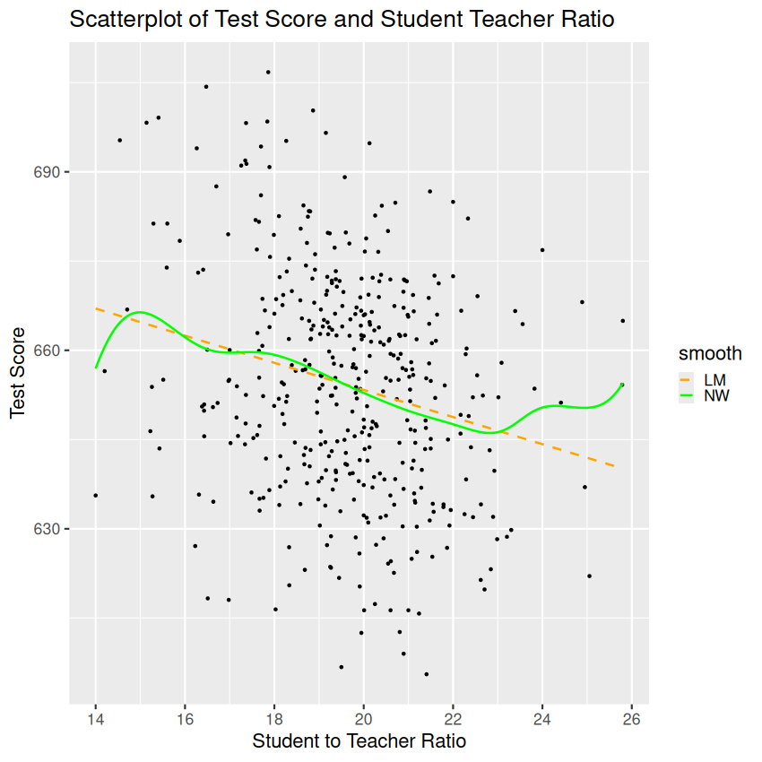

The linear model seems to be a fair fit to this data, but still the green line (NW smoother) does deviate from the linear model especially at the ends.
A quick recap of interpreting the derivative before we move onto estimating it for our data.
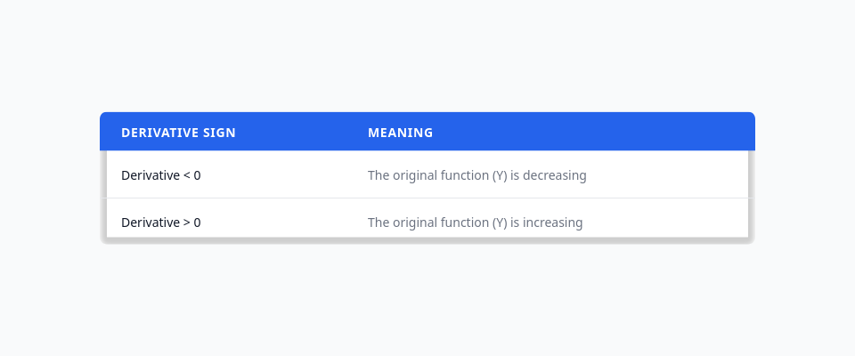

These are the R commands that we need to estimate the derivative.
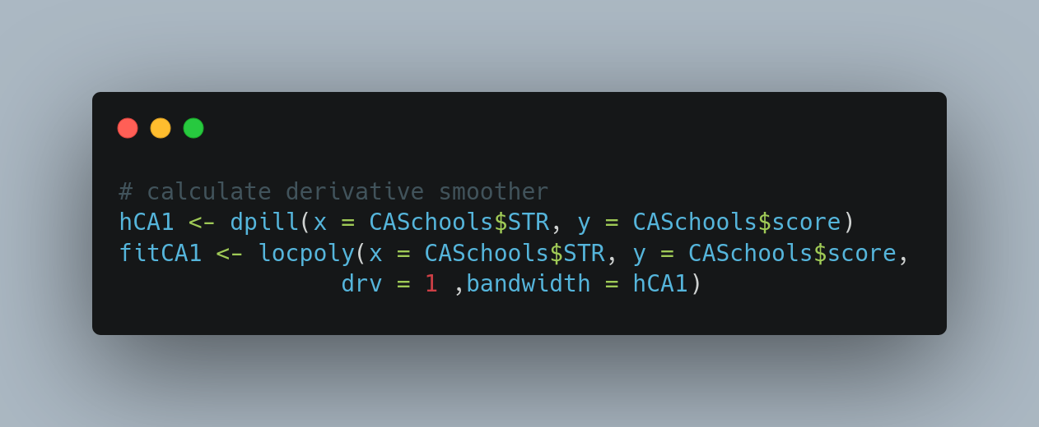
The first function call is to dpill which estimates a bandwidth. Just like regression smoothers, the bandwidth is a key parameter in estimating the function. It can be interpreted as (local) range of data over which the derivative is estimated. This parameter is on the same scale as our X-variable.
Unfortunately, there are no hard rules for selection of the bandwidth. This is a shortcoming but it can be turned into an advantage: Always estimate using several different bandwidths and see what each value reveals.
This is exactly what we done in the next figure. We have plotted the data with 3 different bandwidths: the default, 1.5*default, and 10 (the range of the X-variable).
It is usually observed that dpill underestimates the bandwidth. We can diagnose this by plotting the estimated derivative. If it seems too “wiggly” (too prone to change / too variable), then we need to increase the bandwidth.
The actual estimation is done by the locpoly function, which takes in an integer argument drv which is the order of the derivative that we want to estimate. This can be set to 0, to estimate the regression function, 1 to estimate the derivative of the regression function, or to a higher value.
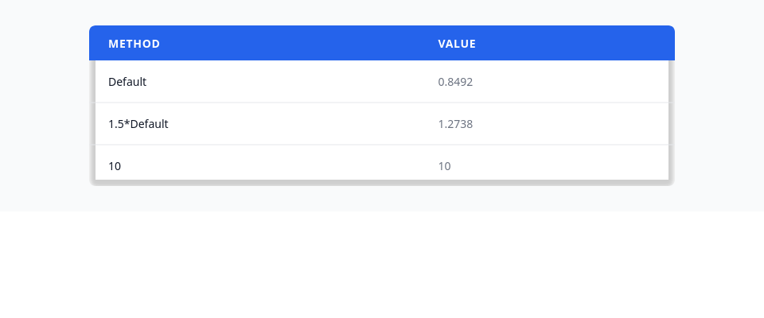

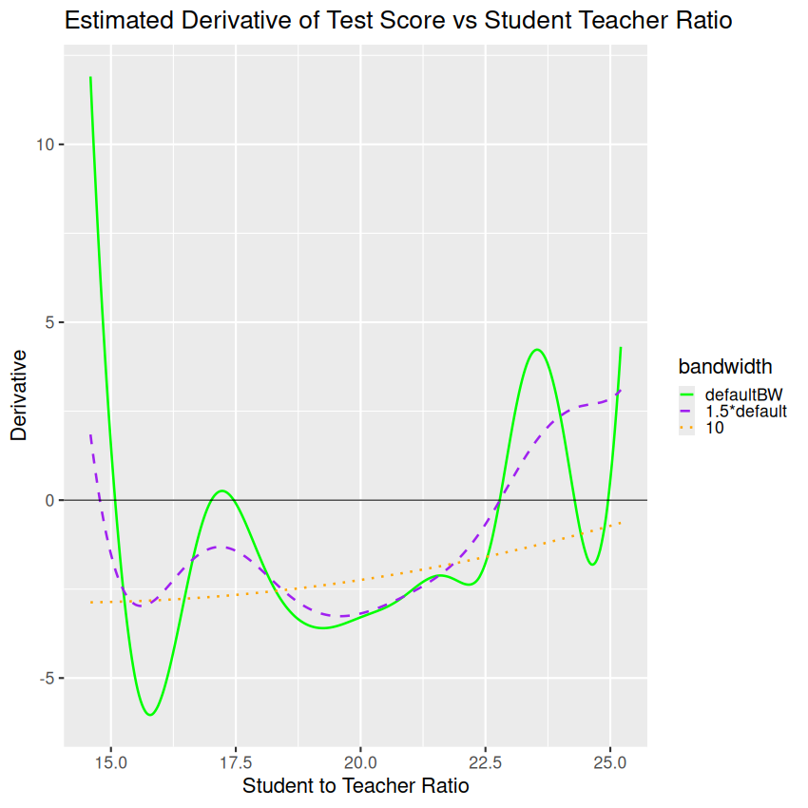

That’s just about it!
A few points about the interpretation:
- For the orange dotted curve, the bandwidth is 10, which is almost the range of the X-axis. So we can expect this estimate to be near the global estimate of -2.3 which we obtained using our linear model. This is shown in the next code block.
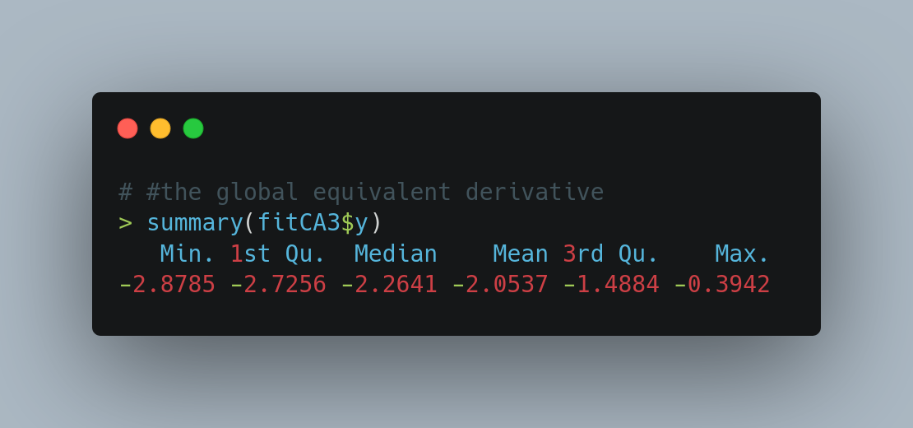
- The median of this derivative function is nearly the same as our global slope. This is a good sanity check.
- The green solid curve I think moves around a bit too much. This is the curve with the default bandwidth, and it is likely that the bandwidth has been under-estimated.
- The curve I like the most is the purple curve. It is globally stable, and yet reveals local details.
Interpreting the Purple Curve
Interpreting the derivative of the regression function goes just like in calculus. Let us first get its zero-crossings. This is easy to do since there are just two of them.
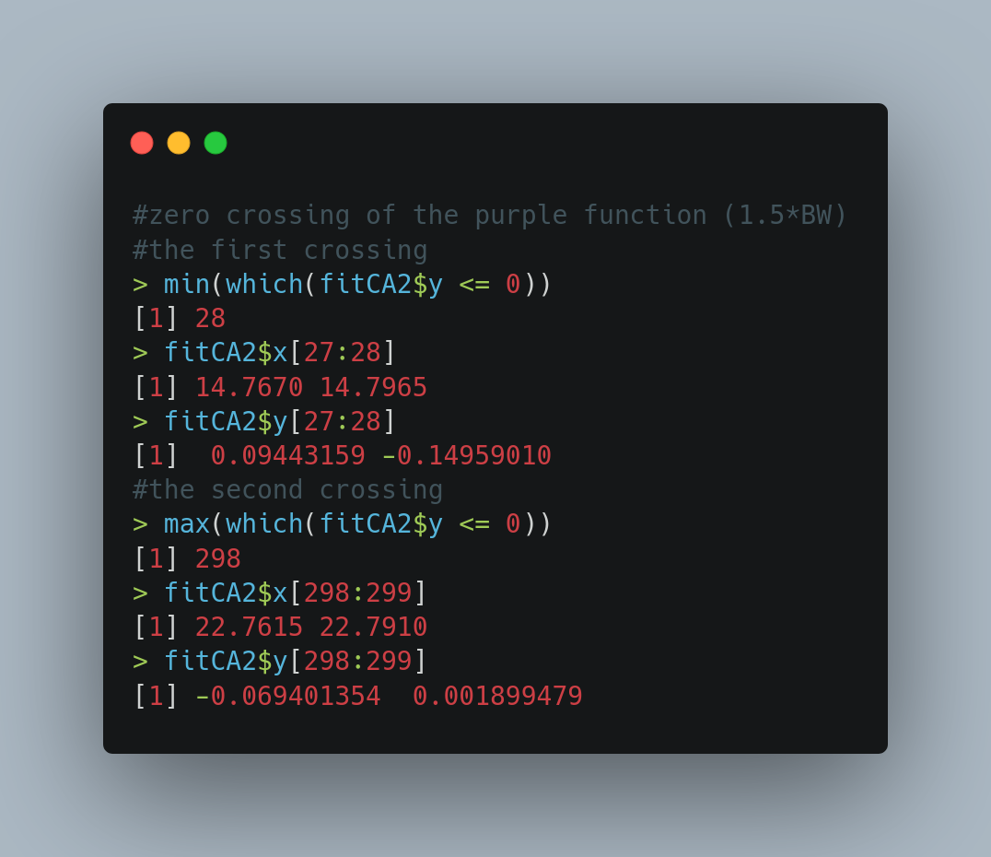

- We can see that this curve starts off descending immediately, although until STR = 14.76 it is still > 0. This shows that at very low values of STR, the test scores have an increasing relationship with STR. Possibly these very low STR values correspond to specialized schools where adding more students does not result in decline in test scores.
- By STR = 14.80, the derivative goes negative. So that increasing STR results in lower test scores. This is also the global pattern.
- There is a golden zone near STR = 17.5, where the derivative actually increases, although still in negative territory. This shows that here the Test Scores increase with increasing STR near this point.
- Finally, a second crossing of zero is seen near STR = 22.76. After this point, the Test Scores increase with increasing STR. Possibly, these high values of STR correspond to cramming schools, so test scores start to increase.
That’s all folks!

