Are we alike?
Mohit Dayal
The field of Statistics is based on very simple ideas that, taken to their logical conclusion, are very powerful. One such idea is sorting. In this article, I will explore how this simple idea forms the basis of some powerful statistical techniques.
Let us start with a small dataset. Here I generate 5 random values from a standard normal distribution. I print the raw values as well as sorted ones.
💡Pro Tip: The technical term for sorted observations is “Order Statistics”. So in the snippet below, -1.44 is the 2nd order statistic, while 2.617 is the 5th order statistic.
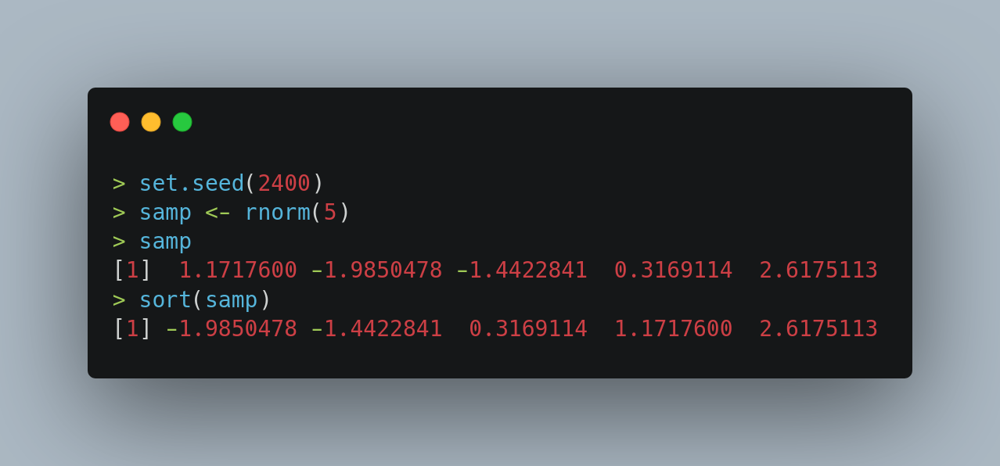
Lets now make this idea more powerful. Let me introduce you to the cumulative distribution function. This is defined as,
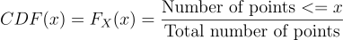

Let me write a small function to compute this.
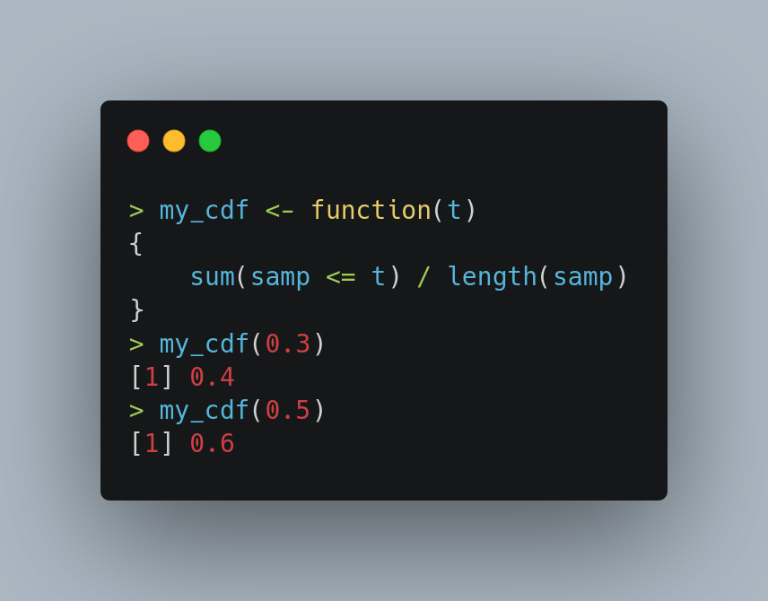Figure 1: It is easy to verify that for t = 0.3, 2 values in the sample, are less than this number and hence 2 / 5 = 0.4 is returned by the my_cdf function.

💡In fact, this is such a common operation in Statistics, that R provides dedicated functionality for this via the ecdf function.
(The ‘e’ in the name stands for “empirical”; meaning that the cdf function is being calculated from a sample. There is a population version of the same function, denoted by p-followed by the name of the distribution, for instance for the normal distribution, pnorm is the name of the population cdf.)
The following code is equivalent to our function above.
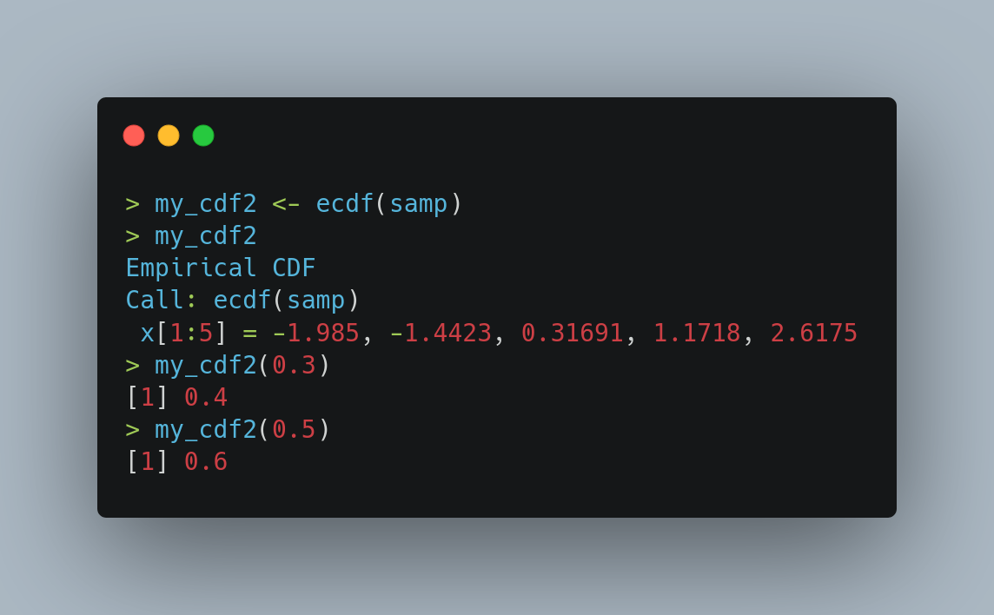

To get some further intuition about this new creature, let me plot it.
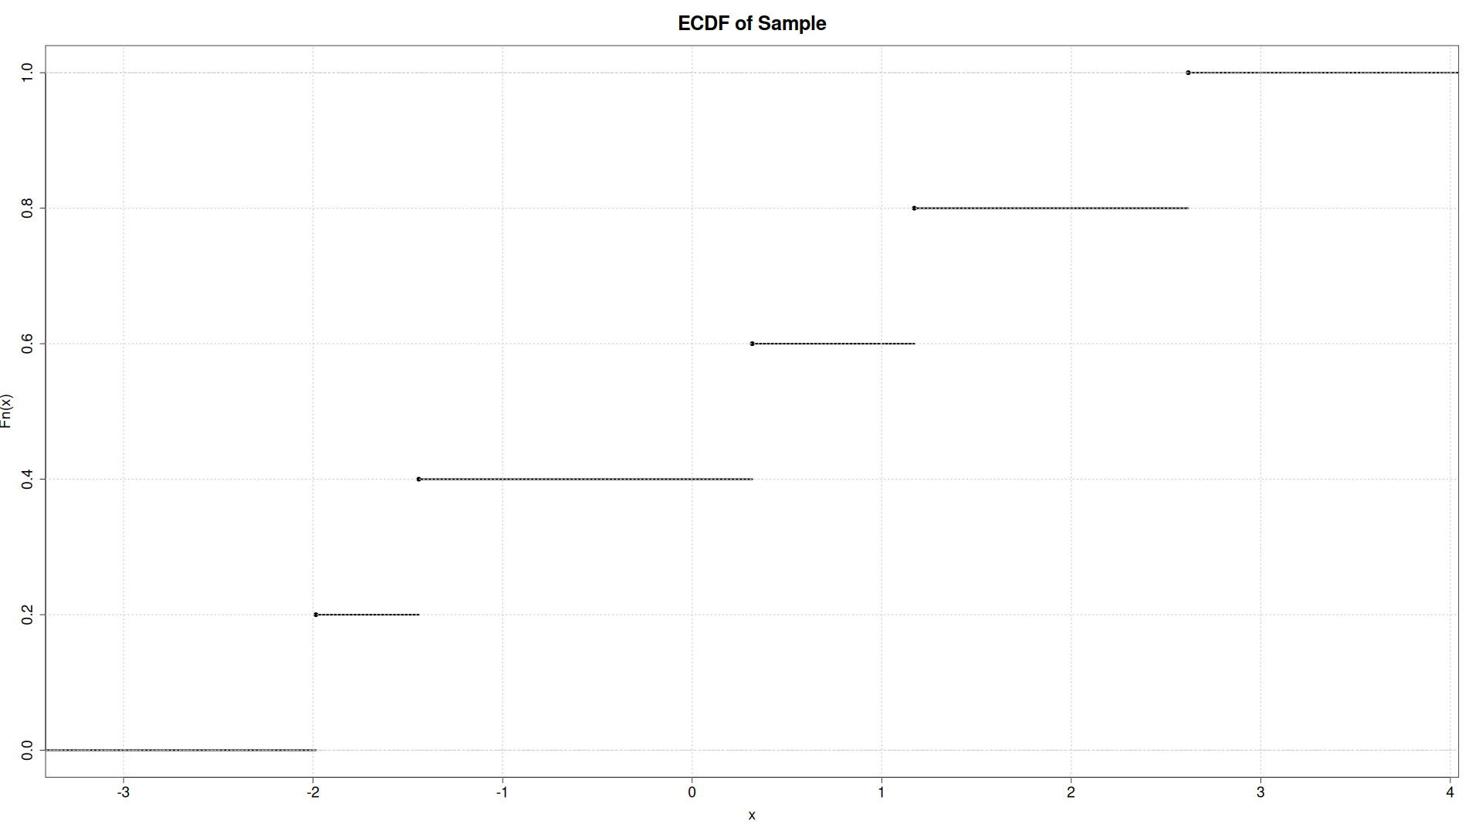Figure 2: The emprical cdf is a step function, that jumps by 1/n at every sample point. There are a total of (n+1) jumps.
💡Now that we know our creature, what can we do with it? A lot, actually. For instance, we can use it to tell if our sample comes from a certain distribution or not. The underlying technology comes from the Kolmogorov-Smirnov test statistic,
Figure 3: The subscripts n and m denote that the two samples being compared need not be of the same size.

Basically, what we are doing now is that we see the maximum y-axis distance between two ecdf functions and if they do not deviate a lot, we can conclude that the two samples come from the same distribution.
For instance consider the following code snippet:
The possibilties are endless: for instance, you can also use the KS test to test if a fitted distribution is really a good fit to the data.
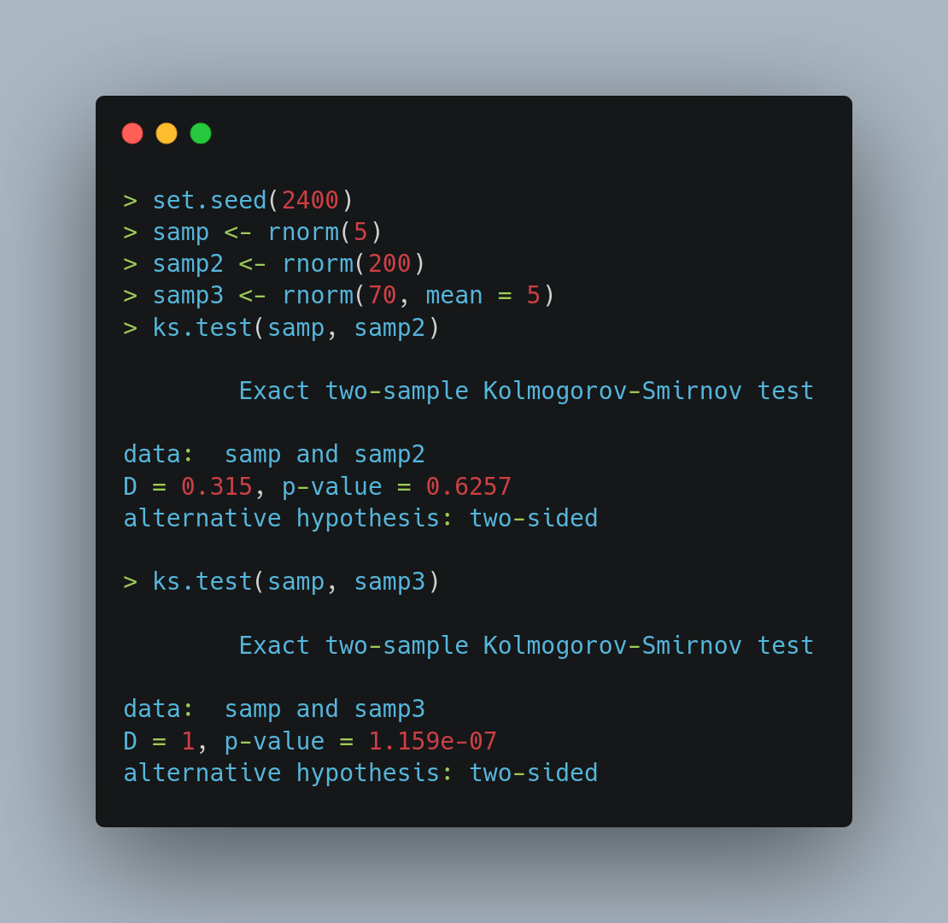Figure 4: In the first test, we generated two samples from the same distribution. And the KS test p-value > 0.05, so we can conclude that the two samples come from the same distribution. In the second case, the second sample came from a normal distribution with mean 5. Our KS test immediately picked up on this change and returned a p-value << 0.05 indicating a rejection of equal distributions.
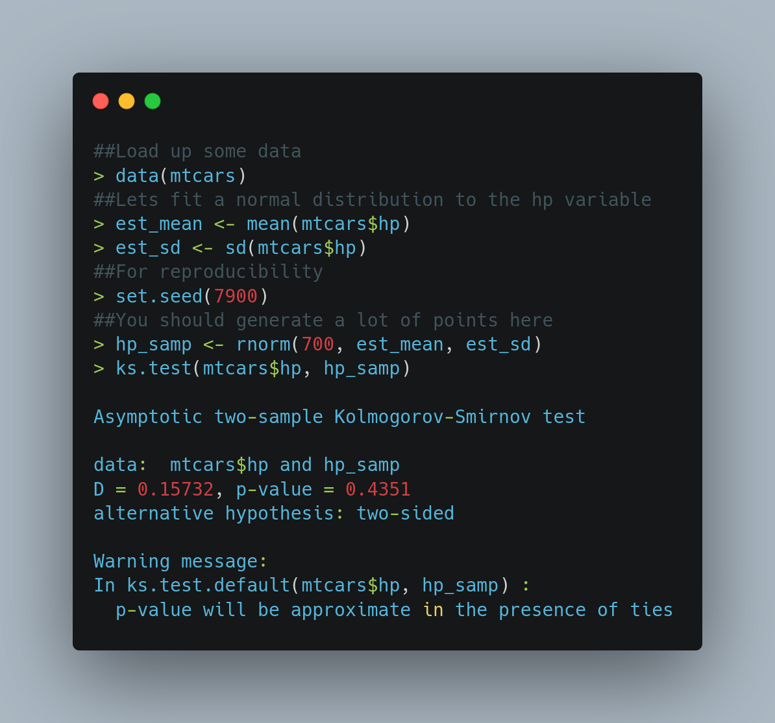
Thats all folks!

