Advanced ggplot2 plotting
ggplot2 is by far the most popular plotting package in R and knowing it well, is essential to becoming a good analyst / scientist. However, certain concepts in ggplot2 can be quite non-obvious for a beginner.
In this article, we’ll talk about how to create a certain kind of graph with the ggplot2 package. The concepts involved are of intermediate difficulty, and are quite non-obvious. It was a bit confusing for me as well, at first, so I thought to pen down my explorations.
Let’s begin!
#R #Rstats #transform #log #datascience #statistics #graphs #local #regression #data #kernel
#smoothing #ggplot2 #visualization #MachineLearning #NonParametric #StatisticalModeling
#KernelRegression #ModelFlexibility #DataDriven #AssumptionFree #PredictiveModeling
#PatternRecognition #DataAnalysis #DataInsights #ComplexRelationships #FlexibleModels
#DataScientists #Statisticians #Tech #BigData
To start, let me show you what I want to accomplish. Here it is. We are continuing with our diamonds data set.
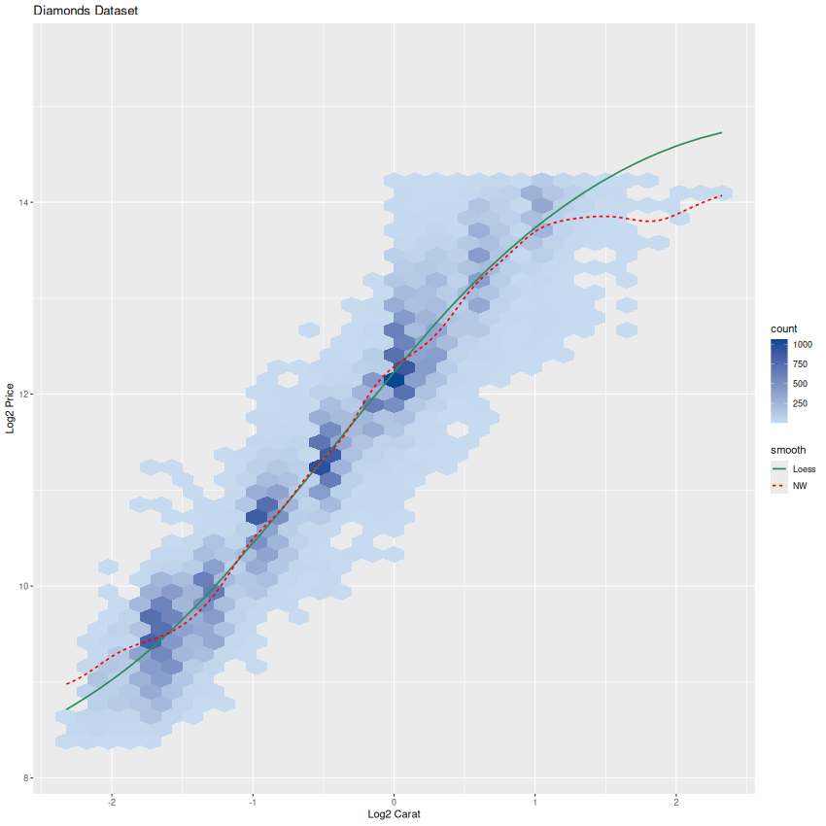

There are 4 elements to this plot:
- A hexbin scatter plot of the log-transformed data with a custom color scale (Darker for higher density, lighter for lower density)
- Customized X and Y axis labels, and a custom header
- Two lines showing two different smoothers – NW kernel and loess, with different line styles and colors
- An automatic legend that works for both the scatter plot as well as the smoothers.
Phew! That’s quite a list. But its essential for any professional quality graph, so we can’t miss any elements.
To begin, lets load up some libraries that we’ll need.
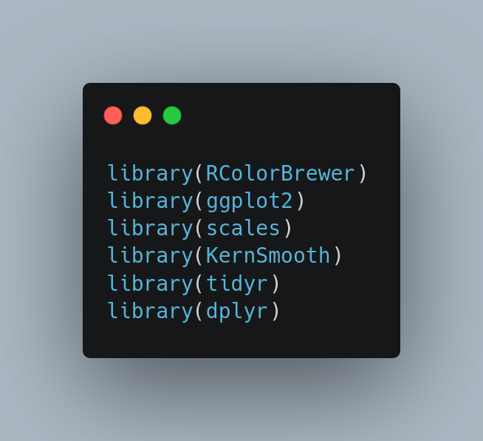

Lets load up our data and create our models.
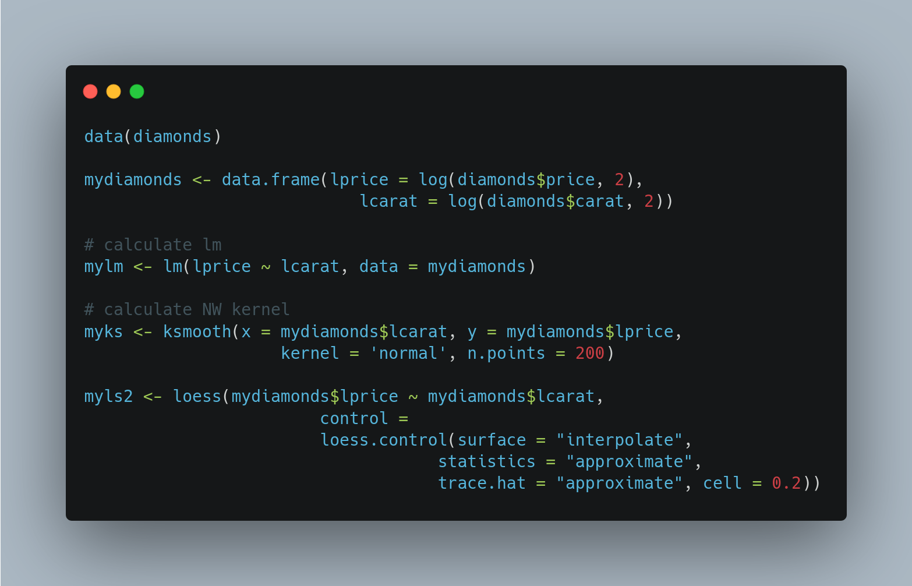
It is essential to know where our models store their results. We do this below:
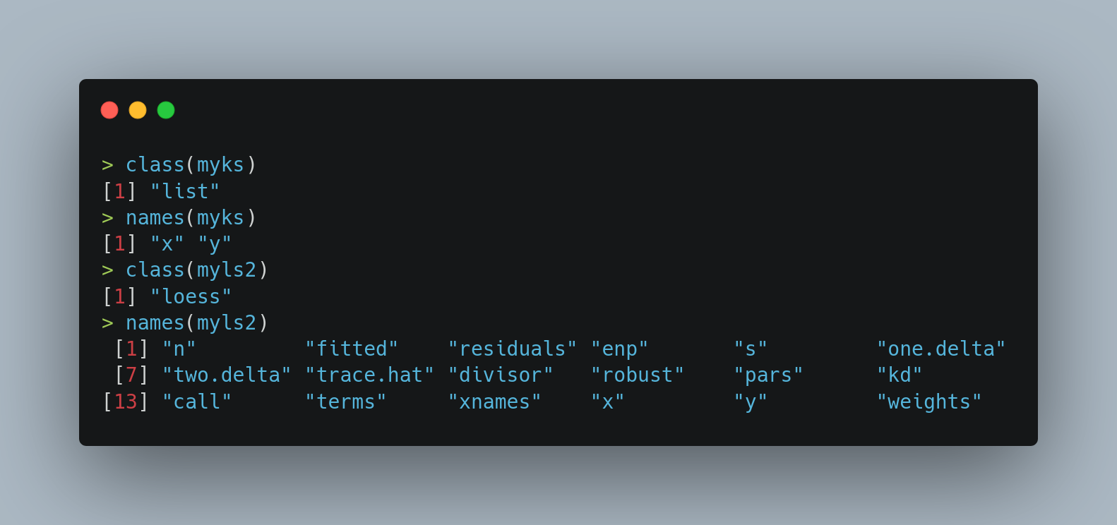
- For the Nadaraya-Watson kernel, the result simply a list ordered by the X-coordinates
- For the loess smoother, we again have a list, with the key elements being “x” and “fitted”.
Now, we can go for data preparation.
ggplot2 requires data to be in long format. What this means is that we need to stack our “data” on top of each other. I have used quotes around the word data, because in this context, that word refers to not only to our original lprice and lcarat variables, but also to the fitted values from our models.
The following code fragment creates our long dataset.
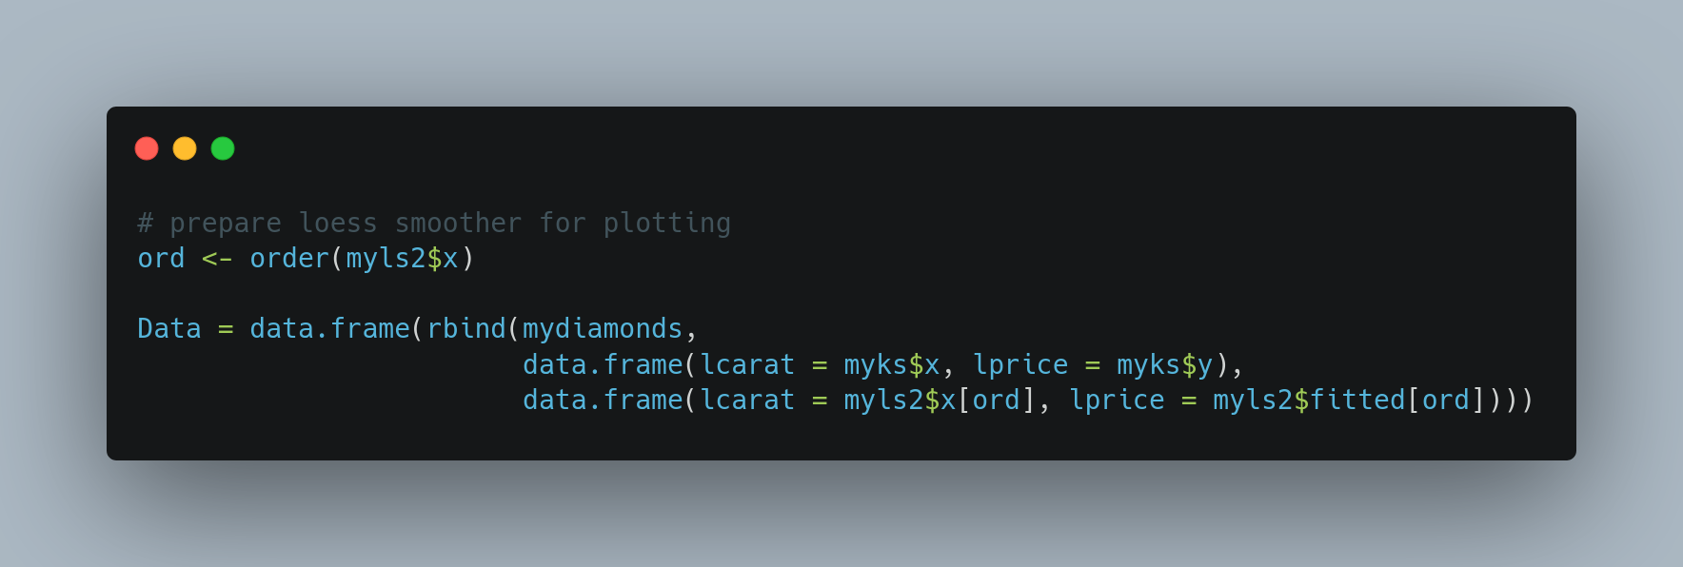
Notice that we ordered the loess data since it is unordered in its raw form.
Now that we have our long data frame, here comes the main trick: we add an additional variable [I call it smooth, you can call it whatever you want] to it, identifying which row came from where. The next piece of code does this.
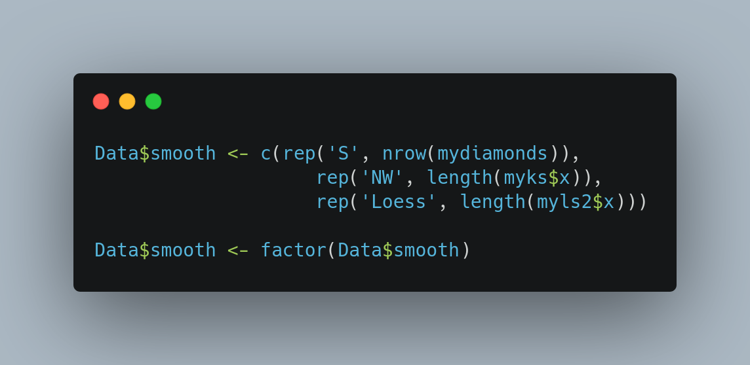

We can see that the first nrow(diamonds) rows have the label ‘S’ (standing for scatter), the next length(myks$x) rows have the label ‘NW’ (standing for Nadaraya-Watson) and finally, the last length(myls2$x) rows have the label ‘Loess’.
At this point, we are now done with data preparation. Our pre-final step is to define the colors and line styles we’ll be using in our plots. Here is the code.
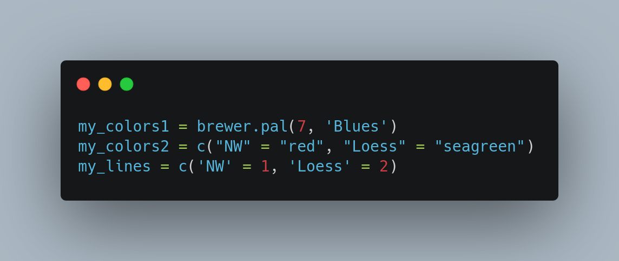

The first variable my_colors1 will be used as colors for the hexbin scatter plot. This vector does not need to be named.
The second variable, my_colors2 will be used as the colors for the lines. Make sure you name this vector same as the smooth variable in your dataset. Finally, we have gone ahead and defined the my_lines variable as well. The key for this is: [0 = blank, 1 = solid, 2 = dashed, 3 = dotted, 4 = dotdash, 5 = longdash, 6 = twodash].
Now let us create our hexbin plot.
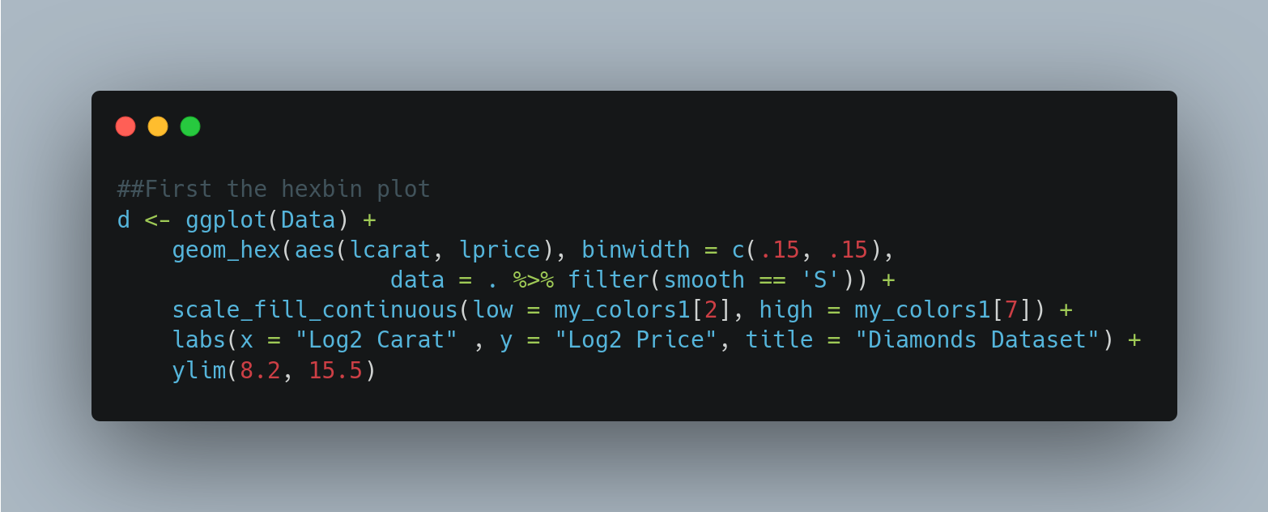
You see how I’ve done it:
- The first call is ggplot, to which we pass our long dataset.
- The second call is to geom_hex to which we pass the pass the variables lcarat and lprice via the aes function.
- We limit the data that geom_hex sees via filtering on the smooth variable.
- Finally, we pass in the color scheme using the scale_fill_continous function.
- The rest is quite obvious.
The output is below.
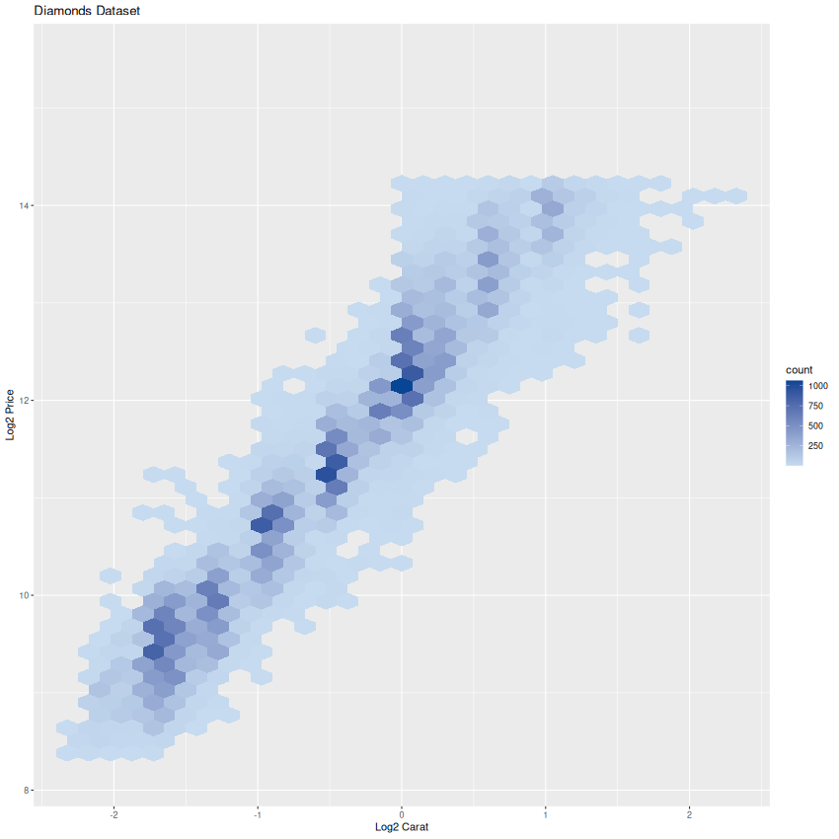

Finally, we add in our lines. Here is the code fragment for it:
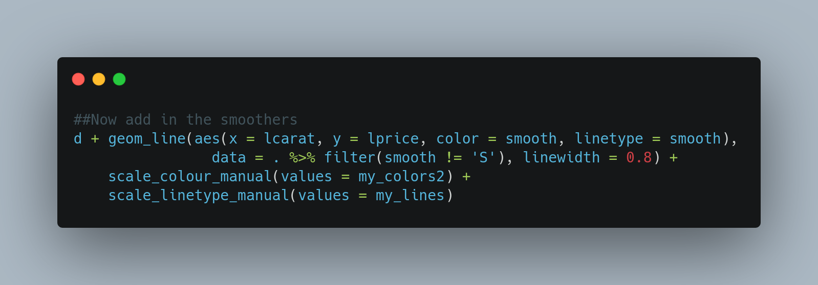
We continue our commands to the previous graph using the helpful “d + …” ggplot2 syntax. The key function is geom_line. The syntax is similar to the geom_hex function we just saw, except that we pass the color and linetype arguments. The value of each of these is the smooth variable in our long dataset.
Finally, we subset the data using the data argument.
We override the default colors and line styles using the scale_color_manual and scale_linetype_manual and to each we pass the the mycolors2 and my_lines variables we had defined earlier.
And that, my friends is how you do it!

