How much does it tell me?
When dealing with any experiment whose outcome is not certain (random), there is a concept of information contained within the outcome of that experiment. This same concept of information also extends to statistical distributions.
Here I explain what this concept of “information” is, and illustrate how to calculate the information content of any distribution using the #R / #Rstats programming language.
First lets understand the concept. Let us consider a very simple illustration of a die roll. Suppose I have a biased die that always turns up 6. Then, instead of the full space S = {1, 2, … , 6} I can represent my space as just S₀ = {6}. Such a die is terrible for playing games, but it would be loved by a statistician. The less randomness we have to deal with, the better! Technically, we say that such a random variable has a lot of information.
Inversely, a perfectly fair die that takes all 6 values with equal probability has the least amount of information possible for a die. There is more randomness, and thus less information.
We could have something in between as well – a die that usually lands outcomes {1,2,3} and lands outcomes {4,5,6} with a smaller probability. Such a die has more information than the perfectly fair die, but less than the one that was completely biased.
Second, how is the information measured. In computer science, the concept of information is codified by its inverse, called “entropy”. Entropy refers to the amount of disorderliness or randomness in a particular variable. So more entropy means less information, and vice-versa.
The most common definition of entropy is due to Claude Shannon who proposed the following formula in 1948:

Finally, how does it work?
For that, we’ll need to go to the concept of statistical distributions. As an example, I have considered 4 Beta densities. The advantage of this is that all Beta distributions are constrained to the interval [0,1] and they are all uni-modal densities. Thus the only thing that changes between these densities is where the mode occurs, and how prominent it is.
I have also considered the Uniform Distribution on [0, 1] as comparison to a very well known distribution.
First I have plotted the actual probability density functions for each of these 5 distributions.
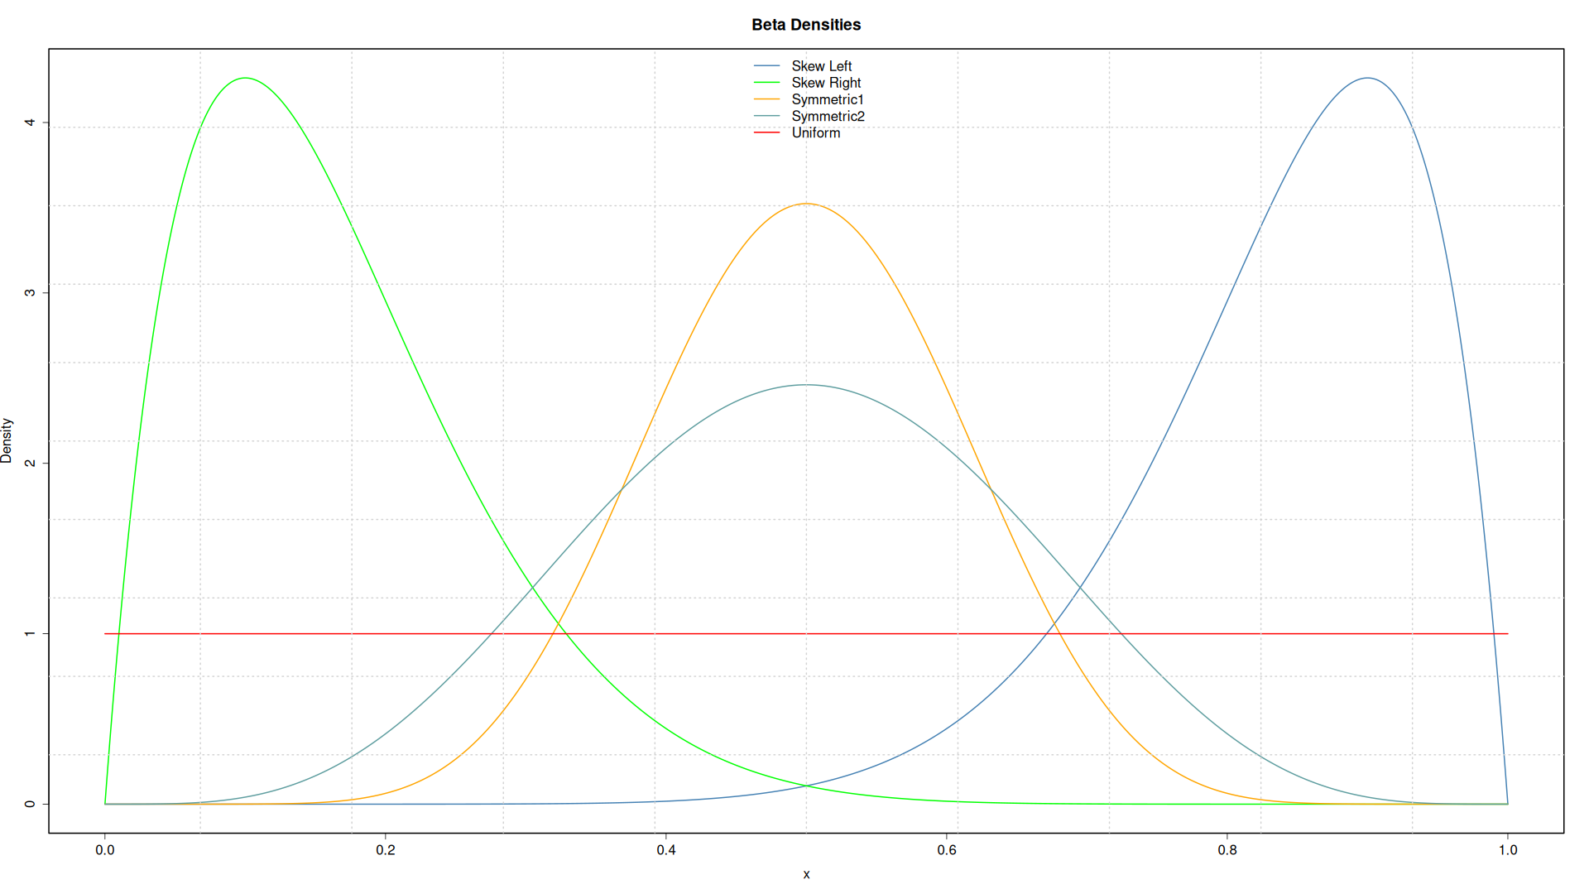
As you can see, the skewed densities have high peaks than the symmetric distributions considered. With this, I have attempted to imitate real life, since in practice, skewed densities are almost always very peaked than symmetric ones. I have also considered two symmetric distributions, one more peaked (less diffuse) than the other (more diffuse)
In R, entropy can be calculated using the entropy function from the entropy package.
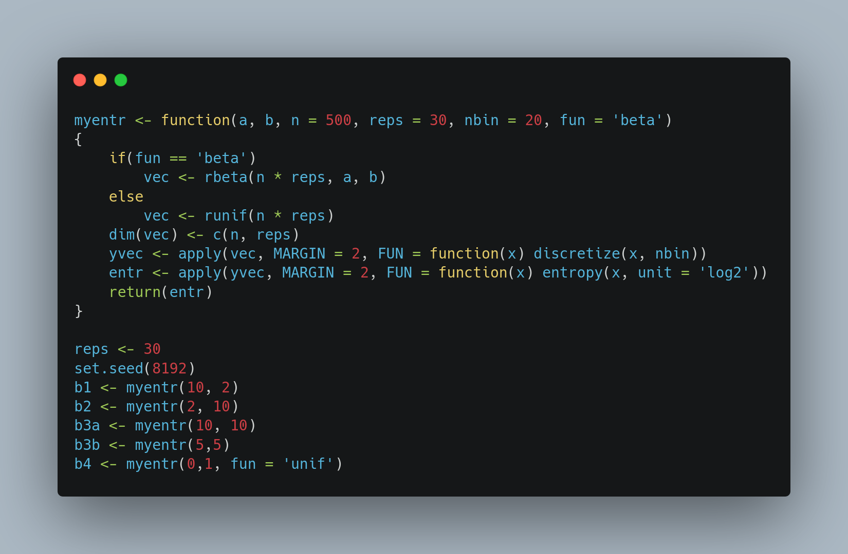
The following code fragment, generates 30 samples, each of size 500 from each of these densities. These samples are then binned into 20 bins using the helpful discretize function from the entropy package. Finally, the entropy is calculated for each sample, resulting in 30 entropy values (one for each sample). [The reason we did 30 repetitions is because it gives us information on how much variability there is because of random sampling.]
Finally, we can obtain a box plot of the entropy measures. Remember, that higher entropy means less information. So the “good” distributions in this graph are those that are concentrated on the left side of the plot.
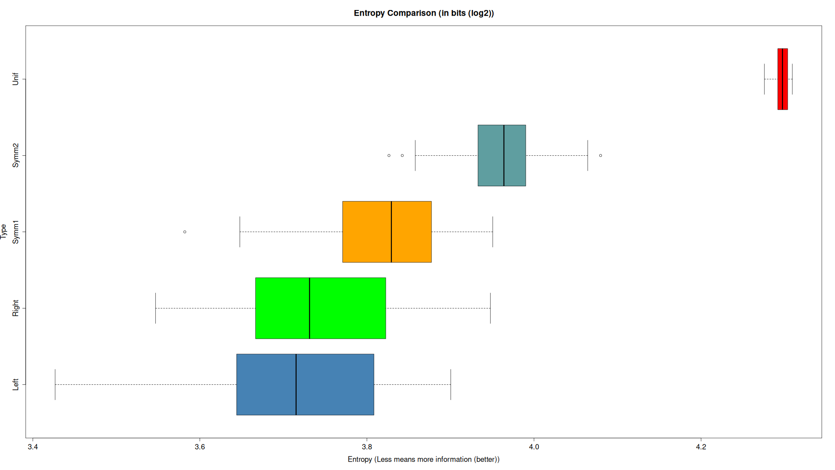
What do we observe?
First thing is that both the skewed densities have the least amount of entropy and thus the maximum amount of information. This is to expected because of their peaked nature.
Then we have a very interesting comparison of the two symmetric distributions. The orange density is more peaked, and this is reflected in the entropy measure. The orange density has substantially less entropy (more information) than the blue symmetric density.
Finally, at the very bottom of the information pile we have our uniform density. It has the maximum entropy of all and thus the least information.
You can grab this article in .odt format and the R code from the link below.

Thats all folks!

