Measuring Skewness in a Modern Way
Most data scientists are familiar with location parameters (mean / median / etc.) and scale parameters (standard deviation / IQR). But to describe a dataset we need more than that.
An important concept in statistics is the balance of the two tails of the distribution. That is, is the left tail of the data as long as the right tail, or is the left tail longer, or is the right tail longer. The technical term for this concept of balance among the data’s tails is called skewness.
In this article, we will see how skewness was traditionally measured and a more modern measure of the same.
Let’s begin!
To start, let us look at a picture.
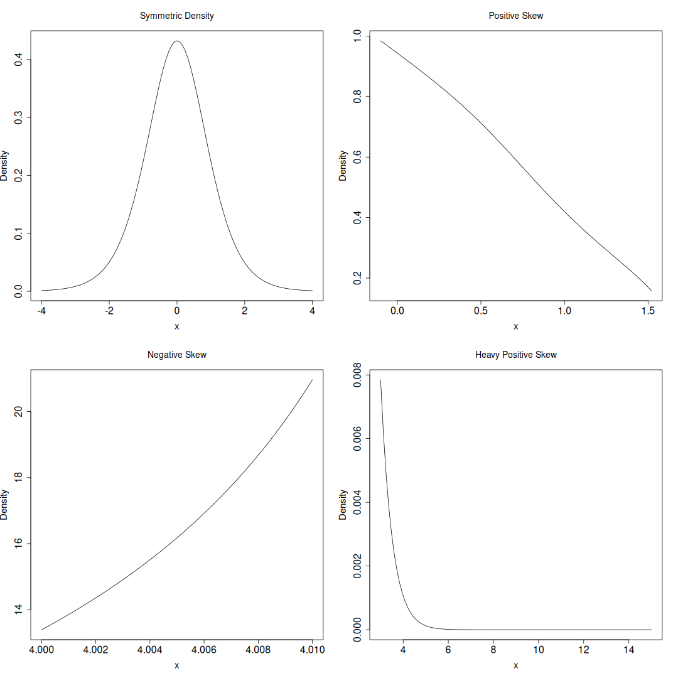
The picture above is of 4 different probability density functions. They come from a versatile family of distributions called “Generalized Lambda Distribution” that we have encountered earlier as well.
Look at the 4 graphs closely.
The first one is obviously symmetric, but think closely why you think that way. Thinking will help you grasp the concept even when the symmetry breaks down. See how the two tails of this distribution – the left and the right, match each other. The concept of skewness deals with this symmetry or asymmetry in the tails.
Now look at the second graph, the one labeled “Positive Skew”. Here, there is no apparent left tail – the distribution starts from a peak, and then tapers down to the right. There is a right tail, but it is not very long. Since the right direction is generally considered positive (as in Left to Right writing scripts), this situation is called positive skew.
Let us now look at the third plot, labeled “Negative Skew”. Here the graph gradually rises from the left, and peaks at the right. The tail on the left (negative direction) is readily apparent, but there is only a peak, and no tail at the right. Since the left tail is longer than the right tail this situation is called negative skew.
Finally, the fourth plot – heavy positive skew. I have added this one here to illustrate how we can attach a degree (or magnitude) to a particular skewness situation. Looking at the two positive skew situations, we can observe that although qualitatively similar, in the last plot the right tail is much much longer. Hence the skewness is heavier in the last plot than in the second one, despite the direction of skewness being the same.
💡Now that we are comfortable with the concept, lets look at how to measure it.
1️⃣ The original proposal to measure skewness comes from Karl Pearson in the early 1900s (more than a century ago). His idea was to use the third central moment as a base to measure skewness. The exact formula he proposed was,
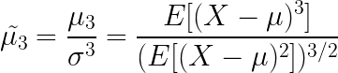

Here the E-operator denotes the expectation – essentially the mean. Thus, one measures the cubed distance from the mean and divides that quantity by the cubed standard deviation.
Karl Pearson’s motivation for this measure comes from physics, where there is the concept of moment of force (torque). He imagined a probability density function as being centered or pivoting around the mean, μ. Then, the third moment around this mean, is a signed (since its cubed) distance.
👉 If the density function is symmetric, the positive and negative distances cancel each other out, yielding a value close to zero.
👉 If the density function is positively skewed, the positive distances overpower the negative distances, and we are left with a value that is positive.
👉 If the density function is negatively skewed, the negative distances overpower the positive distances, and we are left with a value that is negative.
👉 The division by the cubed standard deviation is simply to ensure that the final quantity is dimensionless / scale-invariant.
There are however, several problems with this approach.
💔 First there is the question of outliers. Cubing the distance from the mean, will make distances that much bigger. A single outlier can really blow up this skewness measure.
💔 Next, is the question of interpretation. This skewness measure outputs a real number, but how big is big? In other words, a distribution with skewness of 1.0 is more skewed than one with skewness of 0.5.
💔 But where does heavy skewness lie? Is it 1.0, or 2.0 or 3.0? In fact, this skewness measure is unbounded, so there is no way of telling where light skewness ends, where moderate skewness starts, and where heavy skewness starts.
2️⃣ The modern proposal to measure skewness comes from Brys, Hubert, and Struyf (2004). This measure is called the Medcouple.
Although, there is a formula for this measure, it is much easier to communicate via an algorithm.
🗯️ Let M be the sample median of the data set X = {x₁​,x₂​,…,x_{n}​}.
🗯️ Divide the data into 2 halves, Left Half = {x_{i} | x_{i} ≤ M} and Right Half = {x_{j} | x_{j} ≥ M}.
🗯️ Define the kernel function, h(x_{i}, x_{j}) as,
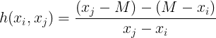

🗯️ Evaluate the kernel function for all pairs (x_{i}, x_{j}) where x_{i} comes from the left half of the data, and x_{j} comes from the right half of the data.
🗯️ List all kernel values in order, and take their median. This median will be the medcouple.
Sounds simple right?
And note how in the definition of the kernel function, we have the denominator (x_{j} – x_{i})? This ensures that the kernel is scaled between -1 and 1. Thus the medcouple is also scaled between -1 and 1.
There are several advantages of the medcouple.
😇 The number is negative for negatively skewed data and positive for positively skewed data, just like Pearson’s measure.
😇 The medcouple always lies between -1 and +1 so its easier to interpret.
😇 The medcouple is robust to outliers – 25% of the outlying data can change and still the medcouple would still remain the same!
😇 Location and Scale Invariant: Adding a constant to all data points or multiplying by a positive constant does not change the Medcouple value.
Let me leave you with some code to compute the traditional skewness measure and the medcouple in R.
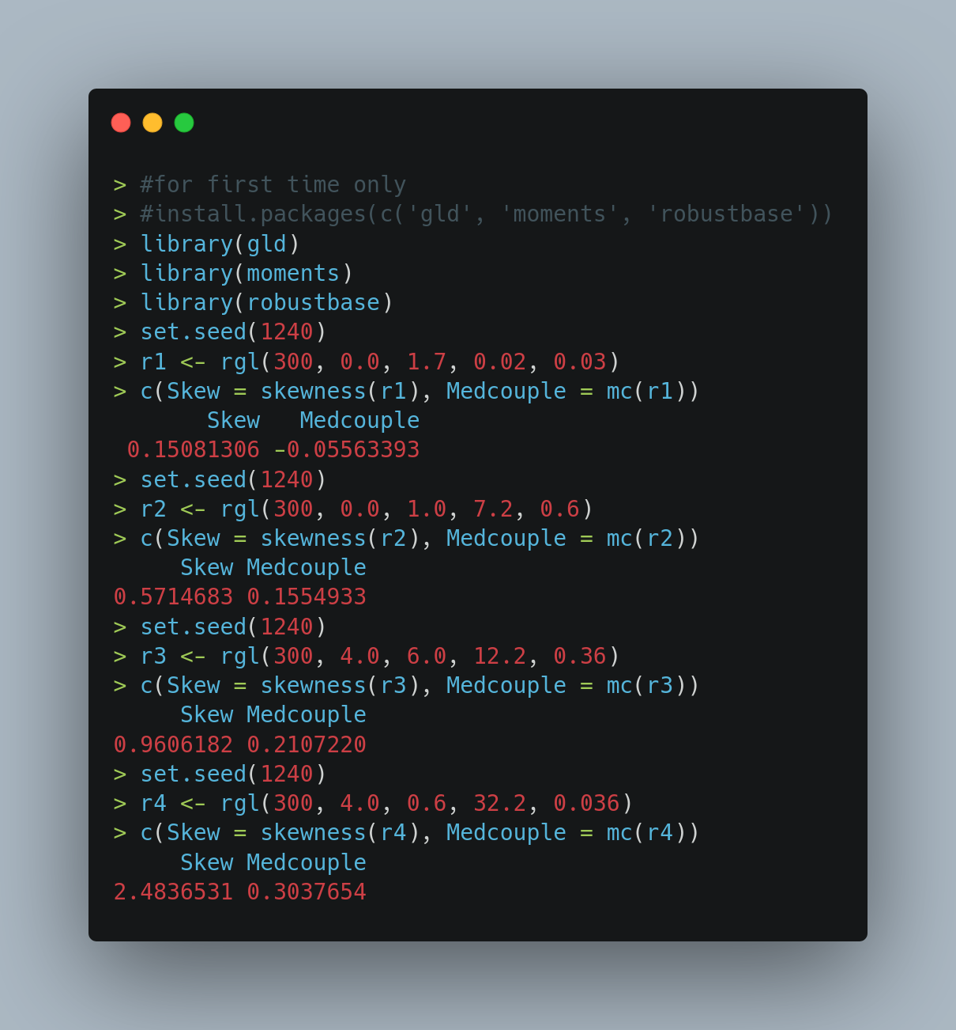
And here is the histograms of the samples generated above.
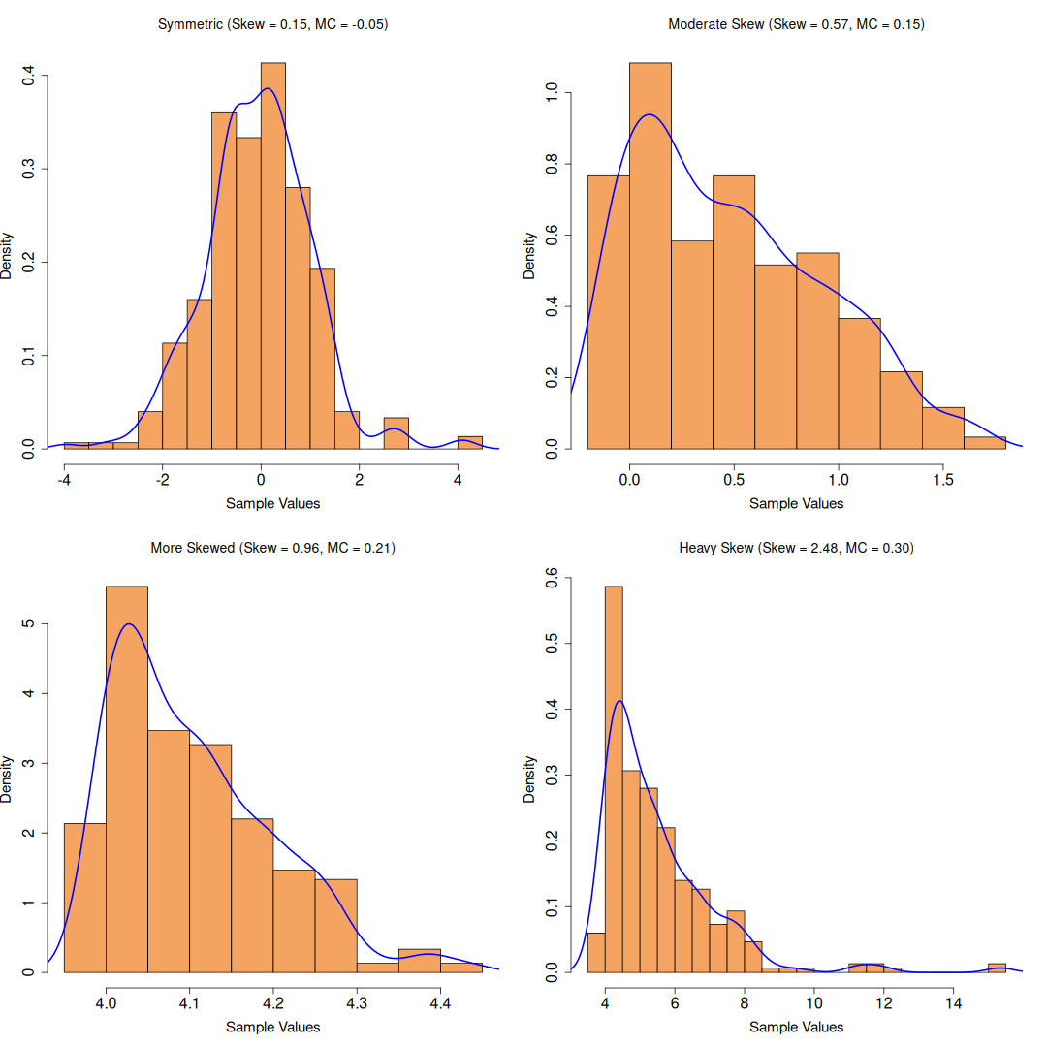
Dont forget to grab the article in odt format and the code from my github!
That’s all folks!

