Density Estimation
Last time we saw data transformations and how to judge the appropriateness of a model using QQ-plots. This time, we explore something that we only briefly touched last time – the histogram.
Of course, we all know histograms. But I’m going to extend histograms from the usual boxes kind of plot to a continuous density curve. And in the process we gain something pretty valuable – generative-ness. That is, our density curves no longer only describe the data, but can now be used to generate data that looks exactly like the original! Lets dive in!!
#R #Rstats #density #histogram #datascience #statistics #graphs #plotting #data
For purposes of illustration, we’ll be using the geyser data from the MASS package. A geyser is a special kind of volcano that throws up hot water and mud at regular intervals. This dataset relates to the “Old Faithful” geyser in Yellowstone National park, USA and has 299 observations relating to eruptions between Aug 1 to Aug 1985.
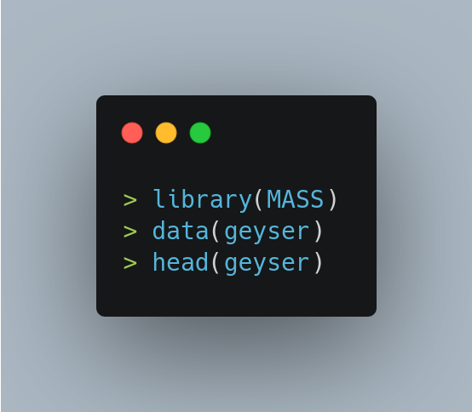

There are 2 variables in the dataset – we’ll be using the waiting variable which is the waiting time between eruptions. Here is the histogram.

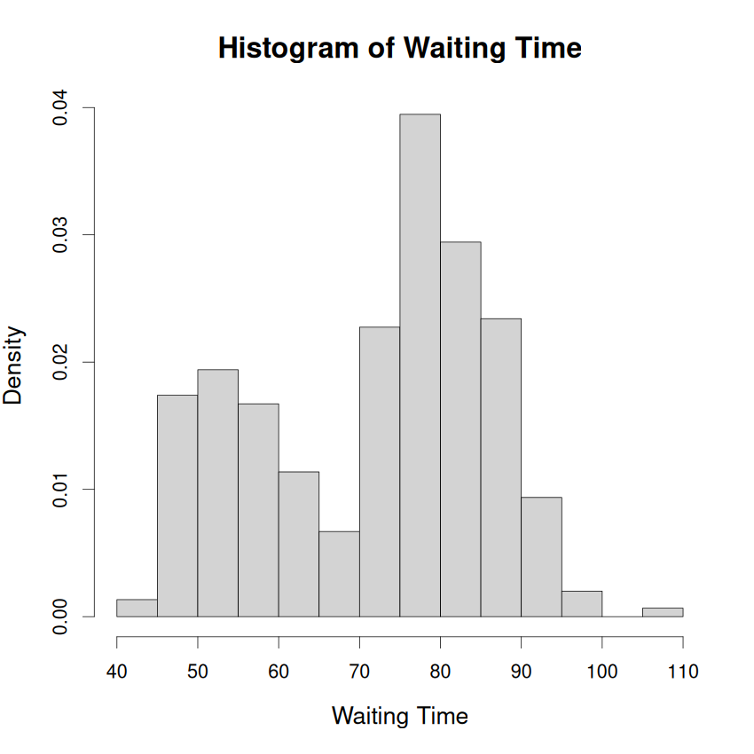
It is easily apparent that this variable has two peaks or modes. Such distributions are called “bi-modal” and are not easy to model. The reason is that almost all models like normal, gamma, cauchy, t, etc are all uni-modal or 1-peak models. Hence we can rule out all such models for our data.
What next?
Enter the kernel density estimate (or kde). The kde is a non-parametric estimate of the probability density function. Non-parametric means that the kde is no longer using a specific global model for the data like normal or gamma. The keyword really, here is “global”. What the kde is saying is that the entire distribution is bimodal, but let me zoom into one very small part of the distribution.
For instance, let us look at the distribution between 40 and 60 in the above histogram. In this very small range, the data will look normal. In case it doesn’t, the kde will try to look at smaller and smaller ranges until the data starts to look normal in that small range. This “range” is technically called the “bandwidth” of the model and is an important parameter of the kde model.
The following code fits the kde model to our data.
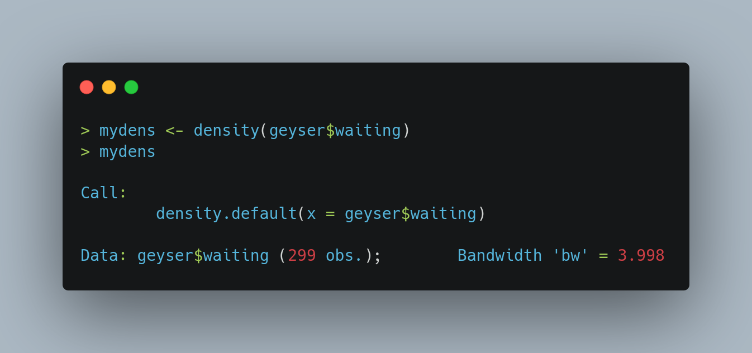
As we can see from the above output, the bandwidth chosen by the kde model is about 4. So its trying to look at intervals of 4 like [40, 44], [41, 45], [42, 46], etc and fitting a normal density to each interval. Hence there is a local model that is parametric and well-known, and the global model is a summed-up version of these numerous local models.
Lets try and look at the fit of this kde model. The dark blue line is the fitted kde.
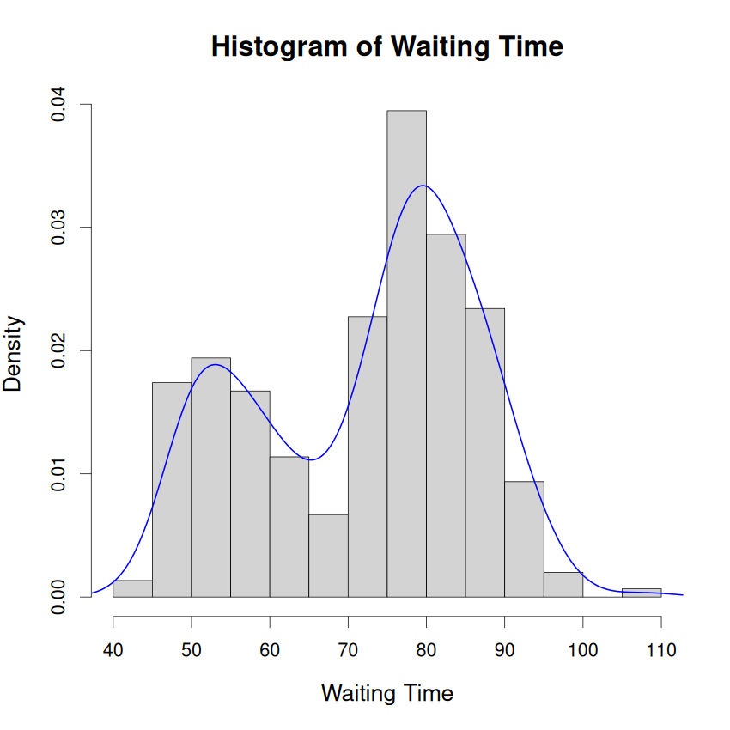

As we learnt in our previous article, a plot like the one above is good enough for getting a snapshot, but to really dive into the details, we need to draw a QQ plot. This is because the QQ plot draws a line that allows us to judge the fit along the left tail, center and right tail.
Additionally, in case of bi-modal distributions, a plot of the density like the one above, rises and falls, which makes judging a fit even more difficult. But the QQ plot, even in case of a bi-modal or multi-modal data is still a straight increasing line.
But there’s a problem still. The version of QQ plot that we saw last time requires a distribution function. But, we just saw, the kde is a non-parametric model and there is no “global” model. So there is no easily available distribution function to get the percentage points.
We solve this problem by generating a sample from our kde model. Yes you heard that right, we are going to generate fake data from our model. This is why kde is a generative model in the same sense as “generative AI” – both models are capable of generating fake data that looks just like the original.
The following function accomplishes this.
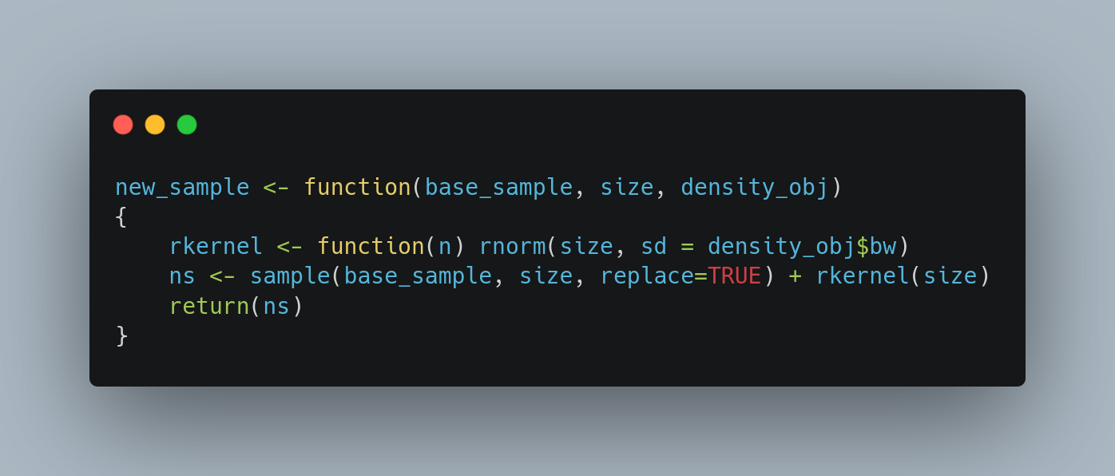
I will briefly explain what is happening in this function.
Remember when we discussed the “bandwidth”? Well, let me reveal something more to you. What the kde is doing is that it is fitting a normal distribution with mean = x₀ and sd = bandwidth. Here x₀ is any sample point of the data.
The function above exploits this. We first pick “size” points from our data (This is the sample function above) and then add to it random noise from our kde estimate.
Pro Tip: You can use the kde and the function above to impute missing data as well. The final dataset will look just like the original!
Lets move on to the QQ plot!
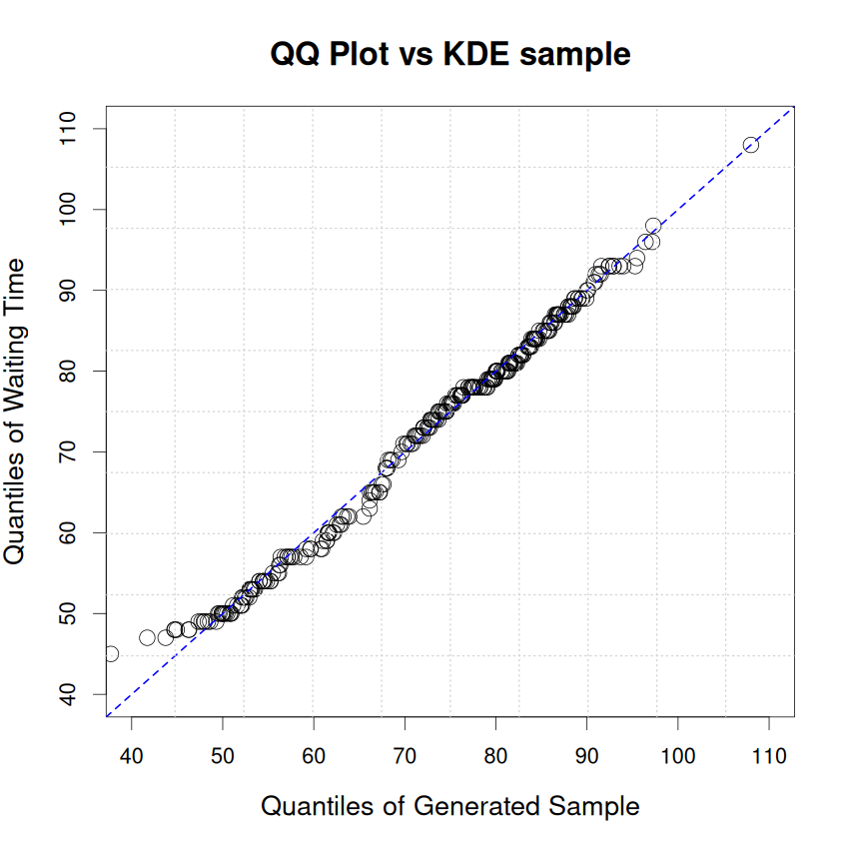
The fit couldn’t have been better!
Thats all folks!!

