Smoothing Scatter plots
In this article, we’ll continue to use the diamonds dataset that we saw last time. We extend our analysis in two directions:
- I’ll show how to generate the hexbin graphs using the more popular ggplot2 package.
- I’ll show what is meant by smoothing a scatter plot and how it can be accomplished in R.
Let’s begin!
#R #Rstats #transform #log #datascience #statistics #graphs #plotting #data #kernel #smoothing
Generating using ggplot2
Well, as to the first point, there is little to provide except the code that generates the figure. Here it is.
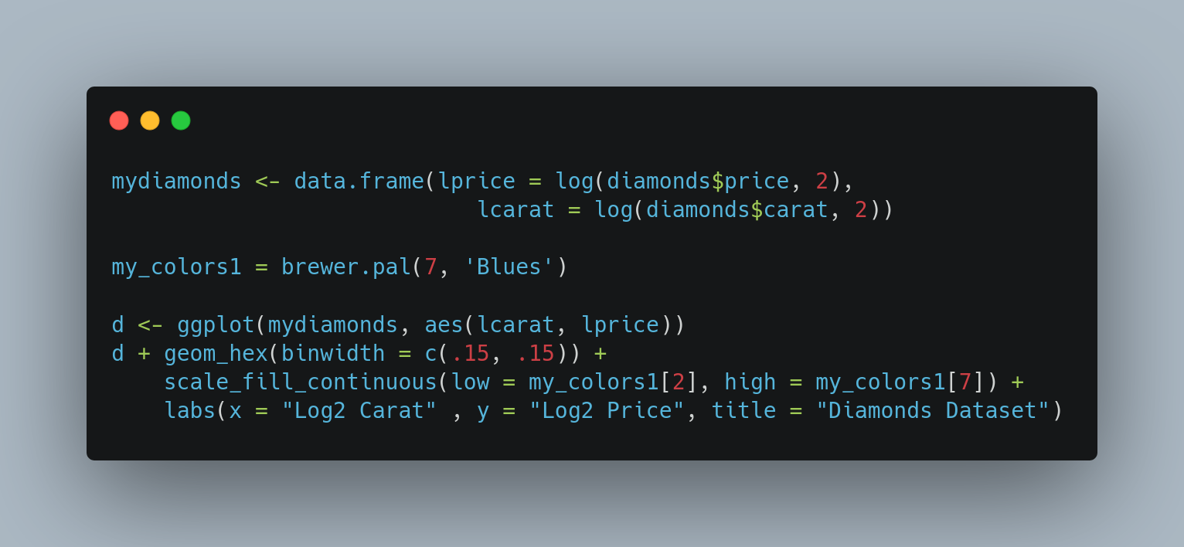
A few important points:
- We now create the lprice and lcarat inside a data frame, since ggplot works best with data frames.
- The hexagons are created using the geom_hex function
- By default, ggplot colors blank areas dark, and high density region as light. I find this counter-intuitive. So I have explicitly generated the colors using the brewer.pal function, and passed the colors using the scale_fill_continuous function.

The result is shown in the next graph.
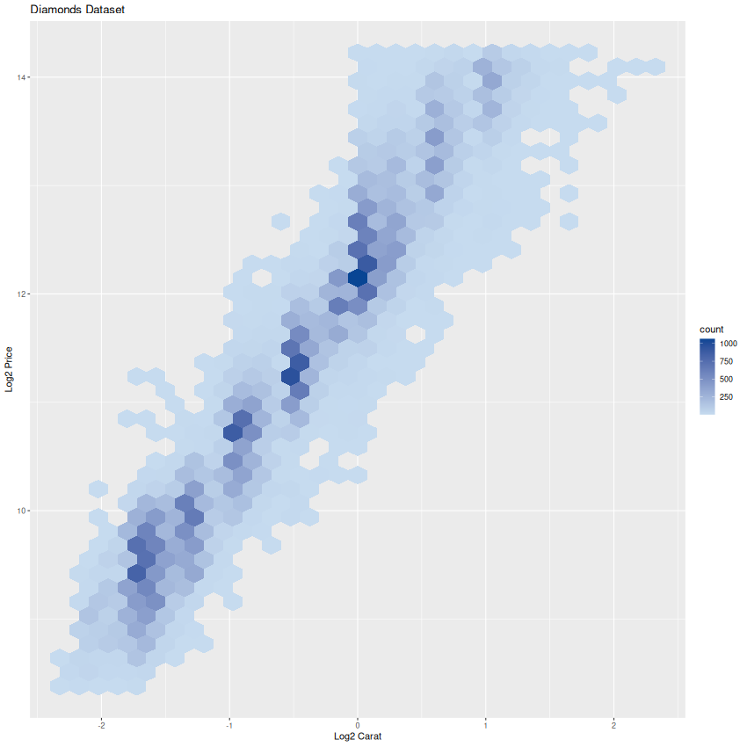

Scatter plot Smoothing
Scatter plot smoothing is just a fancy way of saying that we want to add a curve to the scatter plot that summarizes / visualizes the relationship between the two variables. It is called smoothing since the algorithm literally “smooths” the data.
There is more than 1 mechanism to smooth the data. The one we’ll deal with here is called “Nadaraya-Watson kernel regression” (NW Regression). The way it operates is similar to the density plot we saw in an earlier article. Essentially, it takes a kernel function (usually the Gaussian / Normal density function) and applies it across a grid of points to estimate the relationships locally.
Lets see it in action!

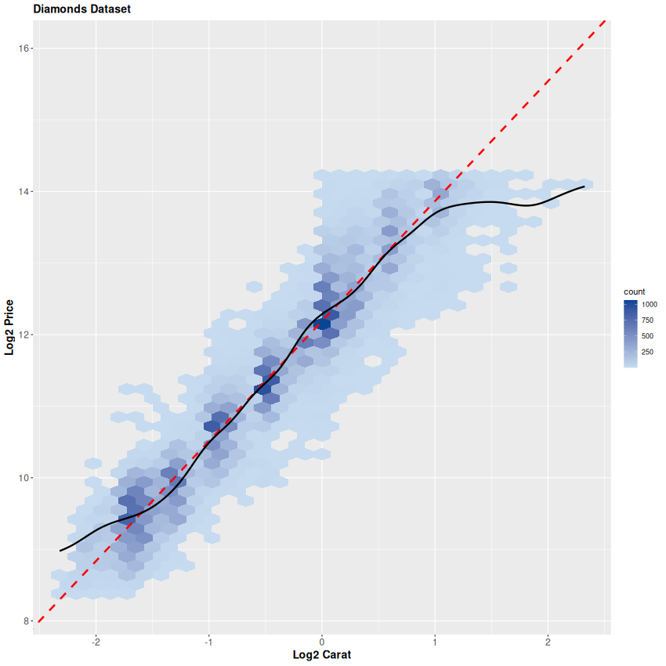
The dashed line is the OLS line we saw in the previous article. The problem with it is obvious: it overshoots the data on the right end. Basically, the price stops increasing after a point, but the OLS is not capable of taking this into account.
The black curve is the NW Regression. This works on the basis of neighborhoods, and local estimates. Essentially what this means is that instead of fitting one “global” relationship across the entire data range, it fits on the basis of local relationships. So that (as we can see from the figure) over the middle range, the NW curve is indistinguishable from the OLS line. But over both the left and right edges of the data, the NW curve flattens out.
Visually, the NW curve is a much better fit to the data than the OLS. And it comes with very little computational overhead. I would recommend to plot it over any scatter plots you make. It helps as a visual cue to the eye for following the relationship.
Thats all folks!

