Choosing Scatter Plot Smoothers
Using a smoother is very helpful when drawing scatter plots in R. But this is not the end of the story: there is more than 1 choice of smoother in R. The most commonly used are
- The Nadaraya-Watson kernel regression (via the ksmooth function) [which we saw last time]
- The Local Polynomial Regression Fitting (via the loess function)
In this article, we will dive just a little bit deeper into both these techniques to help us reach a better understanding.
Lets begin!
#R #Rstats #transform #log #datascience #statistics #graphs #local #regression #data #kernel
#smoothing #ggplot2 #visualization #MachineLearning #NonParametric #StatisticalModeling
#KernelRegression #ModelFlexibility #DataDriven #AssumptionFree #PredictiveModeling
#PatternRecognition #DataAnalysis #DataInsights #ComplexRelationships #FlexibleModels
#DataScientists #Statisticians #Tech #BigData
The Nadaraya-Watson kernel regression is essentially a (local) weighted average of the Y-values at every X point. The formula for this smoother can be written as,
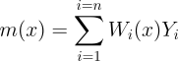

The Nadaraya–Watson estimator can be seen as a weighted average of Y₁,…,Y_{n} by means of the set of weights {W_{i}(x)} (they add to one). The set of varying weights depends on the evaluation point x. That means that the Nadaraya–Watson estimator is a local mean of the Y-values about the point X=x.
The formula for the weights W_{i}(x) can also be written down explicitly,
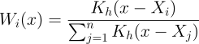

Here, the function K_{h}(.) is called a “kernel” and h is called the bandwidth. Usually, the kernel is taken to be the Gaussian (Normal) density.
Now, the reason I gave you these formulas, is so you can see how easy it is to compute. You just need to:
- divide the range of X into a grid of points,
- then calculate the weights at each of these grid points
- finally, compute local averages of the Y-values with the calculated weights
An important point is that the grid in step (1) can be as fine or coarse as you want. Importantly, there is no direct dependence on the number of data points you have. This is important, as we shall see in just a moment.
The loess smoother (Local Polynomial Regression Fitting) on the other hand is a more complicated creature. There is no formula for loess that can be written down. Instead it is an algorithm. The algorithm steps are:
- A constant called the span (also called α) is chosen. This constant roughly defines the neighborhood of every point. By default, it is set to 0.75 by R, which means that 75% of the closest points determine the local neighborhood of each points.
- The points in the subset are assigned weights. Greater weight is assigned to points closer to the sample point. By default, the weighing function is the tricube kernel.
- A regression line is fit to the subset of points in the local neighborhood. Points with smaller weights will have less leverage on the fitted line than points with larger weights. The fitted line is by default a second order polynomial fit in R.
The most important take-away from this algorithm is that the loess smoother needs to be calculated at each sample point. This is quite unlike the NW kernel where we choose a grid of points.
The most direct effect of this is that the loess smoother is orders of magnitude slower than the NW kernel. In fact, in its native form, loess is unusable for anything other than toy data. Further, the fact that loess needs local regressions, also inflates its memory usage. See this remark in the R documentation:
The memory usage of this implementation of ‘loess’ is roughly quadratic in the number of points, with 1000 points taking about 10Mb.
Let us look at some code now. We will be using the same diamonds dataset as above.
For NW Regression:
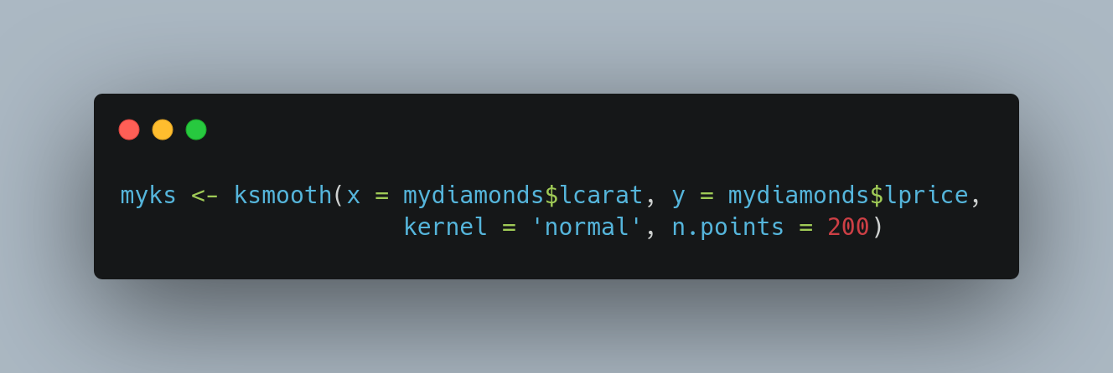
Note the n.points argument above: essentially we calculating the smoother at just 200 points instead of the 50K+ points in the data. This makes the processing practically instantaneous.

For the basic (or naive) loess smoother: (Note that this takes time, don’t run it on a slow computer)
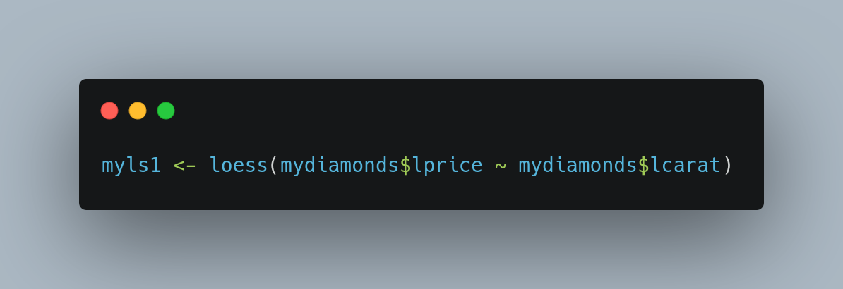
You can speed up the loess calculation, by explicitly telling R not to compute the curve at every single point. This is how you do that:
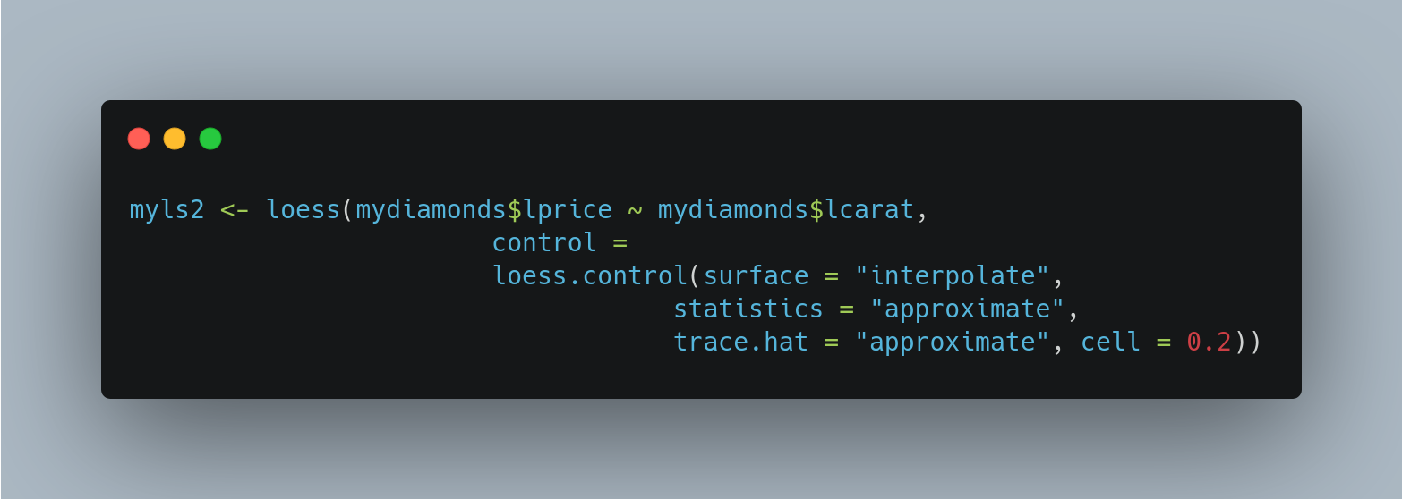
We can also time our functions using the microbenchmark package. Here are the results:
 | min | lq | mean | median | uq | max | neval | Units
NW | 65.69 | 65.82 | 66.11 | 65.88 | 65.98 | 69.17 | 100 | ms
Loess-Exact | 41.44 | 41.51 | 41.67 | 41.58 | 41.61 | 44.35 | 25 | s
Loess-Approx | 85.00 | 85.80 | 88.33 | 88.07 | 89.16 | 146.73 | 100 | ms
Loess- Exact % | 62978% | 62961% | 62936% | 63010% | 62963% | 64012% | (Slower by)
Loess-Approx % | 29% | 30% | 34% | 34% | 35% | 112% | (Slower by)

As we can see, loess exact is thousands of time slower than Nadaraya-Watson regression. Even loess approx is on average 30% slower.
Finally, a plot of both the smoothers: [the orange line is loess, and the dark green line is Nadaraya-Watson kernel]. The two methods agree for most of the data range, but the NW Kernel provides a better fit in the upper range of the data.
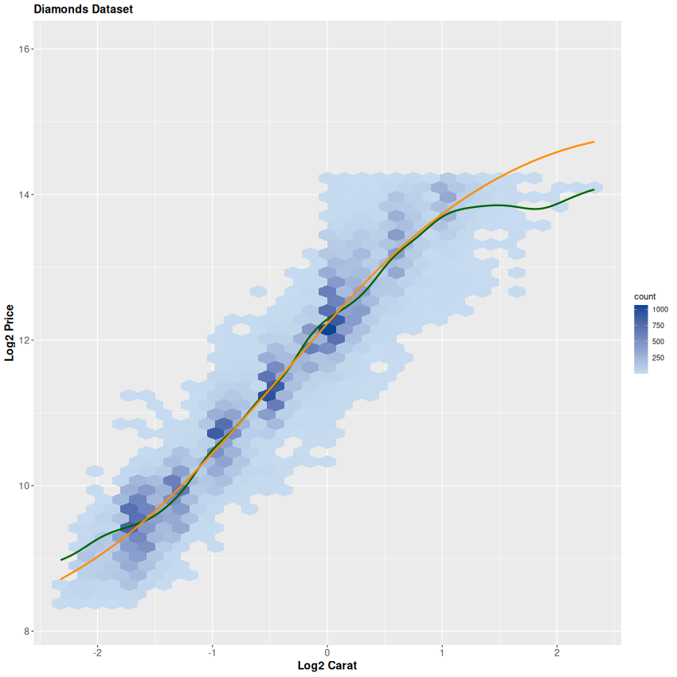
Thats all folks!

