Finding roots of functions
R is not just a powerful statistical language. It also has functions that can help students understand advanced math, especially, in the fields of calculus, real analysis and numerical analysis.
In this article, I will introduce two functions for this purpose: curve and uniroot. Each of these functions is very basic, and does just one thing. When combined, they are a formidable tool to understand the behavior of any function.
Lets Begin!
Lets start from the first step: how can we re-frame an equation into a function that R can understand and work with.
Lets suppose this is the equation we can to work with.
The trick is very simple: get all the terms of the equation on the left hand side (LHS) so that only a zero is left on the RHS.
Thus,
Be careful, putting everything on the left, changes the sign, so we get a (-x) and a (-35).
Thats just about all there is to it. We can now write this as a function in R, and even evaluate it a some chosen points. This is how.
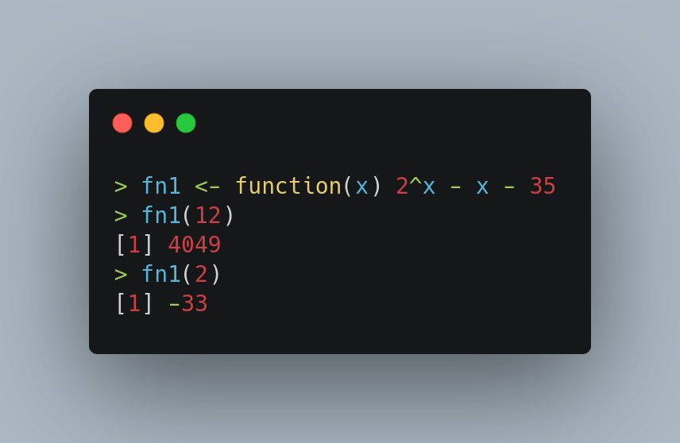

I have defined a function that has the LHS of the equation above. This is now a function that can take on any real value. For instance, I have evaluated it at x = 12 and x = 2 above.
Our original idea, translated to this new setting, is to find the x* where fn1(x*) = 0. I have generalized it, so that fn1 can now take on any value. This generalization is essential since R thinks in terms of functions, not equations.
Thinking in terms of functions gives us a richer vocabulary, than just equations. How so?
Enter our second tool: the curve function. The idea is here is just as simple: instead of evaluating our function at a few discrete points, why not evaluate it at a large number of points within a given range?
This is possible since we have at our disposal a modern computer, that can perform hundreds to thousands of function evaluations in a matter of milliseconds. Think of it as a brute force algorithm.
Here is how you do it.
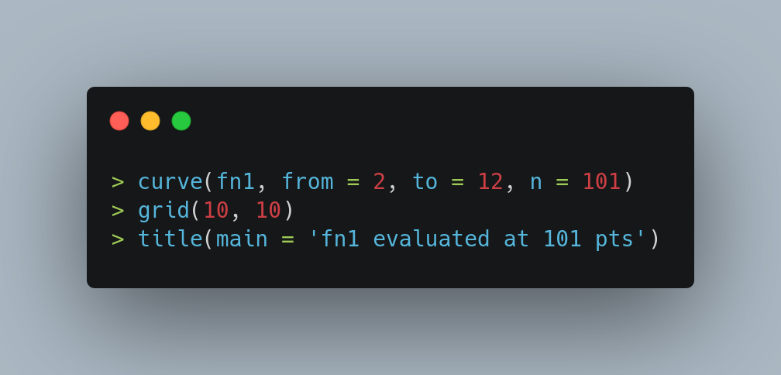
And here is the generated curve.
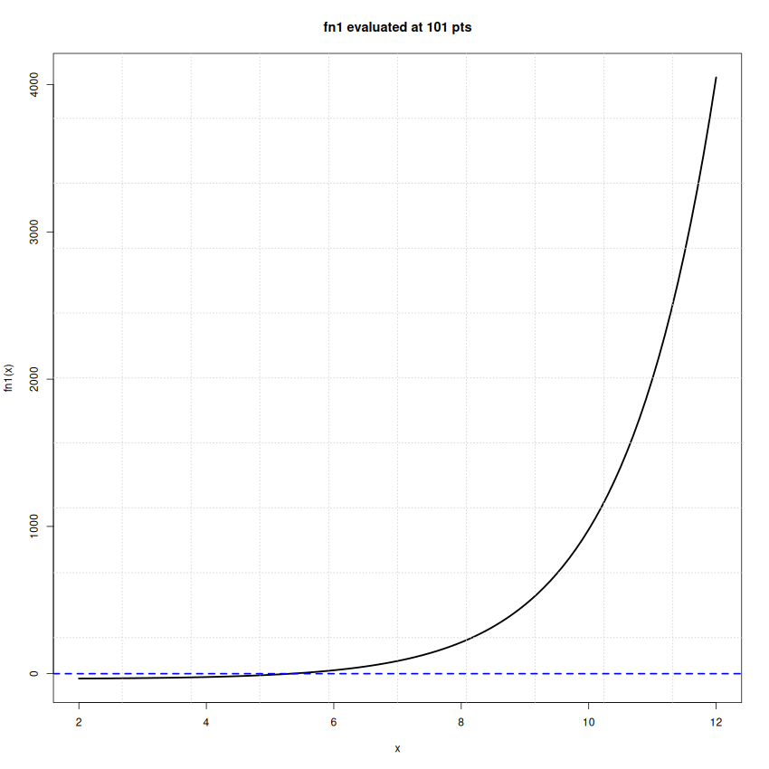

Now there are very good reasons why I asked you to plot the function. The first is, because it tells you about the shape of the function. Like, our fn1 is non-linear and has exponential growth. This gives you a feel for what you are dealing with, with almost no effort.
The theoretical tools from calculus (eg: sign of the derivative to judge where a function is increasing or decreasing) are useful, but with a modern computer, there is no better alternative than looking at the function directly.
There is also another very good reason to look at the function graph. And this comes from our final tool: the uniroot function. This function allows us to directly solve fn1(x) = 0 provided you can give it an interval [a, b] that contains a root.
According to some basic theorems in algebra and real analysis, an interval [a, b] contains a root of a continuous function f(x) if f(a) and f(b) have opposite signs. Using this info is very easy: if you draw the graph of a function using curve and observe the function cross 0 on the Y-axis, you have an interval that will do the trick. If not, try curve again with a different interval.
In our case, we already saw fn1 has opposite signs at 2 and 12. So lets pass uniroot this information.
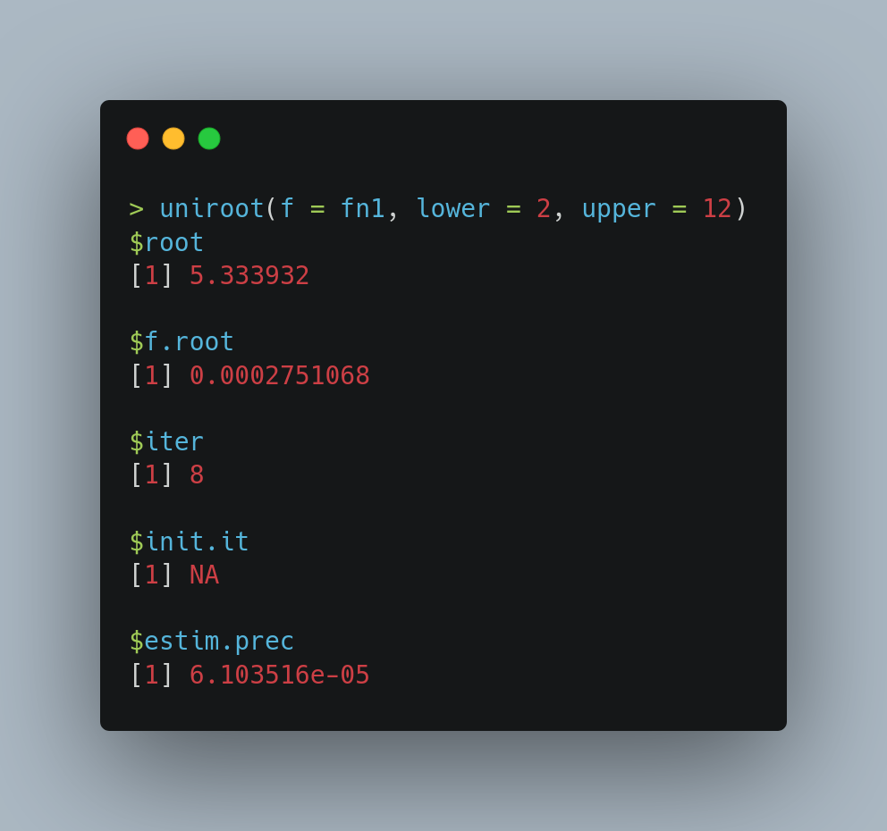
Voila! We have it – our fn1 has a root at x* = 5.3339. The function also helpfully returns the actual functional value at this root, which is fn1(x*) = 0.000275. This value will seldom be exactly 0 since uniroot is a numerical algorithm. Finally, The estim.prec value represents an approximate estimated precision for the found root. It gives an indication of the uncertainty of the calculated root location (smaller the better).
Great!
Before we break, lets look at another example.
Lets rewrite this a function and get its graph.
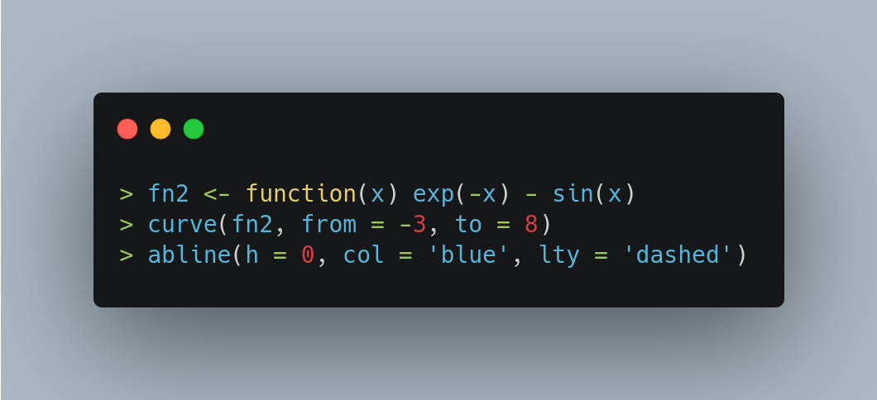
And this is the graph we get. Note the slight periodicity that this function inherits from its sine component.
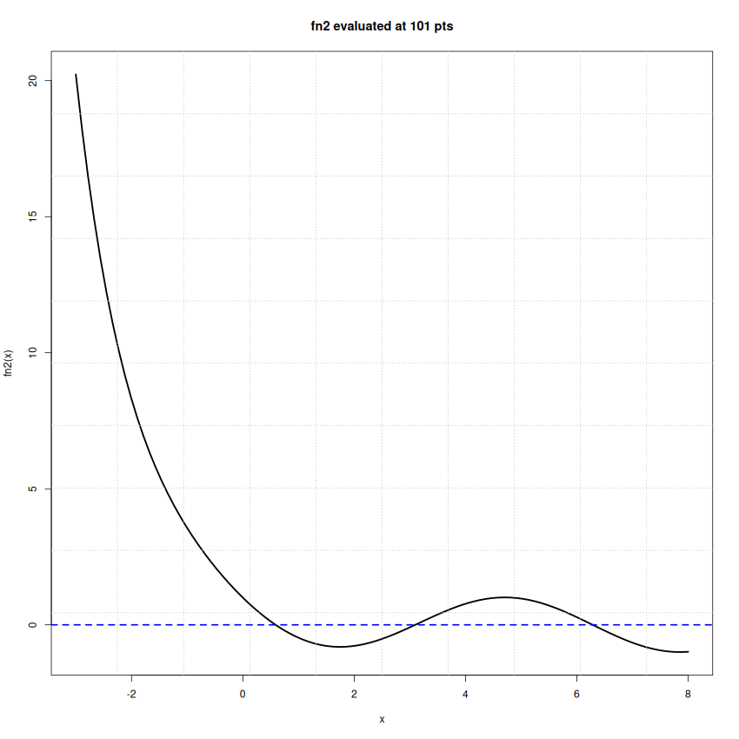

It is easy to see that there are at least 3 roots (zero-crossings). Lets locate them!
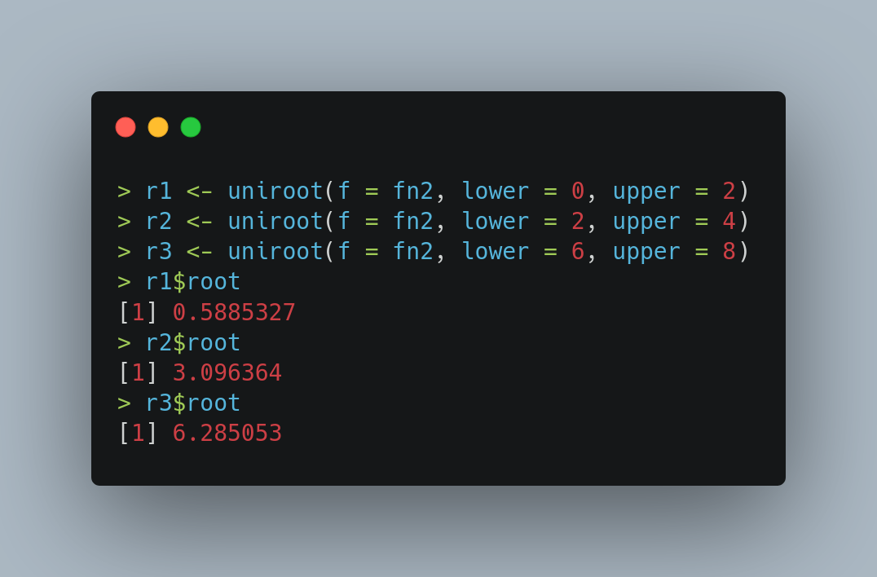
And that’s all for now! Don’t forget to check the associated script file that has more examples!

