Bookstore Management System
Group number 6
Created by: Damian J. Moore
Date: 8/23/2026

Table of Contents
1. Project Vision and Description 3
2. Team Roles and Assignment 3
3. Team Collaboration Methodology 4
4. The Definition of “Done” 4
5. Product Design 5
6. Sprint 1 Retrospective Summary Report 5
7. Sprint 2 Retrospective Summary Report 6
8. References 8

Project Vision and Description

Replace a bookstore's paper logbooks and manual ledger with a simple, reliable desktop software program to track inventory, process sales, and order stock.

The system digitizes paper operations into three direct modules:
- Inventory Tracking: Replaces paper stock cards. Stores book title, author, ISBN/UUID, price, quantity, and store shelf location. Updates quantities automatically when books are sold or received
- Point-of-Sale (POS) & Checkout: Replaces manual cash register logs. Calculates totals, tax, and change, updates stock levels instantly upon checkout, and logs daily cash/card sales.
- Supplier & Customer Orders: Replaces physical order notebooks. Tracks incoming book orders from suppliers and logs special book requests placed by customers.

Team Roles
- Product Owner: Represents the bookstore owner. Defines required features, prioritizes tasks in the backlog, and approves completed features.
- Scrum Master: Facilitates daily standups and sprint meetings, tracks team progress, and removes technical or scheduling blockers.
- Development Team (2 Developers, 1 Tester): Developers write code for the user interface, backend logic, and database. The tester runs manual tests to catch bugs and verify calculation accuracy.

Collaboration Methodology
The team uses SCRUM as its sole collaboration framework, organizing work into fixed 2-week Sprints to build and deliver working software incrementally.
- Sprint Planning: Select backlog tasks to convert specific paper processes into software over the next 2 weeks.
- Daily Standup (15 mins): Sync daily on completed tasks, today's targets, and any technical impediments.
- Sprint Review & Demo: Demonstrate functional software modules to the Product Owner for immediate feedback.
- Sprint Retrospective: Evaluate team performance and fix workflow bottlenecks for the next sprint.
- Collaboration Tools: Jira (task tracking board), GitHub (code repository and version control), Slack (daily communication).

The Definition of “Done”
The entire bookstore software project is officially Done when:
- All three core functionalities (Inventory, POS/Accounting, and Supplier/Customer Orders) are fully coded, integrated, and connected to the main database
- All existing paper logbooks, stock cards, and customer order records are fully entered into the database
- The entire application completes full system testing with zero crashing bugs, accurate tax and total calculations, and correct real-time stock updates across all workflows
- The bookstore owner and store staff complete hands-on testing, verify the system fully replaces their paper workflows, and the Product Owner gives final sign-off for deployment.
- User instruction manuals for store staff are written, code is merged into the production branch on GitHub, and the software is installed on the store's computer

Product Design

The system is a desktop application with three connected modules sharing one central database:
- Inventory Module: stores book records (title, author, ISBN, price, quantity, shelf location)
- POS/Checkout Module: reads from Inventory to process sales, updates Inventory quantities in real time
- Supplier & Customer Orders Module: reads from and writes to Inventory when stock arrives; separately tracks customer requests

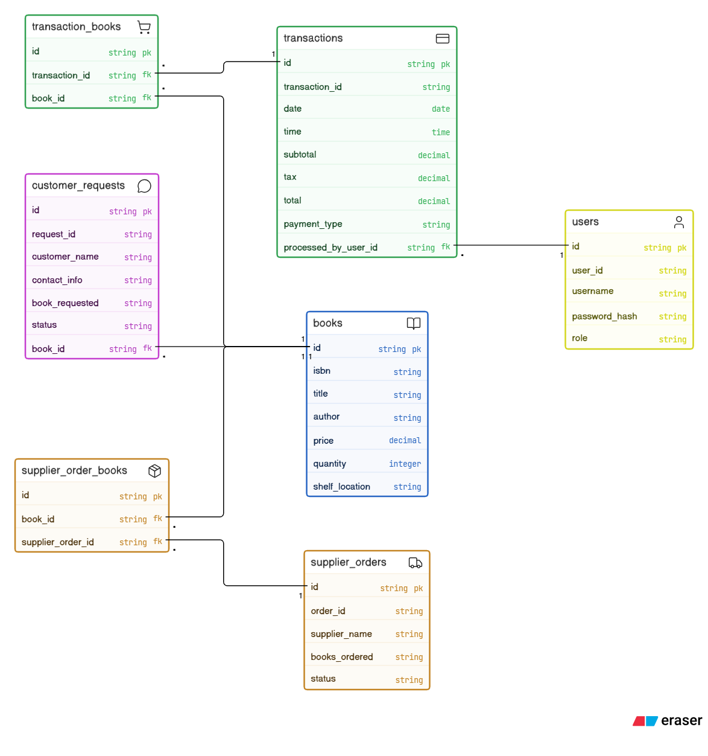
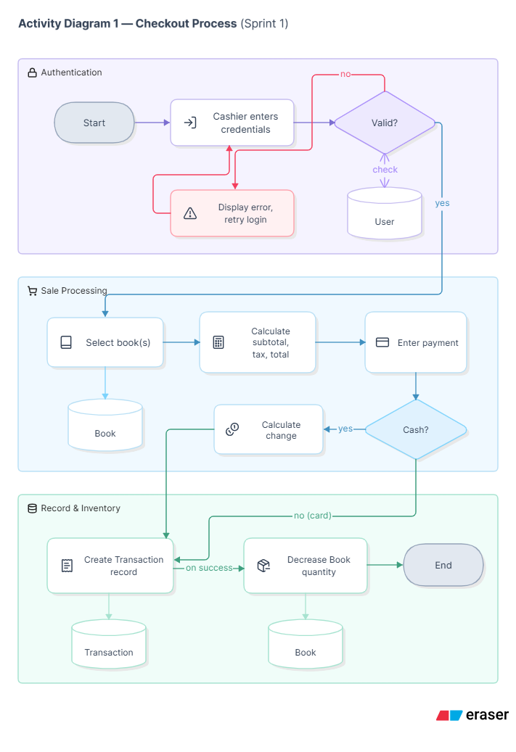

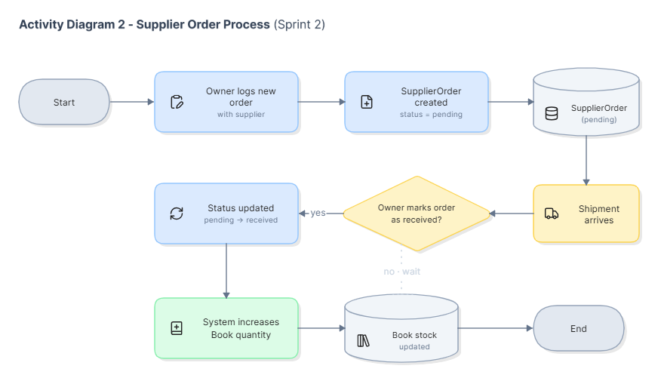

Passwords are stored as password_hash, not plain text. Transaction and CustomerRequest records are restricted to authorized users and included in backups.

Sprint 1 Retrospective Summary Report

Things That Went Well
Things That Could Have Gone Better
Things That Surprised Us
Lessons Learned

Sprint 2 Retrospective Summary Report
Things That Went Well
Things That Could Have Gone Better
Things That Surprised Us
Lessons Learned

References

