Hadoop Installation
- Install Hadoop (v 2.7.4)
- Copy files from hadoop_config.tar.gz (Attached in mail) to ~/hadoop-2.7.4/etc/hadoop directory of Hadoop installation.
- Open this file in editor: hadoop-2.7.4/etc/hadoop/hdfs-site.xml

- Find and replace: "/Users/dhavalthakkar/" with /Your-home-directory/username. NOTE:this is the home directory of the current user.
- Include bin directory of hadoop in PATH environment variable
HADOOP_HOME={ABSOLUTE_PATH_FOR_hadoop-2.7.4} [Note: change it to your hadoop installation directory]
PATH=$PATH:$HADOOP_HOME/bin
- Run "hadoop namenode -format" on command line. Check whether "/Your-home-directory/username/hadoop/HDFS/name/" directory is created.
- Run "ssh-keygen -t dsa" on command line. Don't set password when prompted and keep it empty.
- Copy content of ~/.ssh/id_dsa.pub file to ~/.ssh/authorized_keys [Note: Create this file if it does not exist already. ]
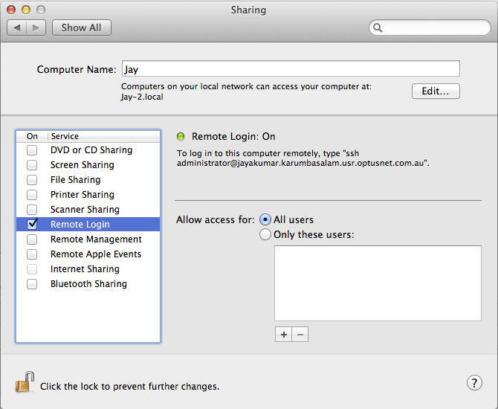
- Mac users only switch on "Remote Login" in "System Preferences" -> "Sharing".
- Install OpenSSH on your Linux using this link: OpenSSH - Ubuntu Linux
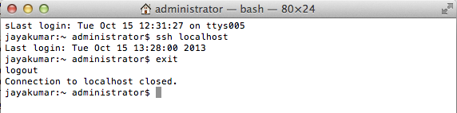
- Test whether ssh works by running "ssh localhost" without password.
- find this file hadoop-2.7.4/etc/hadoop/hadoop-env.sh in your Hadoop installation directory and open it in editor to set JAVA_HOME variable: export JAVA_HOME=[the Java directory in your machine]
- Mac users only. Edit etc/hadoop/hadoop-env.sh file in hadoop installation directory and replace below properties.
export HADOOP_OPTS="-Djava.net.preferIPv4Stack=true -Djava.security.krb5.realm=OX.AC.UK -Djava.security.krb5.kdc=kdc0.ox.ac.uk:kdc1.ox.ac.uk $HADOOP_CLIENT_OPTS"

- Validate Entry in /etc/hosts:
127.0.0.1 localhost
255.255.255.255 broadcasthost

Start Hadoop Application:
- Run below command to start hadoop:
cd hadoop-2.7.4
sh sbin/start-all.sh

- You can check logs in hadoop-2.7.4/logs directory
- Run below to check status from GUI:
http://localhost:50070/

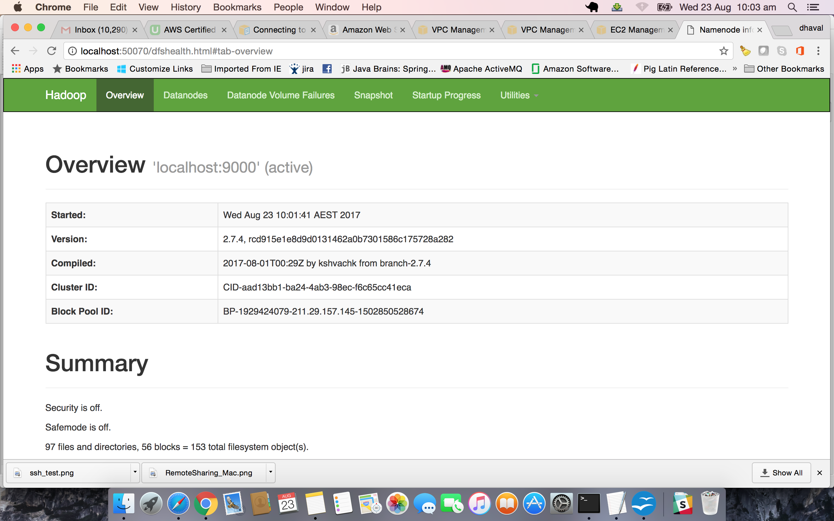
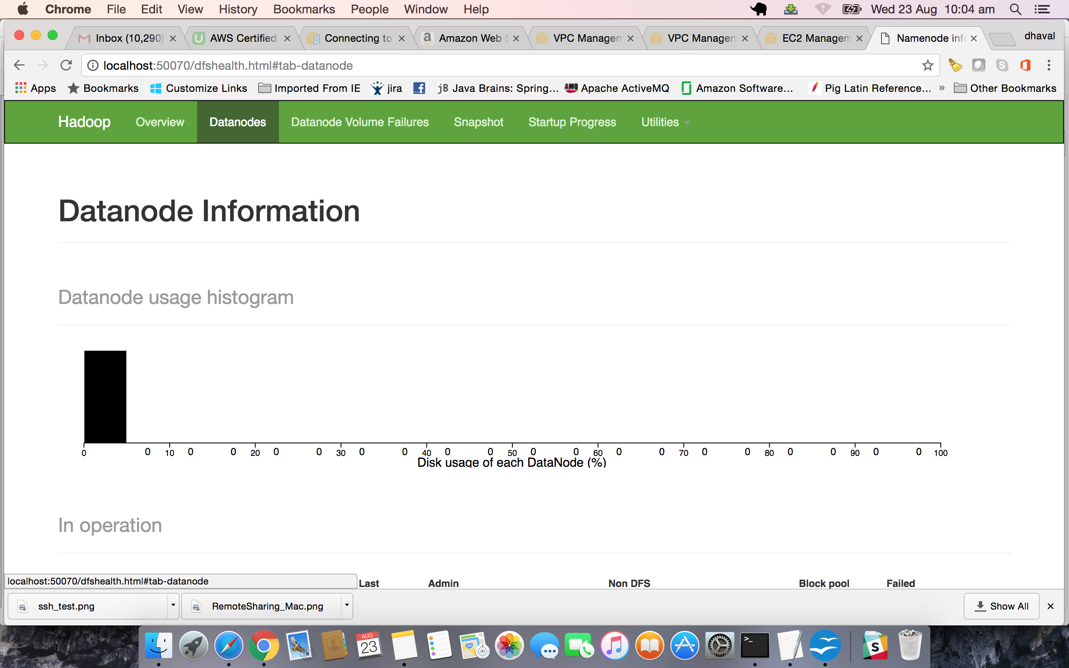

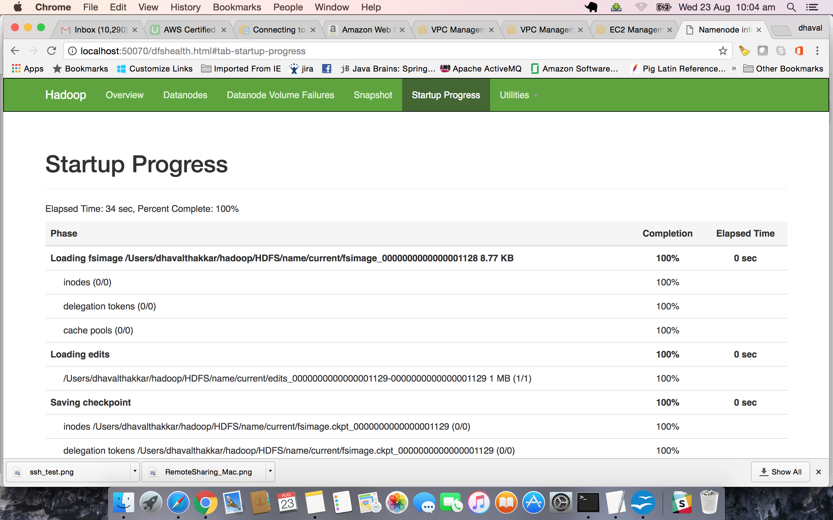

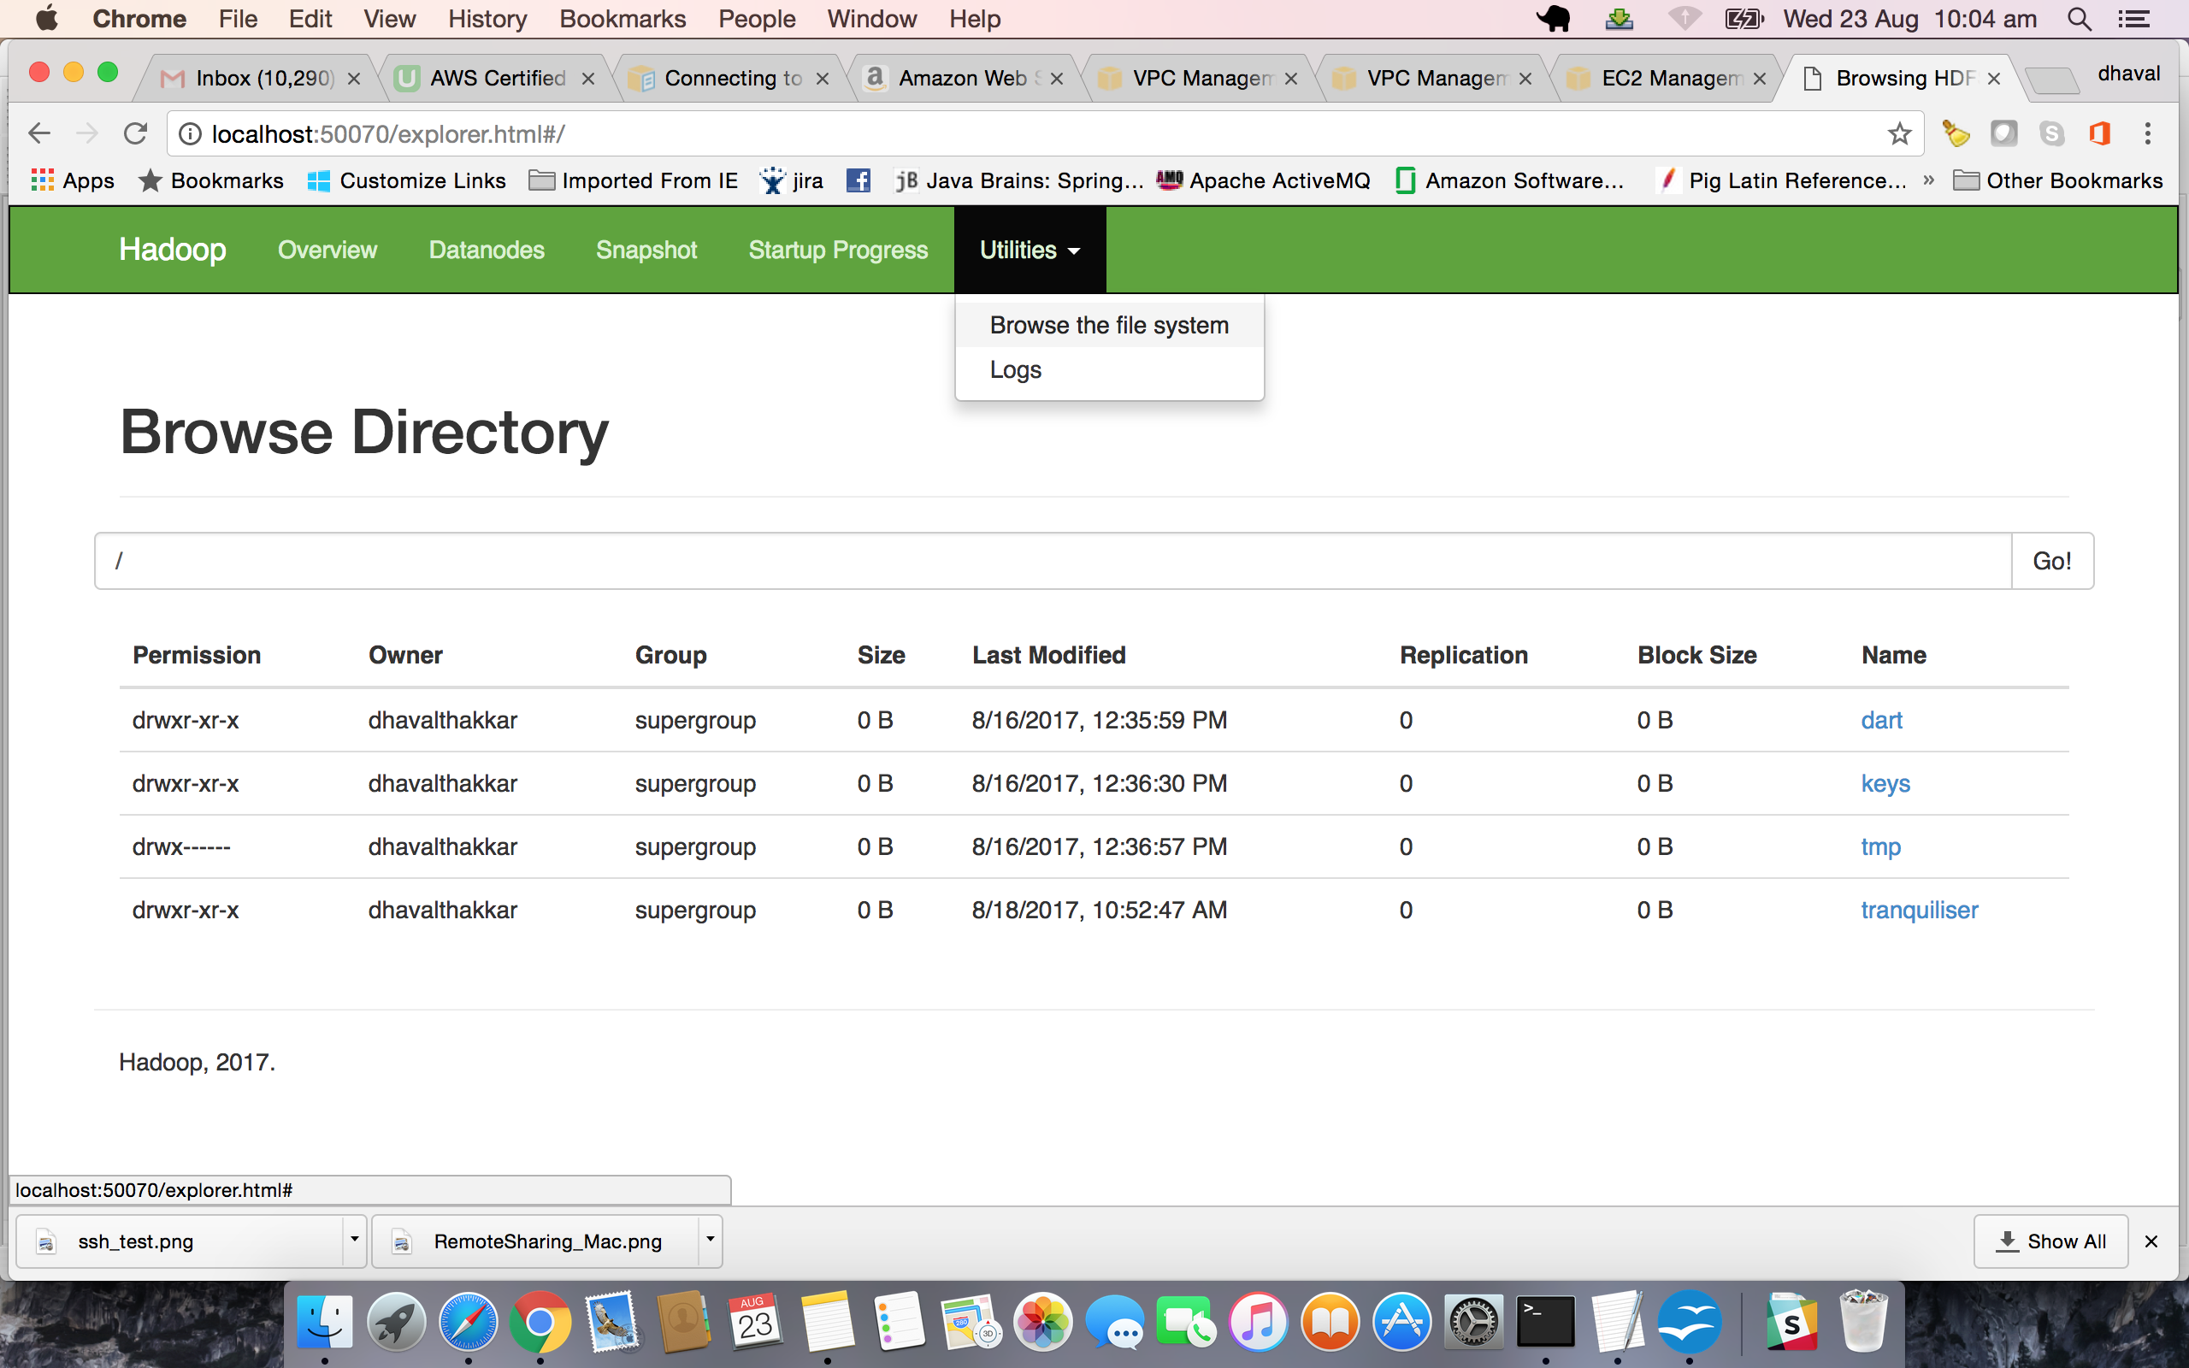

Hadoop Basic Commands:

List of Directories in HDFS:
$hadoop fs -ls /
17/08/23 10:08:00 WARN util.NativeCodeLoader: Unable to load native-hadoop library for your platform... using builtin-java classes where applicable
Found 4 items
drwxr-xr-x - dhavalthakkar supergroup 0 2017-08-16 12:35 /dart
drwxr-xr-x - dhavalthakkar supergroup 0 2017-08-16 12:36 /keys
drwx------ - dhavalthakkar supergroup 0 2017-08-16 12:36 /tmp
drwxr-xr-x - dhavalthakkar supergroup 0 2017-08-18 10:52 /tranquiliser

Note: Files and Directories are already in my HDFS, so it shows me.

Copy Files from Local env to HDFS
$hadoop fs -copyFromLocal dhaval.txt /dart/

Copy Files from HDFS to Local
$hadoop fs -copyToLocal /dart/dhaval.txt .

Note: you can use most of the Linux command in HDFS after 'hadoop fs -'
Ex.
$hadoop fs -mkdir /dhaval # To Create Directory
$hadoop fs -rmr /dhaval # To Remove recursively

