**IoT Assignment-12**

**(Dheeraj Tiwari)**

1. Perform an experiment to turn DC Motor in forward direction when motion is detected and turn it in reverse direction when object is still in front of motion sensor and make it off when object goes out of sight of motion sensor.

Ans :

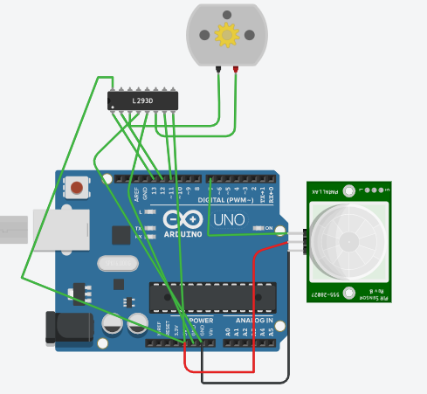

int pirState=LOW;

void setup()

{

pinMode(13, OUTPUT);

pinMode(12, OUTPUT);

pinMode(11, OUTPUT);

pinMode(10, OUTPUT);

pinMode(9, OUTPUT);

pinMode(8, OUTPUT);

pinMode(7, INPUT);

digitalWrite(13,HIGH);

digitalWrite(8,HIGH);

}

void loop()

{

int val=digitalRead(7);

if(val==HIGH){

digitalWrite(11,HIGH);

digitalWrite(12,LOW);

if(pirState==LOW){

Serial.println("Motion detected!");

pirState = HIGH;

}}

else{

digitalWrite(11,HIGH);

digitalWrite(12,HIGH);

if(pirState==HIGH){

Serial.println("Motion detected!");

pirState = LOW;

}}}

1. Perform an experiment to control LED and buzzer in following manner:-
   1. BUZZER- WHEN MOTION IS DETECTED
   2. LED- WHEN MOTION IS NOT DETECTED

Note:-Display it on serial monitor

ANS :

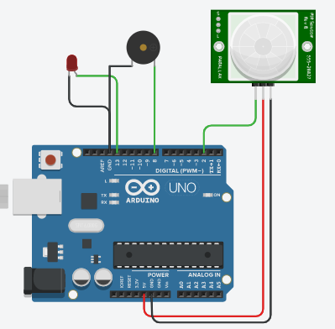

int ledPin = 13; // choose the pin for the LED

int inputPin = 2; // choose the input pin (for PIR sensor)

int pirState = LOW; // we start, assuming no motion detected

int val = 0; // variable for reading the pin status

int buzz=8;

void setup() {

pinMode(ledPin, OUTPUT); //declare LED as output

pinMode(buzz, OUTPUT);// declare buzzer as output

pinMode(inputPin, INPUT); // declare sensor as input

Serial.begin(9600);}

void loop(){

val = digitalRead(inputPin); // read input value

if (val == HIGH) { // check if the input is HIGH

digitalWrite(buzz, HIGH); // turn buzz ON

digitalWrite(ledPin, LOW); // turn LED OFF

if (pirState == LOW) {

// we have just turned on

Serial.println("Motion detected!");

// We only want to print on the output change, not state

pirState = HIGH;}}

else {

digitalWrite(ledPin, HIGH); // turn LED ON

digitalWrite(buzz, LOW); // turn buzz OFF

if (pirState == HIGH){

// we have just turned of

Serial.println("Motion ended!");

// We only want to print on the output change, not state

pirState = LOW;}}}

1. Explain the working principle of PIR Motion sensor?

Ans : Most PIR sensors have a 3-pin connection at the side or bottom. One pin will be ground, another will be signal and the last pin will be power. Power is usually up to 5V. Sometimes bigger modules don’t have direct output and instead just operate a relay which case there is ground, power and the two switch associations. Interfacing PIR with microcontroller is very easy and simple. The PIR acts as a digital output so all you need to do is listening for the pin to flip high or low. The motion can be detected by checking for a high signal on a single I/O pin. Once the sensor warms up the output will remain low until there is motion, at which time the output will swing high for a couple of seconds, then return low. If motion continues the output will cycle in this manner until the sensors line of sight of still again. The PIR sensor needs a warm-up time with a specific end goal to capacity fittingly. This is because of the settling time included in studying nature’s domain. This could be anyplace from 10-60 seconds.

Throughout this time there ought to be as little movement as could reasonably be expected in the sensors field of perspective.

1. Perform an experiment to turn AC Bulb on when motion is detected and turn dc motor on when motion is not detected.

ANS :

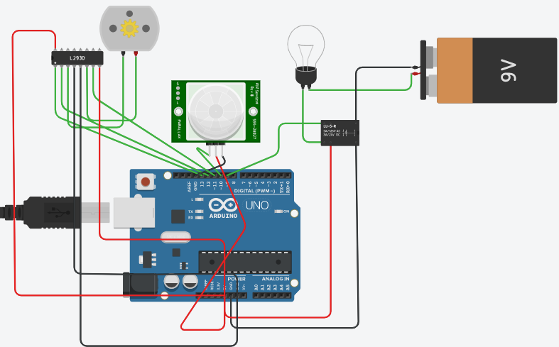

int inputPin=10;

int pirState = LOW;

int val = 0;

void setup() {

pinMode(inputPin, INPUT);

pinMode(13, OUTPUT);

pinMode(12, OUTPUT);

pinMode(11, OUTPUT);

pinMode(9, OUTPUT);

digitalWrite(13, HIGH);

Serial.begin(9600);

}

void loop(){

val = digitalRead(inputPin);

if (val == HIGH) {

digitalWrite(9, HIGH);

delay(500);

digitalWrite(11, LOW);

digitalWrite(12, LOW);

if (pirState == LOW) {

Serial.println("Motion detected!");

pirState = HIGH;}}

else {

digitalWrite(9,LOW);

delay(500);

digitalWrite(11, LOW);

digitalWrite(12, HIGH);

if (pirState == HIGH){

Serial.println("Motion ended!");

pirState = LOW; }}}

1. Explain the applications of Motion sensor?

ANS :

* All outdoor Lights
* Lift Lobby
* Multi Apartment Complexes
* Common staircases
* For Basement or Covered Parking Area
* Shopping Malls
* For garden lights