Assignment-4

(Dheeraj Tiwari)

Que 1 : .Using value of potentiometer, Blink 5 LED’s in forward and reverse manner.

a.If pot value goes above 100, LED’s should blink in reverse manner .

b.If pot value goes below 100, LED’s should blink in forward manner.

Ans:

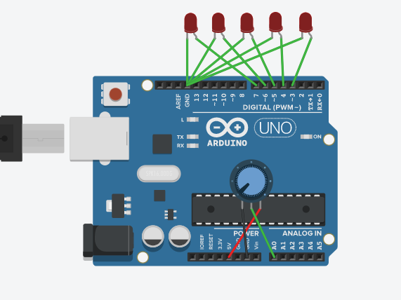

int led[]={7,6,5,4,3};

int pot1=A0;

int i;

int potval;

void setup(){

Serial.begin(9600);

for(int i=0;i<5;i++){

pinMode(led[i],OUTPUT);

}}

void loop(){

potval=analogRead(pot1);

int potv=map(potval,0,1023,0,200);

Serial.println(potv);

if(potv>100){

for(i=4;i>=0;i--){

digitalWrite(led[i],HIGH);

delay(100);

digitalWrite(led[i],LOW);

delay(100);

}}

else{

for(i=0;i<5;i++){

digitalWrite(led[i],HIGH);

delay(100);

digitalWrite(led[i],LOW);

delay(100);

}}}

Que 2 : Control 2 LED’s using two potentiometers :

a.LED1- POT1(Fading brightness).

b.LED2-POT2(Adjusting delay time).

Ans : 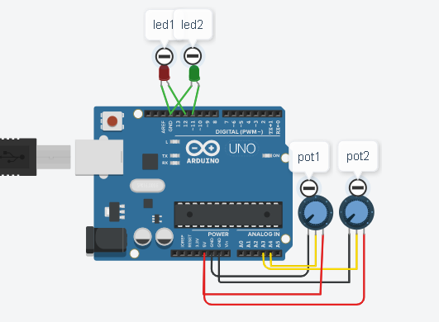

int led1=12;

int led2=11;

int pot1=A4;

int pot2=A3;

int per1,per2;

void setup(){

pinMode(led1,OUTPUT);

pinMode(led2,OUTPUT);

Serial.begin(9600);

}

void loop(){

int p1=analogRead(pot1);

int p2=analogRead(pot2);

int per1=map(p1,0,1023,0,255);

int per2=map(p1,0,1023,0,255);

analogWrite(led1,per1);

delay(per2);

analogWrite(led2,per1);

delay(per2); }