Assignment-5

(Dheeraj Tiwari)

Que 1 : Explain the features of LCD?

Ans: The **liquid crystal display (LCD) technology** has been used in several electronic products over the years. Now this technology has invaded the field of computer and LCD monitors are fast replacing cathode ray tube (CRT) monitors. There are more reasons for LCDs to be more endearing than CRTs than just the "LCDs are cool and CRTs are history" factor. Some of the major reasons are:  
  
• Cost effective  
• Energy efficient  
• Space economy  
• Reduced radiation  
• Lighter weight  
• Less eyestrain  
• Improved image quality/contrast  
• Better screen privacy  
• Long life  
• Easy options and features.

Que 4: Describe analogRead() and analogWrite()?

Ans:

AnalogWrite()

Writes an analog value (PWM wave) to a pin. Can be used to light a LED at varying brightness or drive a motor at various speeds.

Syntax : analogWrite(pin, value)

Parameters ::

pin: the pin to write to. Allowed data types: int.

value: the duty cycle: between 0 (always off) and 255 (always on). Allowed data types: int

AnalogRead()

Reads the value from the specified analog pin. Arduino boards contain a multichannel, 10-bit analog to digital converter. This means that it will map input voltages between 0 and the operating voltage(5V or 3.3V) into integer values between 0 and 1023. On an Arduino UNO, for example, this yields a resolution between readings of: 5 volts / 1024 units or, 0.0049 volts (4.9 mV) per unit. See the table below for the usable pins, operating voltage and maximum resolution for some Arduino boards.

Syntax } analogRead(pin).

Que 5: Using slideSwitch control 10 led in following way ---

SlideSwitch ON--glow 12345 dim 6,7,8,9,10

SlideSwitch OFF--dim 12345 glow 6,7,8,9,10

Ans :

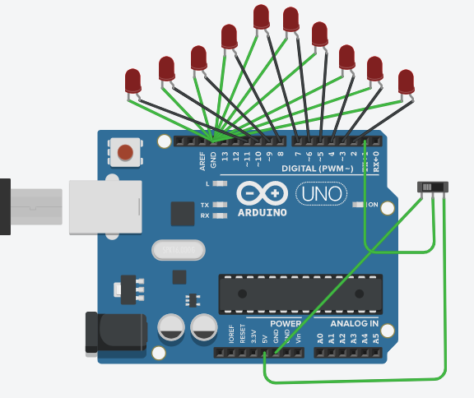

int led[]={11,10,9,8,7,6,5,4,3,2};

int s=1;

int i;

void setup( ) {

for(i=0;i<11;i++){

pinMode(led[i], OUTPUT);}

pinMode(s,INPUT);

Serial.begin(9600);

}

void loop()

{

int s1=digitalRead(s);

if(s1==HIGH){

for(i=0;i<5;i++){

digitalWrite(led[i],HIGH);}

for(i=5;i<11;i++){

digitalWrite(led[i],LOW);}

} else{

for(i=0;i<5;i++){

digitalWrite(led[i],LOW);}

for(i=5;i<11;i++){

digitalWrite(led[i],HIGH);}}}

Que 2 : Perform an experiment to Interface switch with Potentiometer such that Potentiometer fades LED only when switch is on.

Ans:

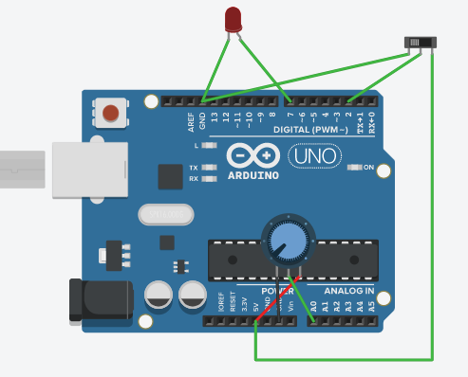

int pot=A0;

int led=7;

int s=2;

void setup()

{

pinMode(led,OUTPUT);

pinMode(s,INPUT);

pinMode(A0, INPUT);

Serial.begin(9600);

}

void loop()

{

int s1=digitalRead(s);

int pr=analogRead(pot);

int potv=map(pr,0,1023,0,200);

if(s1==HIGH){

digitalWrite(led,HIGH);

digitalWrite(led,potv);

}}

Que 3:Perform an experiment to control the brightness of LED through serial monitor.

Ans:

int led = 7;

int brightness = 0;

// Enter values from 0 to 255.

void setup() {

Serial.begin(9600);

pinMode(led, OUTPUT);

Serial.print("Brightness = ");

}

void loop() {

while (Serial.available() > 0)

{

brightness = Serial.parseInt();

Serial.println(brightness);

Serial.print("Brightness = ");

}

analogWrite(led, brightness);

delay(50);

}