Assignment-8

(Dheeraj Tiwari )

Que1: Perform an experiment to display the value 9-0 in reverse order on 7-segment LED display.

Ans :

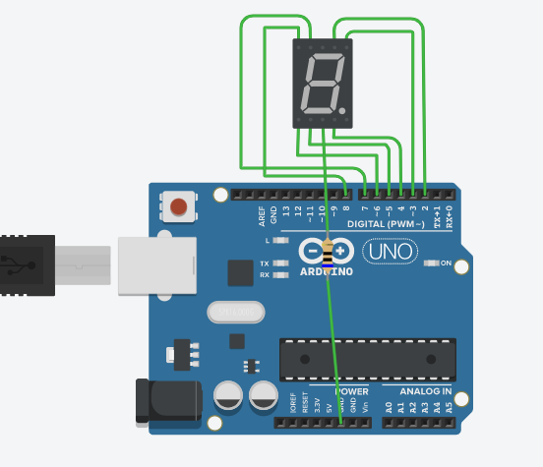

int num_array[10][7] = { { 1,1,1,1,1,1,0 }, // 0

{ 0,1,1,0,0,0,0 }, // 1

{ 1,1,0,1,1,0,1 }, // 2

{ 1,1,1,1,0,0,1 }, // 3

{ 0,1,1,0,0,1,1 }, // 4

{ 1,0,1,1,0,1,1 }, // 5

{ 1,0,1,1,1,1,1 }, // 6

{ 1,1,1,0,0,0,0 }, // 7

{ 1,1,1,1,1,1,1 }, // 8

{ 1,1,1,0,0,1,1 }}; // 9

void setup()

{

// set pin modes

for(int i=2;i<9;i++){

pinMode(i, OUTPUT); }

}

void loop()

{

//counter loop

for (int counter = 10 ; counter > 0; --counter)

{

delay(1000);

Num_Write(counter-1);

}

delay(3000);

}

// this functions writes values to the sev seg pins

void Num_Write(int number)

{

int pin= 2;

for (int j=0; j < 7; j++) {

digitalWrite(pin, num_array[number][j]);

pin++;}}

Que2. Perform an experiment to display 00-99 counter on two 7-segment LED Display.

Ans:

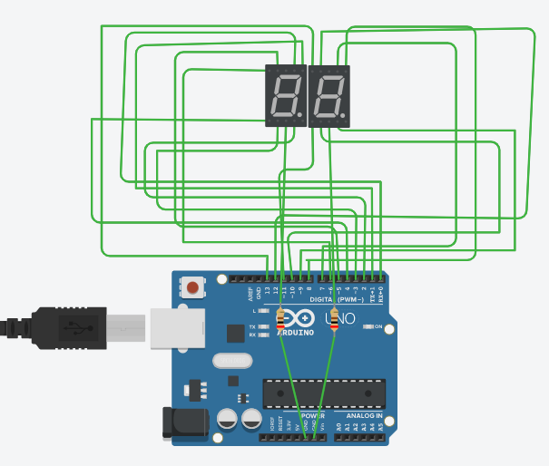

void setup(){

for(int i=0;i<=13;i++){

pinMode(i,OUTPUT);

}

}

const int number[10]=

{0b0111111,0b0000110,0b1011011,0b1001111,0b1100110,0b1101101,0b1111101

,0b0000111,0b1111111,0b1100111};

void loop(){

for(int tens=0;tens<=9;tens++){

display_tens(tens);

delay(500);

}

}

void display_tens(int tens){

int pin1,a,ones;

for(pin1=0,a=0;pin1<=6;pin1++,a++){

digitalWrite(pin1,bitRead(number[tens],a));

}

for(ones=0;ones<=9;ones++){

display_ones(ones);

delay(500);

}

}

void display_ones(int x){

int pin2,b;

for(pin2=7,b=0;pin2<=13;pin2++,b++){

digitalWrite(pin2,bitRead(number[x],b));

}

}

Que3. Perform an experiment to display 99-00 counter on two 7-segment LED Display.

Ans :



void setup(){

for(int i=0;i<=13;i++){

pinMode(i,OUTPUT);

}

}

const int number[10]=

{0b0111111,0b0000110,0b1011011,0b1001111,0b1100110,0b1101101,0b1111101

,0b0000111,0b1111111,0b1100111};

void loop(){

for(int tens=9;tens>=0;tens--){

display_tens(tens);

delay(500);

}

}

void display_tens(int tens){

int pin1,a,ones;

for(pin1=0,a=0;pin1<=6;pin1++,a++){

digitalWrite(pin1,bitRead(number[tens],a));

}

for(ones=9;ones>=0;ones--){

display_ones(ones);

delay(500);

}

}

void display_ones(int x){

int pin2,b;

for(pin2=7,b=0;pin2<=13;pin2++,b++){

digitalWrite(pin2,bitRead(number[x],b));

}}

Que 4: Write the applications of 7-segment LED Display?

## Ans: Applications of Seven Segment Displays :

Common applications of seven segment displays are in:

* Digital clocks
* Clock radios
* Calculators
* Wristwatchers
* Speedometers
* Motor-vehicle odometers
* Radio frequency indicators