**Assinment-1**

1. Blink two LED’s one by one with a delay of 2 secs through Arduino?

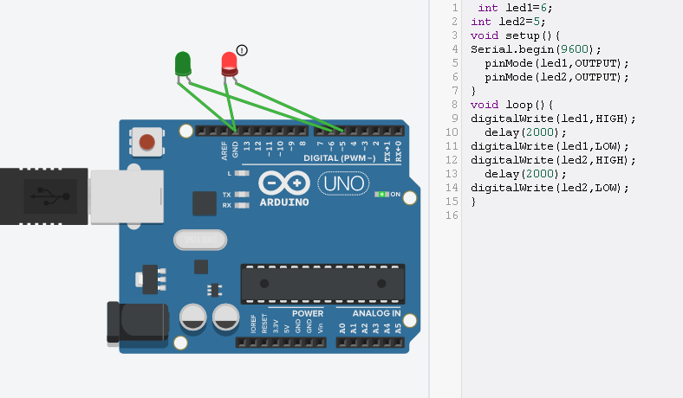

Que 2 : Blink two LED’s together with a delay of 5secs through Arduino?

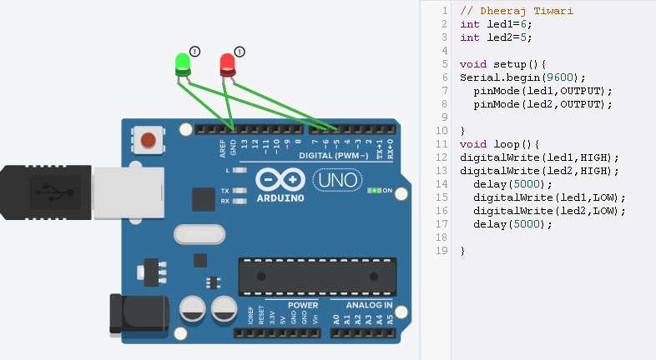

Que 3: Glow 3 LED’s in forward direction one by one and then make them off in reverse direction respectively?

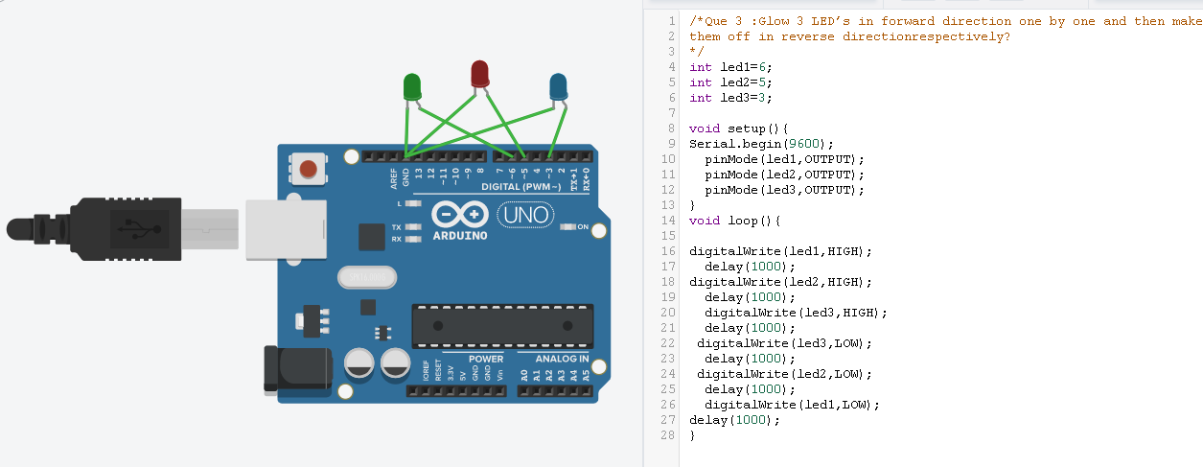

Que 4: Glow 4 LED’s at same time and then make them off with a delay of 3 secs?

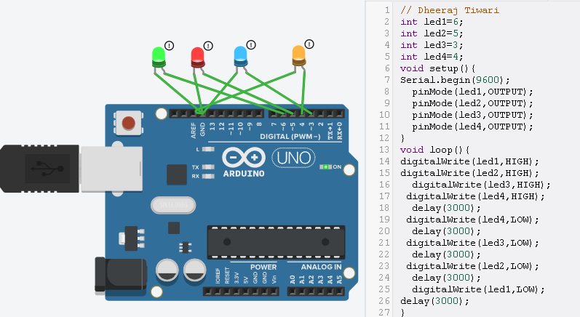

Que 5: Blink LED and show its status on Serial Monitor?

