Assignment-3

(Dheeraj Tiwari)

**Que 1: Write a Program in Arduino IDE using User Defined Function in which- We use 4 LED and make 2 function; each function will operate two LED.**

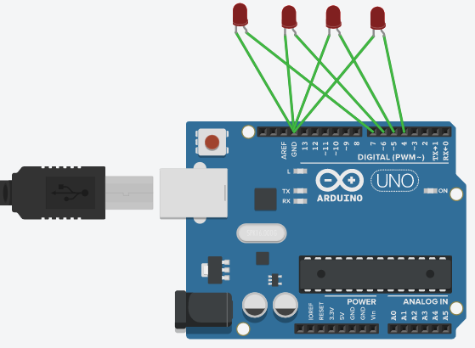

CODE:

int led[]={7,6,5,4};

int i;

void setup()

{

for(i=0;i<4;i++){

pinMode(led[i],HIGH);

} }

void loop()

{ fun1();

fun2()

}

int fun1()

{

int i=0;

digitalWrite(led[i],HIGH);

digitalWrite(led[i+1],HIGH);

delay(2000);

digitalWrite(led[i],LOW);

digitalWrite(led[i+1],LOW);

}

int fun2()

{ int i=2;

digitalWrite(led[i],HIGH);

digitalWrite(led[i+1],HIGH);

delay(2000);

digitalWrite(led[i],LOW);

digitalWrite(led[i+1],LOW);

}

**QUE 2: Open the Serial monitor and send any character. The characters a, b, c, d, e and f will turn on respective LEDs. Any other character other than the above-mentioned will turn the LEDs off. Use switchcase**

CODE:

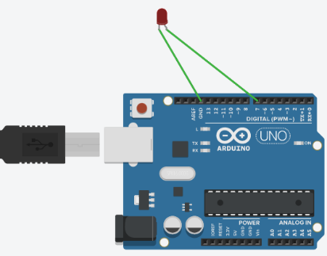

int led=7;

char c;

void setup()

{

pinMode(7,HIGH);

Serial.begin(9600);

}

void loop()

{

if(Serial.available()>0){

c=Serial.read();

switch(c){

case 'a':

digitalWrite(led,HIGH);

break;

case 'b':

digitalWrite(led,HIGH);

break;

case 'c':

digitalWrite(led,HIGH);

break;

case 'd':

digitalWrite(led,HIGH);

break;

case 'e':

digitalWrite(led,HIGH);

break;

case 'f':

digitalWrite(led,HIGH);

break;

default:

digitalWrite(led,LOW);

}}}

**QUE 3 : Turn LED’s on and off upon user choice using switch-case LED1(ON) & LED2(OFF) – when user press 1 on serial monitor LED1(OFF) & LED2(ON) – when user press 2 on serial monitor LED1(ON) & LED2(ON) – when user press 3 on serial monitor BOTH LED GETS OFF – when user press other character on serial monitor.**

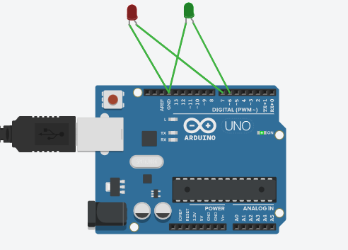

CODE:

int led1=7;

int led2=6;

void setup()

{

pinMode(7,HIGH);

pinMode(6,HIGH);

Serial.begin(9600);

}

void loop()

{

if(Serial.available()>0){

char c;

c=Serial.read();

switch(c)

{

case '1':

digitalWrite(led1,HIGH);

digitalWrite(led2,LOW);

break;

case '2':

digitalWrite(led1,LOW);

digitalWrite(led2,HIGH);

break;

case '3':

digitalWrite(led1,HIGH);

digitalWrite(led2,HIGH);

break;

default:

digitalWrite(led1,LOW);

digitalWrite(led2,LOW);

}}}

**QUE 4:**

**Make a LED Pattern using for loop as following: LED1,LED3,LED5,LED7**

**LED8,LED6,LED4,LED2.**

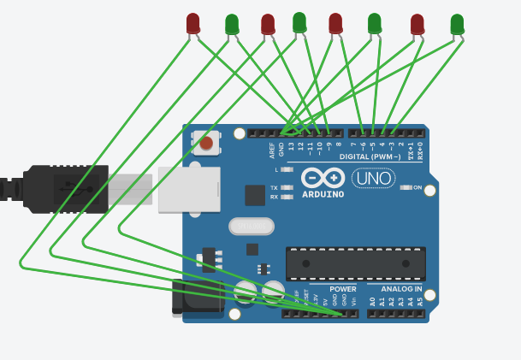

CODE:

int led[]={12,11,10,9,6,5,4,3};

int i;

void setup(){

for(i=0;i<8;i++){

pinMode(led[i],HIGH);

Serial.begin(9600);

}}

void loop(){

for(i=1;i<5;i++){

digitalWrite(led[2*i-1],HIGH);

delay(1000);

digitalWrite(led[2*i-1],LOW);

delay(1000);

}

for(i=0;i<4;i++){

digitalWrite(led[2*i],HIGH);

delay(1000);

digitalWrite(led[2*i],LOW);

delay(1000);

}}

**QUE 5 : Write a Program to run Patterns on LEDs connect at Pins 10,11,12,13. Pattern Example: Use array 1000 0100 0010 0001 1100 0110 0011.**

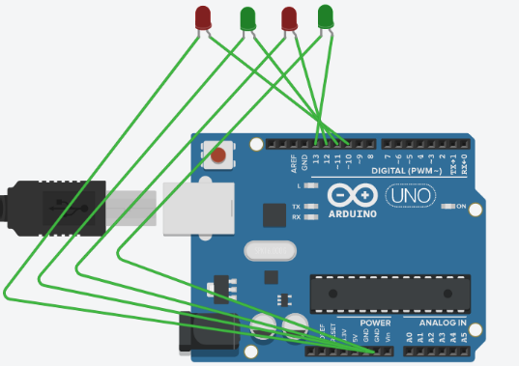

int led[]={10,11,12,13};

int i;

void setup(){

for(i=0;i<4;i++){

pinMode(led[i],HIGH);

Serial.begin(9600);

}

}

void loop(){

for(i=0;i<4;i++){

digitalWrite(led[i],HIGH);

delay(1000);

digitalWrite(led[i],LOW);

delay(1000);

}

for(i=0;i<3;i++){

digitalWrite(led[i],HIGH);

digitalWrite(led[i+1],HIGH);

delay(1000);

digitalWrite(led[i],LOW);

digitalWrite(led[i+1],LOW);

delay(1000);

}

}