|  |  |
| --- | --- |
| **Name:** | Dmytro Kryshenyk |
| **Date of Birth:** | 19/01/1993 - age 26 |
| **Location:** | Ukraine, Uzhhorod |
| **Mobile/Viber/Telegram:** | +380 (99) 321-90-05 |
| **E-mail:** | kryshenykdmytro@gmail.com |
| **Skype:** | dmutres |
| **LinkedIn:** | [**www.linkedin.com/in/dmytro-kryshenyk**](http://www.linkedin.com/in/akartynnik) |
| **GitHub:** | [**https://github.com/DmytroKryshenyk**](https://github.com/DmytroKryshenyk) |

PERSONAL DATA

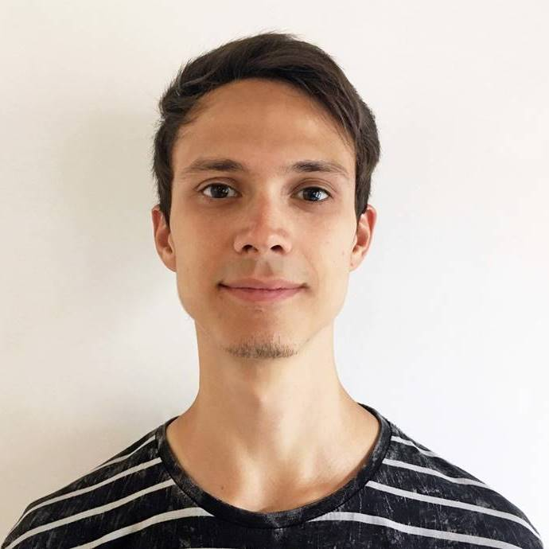

OBJECTIVE

|  |  |
| --- | --- |
| **Desired Position:** | Junior Front-End Developer |

TECHNICAL SKILLS

|  |  |
| --- | --- |
| HTML5, CSS3, SASS | Advanced |
| JavaScript, Gulp, Webpack, Git, Bootstrap 4 | Intermediate |
| Vue. Jest (unit testing) | Basic |
| Visual Studio Code, Git Bash, Photoshop, Zeplin, Chrome Developer Tools | Tools |
| OOP, MVC, BEM, ES6 & CommonJS Modules, RESTful API, npm, ES6, Babel, Pixel Perfect, Responsive/Adaptive/Mobile First Design, SEO, Agile | Other |

EXPERIENCE

* **My portfolio**

**Tools & Technologies:** HTML5, CSS3, SASS (scss), BEM, JS ES6, ES6 Modules, NPM, Webpack, Babel  
**Web Site:** <https://dmytrokryshenyk.github.io/Portfolio/build/>  
**Source code:** <https://github.com/DmytroKryshenyk/Portfolio>

* **Client project for YotaLabs**

**Company**: YotaLabs  
**Company Location:** Uzhhorod  
**Completed work:** I coded a layout of the page and added a JS slider.  
**Tools & Technologies:** HTML5, CSS3, Gulp, Slick JS, BEM, SASS (scss)  
**Source code:** link to the repo with my code contribution to this project <https://github.com/DmytroKryshenyk/YLbs>

* **Local weather app**

**Tools & Technologies:** HTML5/CSS3, JS, DarkSky API, Webpack, OOP, BEM  
**Description:** Local Weather App was created using Dark Sky API and vanilla JS with some OOP approaches.  
**Project Web Site:** <https://dmytrokryshenyk.github.io/weather-app/build/>  
**Project sources:** <https://github.com/DmytroKryshenyk/weather-app>

* **Bookmark link manager** - personal self-study project

**Tools & Technologies:** HTML5/CSS3, React, SASS, BEM, JS, ES6 Modules, Webpack, NPM, Babel, LinkPreview API  
**Description**: App for the links saving. Built using React architecture and Web Storage API  
**Project Web Site:** <https://dmytrokryshenyk.github.io/React-bookmark-link-manager/build/>  
**Project sources:** <https://github.com/DmytroKryshenyk/React-bookmark-link-manager>

Also, I made this bookmark manager using the MVC pattern architecture (link below)   
<https://dmytrokryshenyk.github.io/js-group-3-4/js/module-14/build/>

* **Stopwatch** - personal self-study project

**Tools & Technologies:** HTML5, CSS3, JS, OOP  
**Description**: The stopwatch was created using Vanilla JS with some OOP approaches

**Project Web Site:** <https://dmytrokryshenyk.github.io/Stopwatch-OOP/>  
**Project sources:** <https://github.com/DmytroKryshenyk/Stopwatch-OOP>

* **To Do List** - personal self-study project

**Tools & Technologies:** HTML5/CSS3, Vue, SASS, BEM, JS, ES6 Modules, Webpack, NPM, Babel,  
**Description**: To do list app. Built using Vue CLI 3 and Vue single file components architecture

**Project Web Site:** <https://dmytrokryshenyk.github.io/todo-list-vue-app/dist/>  
**Project sources:** <https://github.com/DmytroKryshenyk/todo-list-vue-app>

OTHER EXPERIENCE AND INFORMATION ABOUT ME

|  |
| --- |
| - 7 years as a video editor,  - 2 years as a camera man,  - 2 years freelancing as a graphic video 3d-animator,  - 1 year as a sound engineer,  - 3 years as a sales consultant of tourist equipment.  I’m into a healthy lifestyle, traveling, biking, skiing and so on. I spend part of my free time on my own projects and self-study activities. I am interested in urbanism, natural sciences and psychology. I’m resourceful and able to figure out how to solve issues by myself. |

EDUCATION

2010-2015 / Uzhhorod National University / Faculty of Physics / Physics / Level of qualification - Master degree

LANGUAGES

* English – Pre-Intermediate
* Ukrainian – Native Speaker
* Russian – Advanced

COURSES AND CERTIFICATES

|  |  |  |  |  |  |  |  |  |
| --- | --- | --- | --- | --- | --- | --- | --- | --- |
| |  |  | | --- | --- | | **Course name:** | Front End Advanced JS | | **Duration:** | 04/2018 – 09/2018 | | **Certificates:** | <https://raw.githubusercontent.com/DmytroKryshenyk/Portfolio/master/docs/JS-certificate.jpg>  <https://github.com/DmytroKryshenyk/Portfolio/blob/master/docs/JS-certificate-knowledge-list.pdf> |  |  | | --- | | **Other training platforms, courses and books that I've used** | | learn.javascript.ru  codecademy.com  coursehunter.net  udacity.com  englishdom.com  Astound Frontend Boot Camp  Выразительный JavaScript 2-е издание (Марьян Хавербеке) | |