**Pavlo Chubynskyi**

**(1839-1884)**

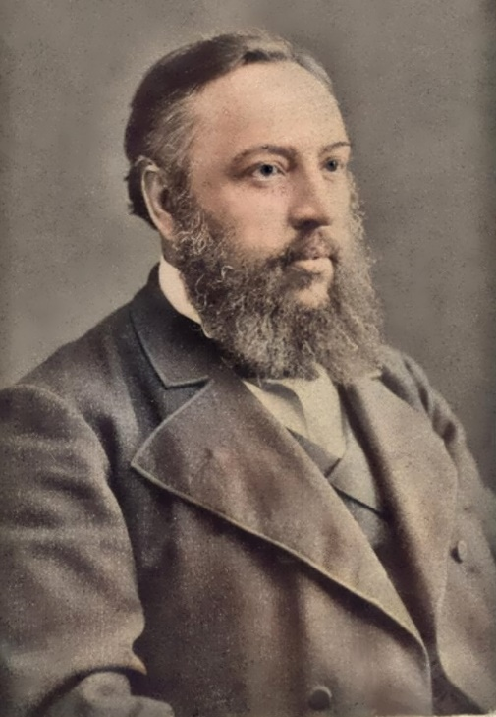

Pavlo Chubynskyi was born on January 27, 1839, in a hamlet that is now part of the city of Boryspil near Kyiv, into the family of a poor nobleman. He graduated from the Second Kyiv Gymnasium and studied at the Faculty of Law at St. Petersburg University. During his student years, he participated in the activities of the Ukrainian community in St. Petersburg. He was the author of the journal "Osnova," through which he got acquainted with T. Shevchenko and M. Kostomarov.

After a protest against the crackdown on participants of the Warsaw Manifestation, Chubynskyi was expelled from the university, and he lived for some time in the village of Ropsha in Chernihiv region. In 1861, he defended his dissertation "Essays on the Folk Legal Customs and Concepts of Civil Law in Little Russia" in St. Petersburg and received a degree in jurisprudence. Upon returning to Ukraine, during 1861-1862, he wrote articles for "Osnova," contributed to the "Chernihiv Leaflet" and the "Kyiv Governorate Gazette," in which his "Program for the Study of Folk Legal Customs in Little Russia" (1862) was published.

In 1862, in Kyiv, several Ukrainianophile circles merged to form the Hromada (Community), among the first members of which were P. Chubynskyi, V. Antonovych, P. Zhytetsky, and Tadei Rylsky. A criminal case was soon initiated against the Hromada, and an investigation began. In the same autumn, P. Chubynskyi wrote the poem "Shche ne vmerla Ukraina" ("Ukraine Has Not Yet Perished"), which became the anthem of the Ukrainian people. On October 20th, Prince Dolgorukov, the chief of gendarmes, ordered Chubynskyi to be exiled to the Arkhangelsk Governorate under police supervision.

A year later, he settled in Arkhangelsk, where he worked as an investigator, then as a secretary of the statistical committee, editor of the provincial newspaper, and a special assignments official under the governor. During his seven years of exile in Arkhangelsk, the Ukrainian Chubynskyi contributed significantly to Russian science. He conducted research on fairs in the Arkhangelsk region, mortality in the North, the Pechora region, trade in the northern provinces of Russia, and studied legal customs in the province and more.

In 1869, he was allowed to return to St. Petersburg and later to Ukraine to lead an expedition to the Southwestern region for ethnographic and statistical research. Over the course of two years, the expedition explored the Kyiv, Volyn, Podil, parts of Minsk, Grodno, Lublin, Siedlce provinces, and Bessarabia, where Ukrainians resided.

Pavlo Chubynskyi worked under extremely challenging conditions of persecution by the Tsarist government against Ukrainian culture. Despite his relatively short life, he achieved so much that, according to his friend and collaborator Fedor Vovk, his accomplishments could have sufficed for several professional scholars. His single verse "Shche ne vmerla Ukraina" ("Ukraine Has Not Yet Perished") immortalized his name forever. Not to mention his titanic work in the field of ethnography. According to academician L. Berg, the expedition led by Pavlo Chubynskyi to the Southwestern region was the most significant event in the history of contemporary ethnography.

The scope and depth of the expedition's research work are impressive, just as the countless treasures of folk culture collected in 7 volumes (9 books) "Works of the Ethnographic-Statistical Expedition to Western Russian Territory," published in St. Petersburg between 1872 and 1879. Achieving this from a government that believed there was no Ukrainian people or language, only a southern borderland of the Russian Empire with a corrupted "Little Russian dialect" influenced by Polish, was exceedingly difficult, let alone conducting such a large-scale expedition.

Chubynskyi recorded nearly four thousand ritual songs, three hundred fairy tales, and in sixty localities documented and studied dialects, customs, beliefs, and omens. From books of volost and district courts, starostas and administrators, he selected a multitude of materials that represented characteristic types of human relationships, revealed remnants of ancient customs, beliefs, customary law, pre-Christian beliefs of the Ukrainian people, their remnants, and the organic fusion of Old Ukrainian, pre-Christian, and Christian cultures. The scientist paid special attention to the main events of human life – birth, marriage, farewells to conscripts, human death. Chubynskyi vividly demonstrated the great aesthetic significance and humanistic importance of ritual actions during these events through numerous striking examples. Thanks to Chubynskyi's expedition, materials about the state of trade in different localities, beekeeping, tobacco cultivation, winemaking, sericulture, and brewing have been preserved.

Chubynskyi's expedition gained recognition, and many enthusiasts joined it, providing their materials. Mykola Lysenko put to music the motifs of wedding and other ritual songs from Boryspil region published in the "Works." The "Works of the Ethnographic-Statistical Expedition to Western Russian Territory" were of immense significance in the history of Ukrainian culture. They showcased vivid examples of the manifestation of innate spiritual qualities of Ukrainians to the world – grand simplicity, directness, and at the same time profound emotional depth, aesthetic richness, the power of poetic sentiment, the vividness of colors in folk poetry and songs. These are the key traits that distinguish the Ukrainian people among other Slavic nations.

The successful completion of the expedition made Chubynskyi's name well-known and respected in official scientific circles, and it allowed him to persuade the government to establish the South-Western Branch of the Russian Geographical Society in Kyiv. This branch played a significant role in collecting, researching, and popularizing folklore, historical, ethnographic, and archaeological monuments in Ukraine. Within a few years, this scientific institution published two volumes of "Notes of the Imperial Russian Geographical Society's South-Western Branch," featuring works by M. Drahomanov, V. Antonovych, P. Chubynskyi, F. Vovk, and many other renowned scholars. The branch also prepared three volumes of works by Mykhailo Maksymovych for publication and first published Ukrainian dumas and songs from the repertoire of kobzar Ostap Veresay.

In 1873, the Russian Geographical Society awarded Chubynskyi a gold medal. In 1875, the International Ethnographic Congress in Paris also awarded him a gold medal. In 1879, he received the most prestigious scientific award in Russia – the Uvarov Prize from the St. Petersburg Academy of Sciences.

However, the success of Chubynskyi and his like-minded colleagues from the Kyiv branch of the Russian Geographical Society sparked waves of attacks and ridicule in chauvinistic press. Clouds of criticism loomed over Chubynskyi once again, and he moved to St. Petersburg, where he was allowed to work as an official in the Department of General Affairs of the Ministry of Ways. A diligent worker, although forcibly detached from his beloved work, he achieved success here as well, and in 1878, he was appointed a state councilor.

During that time, he fell seriously ill, and in April 1879, he retired. After persistent efforts, he obtained permission to return to Ukraine. He lived in Boryspil and on his estate nearby. In 1880, he suffered a stroke and was bedridden until the end of his life. Chubynskyi passed away on January 26, 1884.

His work was continued by Holovatsky, Ivanov, Rudchenko, Hrinchenko, Manzhura, Hnatyuk, Franko, Yavornytsky, Novytsky, Myloradovych, Sumtsov, Shcherbakivsky, and Bilyashivsky.

Chubynskyi's works and his poem "Shche ne vmerla Ukraina" ("Ukraine Has Not Yet Perished"), as well as the "Works" of the ethnographic expedition, were banned for a long time, although many Soviet scientists freely used them without acknowledging the author.

With Ukraine's independence, the words of Pavel Chubynskyi's poem "Shche ne vmerla Ukraina" became the national anthem of the state. In 1995, the "Mystetstvo" publishing house released an illustrated two-volume book titled "Wisdom of Ages. Ukrainian Ethnography in the Creative Heritage of Pavel Chubynskyi."