Documentation

*Document*

**Title**: Astro_project

**Date**: 29/10/2024

**Author**: Dmytro Reva

Index

Explanation - 2

Explanation - 3

Explanation - 7

Explanation - 7

Explanation - 12

Explanation - 17

Explanation - 20

Explanation - 23

Explanation - 24

Explanation - 24

Explanation - 29

{project.nombre} 29

Explanation - 31

Provide a technical overview of the class, its purpose, and its features.

### Explanation -

Code Summary for Documentation:

The provided code snippet defines a card component using Astro, a static site generator. This component is designed to display an image and a title, and it is enclosed within a clickable link that directs users to a specified URL.

### Component Breakdown:

- Props:

- `img`: The source URL for the image that will be displayed.

- `tema`: The title or text that will be shown beneath the image.

- `url`: The hyperlink that the card will navigate to when clicked.

### HTML Structure:

- The main element is an anchor (`

Version 1.0

Provide a technical overview of the class, its purpose, and its features.

### Explanation -

Code Summary for Documentation:

This code represents a contact page constructed using Astro, a static site generator. It leverages components and layouts to create a structured and styled user interface. The page imports essential components such as `Footer`, `Header`, and `Layout` from their respective directories, alongside a data-fetching function `getDatos` from the `Data.astro` component.

Initially, the data is fetched asynchronously via `await getDatos()`, populating the `data` variable with contact details such as name, email, and phone number. The main structure is encapsulated within a `

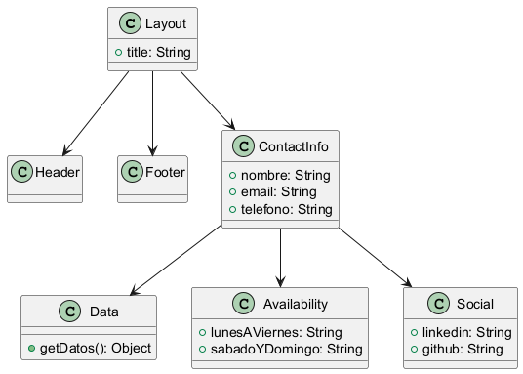

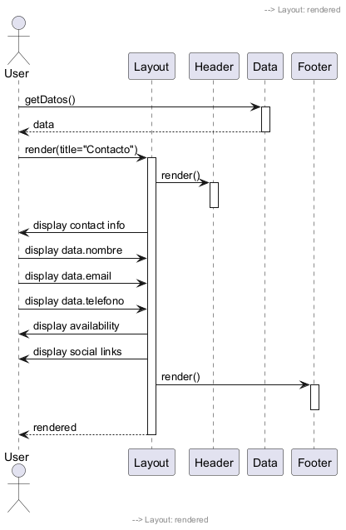

# Time Complexity Analysis

The provided code snippet consists of an Astro component that imports various other components and renders a contact information page. The main operations within the component can be analyzed as follows:

1. Data Fetching:

- The code includes an `await getDatos();` statement which fetches data asynchronously. The time complexity of fetching data can vary depending on the implementation of the `getDatos()` function, but it generally operates in O(n) time complexity, where n is the size of the data being fetched. However, since this operation is asynchronous and does not block the rendering of the component, it is not part of the rendering time complexity.

2. Rendering Components:

- The component renders several sub-components like `Header`, `Footer`, and `Layout`. The time complexity for rendering these components can be considered O(1) for the current scenario since the rendering of components does not depend on the size of the data. Each of these components will typically have its own internal complexity, but there are no loops or recursive calls in this snippet that would lead to a higher complexity.

3. Data Display:

- The code displays several properties from the `data` object (e.g., `data?.nombre`, `data?.email`, etc.). The access to these properties is O(1) as it involves direct access to the attributes of the `data` object.

4. Static Content:

- The static content, such as the availability schedule and social media links, is also rendered in constant time, O(1).

5. CSS Styling:

- The style section includes various CSS rules. The application of these styles does not impact the time complexity of the rendering process; it is treated as a constant time operation.

### Summary

In conclusion, the overall time complexity of rendering this component can be considered as O(1), as the rendering process does not depend on the size of the data fetched or the number of elements rendered. The data fetching is an asynchronous operation that occurs outside the synchronous rendering flow. Therefore, while the data fetching might introduce latency, it does not affect the rendering time complexity directly.

Code Review Summary

Identified Issues:

1. Async Data Fetching: The `await getDatos();` is used at the top-level scope, which may not be supported in all environments. It should ideally be wrapped in an async function or handled using an effect hook if this were a React component.

2. Improper Target Attribute: The `target="_blanc"` is likely a typo and should be `target="_blank"` to open links in a new tab.

3. SVG Accessibility: The SVGs lack `role` and `aria-label` attributes, which can improve accessibility for screen readers.

Recommendations for Improvement:

1. Error Handling: Implement error handling for the data fetching process to manage potential failures gracefully.

2. Type Checking: Consider using TypeScript or PropTypes to enforce type checking on the `data` object to ensure it has the expected structure.

3. Link Management: External links could benefit from additional attributes like `rel="noopener noreferrer"` for security reasons.

Areas of Strength:

1. Code Structure: The code is organized and follows a clear structure with logical separation of components.

2. Styling: The CSS is well-structured and improves readability. Styles are organized, promoting maintainability.

3. User Experience: The interactive SVG hover effects enhance the overall user experience.

Potential Bugs:

1. Data Availability: If `data` is `undefined`, it may lead to runtime errors when trying to access properties like `data.nombre`. Consider using a loader or default values to prevent this.

2. Missing Fallbacks: When using optional chaining (`data?.nombre`), ensure that the UI can handle cases where these values are `undefined`.

Performance Bottlenecks:

- The SVGs are heavy and may impact loading times if there are many icons. Consider optimizing the SVGs or using icon fonts for better performance.

Security Vulnerabilities:

- Be cautious with external links; adding `rel="noopener noreferrer"` is recommended to mitigate security risks associated with opening new tabs.

Overall Code Quality Assessment:

- Score: 7/10

- The code is mostly well-structured and functional but needs improvements in error handling, accessibility, and security practices. Addressing these concerns would elevate the overall quality significantly.

Version 1.0

Provide a technical overview of the class, its purpose, and its features.

### Explanation -

Code Summary for Documentation:

This code is a component for an Astro-based web application that serves a curriculum vitae (CV) in both Spanish and English. It imports essential components such as `Footer`, `Header`, and a `Layout` to structure the page. The `getDatos` function is called asynchronously to fetch user data, which is then utilized to dynamically set the title of the layout based on the user's name.

The main content of the layout includes a header, a button for toggling the language of the CV, an embedded PDF viewer, and a footer. The button labeled with a flag icon allows users to switch between the Spanish CV (`cv_es.pdf`) and the English CV (`cv_eng.pdf`). The button's click event is handled by an inline script that checks the current source of the PDF viewer and toggles it accordingly.

Styling is applied directly within the component using a `

Version 1.0

Provide a technical overview of the class, its purpose, and its features.

### Explanation -

Code Summary for Documentation:

This code defines a module that interacts with a database to retrieve various datasets related to a web application. It utilizes a connection pool for efficient database access and includes multiple asynchronous functions to fetch specific data.

1. URL Constants: The `urls` object contains predefined routes for navigation within the application, such as "inicio" for home and "cv" for a curriculum vitae.

2. Data Interfaces: Several TypeScript interfaces define the structure of the data being retrieved:

- `Data`: Represents key-value pairs stored in the database.

- `Project`: Details regarding projects, including their name, description, image, URL, and associated technologies.

- `Tecnology`: Represents technology details, such as image and URL.

- `Habilidades`: Represents skills, including an image, name, description, and URL.

3. Data Retrieval Functions:

- getDatos(): Fetches all entries from the "datos" table. It constructs an object mapping each `dato` to its corresponding `valor`. Errors during data retrieval are logged.

- getProjects(): Retrieves project data from the "projects" table, joining with "projects_tecnologias" and "tecnologias" to gather associated technologies. It processes the results to create a structured array of projects, each containing an array of its relevant technologies. Errors are handled similarly by logging them.

- getHabilidades(): Queries the "habilidades" table and returns an array of skills. Like the other functions, it logs any errors encountered.

Overall, this module is structured to cleanly separate concerns, utilize TypeScript for type safety, and handle potential errors gracefully, making it robust for future extensions or modifications.

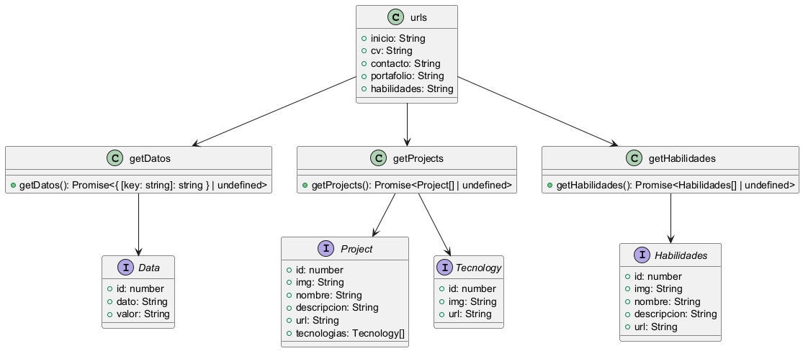

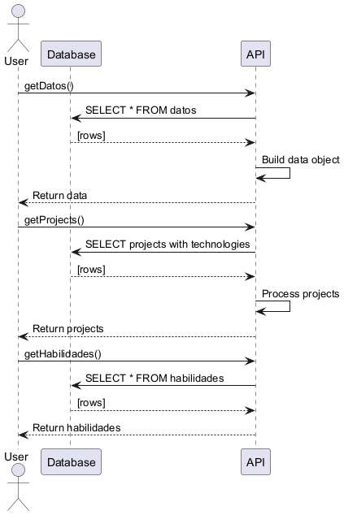

## Time Complexity Analysis

The code consists of three asynchronous functions that query a database and process the results. Below is a detailed analysis of the time complexity for each function.

### 1. `getDatos()`

- Database Query: The function executes a SQL query to fetch all rows from the `datos` table. Assuming `n` is the number of rows in this table, the time complexity of this query is `O(n)`.

- Processing Rows: The function iterates over the retrieved rows using the `forEach` method, which also runs in `O(n)` time.

- Overall Complexity: The overall time complexity for the `getDatos()` function is:

\[

O(n) + O(n) = O(n)

\]

### 2. `getProjects()`

- Database Query: This function runs a more complex SQL query involving multiple joins. The complexity of this query depends on the database's execution plan and the number of rows in each involved table. For simplicity, we denote the total number of resulting rows as `m`. Thus, the complexity of this query can be approximated as `O(m)`.

- Processing Rows: The function processes each row in a `for...of` loop:

- Checking if a project ID exists in the `projectsMap` and, if not, inserting it. This operation is `O(1)` on average due to the properties of a Map.

- If there is a technology associated with the project, it pushes it into the `tecnologias` array, which is also `O(1)`.

Since every row is processed once, the overall complexity for this part is `O(m)`.

- Converting Map to Array: Finally, converting the `projectsMap` to an array using `Array.from()` takes `O(p)`, where `p` is the number of unique projects.

- Overall Complexity: The overall time complexity for the `getProjects()` function can be summarized as:

\[

O(m) + O(m) + O(p) = O(m + p)

\]

### 3. `getHabilidades()`

- Database Query: Similar to `getDatos()`, this function executes a SQL query to fetch all rows from the `habilidades` table. Assuming `h` is the number of rows, the time complexity is `O(h)`.

- Returning Rows: The function directly returns the rows fetched from the database, which is a constant time operation `O(1)`.

- Overall Complexity: The overall time complexity for `getHabilidades()` is:

\[

O(h) + O(1) = O(h)

\]

### Summary

- `getDatos()`: Time Complexity: \( O(n) \)

- `getProjects()`: Time Complexity: \( O(m + p) \)

- `getHabilidades()`: Time Complexity: \( O(h) \)

Where:

- \( n \) = number of rows in `datos`

- \( m \) = number of resulting rows from the `projects` query

- \( p \) = number of unique projects

- \( h \) = number of rows in `habilidades`

The time complexities indicate that the functions scale linearly with respect to the number of records in their respective database tables.

Code Review Summary

### Identified Issues

1. Error Handling: The functions `getDatos`, `getProjects`, and `getHabilidades` catch errors but do not propagate them. This makes it difficult for calling functions to handle errors appropriately.

2. Type Safety: The `getProjects` function uses `any[]` for the query result type, which undermines type safety and defeats the purpose of using TypeScript. A more specific type should be defined.

### Recommendations for Improvement

- Improve Error Handling: Consider throwing the error after logging it. This allows the caller to be aware of the failure.

- Use Specific Types: Instead of `any[]`, define a specific interface for the database rows returned by `getProjects`. This enhances type safety and maintainability.

- Consistent Naming: Consider using consistent naming conventions across your interfaces, e.g., using either English or Spanish throughout.

### Areas of Strength

- Use of Interfaces: The use of interfaces for defining data types (`Data`, `Project`, `Tecnology`, `Habilidades`) improves code readability and maintainability.

- Clear Structure: The code is structured clearly, with separate functions for fetching different types of data.

### Potential Bugs

- If the database query returns results where `techId` is null, it could lead to unexpected behavior when accessing properties on `undefined` objects. Ensure proper null checks are in place.

### Performance Bottlenecks

- Query Optimization: The SQL queries could be optimized depending on the database schema and indexes. Consider adding indices on commonly queried columns to improve performance.

- Mapping Logic: The use of `Map` for projects is efficient. However, if the dataset is large, further optimizations could be considered, such as using a more efficient data structure.

### Security Vulnerabilities

- SQL Injection: While not directly visible in this code, ensure that any dynamic SQL queries are parameterized to prevent SQL injection vulnerabilities.

- Error Logging: Sensitive information should not be logged. Ensure that error messages do not expose sensitive data.

### Overall Code Quality Assessment

Score: 7/10

This code is well-structured and utilizes TypeScript effectively, but there are areas for improvement, particularly in error handling and type safety. Addressing these recommendations will enhance the overall quality and maintainability of the code.

Version 1.0

Provide a technical overview of the class, its purpose, and its features.

### Explanation -

Code Summary for Documentation:

The provided code is an implementation of a footer component designed for a web application using Astro, a modern static site generator. The code begins by importing data from a local file, `Data.astro`, which supplies user-specific information such as name, email, and phone number. This data is fetched asynchronously using the `getDatos` function.

The footer is structured into three main sections: general information, useful links, and social media connections.

1. General Information: This section displays copyright information, the owner's name (fetched from `data`), and contact details, including an email link and a telephone number that provides direct dialing functionality.

2. Links: A list of navigation links is presented, which directs users to various pages of the site, such as the homepage, CV, contact page, portfolio, and skills section. Each link is sourced from the imported `urls` object.

3. Social Media: Icons link to the user's LinkedIn and GitHub profiles. The icons are SVG graphics, ensuring scalable and high-quality visuals. Each icon is styled to slightly enlarge on hover for interactivity.

The footer uses CSS for styling, ensuring a visually appealing layout. It employs Flexbox for alignment and responsiveness, adapting to smaller screens with a media query that changes the layout to a block format. The CSS also includes hover effects for links and icons to enhance user interaction.

Overall, this code snippet efficiently combines structure, data integration, and aesthetic design to create a functional footer component that enhances the user experience on the website.

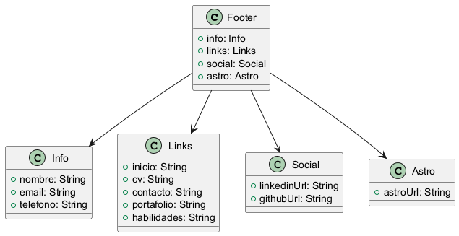

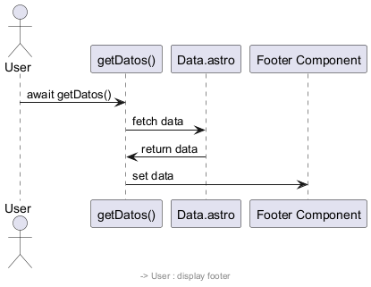

## Time Complexity Analysis

The provided code snippet primarily involves rendering a footer element in a web application using Astro, a modern static site generator. The focus of the analysis will be on the significant operations and their time complexities.

1. Data Fetching:

```javascript

let data = await getDatos();

```

The fetching of data using `await getDatos()` is an asynchronous operation. The time complexity for this operation depends on the implementation of the `getDatos` function. If `getDatos` performs a single API call or reads from a database, we can assume it has a time complexity of O(1) for the operation itself, contingent upon the response time. If the function includes iterating through a dataset or making multiple calls, it could be O(n) or worse, depending on the specifics.

2. Conditional Rendering:

```html

```

The use of optional chaining (`data?.nombre`) allows for safe access to the `nombre` property. This is a constant time operation, O(1), as it simply checks if `data` exists and retrieves `nombre` if it does.

3. Static Links Rendering:

```html

```

The static rendering of the links is O(1) in terms of time complexity because there is a fixed number of list items. Rendering them does not depend on any variable size inputs.

4. SVG Icon Rendering:

The rendering of SVG icons is also O(1) as the number of SVG icons is fixed and does not depend on any external variable size inputs.

5. Styling:

The CSS styles provided are static and do not contribute to time complexity in terms of rendering the HTML elements. They affect the appearance but not the computational aspect of rendering.

### Overall Complexity

Considering all the factors:

- The main factor affecting time complexity is the data fetching operation, which we assumed to be O(1) for single data retrieval or potentially O(n) if it involves more complex operations.

- The rest of the rendering and static content operations are O(1).

Thus, the overall time complexity can be summarized as:

- O(1) if `getDatos()` is a basic data fetching function with constant time complexity.

- O(n) if complex data fetching (like iterating through datasets) is involved.

In conclusion, the performance of this code snippet is fundamentally efficient with constant rendering time for the static content, while the data-fetching complexity would need to be evaluated based on the implementation of `getDatos()`.

Derechos de autor © 2024 {data?.nombre}...

Code Review Summary

Identified Issues:

1. Import Redundancy: The import statement for `getDatos` is redundant since `urls` is also imported from the same file. It can be consolidated.

2. Potential Null Reference: The usage of optional chaining (`data?.nombre`, `data?.email`, etc.) implies that `data` might be `undefined` or `null`. Consider adding error handling in case the data fetch fails.

3. SVG Accessibility: The SVG elements lack proper `aria-labels` or descriptive titles, which may hinder accessibility for screen readers.

Recommendations for Improvement:

1. Code Consolidation: Consolidate the import statements to avoid redundancy.

```javascript

import { urls, getDatos } from '../components/Data.astro';

```

2. Error Handling: Implement error handling for the asynchronous data fetching. Consider using a try-catch block or default values.

```javascript

let data;

try {

data = await getDatos();

} catch (error) {

console.error("Failed to fetch data:", error);

data = { nombre: 'Unknown', email: 'N/A', telefono: 'N/A' }; // Fallback values

}

```

3. Accessibility Enhancements: Add `aria-label` attributes or titles to SVGs to improve accessibility.

```html

Version 1.0

Provide a technical overview of the class, its purpose, and its features.

### Explanation -

Code Summary for Documentation:

This code snippet is an Astro component that renders a skills page. It imports necessary components and layout structures to create a coherent user interface. The primary components imported include `Footer`, `Header`, `Layout`, and `SkillCard`, each serving distinct roles in the page structure.

Initially, the code fetches user data and skills data asynchronously using the `getDatos` and `getHabilidades` functions from the `Data.astro` module. This data is stored in the `data` and `habilidades` variables, respectively. The `Layout` component is utilized to wrap the content, setting the title dynamically based on the user's name retrieved from `data`.

Inside the `main` section, the `Header` component is displayed first, followed by a heading ("Mis Habilidades:") that introduces the skills section. The core functionality lies in mapping over the `habilidades` array to create clickable `SkillCard` components for each skill. Each skill card is wrapped in an anchor tag that links to the respective skill's URL.

The styling is embedded within the component, which enhances the page's visual appeal. The background color is set to a light shade, and the main content is centered with defined margins. The heading is styled for prominence, while the skill cards are arranged centrally. Additionally, a media query ensures the skill cards stack vertically on smaller screens, improving responsiveness.

Overall, the code effectively combines data fetching, dynamic content rendering, and responsive design, ensuring a seamless user experience on the skills page.

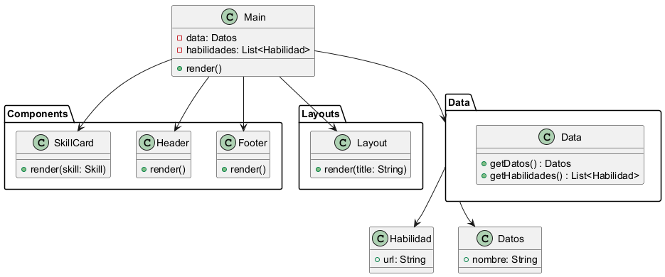

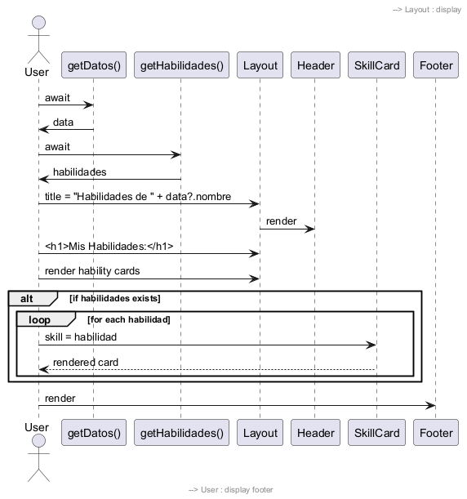

Time Complexity Analysis

The provided code snippet primarily consists of an Astro component that renders a layout containing a header, a list of skill cards, and a footer. The main operations that contribute to the time complexity are as follows:

1. Data Fetching:

- The code retrieves data using two asynchronous functions: `getDatos()` and `getHabilidades()`. The time complexity of these functions depends on the implementation of the data retrieval logic, which is not provided. Therefore, we assume the fetching operations are O(1) for this analysis, as they are typically treated as constant time for the purpose of rendering. However, if these functions involve complex operations (like querying a database or an API), their complexities would need to be considered separately.

2. Rendering Skill Cards:

- The key operation that impacts the time complexity is the rendering of skill cards. The `habilidades?.map(...)` function iterates over the `habilidades` array. If `n` is the number of habilidades (skills), the time complexity of this mapping operation is O(n), as each skill card is rendered individually.

3. Overall Complexity:

- Combining the above points, the overall time complexity of the rendering portion of the component can be expressed as O(n), where `n` is the number of skills. The constant-time operations for fetching data do not alter the linearity of the mapping operation.

In conclusion, the primary time complexity of the code snippet is O(n), where `n` is the number of skills being rendered. This assumes that the data fetching operations are performed efficiently in constant time.

Code Review Summary

Identified Issues:

1. Error Handling: There is no error handling for the asynchronous data fetching. If `getDatos` or `getHabilidades` fails, the application may encounter unhandled promise rejections.

2. Null/Undefined Checks: While optional chaining is used (`data?.nombre`), similar checks should be employed when URL and other properties of `habilidad` are accessed to avoid potential runtime errors.

Recommendations for Improvement:

1. Implement Error Handling: Introduce try-catch blocks around the `await` calls for data fetching to gracefully handle any errors and provide user feedback.

2. Improve URL Handling: Ensure that `habilidad.url` is defined before rendering the anchor tag to prevent navigation errors.

3. Component Keys: When rendering lists with `map`, it is advisable to provide a unique `key` prop for each component to optimize rendering and help React manage re-renders efficiently.

Areas of Strength:

1. Component Structure: The use of modular components (Header, Footer, SkillCard) promotes reusability and a clear structure.

2. Responsive Design: Media queries are well-implemented to ensure the layout adjusts for smaller screens.

Potential Bugs:

1. Links Without Valid URLs: If any `habilidad` does not have a valid URL, clicking might lead to unexpected behavior. Ensure that valid URLs are provided.

Performance Bottlenecks:

- The current implementation is efficient for a small dataset. However, if the number of skills grows significantly, consider implementing pagination or lazy loading to improve performance.

Security Vulnerabilities:

- If `habilidad.url` is user-generated, ensure to sanitize it to prevent XSS (Cross-Site Scripting) attacks. Use libraries like DOMPurify for sanitization.

Overall Code Quality Assessment:

- Score: 7/10

The code is generally well-structured and modular, but lacks sufficient error handling and validation for user input. Addressing these issues will enhance robustness and maintainability.

Version 1.0

Provide a technical overview of the class, its purpose, and its features.

### Explanation -

Code Summary for Documentation:

The provided code snippet outlines a header component for a web application, implemented using Astro framework syntax. It incorporates a navigation bar along with interactive SVG icons that serve as links to various sections of the site. The header is structured with two main elements: a logo area containing SVG icons and a navigation menu.

### Key Components:

1. Imports: The `urls` object is imported from a data component, which presumably contains the URLs for the navigation links.

2. Header Structure:

- The header is divided into a logo section (`

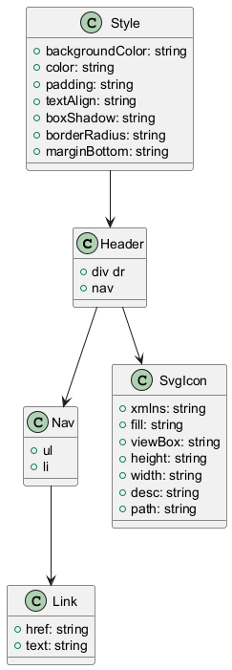

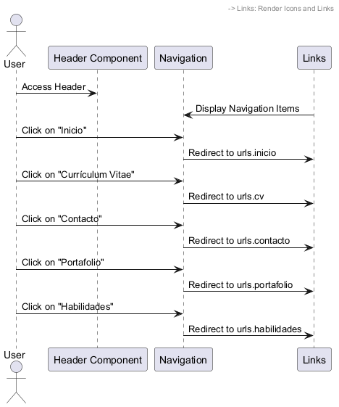

# Time Complexity Analysis

The provided code snippet primarily consists of HTML markup with embedded JavaScript and CSS styling. It does not contain any computational loops or algorithms that would typically be analyzed for time complexity in the traditional sense. However, we can still analyze the components of the code:

1. Static Rendering: The header, navigation links, and SVG icons are statically rendered. The time complexity for rendering static HTML content is O(1) since it does not depend on any variable input size.

2. SVG Rendering: The SVG elements are also statically defined. The rendering time for SVGs is constant, O(1), as they are not dynamically generated or manipulated based on user input.

3. CSS Styling: The CSS styles are applied uniformly to all elements. The complexity of applying styles is also O(1) for the initial load. However, the styling may affect performance during interactions (e.g., hover effects), but these are still O(1) operations since they do not depend on the number of elements being styled.

4. Dynamic Links: The links reference a `urls` object, which appears to be imported from another module. Accessing properties from an object is an O(1) operation. Therefore, the time complexity of rendering the links and their associated URLs is O(n), where n is the number of links, but in this case, it remains constant as there are five links.

5. Responsive Design: The CSS media queries allow the layout to change based on the screen size, but the responsiveness itself does not contribute to time complexity in the traditional sense; it mainly affects how the content is presented rather than how it is processed.

In summary, the overall time complexity of rendering this header component, including the navigation links and SVGs, can be considered O(1) because the number of elements is fixed and does not scale with input size. The only variable aspect, the number of links, remains constant here.

Thus, the final evaluation for time complexity is:

Overall Time Complexity: O(1)

Code Review Summary

### Identified Issues:

1. Accessibility: The SVG elements lack `aria-label` or descriptive text attributes which can hinder screen reader users. Consider adding `role="img"` and `aria-label` to enhance accessibility.

2. Hardcoded Styles: The use of hardcoded colors such as `#f0f0f0` and `#666` instead of CSS variables limits flexibility. It’s advisable to use variables to maintain a consistent color theme.

3. Potential Missing Fallback: The usage of CSS variables (`var(--text-color)`, `var(--primary-color)`) without fallback values may lead to issues if these properties are not defined elsewhere.

### Recommendations for Improvement:

- Enhance Semantic HTML: Consider using more semantic elements (like `

Version 1.0

Provide a technical overview of the class, its purpose, and its features.

### Explanation -

Code Summary for Documentation:

This code is an Astro component that serves as a web page layout, incorporating a header, footer, and main content area. The primary function of this component is to present a personal website that combines a blog and a resume.

At the beginning, the code imports necessary components such as `Footer`, `Header`, `Layout`, and `Card`, along with a data-fetching function `getDatos` from a data module. The `data` variable is initialized by invoking `getDatos()`, which retrieves user-specific data such as `nombre` (name) and `role`.

The main structure is wrapped in a `Layout` component that dynamically sets the page title using the user's name. Inside the `main` tag, the `Header` component is rendered first, followed by a welcoming message that includes the user's name and role. This section also contains introductory text about the user's passion for learning and sharing knowledge.

A series of `Card` components are included to direct users to different sections of the website, such as the CV, portfolio, and skills. Each card is populated with relevant images and URLs sourced from the imported `urls` object.

Styling is applied through a `

Version 1.0

Provide a technical overview of the class, its purpose, and its features.

### Explanation -

Code Summary for Documentation:

This code snippet defines a simple HTML template using Astro, a modern static site generator. The template is structured to accept a `title` prop, which is required for setting the page's title dynamically.

### Breakdown of Components:

1. Props Interface:

- The `Props` interface defines a single property, `title`, which is a string. This structure ensures that any component utilizing this template must provide a `title` value.

2. Destructuring Title:

- The line `const { title } = Astro.props;` extracts the `title` from the `Astro.props` object. This enables the template to use the provided title in the HTML `

Version 1.0

Provide a technical overview of the class, its purpose, and its features.

### Explanation -

Code Summary for Documentation:

This code is an Astro component that serves as a portfolio page, displaying various projects. It imports essential components such as `Footer`, `Header`, and `ProjectCard`, as well as a layout component called `Layout`. The code also imports two functions, `getDatos` and `getProjects`, from a data management module to fetch user and project data asynchronously.

Upon execution, the `getDatos` function retrieves user information, which is utilized to set the title of the page dynamically, incorporating the user's name. The `getProjects` function fetches an array of project objects, each containing details about individual projects.

The main structure of the component is wrapped in the `Layout` component, which provides a consistent design for the portfolio. Inside the `

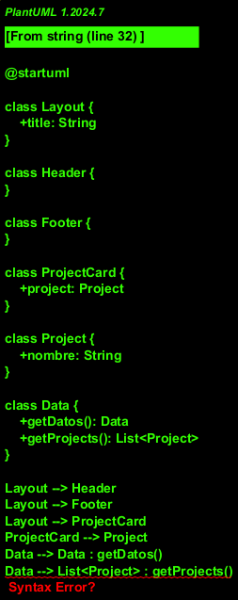

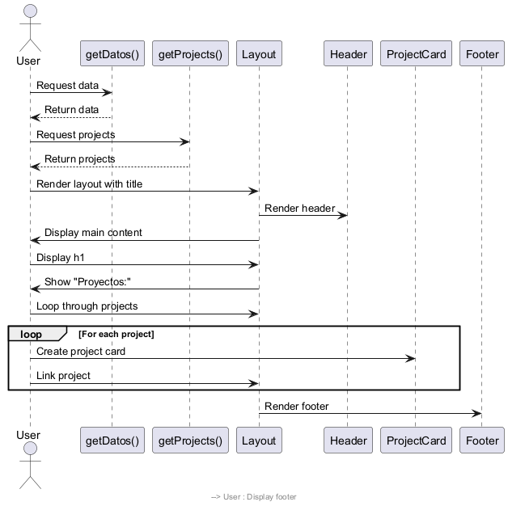

Time Complexity Analysis

The provided code snippet is primarily focused on rendering a portfolio webpage and includes data fetching, component rendering, and basic styling. Here's a breakdown of the time complexity:

1. Data Fetching:

- The functions `getDatos()` and `getProjects()` are both called using `await`, indicating that they are asynchronous operations. The time complexity here depends on the implementation of these functions. If they involve fetching data from an external source, such as a database or an API, the time complexity is typically O(1) for the fetching part itself but can be O(n) or more depending on the size of the data retrieved and how it is processed within those functions.

2. Mapping Projects:

- The line `projects?.map((project) => (...))` iterates over the `projects` array. If the size of the `projects` array is `m`, then the time complexity for this operation is O(m). Each project in the array is processed to create a new component, which is also O(1) for each iteration.

3. Rendering Components:

- Each iteration of the `map` function renders a `ProjectCard` component. The complexity involved in rendering components usually depends on the complexity of the component itself. Assuming the `ProjectCard` component has a constant time complexity, rendering all project cards will still be O(m).

4. Overall Complexity:

- The overall time complexity of the code snippet can be summarized as:

- Data fetching: O(1) to O(n) (depending on data source and size)

- Mapping through projects: O(m)

- Rendering project cards: O(m)

Hence, the overall time complexity of the provided code snippet can be approximated as O(n + m), where `n` is related to the data fetching and `m` is the number of projects being rendered. If the data fetching complexity is negligible compared to the rendering complexity, it can effectively be simplified to O(m) for practical purposes in rendering multiple project cards.

In conclusion, the time complexity is primarily linear concerning the number of projects that need to be rendered on the page.

Code Review Summary

### Identified Issues

1. Error Handling: There is no error handling for the asynchronous data fetching (`getDatos()` and `getProjects()`). If these functions fail, the user might see an empty page or a broken layout.

2. Null Checks: While optional chaining is used (`data?.nombre`), it may be beneficial to add more robust error handling to ensure that data is correctly loaded before rendering components that depend on it.

### Recommendations for Improvement

1. Add Error Handling: Consider implementing try-catch blocks around the data-fetching logic to handle potential errors gracefully.

2. Loading State: Introduce a loading state to inform users that data is being fetched, improving user experience.

3. Type Checking: If using TypeScript or PropTypes, ensure that the `ProjectCard` component receives the correct props to enforce data integrity.

4. Semantic HTML: Use more semantic HTML elements (e.g., `

Version 1.0

Provide a technical overview of the class, its purpose, and its features.

### Explanation -

Code Summary for Documentation:

This code snippet defines a component using Astro that displays project information on a web page. The component is structured to present a clickable card interface, which includes an image, project name, description, and a list of technologies associated with the project.

1. Component Structure:

- The `project` data is accessed from `Astro.props`, which contains properties such as `url`, `img`, `nombre`, `descripcion`, and `tecnologias`.

- The main content is wrapped in an anchor tag (`

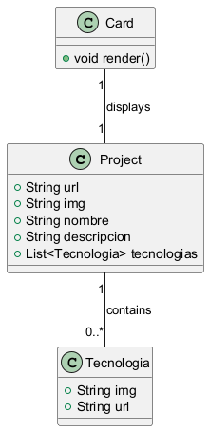

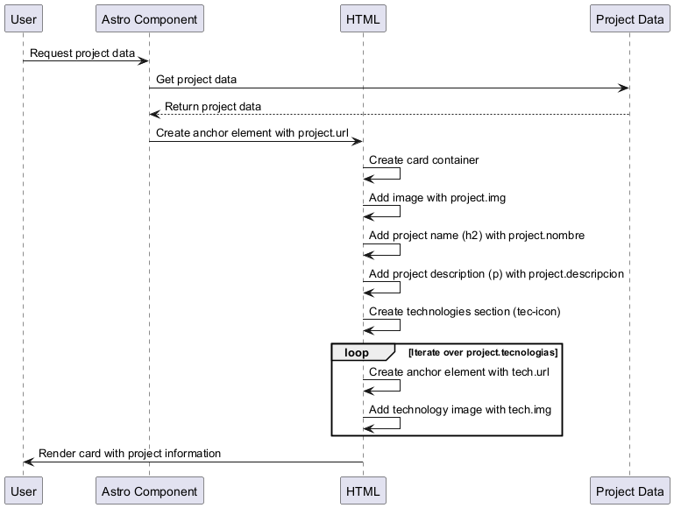

Time Complexity Analysis

The provided code snippet primarily consists of a React component that renders a project card with various elements, including an image, project description, and a list of technologies. The analysis focuses on the key operations and their associated complexities:

1. Rendering the Project Information:

- Accessing properties like `project.url`, `project.img`, `project.nombre`, and `project.descripcion` is done in constant time, O(1). This is because these are direct property accesses of the `project` object.

2. Mapping Over Technologies:

- The code includes a mapping operation on `project.tecnologias`, which is an array of technology objects. The `map` function iterates through each technology, creating an anchor (`

Version 1.0

Provide a technical overview of the class, its purpose, and its features.

### Explanation -

Code Summary for Documentation:

The provided code snippet is a component designed using Astro, a modern static site generator. It displays a skill card with an image, a title, and a description. The skill data is sourced from the `Astro.props.skill` object, which includes properties such as `img` for the image source and `nombre` for the skill's name. The card is structured using HTML with a combination of CSS for styling and layout.

### Structure:

- HTML Elements:

- A `div` element with the class `card` encapsulates the content.

- An `img` tag displays the skill's image, with the `src` attribute dynamically referencing `skill.img` and the `alt` attribute set to `skill.nombre`.

- A nested `div` contains an `h2` heading for the skill name and a `p` paragraph that highlights the skill level.

### Styling:

- The CSS styles are embedded within a `