Week 1

1.1 Observation and Experiment

Based on observational studies, we can only establish an association. In other words, correlation between the explanatory and the response variables.
In an experiments on the other hand, researchers randomly assign subjects to treatments and can, therefore, establish causal connections between the explanatory and response variables

Observational studies for the most part, allow us to make only correlational statements
While experiments, allow us to infer causation.

Confounding variable – викривляючий фактор

1.2 Sampling

Sample bias – зміщення виборки
Convenience sample – зручна виборка, нерепрезентативна, але є зручною з певних міркувань
Convenience sample – не репрезентативна вибірка
Non-response – нерепрезентативна (зміщена) виборки в результаті неотримання відповідей
Voluntary sample – виборка з добровольців.

The difference between voluntary response bias and non-response bias, is that in non-response there is a random sample that is surveyed, but the people who choose to respond are not representative of the sample while in voluntary response there is no initial random sample.

1.3 Sampling methods

Simple random sampling (SRS) randomly select cases from the population, such that each case is equally likely to be selected.
Stratified sampling we first divide the population into homogenous (однорідні) groups called strata, and then randomly sample from within each stratum. For example, if we wanted to make sure both genders are equally represented in a study, we might divide the population first into males and females, and then randomly sample from within each group
Cluster sampling we divide the population into clusters, randomly sample a few clusters, and then sample all observation within these clusters.
Кластер – група елементів, пов’язана спільними ознаками
Multistage sampling Just like in cluster sampling, we divide the population into clusters, randomly sample a few clusters, and then we randomly sample observations from within these clusters. Usually, we use cluster sampling and multistage sampling for economical reasons. For example, one might divide a city into geographic regions that are on average similar to each other, and then sample randomly a few of these regions, go to these randomly picked regions, and then, sample a few people from within these regions. This avoids the need to travel to all of the regions in the city.

1.4 Experimental design
The four principles of experimental design are control, randomize, replicate, and block.
To control, means to compare treatment of interest to a control group.
Treatment group – основна, експериментальна група
To randomize, means randomly assigning subjects to treatments.
To replicate, means collecting a sufficiently large sample within the study or to replicate the entire study.
The last principle of experimental design is blocking. If there are variables that are know or suspected to effect the response variable, first group the subjects into blocks based on these variables. And then randomized cases with in each block to treatment groups. Lets discuss blocking a bit more, we would like to design and experiment to investigate if energy gels make you run faster. The treatment group gets the energy gel, the control group does not get any energy gel. It is suspected that energy gels might effect pro and amateur athletes differently therefore we block for pro status. To do so, we divide our sample into pro and amateur athletes, and then, we randomly assign pro and amateur athletes to treatment and control groups, therefor, pro and amateur athletes are equally represented in the resulting treatment and control groups.

The difference between a blocking variable and an explanatory variable (впливаюча змінна, також відома як фактор). Explanatory variables also sometimes called factors, are conditions we can impose on our experimental units (умови, які ми можемо застосувати до наших предметів дослідження). Blocking variables, on the other hand, are characteristics that the experimental units come with, that we would like to control for. Blocking is basically like stratifying, expect used in experimental settings when randomly assigning as opposed to when sampling.

1.5 Random Sampling and Random Assignment
Random sampling occurs when subjects are being selected for a study. If subjects are selected randomly from the population, then each subject in the population is equally likely to be selected, and the resulting sample is likely representative of the population.
Random Assignment Random assignment occurs only in experimental settings, where subjects are being assigned to various treatments

WEEK 2 - Agenda
Explor ing Numeric Data
Suggested reading: OpenIntro Statistics, 3rd edition, Chapter 1, Section 1.6
LO 1. Use scatterplots for describing the relationship between two numerical variables making sure to note the direction (positive or negative), form (linear or non-linear) and the strength of the relationship as well as any unusual observations that stand out.
LO 2. When describing the distribution of a numerical variable, mention its shape, center, and spread, as well as any unusual observations.
LO 3. Note that there are three commonly used measures of center and spread:
- center: mean (the arithmetic average), median (the midpoint), mode (the most frequent observation).
- spread: standard deviation (variability around the mean), range (max-min), interquartile range (middle 50% of the distribution).
LO 4. Identify the shape of a distribution as symmetric, right skewed, or left skewed, and unimodal, bimodal, multimodal, or uniform.
LO 5. Use histograms and box plots to visualize the shape, center, and spread of numerical distributions, and intensity maps for visualizing the spatial distribution of the data.
LO 6. Define a robust statistic (e.g. median, IQR) as a statistic that is not heavily affected by skewness and extreme outliers, and determine when such statistics are more appropriate measures of center and spread compared to other similar statistics.
LO 7. Recognize when transformations (e.g. log) can make the distribution of data more symmetric, and hence easier to model.
Transforming data - view E.Tuckey "Exploratory Data Analisys" part 3.
Exploring Categorical Data and Introduction to Inference
Suggested reading: OpenIntro Statistics, 3rd edition, Chapter 1, Sections 1.7 - 1.8
LO 1. Use frequency tables and bar plots to describe the distribution of one categorical variable.
LO 2. Use contingency tables and segmented bar plots or mosaic plots to assess the relationship between two categorical variables.
LO 3. Use side-by-side box plots for assessing the relationship between a numerical and a categorical variable.
Test yourself:
- Interpret the plot in Figure 1.30 of OpenIntro Statistics (page 39).
- You collect data on 100 classmates, 70 females and 30 males. 10% of the class are smokers, and smoking is independent of gender. Calculate how many males and females would be expected to be smokers. Sketch a mosaic plot of this scenario.

WEEK 2 – Exercises

Suggested reading for this week: OpenIntro Statistics, 3rd edition, Chapter 1, Sections 1.6, 1.7, 1.8
Practice exercises: End of chapter exercises Chapter 1: 1.39, 1.41, 1.45, 1.49, 1.51, 1.55, 1.59, 1.63, 1.65, 1.67, 1.69
(Reminder: the solutions to the end of chapter exercises are at the end of the OpenIntro Statistics book)

Anatomy of Facebook
Think back to the last time you were in a crowded airport or bus terminal far from home. Did you consider that the person sitting next to you probably knew a friend of a friend of a friend of yours? In the 1960s, social psychologist Stanley Milgram’s “small world experiment” famously tested the idea that any two people in the world are separated by only a small number of intermediate connections, arguably the first experimental study to reveal the surprising structure of social networks.
With the rise of modern computing, social networks are now being mapped in digital form, giving researchers the ability to study them on a much grander, even global, scale. Continuing this tradition of social network research, Facebook, in collaboration with researchers at the Università degli Studi di Milano, is today releasing two studies of the Facebook social graph.
First, we measured how many friends people have, and found that this distribution differs significantly from previous studies of large-scale social networks. Second, we found that the degrees of separation between any two Facebook users is smaller than the commonly cited six degrees, and has been shrinking over the past three years as Facebook has grown. Finally, we observed that while the entire world is only a few degrees away, a user’s friends are most likely to be of a similar age and come from the same country.
In our studies, performed earlier this year, we examined all 721 million active Facebook users (more than 10% of the global population), with 69 billion friendships among them. To date, these are the largest social network studies ever released.
How many friends?
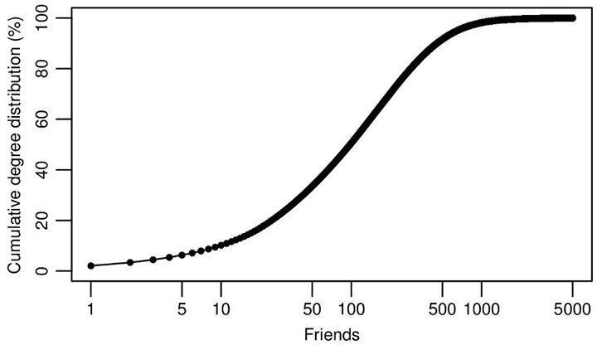 An important basic view of any social network is the cumulative degree distribution, which shows the percentage of individuals that have less than a given number of friends. As you can see above, only 10% of people have less than 10 friends, 20% have less than 25 friends, while 50% (the median) have over 100 friends. Meanwhile, because the distribution is highly skewed, the average friend count is 190. An important finding from our study, however, is that the distribution is not nearly as skewed as earlier studies of social networks have suggested.
At first glance, the median friend count on Facebook — 100 — may seem surprisingly low; a quick survey of my own friends reveals that they almost all have more than 100 friends. But no, your friends are not atypically social – a classic paradox regarding social networks dictates that, for most people, the median friend count of their friends is higher than their own friend count. On Facebook, that’s the case for 84% of our users. Why? Scott Feld wrote about this phenomenon in his 1991 paper Why Your Friends Have More Friends than You Do, showing that the same phenomenon dictates that college students typically find that their classes to be larger than the average class size, and that when sitting on an airplane, it will typically be more crowded than the average occupancy. These effects all arise because for people, classes, and flights to be popular, you must be much more likely to choose them. So you shouldn’t feel bad if it seems like all your friends are more popular than you: it appears this way to most of us.

Four degrees of separation.
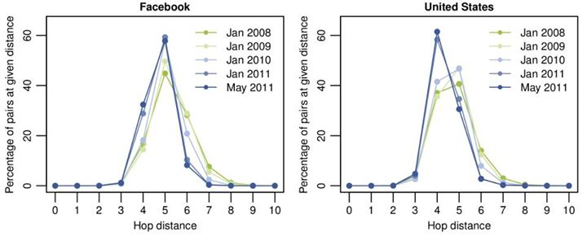
The idea of ‘six degrees of separation’ -- that any two people are on average separated by no more than six intermediate connections -- was first proposed in 1929 in a short story by Hungarian author Frigyes Karinthy, and made popular by the John Guare play and movie, Six Degrees of Separation. The idea was first put to the test by Stanley Milgram in the 1960’s. Milgram selected 296 volunteers and asked them to dispatch a message to a specific individual, a stockholder living in the Boston suburb of Sharon, Massachusetts. The volunteers were told that they couldn’t send the message directly to the target person (unless the sender knew them personally), but that they should route the message to a personal acquaintance that was more likely than the sender to know the target person. Milgram found that the average number of intermediate persons in these chains was 5.2 (representing about 6 hops). The experiment showed that not only are there few degrees of separation between any two people, but that individuals can successfully navigate these short paths, even though they have no way of seeing the entire network.
While we will never know if it was true in 1929, the scale and international reach of Facebook allows us to finally perform this study on a global scale. Using state-of-the-art algorithms developed at the Laboratory for Web Algorithmics of the Università degli Studi di Milano, we were able to approximate the number of hops between all pairs of individuals on Facebook. We found that six degrees actually overstates the number of links between typical pairs of users: While 99.6% of all pairs of users are connected by paths with 5 degrees (6 hops), 92% are connected by only four degrees (5 hops). And as Facebook has grown over the years, representing an ever larger fraction of the global population, it has become steadily more connected. The average distance in 2008 was 5.28 hops, while now it is 4.74.
Thus, when considering even the most distant Facebook user in the Siberian tundra or the Peruvian rainforest, a friend of your friend probably knows a friend of their friend. When we limit our analysis to a single country, be it the US, Sweden, Italy, or any other, we find that the world gets even smaller, and most pairs of people are only separated by 3 degrees (4 hops). It is important to note that while Milgram was motivated by the same question (how many individuals separate any two people), these numbers are not directly comparable; his subjects only had limited knowledge of the social network, while we have a nearly complete representation of the entire thing. Our measurements essentially describe the shortest possible routes that his subjects could have found.
Your friends and you.
It’s easy for me to imagine that a path from me to a random person in Siberia goes first to one of my few Russian friends in California, and then hops around the globe to a friend of theirs living in Russia. But, while I can imagine these short paths connecting all pairs of people in the world, this notion stands in sharp contrast to my day-to-day experience. Most of my friends live in the US, and the ones I am closest to live within just a few miles of me.
This is what makes social networks somewhat unique: they are both well-connected in the sense that you can reach anyone from anyone else in a relatively short number of hops, but at the same time, they are very locally clustered, with the vast majority of connections spanning a short distance. In our study, we found that 84% of all connections are between users in the same country. But this isn’t the only dimension along which people tend to cluster. We also find that people tend to have a similar, albeit typically smaller, number of friends as their neighbors, and tend to be about the same age. Somewhat surprisingly, even for individuals aged 60, the distribution of their friends’ ages is sharply peaked at exactly 60.
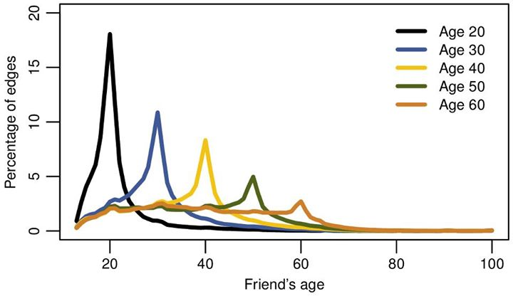

Conclusions
To facilitate open access within the scientific community, the two works are available for download:
J. Ugander, B. Karrer, L. Backstrom, C. Marlow.
The Anatomy of the Facebook Social Graph,
http://arxiv.org/abs/1111.4503
L. Backstrom, P. Boldi, M. Rosa, J. Ugander, S. Vigna.
Four Degrees of Separation,
http://arxiv.org/abs/1111.4570
In these two works, we show how the Facebook social network is at once both global and local. It connects people who are far apart, but also has the dense local structure we see in small communities. We show that, as Facebook has grown over the years, representing an ever larger fraction of the global population, it has become even more connected. In the years to come, we look forward to continuing to illuminate social trends and helping people understand how the world is becoming more connected.

Week 3 Probability
Suggested reading: OpenIntro Statistics, 3rd edition, Chapter 2, Section 2.1
LO 1. Define the probability of an outcome as the proportion of times the outcome would occur if we observed the random process that gives rise to it an infinite number of times.
LO 2. Explain why the long-run relative frequency of repeated independent events settles down to the true probability as the number of trials increases, i.e. why the law of large numbers holds.
LO 3. Define disjoint (mutually exclusive) events as events that cannot both happen at the same time:
- If A and B are disjoint, P(A and B) = 0
LO 4. Distinguish between disjoint and independent events.
- If A and B are independent, then having information on A does not tell us anything about B (and vice versa).
- If A and B are disjoint, then knowing that A occurs tells us that B cannot occur (and vice versa).
- Disjoint (mutually exclusive) events are always dependent since if one event occurs we know the other one cannot.
LO 5. Draw Venn diagrams representing events and their probabilities.
LO 6. Define a probability distribution as a list of the possible outcomes with corresponding probabilities that satisfies three rules:
- The outcomes listed must be disjoint.
- Each probability must be between 0 and 1.
- The probabilities must total 1.
LO 7. Define complementary outcomes as mutually exclusive outcomes of the same random process whose probabilities add up to 1.
- If A and B are complementary, P(A) + P(B) = 1
LO 8. Distinguish between union of events (A or B) and intersection of events (A and B).
- Calculate the probability of union of events using the (general) addition rule:
If A and B are not mutually exclusive, P(A or B) = P(A) + P(B) − P(A and B)
If A and B are mutually exclusive, P (A or B) = P (A) + P (B), since for mutually exclusive events P(A and B) = 0
- Calculate the probability of intersection of independent events using the multiplication rule:
If A and B are independent, P(A and B) = P(A) × P(B)
If A and B are dependent, P(A and B) = P(A|B) × P(B)
Test yourself:
1. What is the probability of getting a head on the 6th coin flip if in the first 5 flips the coin landed on a head each time?
2. True / False: Being right handed and having blue eyes are mutually exclusive events.
3. P(A) = 0.5, P(B) = 0.6, and there are no other possible outcomes in the sample space. What is P(A and B)?
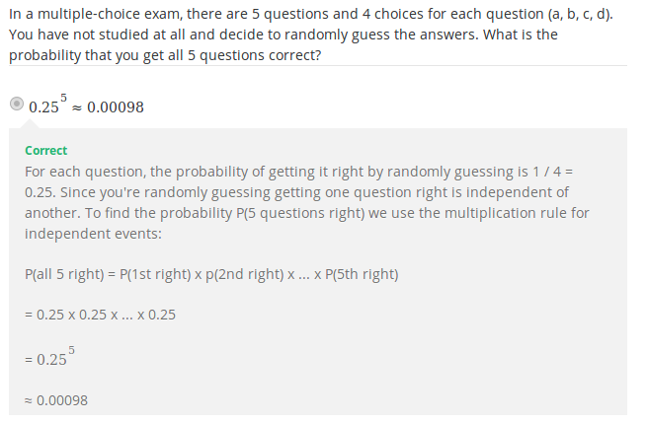
Two outcomes are called disjoint or mutually exclusive if they cannot both happen.
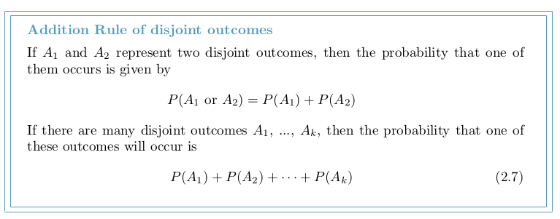
WEEK 3 - Conditional Probability

Suggested reading: OpenIntro Statistics, 3rd edition, Chapter 2, Section 2.2
LO 1. Distinguish between marginal and conditional probabilities.
LO 2. Construct tree diagrams to calculate conditional probabilities and probabilities of intersection of non-independent events using Bayes’ theorem
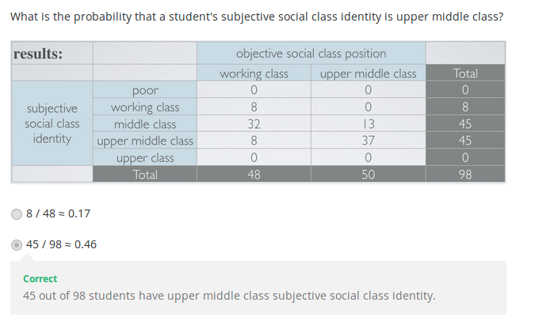
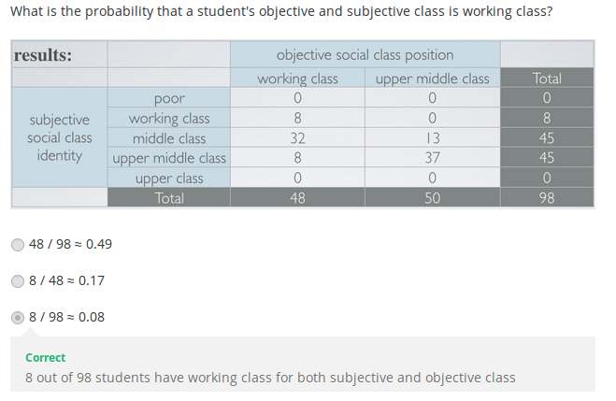
marginal probability – безумовна ймовірність
joint probability – сумісна ймовірність
If a probability is based on a single variable, it is a marginal probability. The probability of outcomes for two or more variables or processes is called a joint probability.
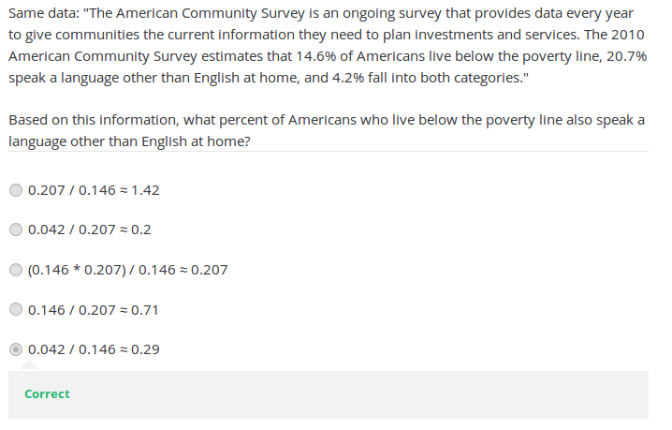
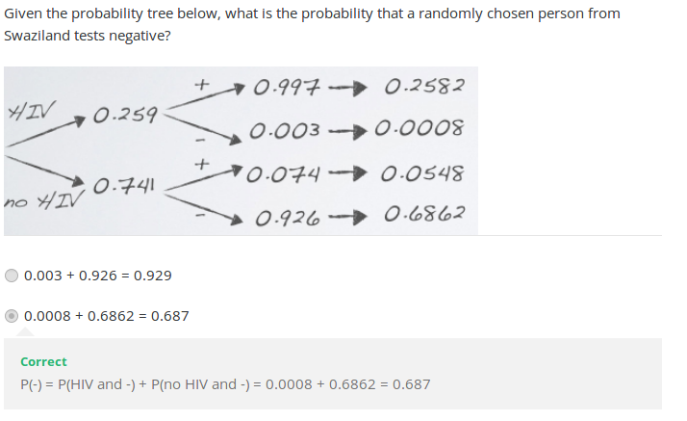
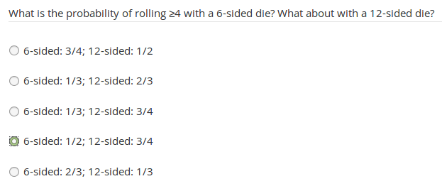
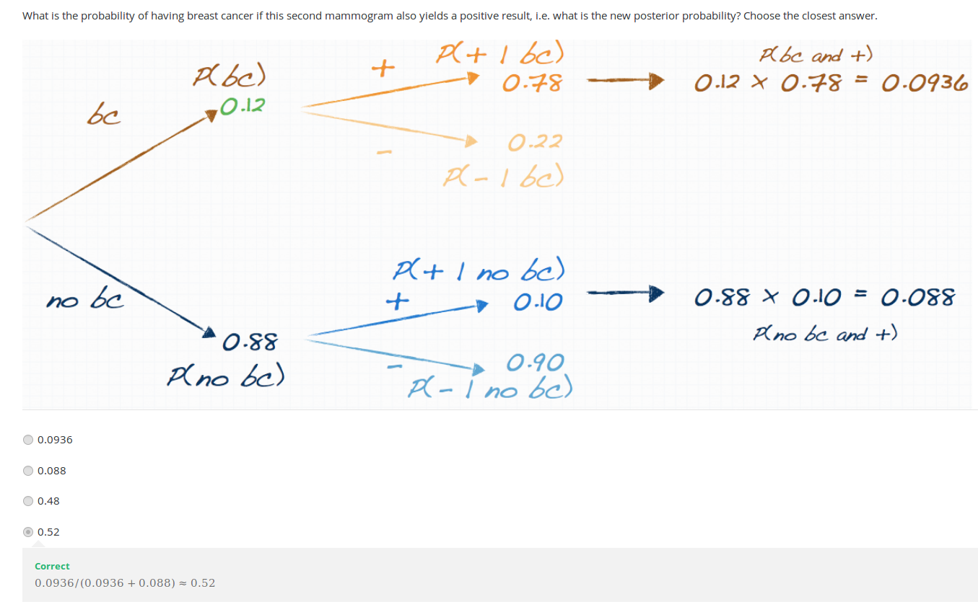
Practice
Suggested reading for this week: OpenIntro Statistics, 3rd edition, Chapter 2, Sections 2.1 and 2.2
Practice exercises: End of chapter exercises Chapter 2: 2.1, 2.3, 2.5, 2.7, 2.13, 2.15, 2.19, 2.21, 2.23
Answers:
2.1: a) False; b) False; c) True
2.5 Coin flips. If you flip a fair coin 10 times, what is the probability of
(a) getting all tails? 0.5*0.5*0.5*0.5*0.5*0.5*0.5*0.5*0.5*0.5 =
(b) getting all heads? The same
(c) getting at least one tails? P (at least one tails) = 1 P (no tails) = 1- (0.5 10¹⁰ ) - 1 0.001 = 0.999.
2.7 Swing voters. A 2012 Pew Research survey asked 2,373 randomly sampled registered voters their political affiliation (Republican, Democrat, or Independent) and whether or not they identify as swing voters. 35% of respondents identified as Independent, 23% identified as swing voters, and 11% identified as both.
(a) Are being Independent and being a swing voter disjoint, i.e. mutually exclusive?
No
(b) Draw a Venn diagram summarizing the variables and their associated probabilities.
(c) What percent of voters are Independent but not swing voters? 24%
(d) What percent of voters are Independent or swing voters? 69% 24 + 23 = 47%
(e) What percent of voters are neither Independent nor swing voters? 100 – 69 = 31% 53%
(f) Is the event that someone is a swing voter independent of the event that someone is a political
Independent
2.11 Educational attainment of couples. The table below shows the distribution of education level attained by US residents by gender based on data collected during the 2010 American Community Survey.
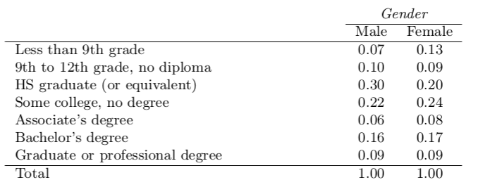

(a) What is the probability that a randomly chosen man has at least a Bachelor’s degree?
0.09+0.16 = 0.25
(b) What is the probability that a randomly chosen woman has at least a Bachelor’s degree?
0.09+0.17 = 0.27
(c) What is the probability that a man and a woman getting married both have at least a Bach-
elor’s degree? Note any assumptions you must make to answer this question.
0.25*0.26 = 0.065
2.15 Joint and conditional probabilities. P(A) = 0.3, P(B) = 0.7
(a) Can you compute P(A and B) if you only know P(A) and P(B)?
(b) Assuming that events A and B arise from independent random processes,
i. what is P(A and B)? 0.3*0.7 = 0.21
ii. what is P(A or B)?
iii. what is P(A|B)? 0.21/0.7 = 0.3
(c) If we are given that P(A and B) = 0.1, are the random variables giving rise to events A and
B independent?
No, because 0.1 6 = 0.21, where 0.21 was the value computed under independence from part (a)
(d) If we are given that P(A and B) = 0.1, what is P(A|B)? 0.1/0.7 = 0.1429
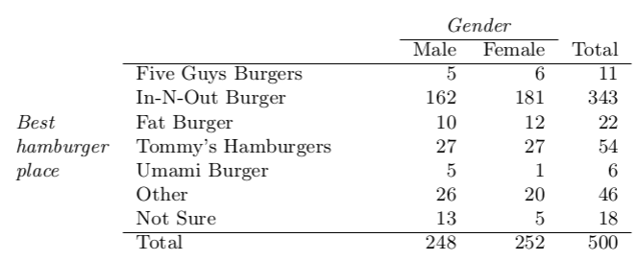
2.19 Burger preferences. A 2010 SurveyUSA poll asked 500 Los Angeles residents, “What is the best hamburger place in Southern California? Five Guys Burgers? In-N-Out Burger? Fat Burger? Tommy’s Hamburgers? Umami Burger? Or somewhere else?” The distribution of responses by gender is shown below.

(a) Are being female and liking Five Guys Burgers mutually exclusive? No
(b) What is the probability that a randomly chosen male likes In-N-Out the best?
162/248 = 0.65
(c) What is the probability that a randomly chosen female likes In-N-Out the best?
181/252 = 0.71
(d) What is the probability that a man and a woman who are dating both like In-N-Out the best? Note any assumption you make and evaluate whether you think that assumption is reasonable.
0.65*0.71 = 046
(e) What is the probability that a randomly chosen person likes Umami best or that person is
female?
(6 + 252 - 1)/500 = 0.514
2.23 HIV in Swaziland. Swaziland has the highest HIV prevalence in the world: 25.9% of this country’s population is infected with HIV. 66 The ELISA test is one of the first and most accurate tests for HIV. For those who carry HIV, the ELISA test is 99.7% accurate. For those who do not carry HIV, the test is 92.6% accurate. If an individual from Swaziland has tested positive, what is the probability that he carries HIV?

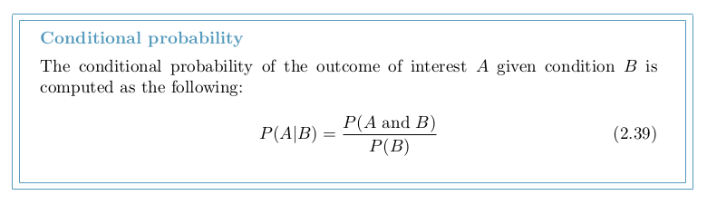
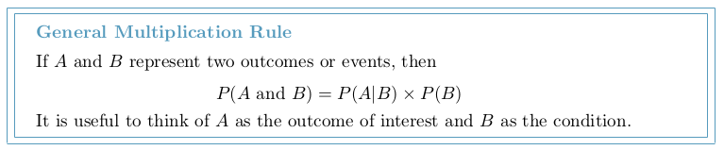
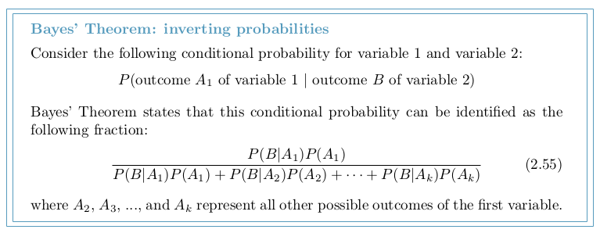

Week 4. The normal distribution
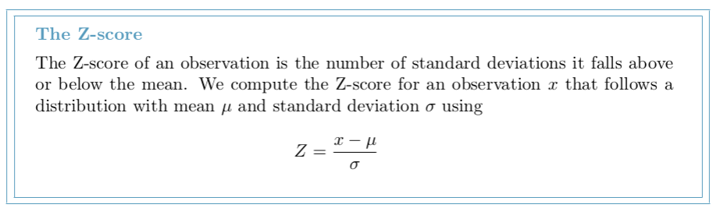
TIP: always draw a picture first, and find the Z-score second
For any normal probability situation, always always always draw and label the normal curve and shade the area of interest first. The picture will provide an estimate of the probability. After drawing a figure to represent the situation, identify the Z-score for the observation of interest.
Bernoulli random variable, descriptive
A Bernoulli random variable has exactly two possible outcomes. We typically label one of these outcomes a “success” and the other outcome a “failure”. We may also denote a success by 1 and a failure by 0.
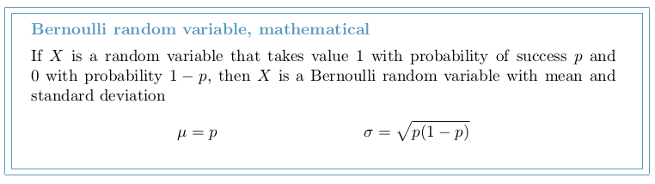
Binomial Distribution
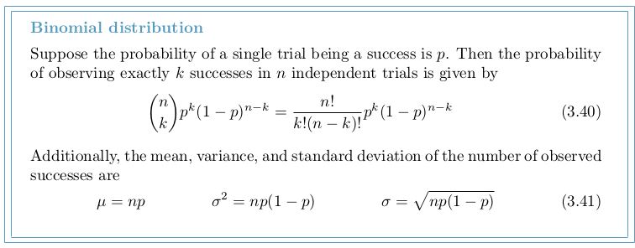
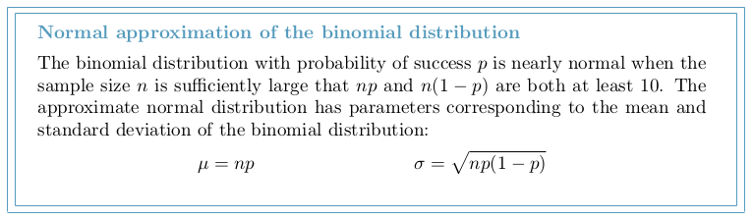
Caution: The normal approximation may fail on small intervals
The normal approximation to the binomial distribution tends to perform poorly when estimating the probability of a small range of counts, even when the conditions are met.
TIP: Improving the accuracy of the normal approximation to the binomial distribution
The normal approximation to the binomial distribution for intervals of values is usually improved if cutoff values are modified slightly. The cutoff values for the lower end of a shaded region should be reduced by 0.5, and the cutoff value for the upper end should be increased by 0.5.

Week 4 Practice Quiz
