**Environment description.**

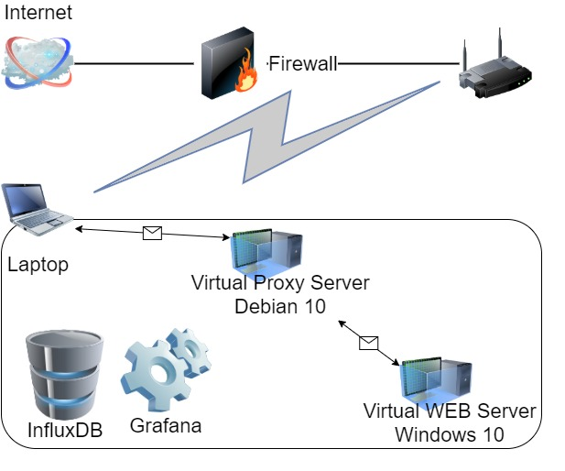

**Laptop** Windows 10**:**

Intel Core i7-8665U / 32 GB

**Virtual Proxy Server** Debian 10:

2 CPU (70%) / 4 GB

**Virtual WEB Server** Windows 10:

4 CPU (100%)/ 4 GB

1. Regular load
   1. Script: Task 7
   2. Users: Editor – 2, Admin – 1, Anonymous – 23
   3. Rump-up: Editor – 120s, Admin – 60s, Anonymous – 1h
   4. Test duration – 8h
2. KPI – avg response time, throughput, percentage of errors, CPU and Memory utilization, Get Home Page (First Page) samples results (avg, 90 pct, 95 pct), numbers of actions.
3. Graphs:

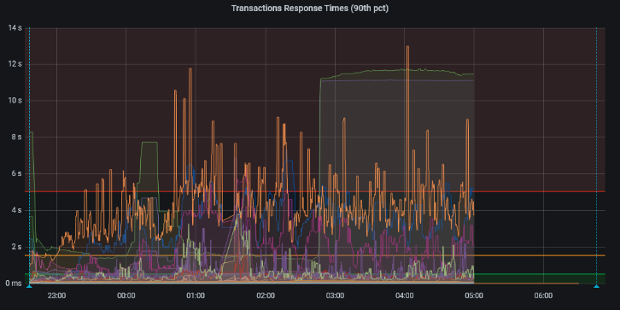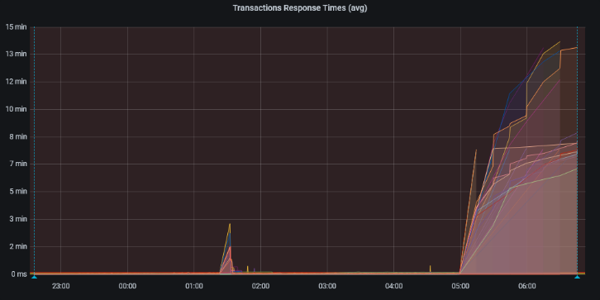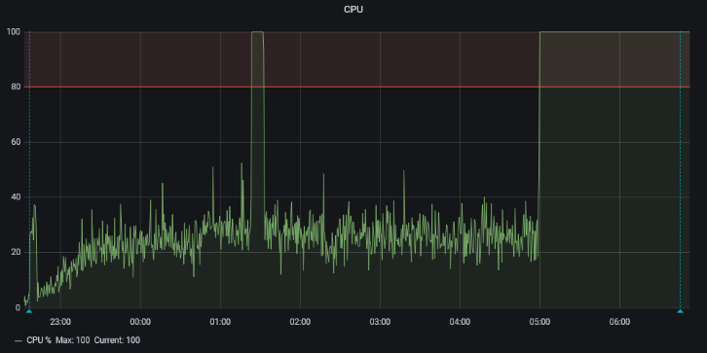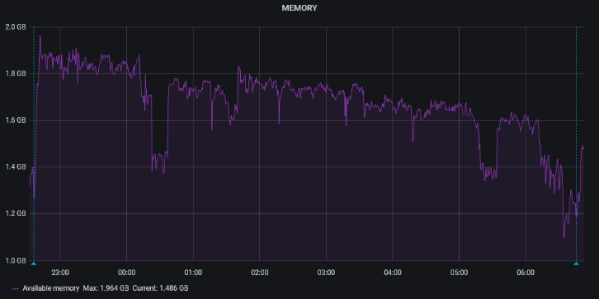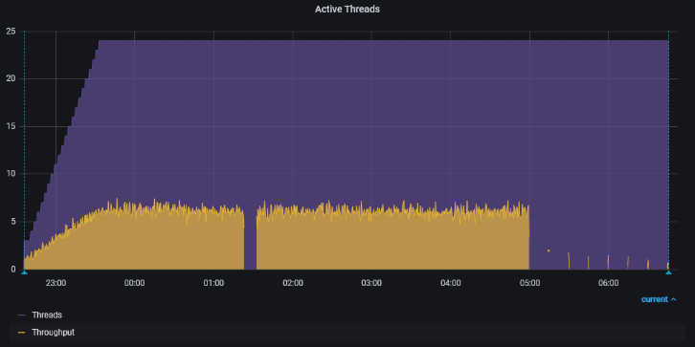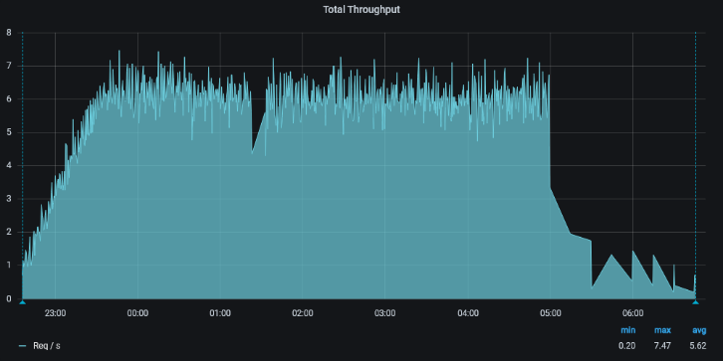

1. Summary:

Max avg response time – not valid (CPU utilization 100%)

Max 90pct response time – 13.01 s

Max throughput – 7.8 req/s

Percentage of errors – 0.23%

Max CPU utilization – 100 %

Average CPU utilization – 30 %

Min available Memory – 1.125 GB

Get Home Page: avg – not valid, 90pct – 4.64 s, 95pct – 10.76 s.

Total Number of started samples – 5071

Failed samples – 15 (with responses) N/A (without responses)

Bottleneck: network configuration (proxy server).

Issue: after some period of work “Windows Software Protection" may recognize user's calls as attacks and start to scan them. After this CPU load becomes 100% and the server stops responding.