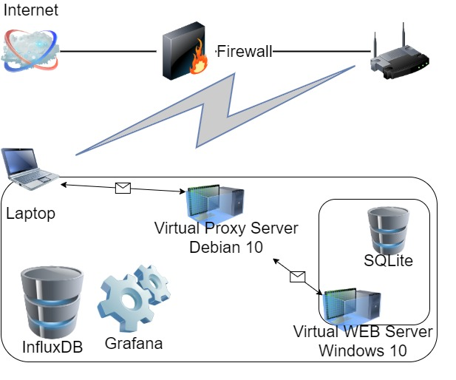**Environment description.**

**Laptop** Windows 10**:**

Intel Core i7-8665U / 32 GB

**Virtual Proxy Server** Debian 10:

2 CPU / 4 GB

**Virtual WEB Server** Windows 10:

1-4 CPU / 2-4 GB

1. Regular load
   1. Script: [HomeTask11.jmx](https://github.com/DmytroYaroslavtsev/study/blob/master/HomeTask11/HomeTask11.jmx)
   2. Users: Editor – 2, Admin – 1, Anonymous – 188
   3. Rump-up: Editor – 120s, Admin – 60s, Anonymous – 1800s
   4. Test duration – 1h
   5. Number of posts: 1000
   6. Cases: 4 CPU 2GB, 4 CPU 3GB, 4 CPU 4GB, 1 CPU 4GB, 2 CPU 4GB, 3 CPU 4GB.
2. KPI & Metrics
   1. Metrics to collect – response time, throughput, percentage of errors, CPU and Memory utilization, Get Home Page (First Page) samples results (avg, 90pct, 95pct)
   2. KPI - Get Home Page (First Page) samples results (avg, 90pct, 95pct), max throughput, percentage of errors, max CPU utilization, min available memory.
3. Results: [Graphs](https://github.com/DmytroYaroslavtsev/study/tree/master/HomeTask11/Graphs/Scalability)

|  |  |  |  |  |  |  |
| --- | --- | --- | --- | --- | --- | --- |
| Cases | 4 CPU 2GB | 4 CPU 3GB | 4 CPU 4GB | 3 CPU 4GB | 2 CPU 4GB | 1 CPU 4GB |
| Home avg | 938.19 ms | 696.35 ms | 294.98 ms | 601.5 ms | 3.49 s | 2.06 s |
| Home 90 pct | 2.94 s | 1.44 s | 1.03 s | 1.84 s | 5.71 s | 3.69 s |
| Home 95 pct | 3.36 s | 1.75 s | 1.13 s | 2.03 s | 6.16 s | 5.06 s |
| Max throughput | 65.20 req/s | 66.8 req/s | 62.00 req/s | 58.2 req/s | 60.00 req/s | 60.40 req/s |
| Avg throughput | 36.61 req/s | 33.62 req/s | 37.02 req/s | 36.37 req/s | 33.87 req/s | 34.21 req/s |
| % of Errors | 0.07 % | 0.02 % | 0.02 % | 0.03 % | 0.01% | 0 % |
| Max CPU use | 61 % | 72 % | 59 % | 89 % | 100 % | 100 % |
| Avg CPU use | 26 % | 30 % | 22 % | 34 % | 54 % | 80 % |
| Min memory | 86 MB | 233 MB | 559 MB | 1.025 GB | 930 MB | 853 MB |

Test with 1 CPU 4 GB not valid because it was done after some Environment optimization actions.

Degradation depends on the number of CPUs and the size of the RAM of the server. But also there is a deviation which cause is the configuration of Environment (optimization internal processes and Network connection).

Bottleneck: network configuration (proxy server).