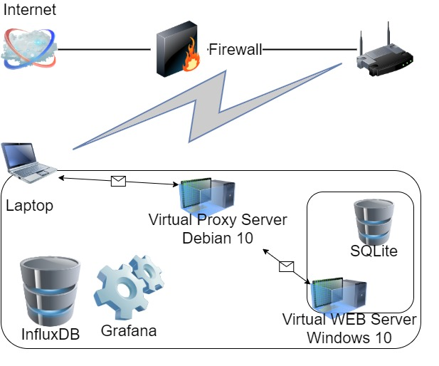**Environment description.**

**Laptop** Windows 10**:**

Intel Core i7-8665U / 32 GB

**Virtual Proxy Server** Debian 10:

2 CPU / 4 GB

**Virtual WEB Server** Windows 10:

4 CPU / 4 GB

1. Regular load
   1. Script: [HomeTask11.jmx](https://github.com/DmytroYaroslavtsev/study/blob/master/HomeTask11/HomeTask11.jmx)
   2. Users: Editor – 2, Admin – 1, Anonymous – 188
   3. Rump-up: Editor – 120s, Admin – 60s, Anonymous – 1800s
   4. Test duration – 1h
   5. Cases: 100 posts, 1000 posts, 2000 posts, 5000 posts, 1000 posts with 1MB photo.
2. KPI & Metrics
   1. Metrics to collect – response time, throughput, percentage of errors, CPU and Memory utilization, Get Home Page (First Page) samples results (avg, 90pct, 95pct)
   2. KPI - Get Home Page (First Page) samples results (avg, 90pct, 95pct), max throughput, percentage of errors, max CPU utilization, min available memory.
3. Results: [Graphs](https://github.com/DmytroYaroslavtsev/study/tree/master/HomeTask11/Graphs)

|  |  |  |  |  |  |
| --- | --- | --- | --- | --- | --- |
| Cases | 100 | 1000 | 2000 | 5000 | 1000+photo |
| Home avg | 93.5 ms | 294.98 ms | 6.36 s | 23.41 s | 2.85 s |
| Home 90 pct | 301.1 ms | 1.03 s | 11.97 s | 32.61 s | 5.73 s |
| Home 95 pct | 413.2 ms | 1.13 s | 13.38 s | 35.00 s | 6.46 s |
| Max throughput | 64.2 req/s | 62.0 req/s | 58.6 req/s | 38.8 req/s | 58.2 req/s |
| Avg throughput | 37.13 req/s | 37.02 req/s | 29.27 req/s | 15.37 req/s | 36.61 req/s |
| % of Errors | 0.02 % | 0.02 % | 0 % | 0 % | 0.02 % |
| Max CPU use | 71 % | 59 % | 76 % | 62 % | 71 % |
| Min memory | 684.3 MB | 538 MB | 507 MB | 604 MB | 364 MB |

Degradation depends on data as number of posts or picture availability (post size).

Bottleneck: network configuration (proxy server).