**Performance Test Plan**

For BlogEngine.NET 3.2 ver. 1.0.0

1. Test items

[BlogEngine.NET Documentation](https://docs.microsoft.com/en-us/iis/publish/deploying-application-packages/blogenginenet)

[JMeter Documentation](https://jmeter.apache.org/usermanual/get-started.html)

[BlogEngine.NET Algorithms](https://github.com/DmytroYaroslavtsev/study/tree/master/BlogEngine%20algorithms.docx)

[Performance Test Strategy](https://github.com/DmytroYaroslavtsev/study/tree/master/HomeTask12/Stady_project_Test_strategy.docx)

1. Introduction

This document describes the activities, pass/fail criteria, suspension criteria and resumption requirements, test deliverables, testing tasks, environment description, responsibilities, staffing and training needs, schedule, risks and contingencies, techniques and tools which could be used for the performance testing of the BlogEngine.NET 3.2 application.

The aim of BlogEngine.NET 3.2 performance testing is to determine the overall complex evaluation of the back-end server system (software + hardware) in different conditions of usage:

* Different number of the posts.
* Posts with a text and attached photo.
* Different number of the users.
* Different types of data storage.

1. Features to be tested

Admin features: login/logout, user creating/deleting.

Editor features: login/logout, posts creation/editing.

Users features: post opening/commenting, calendar opening, contacts opening, search by name.

1. Features not to be tested

Additional plugins, user’s login/logout (except admin and editor role), third party services, archive, etc.

1. Approach (activities, techniques, tools)

Generate user scripts based on [BlogEngine.NET Algorithms](https://github.com/DmytroYaroslavtsev/study/tree/master/BlogEngine%20algorithms.docx) and use them for load model.

Performance Testing types: Smoke testing, Capacity testing, Load testing, Volume testing, Scalability testing.

All Activities could be found by link: <https://learn.epam.com/myLearning/program?groupGuid=76eddfcc-ffff-4476-81c7-a87b1c3b2807&tab=panels.>

Tools:

* Apache “JMeter” as load generator.
* “Grafana” as visualization tool.
* “Telegraf” as server monitoring tool.
* “InfluxDB” as DB for storing metrics.
* “SQUID” as proxy server.

1. Item pass/fail criteria

Error rate less than 2% (according to BlogEngine.NET 3.2 documentation).

Response time for Home page opening less than 3s.

1. Suspension criteria and resumption requirements

|  |  |  |
| --- | --- | --- |
| # | Suspension criteria | Resumption requirements |
| 1 | Test Environment is unavailable | Environment is Up and Running  Or Backup Environment is available for Tests |
| 2 | Connection to server is unavailable | Connection is Up. Server available. |
| 3 | Access restrictions | Resuming access |

1. Test deliverables

|  |  |  |  |  |
| --- | --- | --- | --- | --- |
| # | Title | Responsible person(s) | Frequency (delivery time) | Method of delivery |
| 1 | STB Performance Test Plan | Dmytro Yaroslavtsev | Once before the testing start Update upon required changes (i.e. scope changes, requirements changes, sprint planning, etc.) | Document in Git |
| 2 | Performance tests reports | Dmytro Yaroslavtsev | After each Testing Activity (according to the schedule) | Document in Git |

1. Testing tasks

Determine the overall complex evaluation of the back-end server system in different conditions:

* Different data storage system (file system vs database)
* Different size of storage data (number of posts: 100, 1000, 2000, 5000, 1000 with photo).
* Different numbers of server CPUs.
* Different size of server RAM.

1. Test environments description

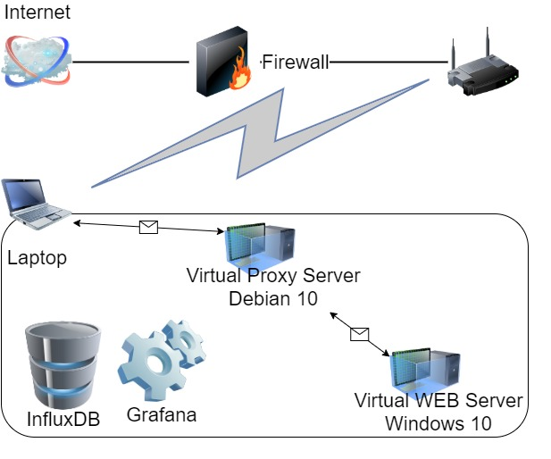**Server with data storage in file system:**

**Laptop** Windows 10**:**

Intel Core i7-8665U / 32 GB

**Virtual Proxy Server** Debian 10:

2 CPU / 4 GB

**Virtual WEB Server** Windows 10: 4 CPU / 4 GB (configurable)

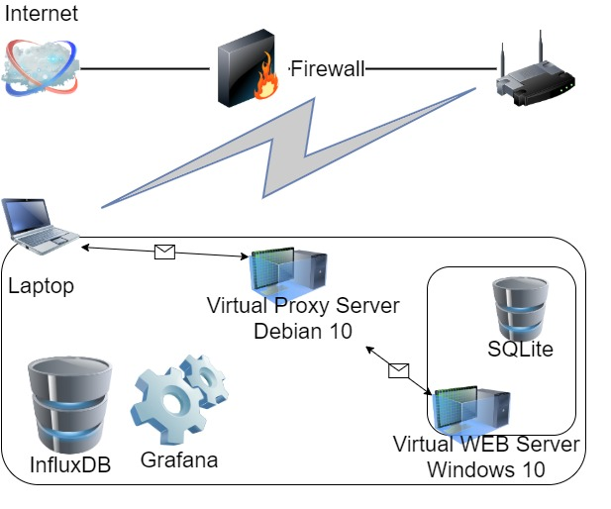**Server with data storage in database:**

**Laptop** Windows 10**:**

Intel Core i7-8665U / 32 GB

**Virtual Proxy Server** Debian 10:

2 CPU / 4 GB

**Virtual WEB Server** Windows 10: 4 CPU / 4 GB (configurable)

**Server Database:** SQLite

1. Responsibilities

|  |  |  |  |  |
| --- | --- | --- | --- | --- |
| # | Project Role | Name | Location | Responsibilities |
| 1 | Performance Tester | Dmytro Yaroslavtsev | Vinnytsia, Ukraine | Performance Test documentation creation and updating;  Test scripts creation and updating;  Performance testing;  Performance test results reporting. |

1. Staffing and training needs

Communication channel with BlogEngine.NET 3.2 Development team for consultation about its configuration.

1. Schedule (test milestones and item transmittal events)

Active phase: 31 AUG 2020 – 22 DEC 2020

Configuration phase: 31 AUG 2020 – 13 SEP 2020

Load investigation phase: 14 SEP 2020 – 18 OCT 2020

Testing phase: 19 OCT 2020 - 22 NOV 2020

General reporting: 22 NOV 2020 - 22 DEC 2020

More descriptive Schedule by the link: <https://learn.epam.com/myLearning/program?groupGuid=76eddfcc-ffff-4476-81c7-a87b1c3b2807&tab=calendar>

1. Risks and contingencies

• Using Proxy server may affect response time.

• Monitoring of CPU and memory utilization create an additional load.

• Using complex Network infrastructure affects the time of response.

1. Approvals

|  |  |  |  |
| --- | --- | --- | --- |
| **#** | **Project Role** | **Name** | **Date of approving** |
| 1 | Project Manager |  |  |
| 2 | Development Team Lead |  |  |
| 3 | Testing Team Lead |  |  |